All I want for Christmas Toolkit
Instagram:
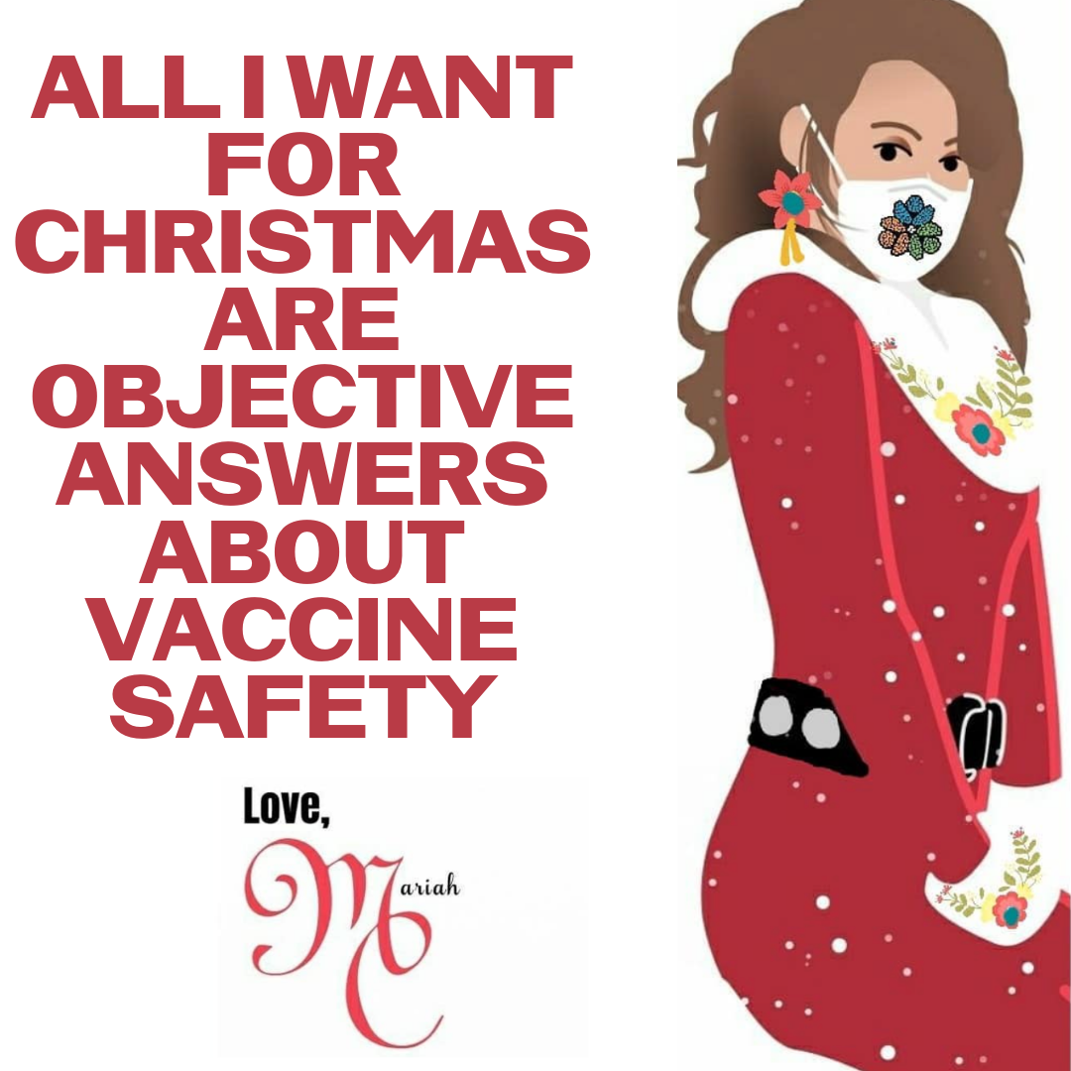

Description:
Want to attend a holiday gathering, but not sure about #COVID19 risk and #vaccines? Get the important facts fast — now answered by VIRA and vetted by Hopkins, all at http://vaxchat.org! Graphic modified from @johnshopkinssph

Twitter and Facebook:

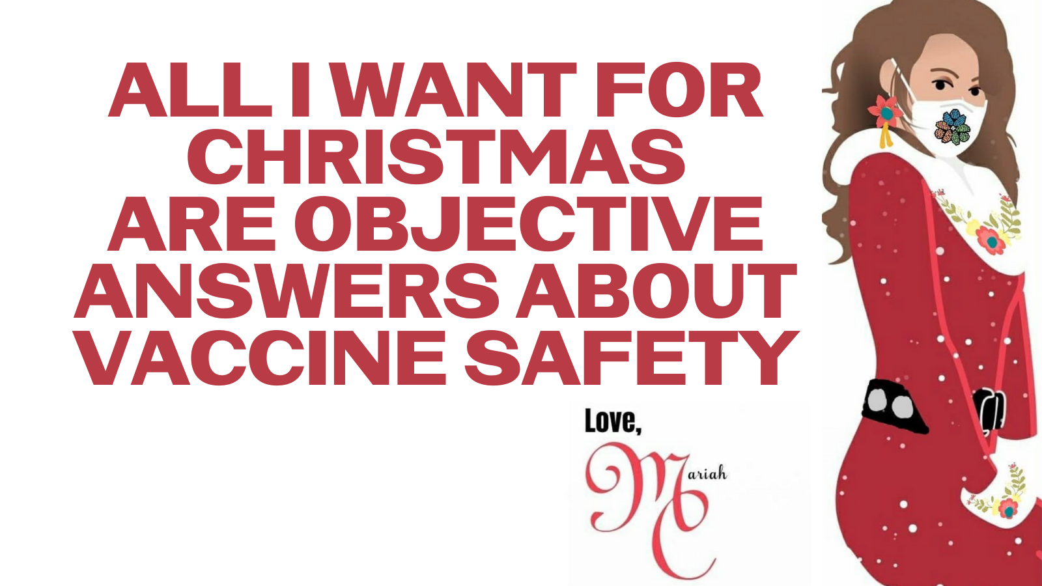
Description: Want to attend a holiday gathering, but not sure about #COVID19 risk and #vaccines? Get the important facts fast — now answered by VIRA and vetted by Hopkins, all at http://vaxchat.org! Graphic modified from @johnshopkinssph

