Big Auntie Energy IWTK/Native Test Toolkit
Instagram, three slide carousel:
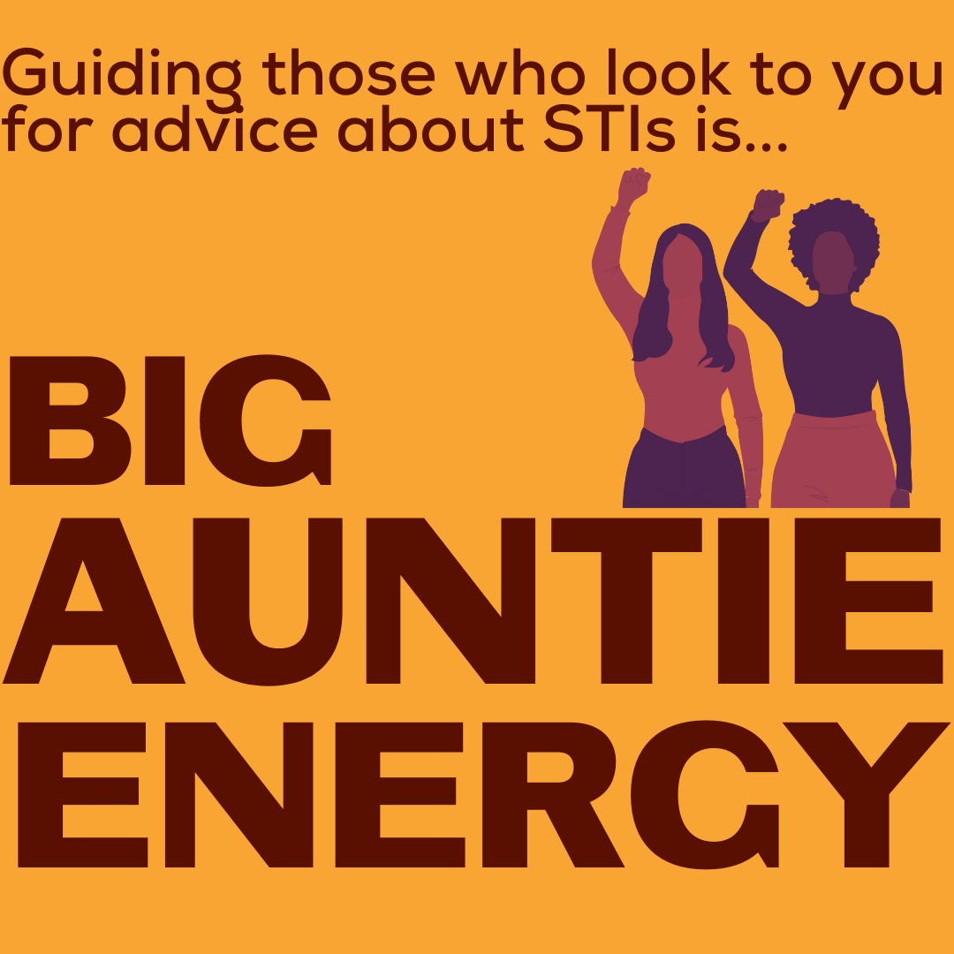
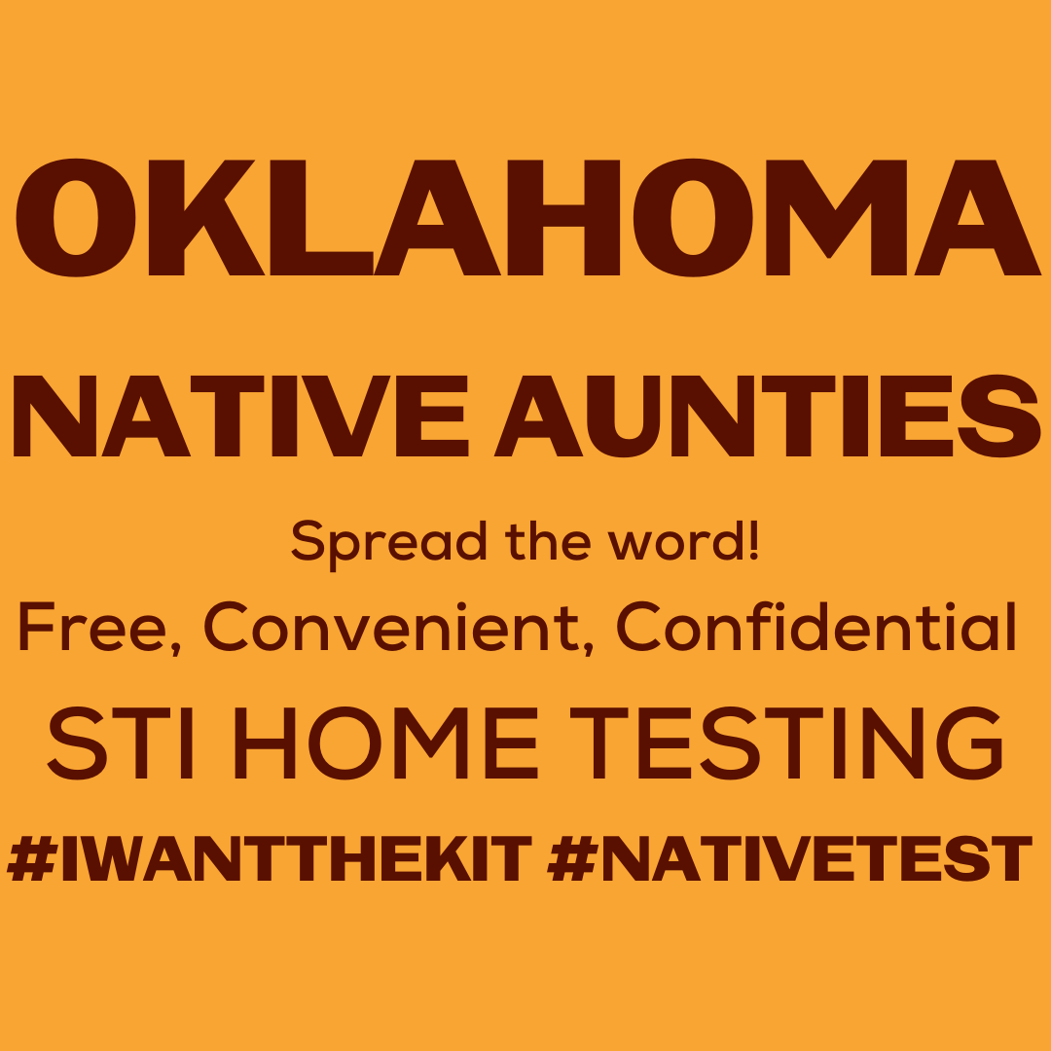
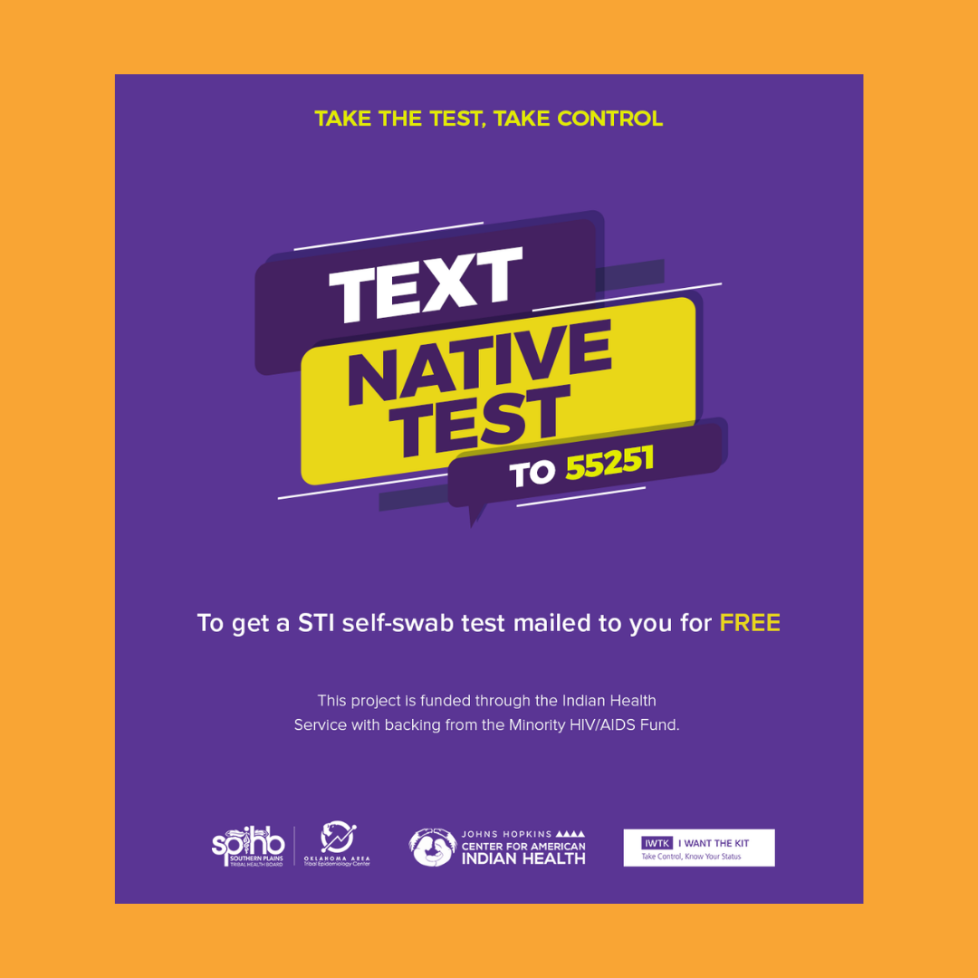

Description:
Oklahoma Native Aunties, everyone asks for your advice. Tell your loved ones to text “Native Test” to 55251 to order a FREE confidential STI self-test kit right to their door. #NativesKnowYourStatus #NativesGetTested #STIselftest #HIVselftest #OklahomaNativeAmericans #OklahomaNDN #SafeNatives #IWTK #NativeTest

Twitter and Facebook:
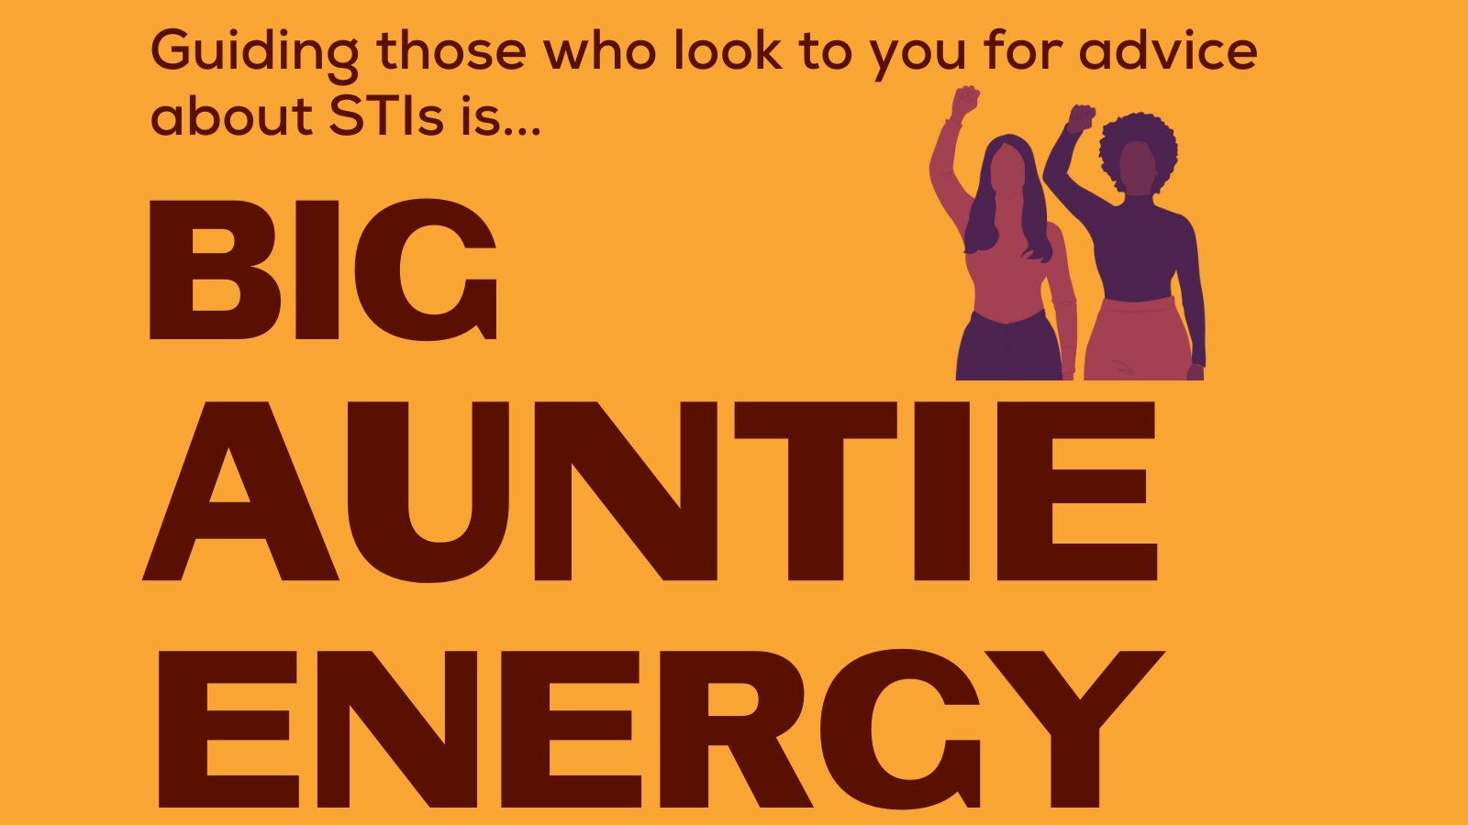
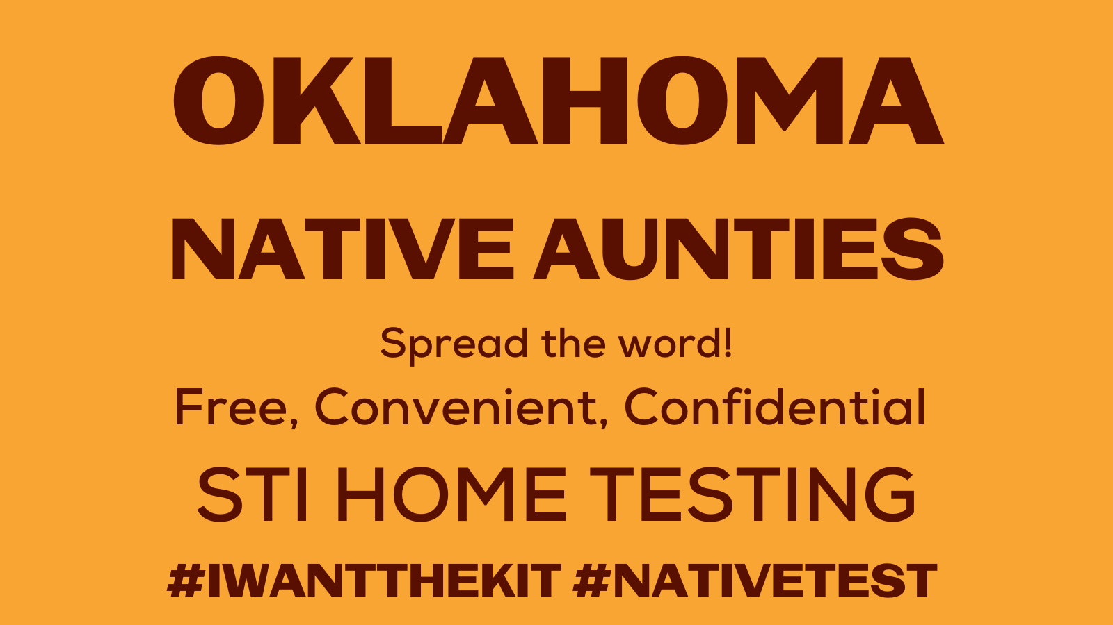
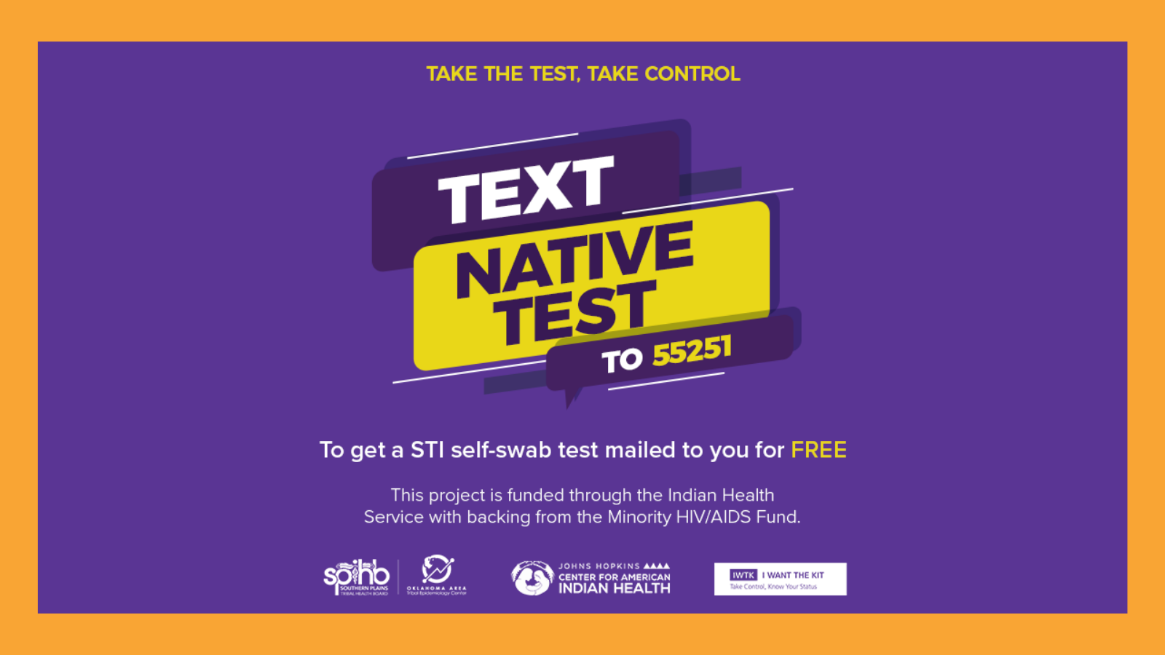

Description: Oklahoma Native Aunties, everyone asks for your advice. Tell your loved ones to text “Native Test” to 55251 to order a FREE confidential STI self-test kit right to their door. #NativeTest #IWantTheKit #HIV #STI #STD #IWTK #NativesKnowYourStatus #STISelfTest #HIVSelfTest

