Booster Eligibility Social Media Toolkit
Social Media Message: Getting your #Booster is the new #FullyVaccinated! With rapid spread of the #Omicron variant, booster vaccines provide you stronger protection from #COVID19. Get the shot when you can to strengthen your #Immunity and prevent the spread in our communities.
#NativesStopTheSpread #COVIDWarrior #VacciNation #SkoVaxDen #StoodisVaccine #CommunityImmunity #Vaccinated

Twitter/FB:
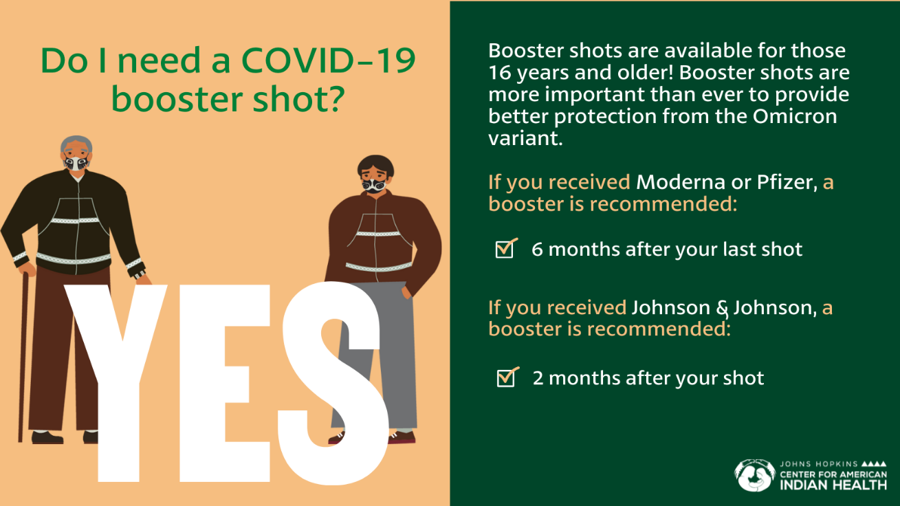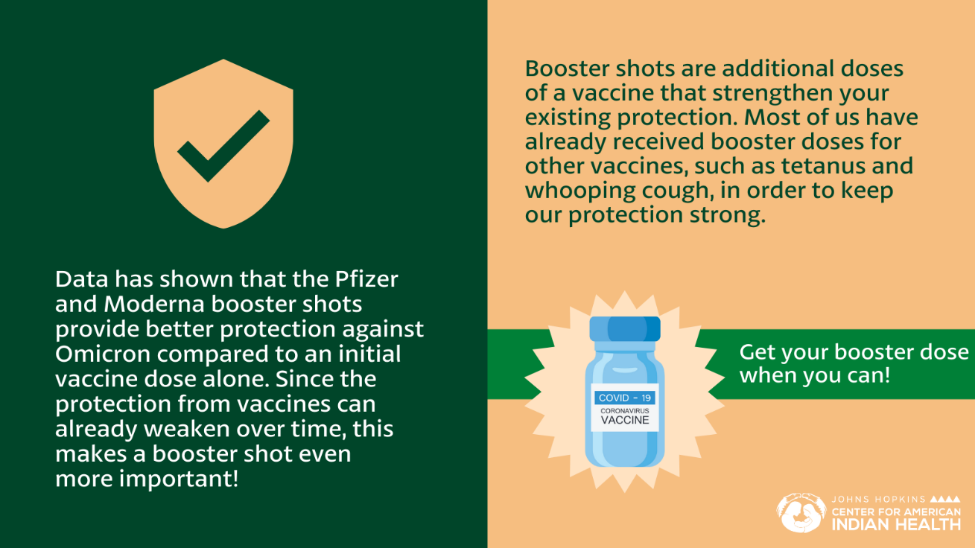
Instagram:
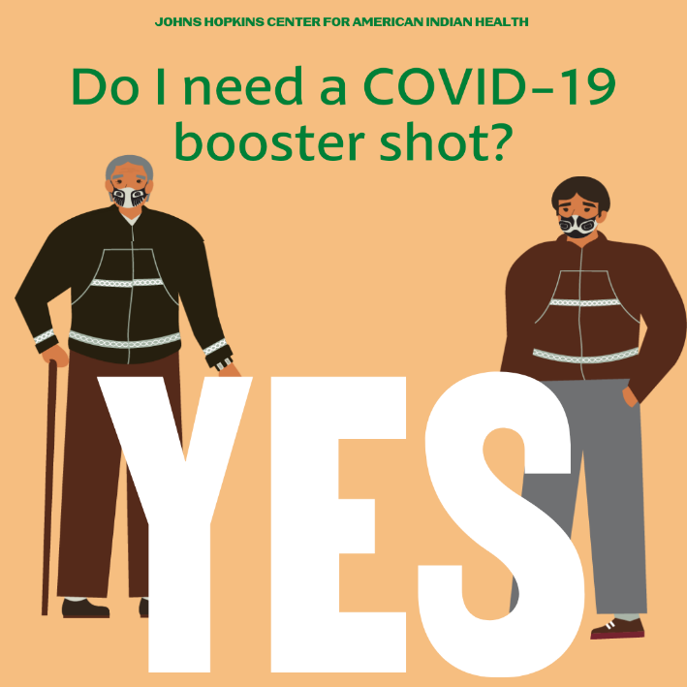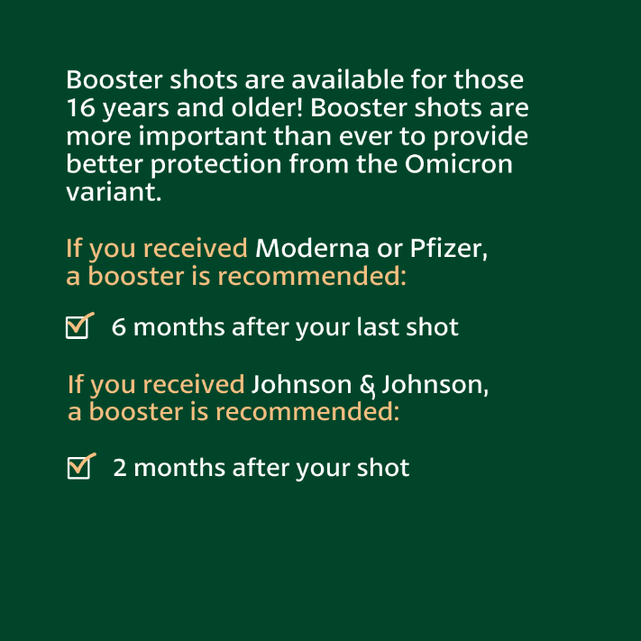
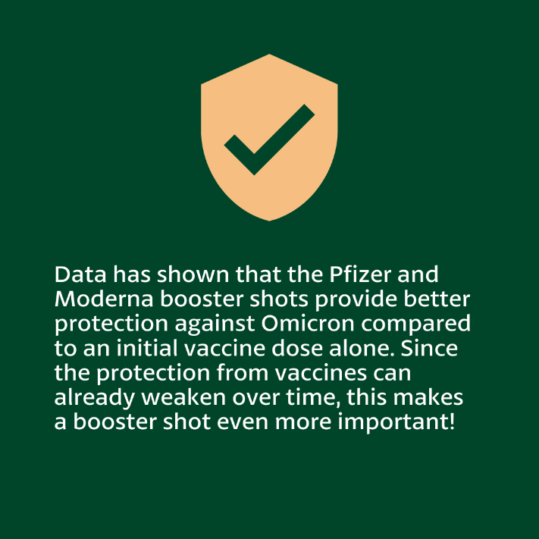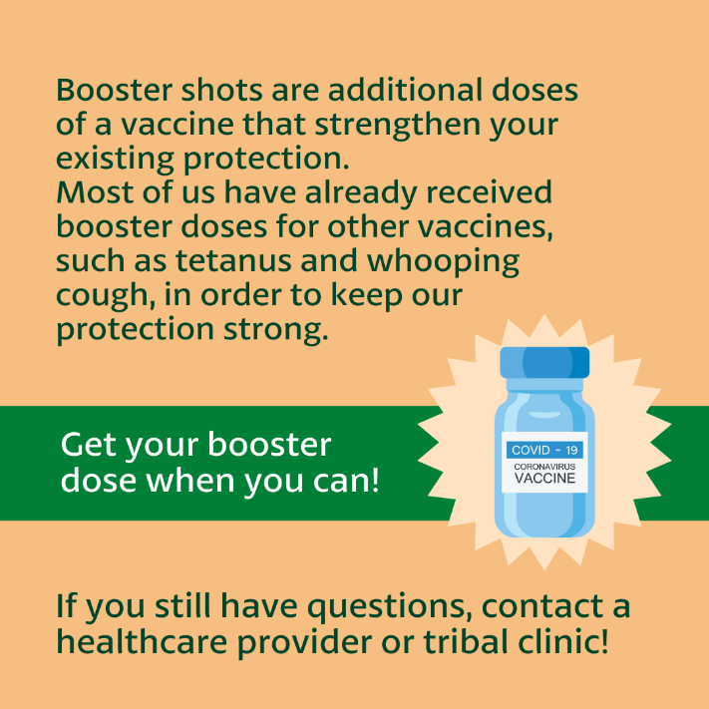
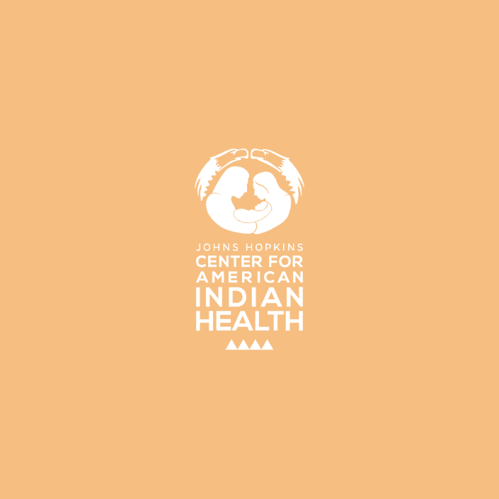

To tag: @Anthctoday @Aaipdocs @CDCgov @HealthyNativeYouth @HonoringNations @IndianCountryToday @_IllumiNatives @IndianHealthBoard_Minneapolis @IndianHealthService
@Indianz @JohnsHopkinsSPH @NationalIndianHealthBoard @Npaihb @Nihb1 @NationalNativeNews @NativeAmericans @NativeAmericanLifelines @Nimhgov @NNNnativenews @ProjectMosaicllc @SeattleIndianHealthBoard @UrbanIndigenousCollective @UrbanIndianHealth
@UrbanIndianHealthInstitute @WeAreHealers @wernative

