COVID-19 Vaccine Q&A Social Media Toolkit

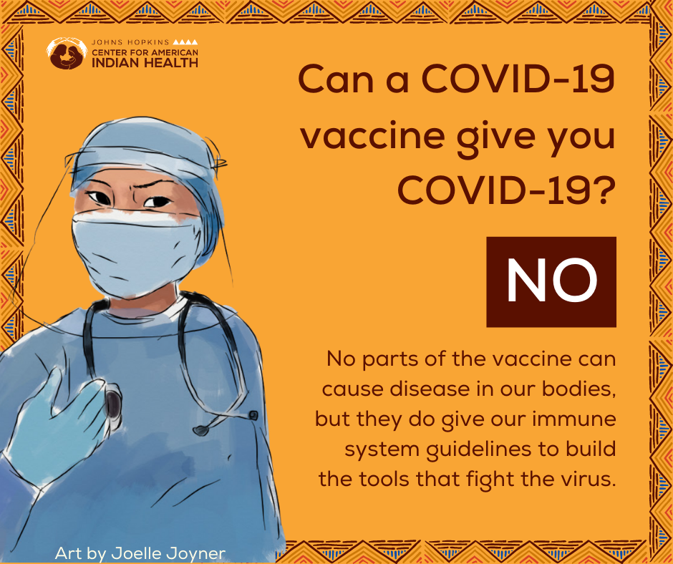
Social Media Message: None of the #COVID19 #vaccines can give you #COVID19 disease, but all vaccines will protect our bodies by giving our immune system guidelines to build tools and fight off the virus. The @US_FDA found that the vaccines were safe and effective. Have more questions? Click here for more information bit.ly/3a0Td33. #VaccinesWork

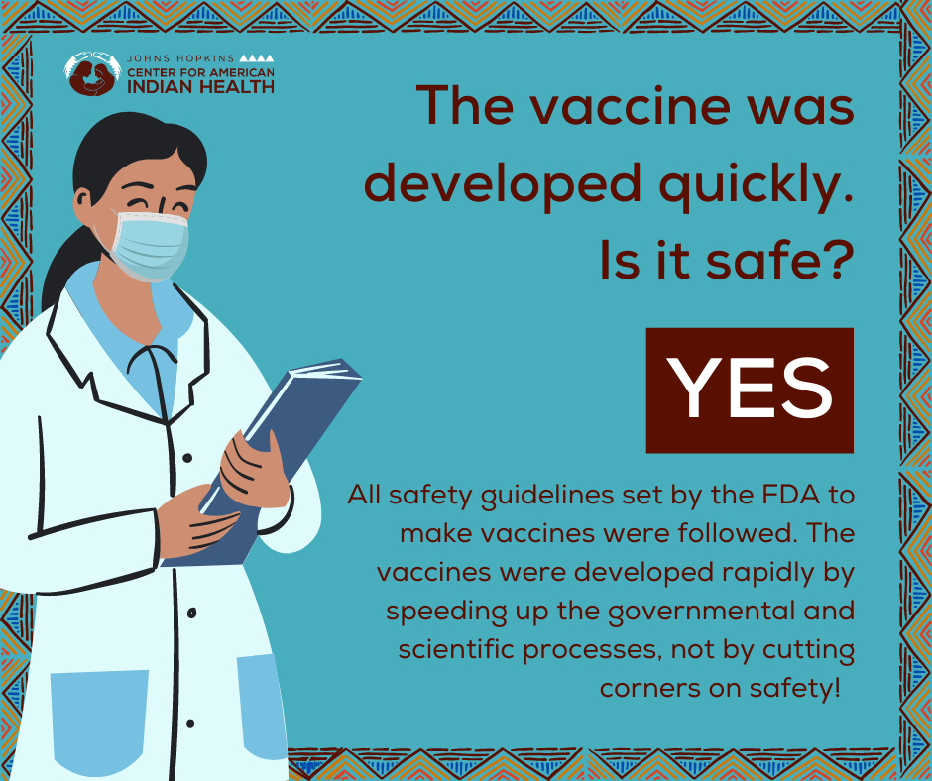
Social Media Message: All safety guidelines set by @US_FDA to make the vaccines were followed. The vaccines were developed rapidly by speeding up the governmental and scientific process, not by cutting corners on safety! Still have unanswered questions? Visit caih.jhu.edu/news/coronavirus or click here for more information bit.ly/3a0Td33. #VaccinesWork

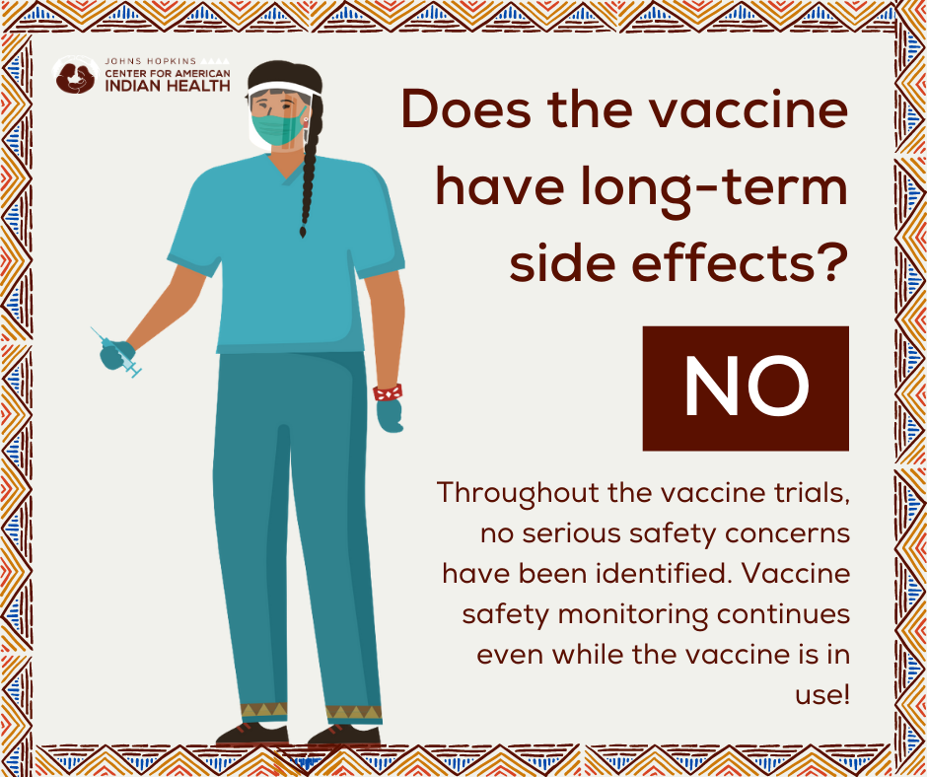
Social Media Message 1: While some participants in the #COVID19 #vaccine clinical trials experienced minor short-term side effects, like headache and fever, no serious safety concerns were found. @US_FDA approved the vaccine after finding it #safe and effective, but safety monitoring continues even while the vaccine is in use! Have more questions about the COVID-19 vaccine? Click here to learn more: bit.ly/3a0Td33. #VaccinesWork

Social Media Message 2: While some participants in the #COVID19 #vaccine clinical trials reported serious medical conditions during the trial, these were found to not be related to the vaccine. @US_FDA approved the vaccine after finding it #safe and effective, but safety monitoring continues even while the vaccine is in use! Have more questions about the COVID-19 vaccine? Click here to learn more: bit.ly/3a0Td33. #VaccinesWork

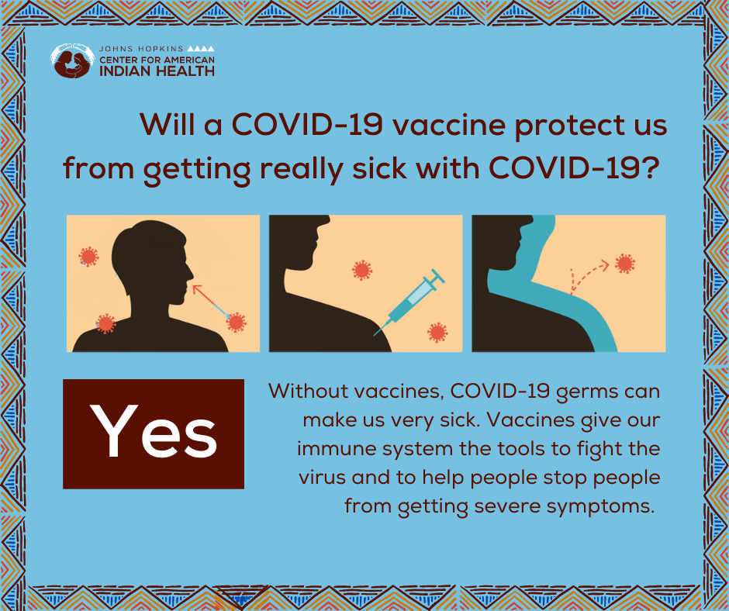
Social Media Message: All vaccines, including the COVID-19 vaccine, protect our bodies by giving our immune system guidelines to build tools and fight off the virus. This stops people from getting very sick and needing to be hospitalized, and might help to #StoptheSpread of COVID-19 disease. Have more questions? Click here for more information bit.ly/3a0Td33. #VaccinesWork

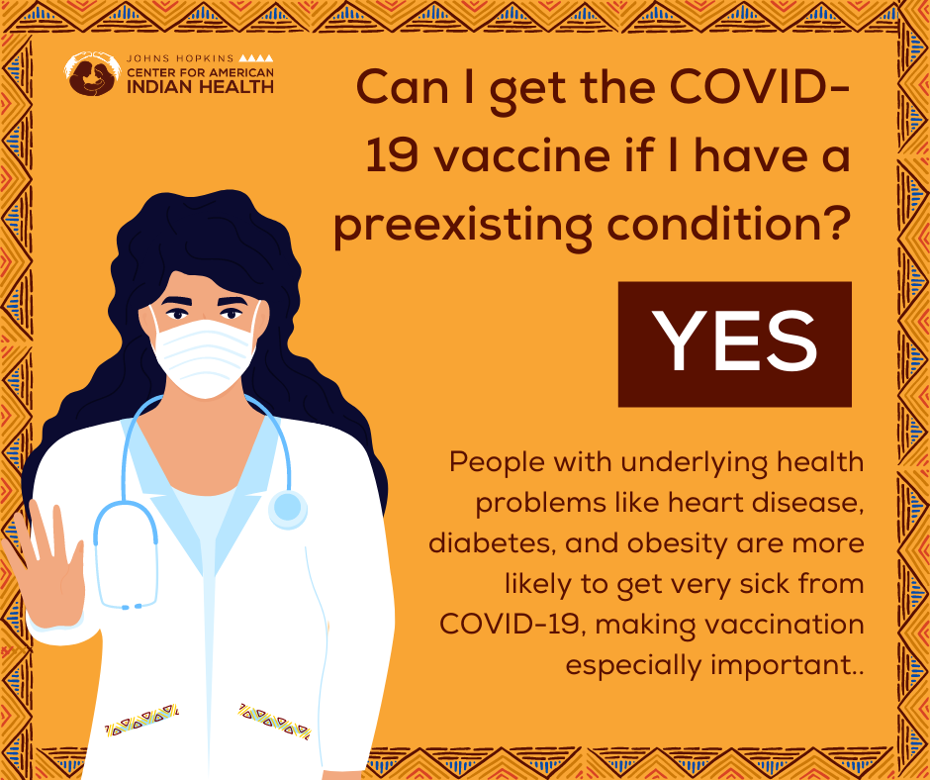
Social Media Message: People with health problems like diabetes, heart disease, or autoimmune disorders are more likely to get very sick from #COVID19, making #vaccination especially important in those with pre-existing conditions. Ask your health care provider if you have more specific questions about your health and the #vaccine. Click here for more information bit.ly/3a0Td33. #VaccinesWork

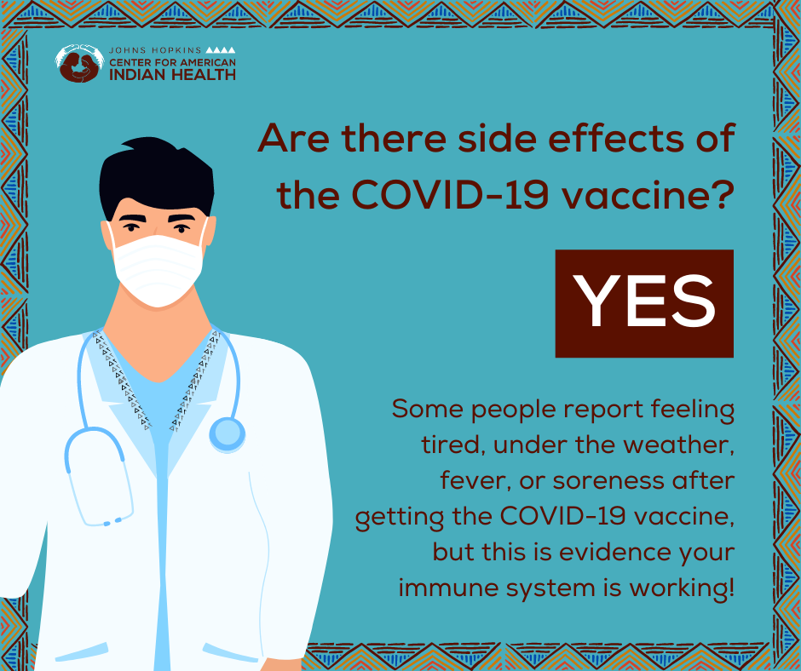
Social Media Message: While some people report feeling tired, under the weather, fever, or soreness after getting the #COVID19 #vaccine, this is evidence that your body is building the tools needed to fight off the #virus. Symptoms generally resolve quickly, though some have stronger side effects after the second dose. The COVID-19 vaccine is #YourBestShot against COVID-19! #VaccinesWork

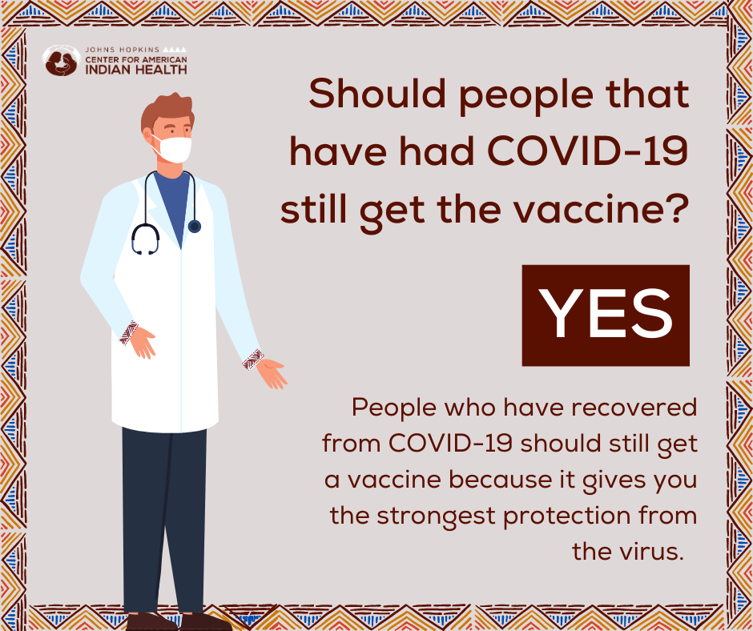
Social Media Message 1: Because the vaccine offers the strongest protection against the virus, people who have recovered from #COVID19 should still get a vaccine after they recover. The vaccine is #OurBestShot against #COVID19 disease. Have more questions about the COVID-19 vaccine? Click here to learn more: bit.ly/3a0Td33. #VaccinesWork

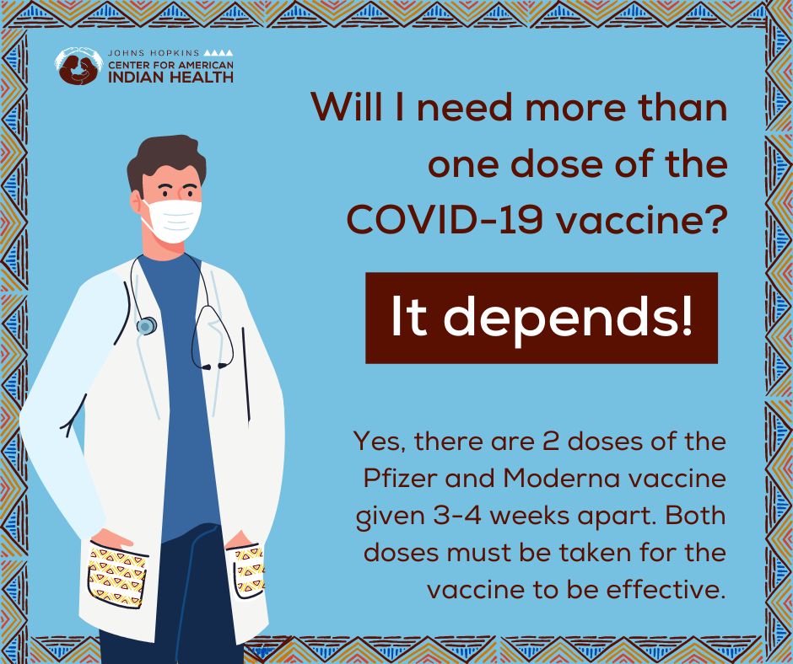
Social Media Message: The Pfizer and Moderna vaccines require two doses in order for the vaccine to be fully effective. The doses are usually given 3-4 weeks apart, but still approved up to 6 weeks. Be sure to keep wearing your face mask and social distancing after getting the vaccine to protect our communities! Have more questions? Click here for more information bit.ly/3a0Td33. #VaccinesWork

