Children’s Vaccines Video Social Media Toolkit
Social Media Message: #COVID19 vaccines are safe and work to protect your kids 5 and up from infection and serious illness. Get a vaccine appointment for your children today by calling your tribal clinic, health provider or local pharmacy. For more, watch: https://bit.ly/3uo6VJp #ProtectTheOnesYouLove
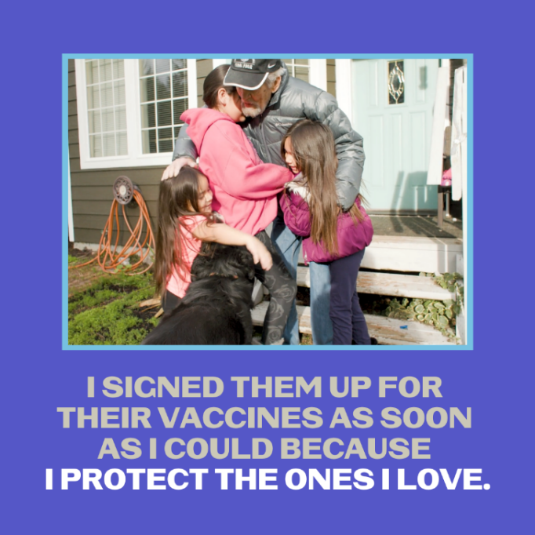

Social Media Message: #COVID19 vaccines are the best studied #vaccines in history. They are safe and effective for your kids 5 and older. Contact your tribal clinic, health provider, or local pharmacy to get your kids vaccinated and #ProtectTheOnesYouLove. For more, watch: https://bit.ly/3uo6VJp.
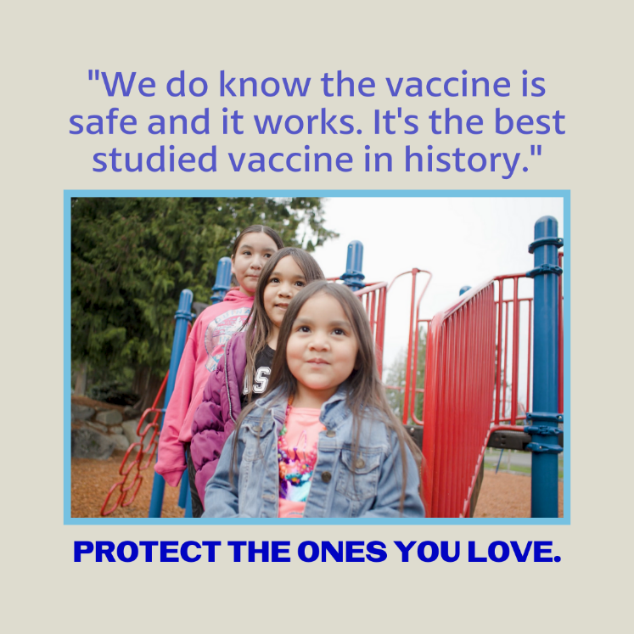
Partners to Tag: @Anthctoday @Aaipdocs @CDCgov @HealthyNativeYouth @HonoringNations @IndianCountryToday @_IllumiNatives @IndianHealthBoard_Minneapolis @IndianHealthService
@Indianz @JohnsHopkinsSPH @NationalIndianHealthBoard @Npaihb @Nihb1 @NationalNativeNews @NativeAmericans @NativeAmericanLifelines @Nimhgov @NNNnativenews @ProjectMosaicllc @SeattleIndianHealthBoard @UrbanIndigenousCollective@UrbanIndianHealth
@UrbanIndianHealthInstitute @WeAreHealers @WeRNative

