Confidence in Confidentiality-Receptionist IWTK/Native Test Toolkit
Instagram and Facebook, two slide carousel:

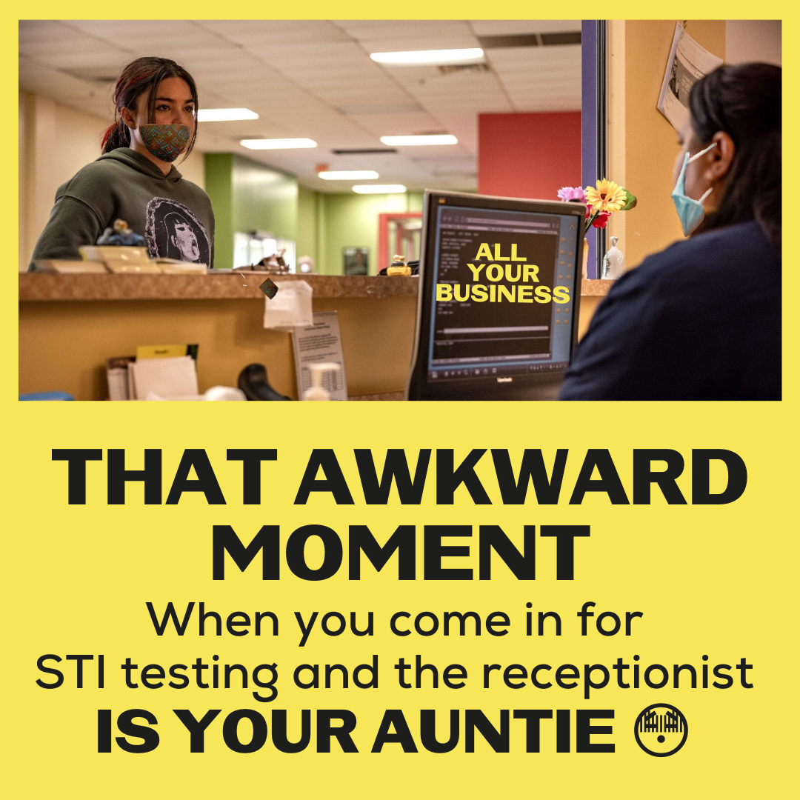
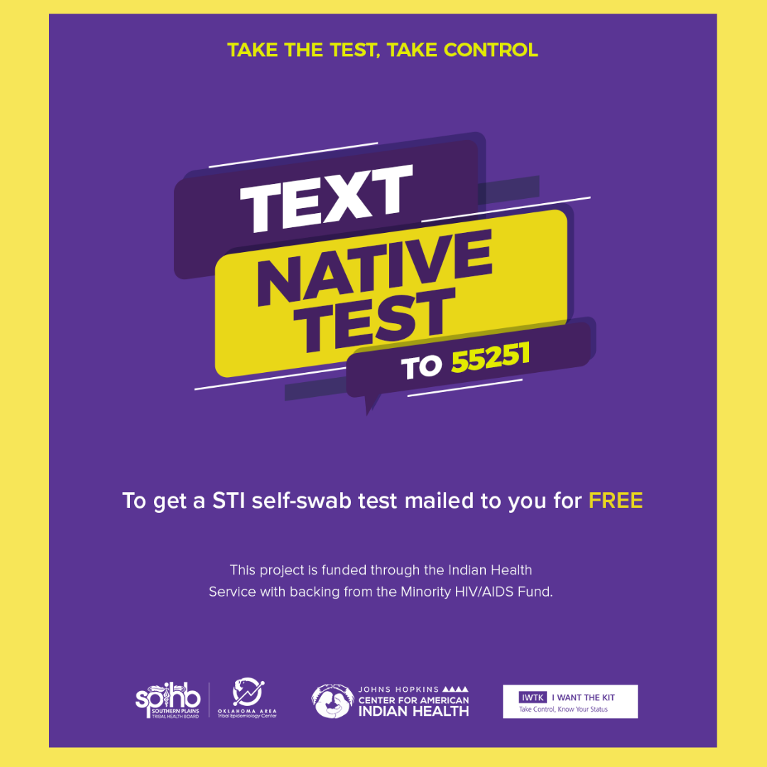

Description:
Oklahoma Native Americans, now it’s easier to have confidence in confidentiality about your sexual health. We’re sure your auntie will honor the “What happens at the clinic STAYS at the clinic” rule, but if you’d just rather not...you have options. Don’t let an awkward situation keep you from getting tested. Text “Native Test” to 55251 to order a FREE confidential STI self-test kit right to your door. #NativesKnowYourStatus #NativesGetTested #STIselftest #HIVselftest #OklahomaNativeAmericans #OklahomaNDN #SafeNatives #IWTK #NativeTest #ReservationDogs

NOTE: On Instagram tag @RezDogsFX

Twitter and Facebook:
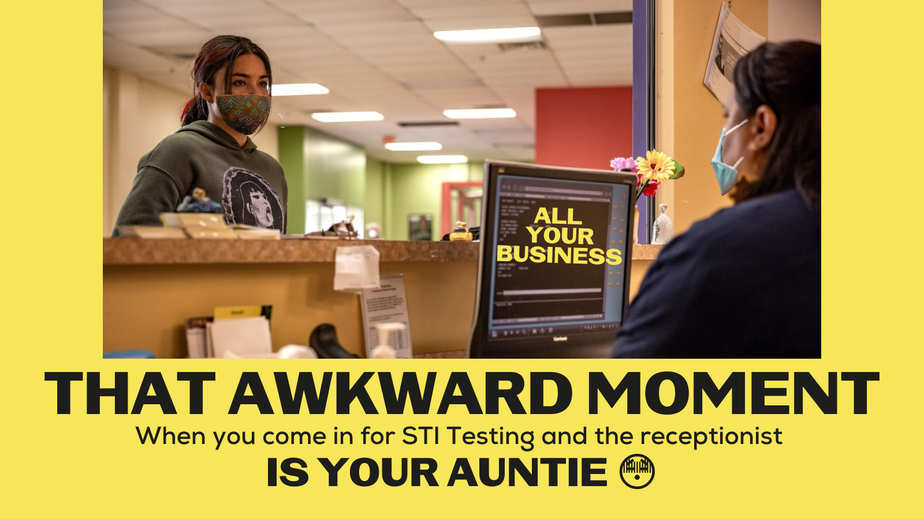
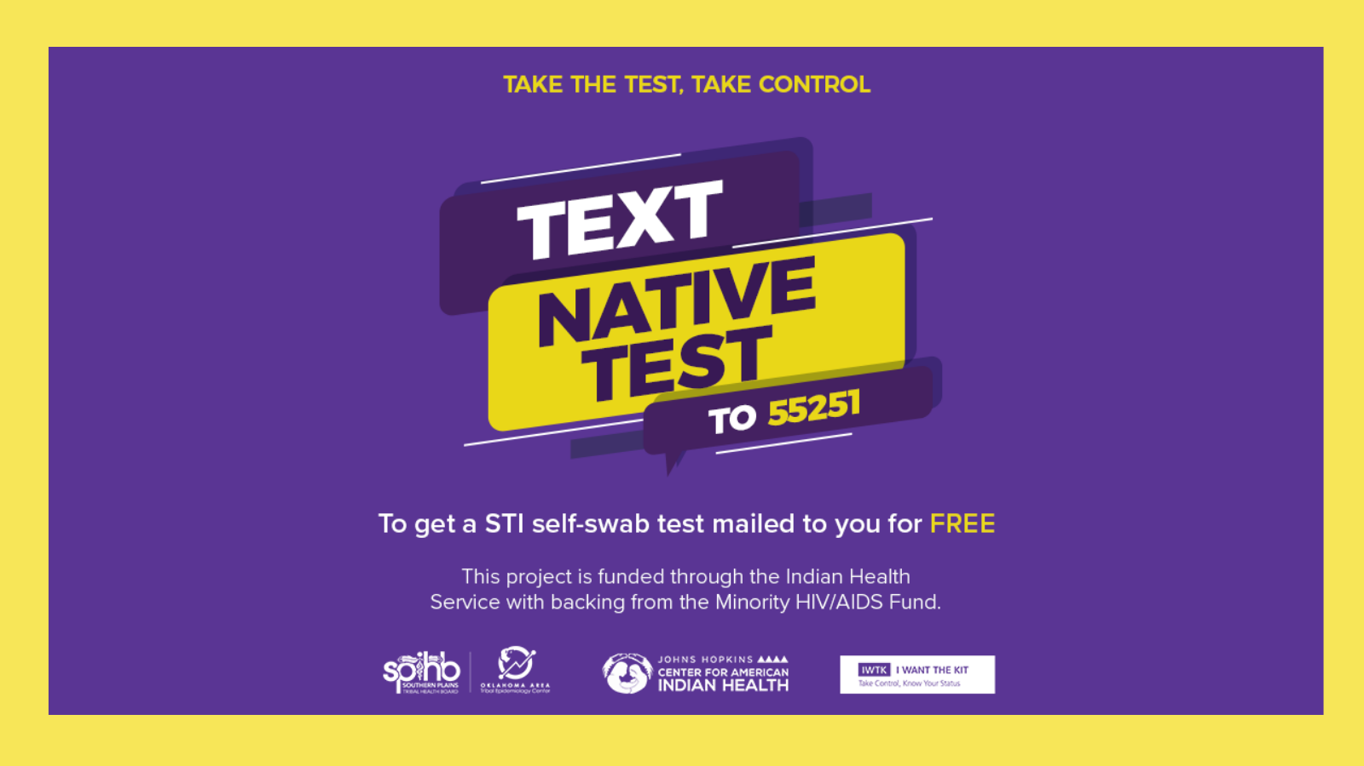
Description: Don’t let an awkward situation keep you from getting tested. Oklahoma Natives, Text “Native Test” to 55251 to order a FREE confidential STI self-test kit right to your door. #NativesGetTested #STIselftest #HIVselftest #OklahomaNDN #IWTK #NativeTest

Tag: @RezDogsFX

