Dark Days Toolkit
Instagram:

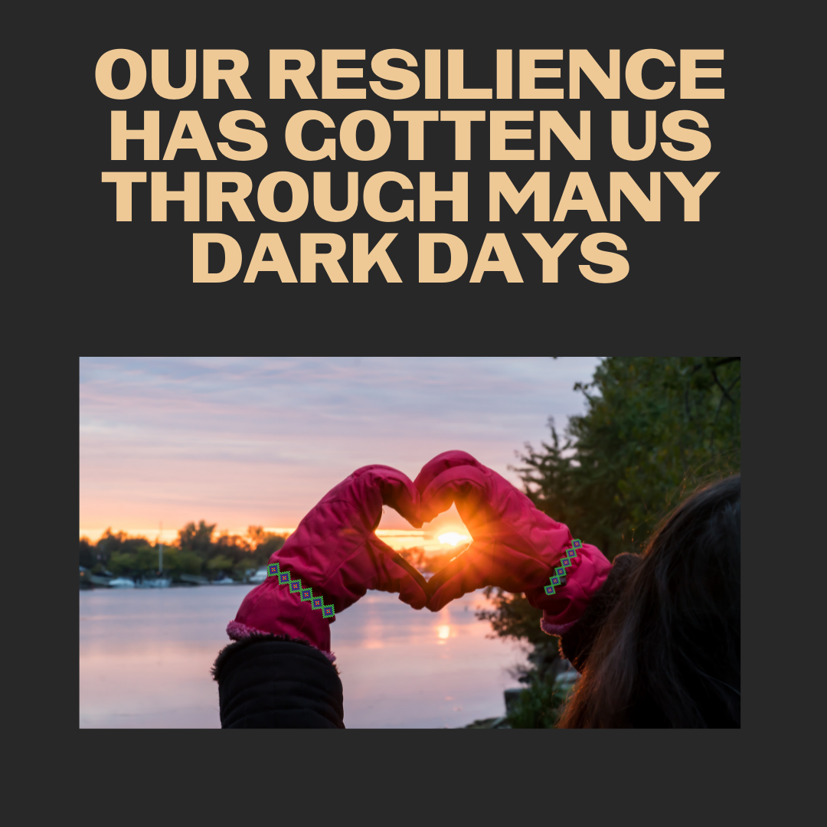
Description:
The days are getting shorter, but our community values of caring for one another have gotten us through many dark seasons. Those ways will see us to brighter days once more.
#NativeValues #NativeHealth #NativesStopTheSpread

Twitter and Facebook:

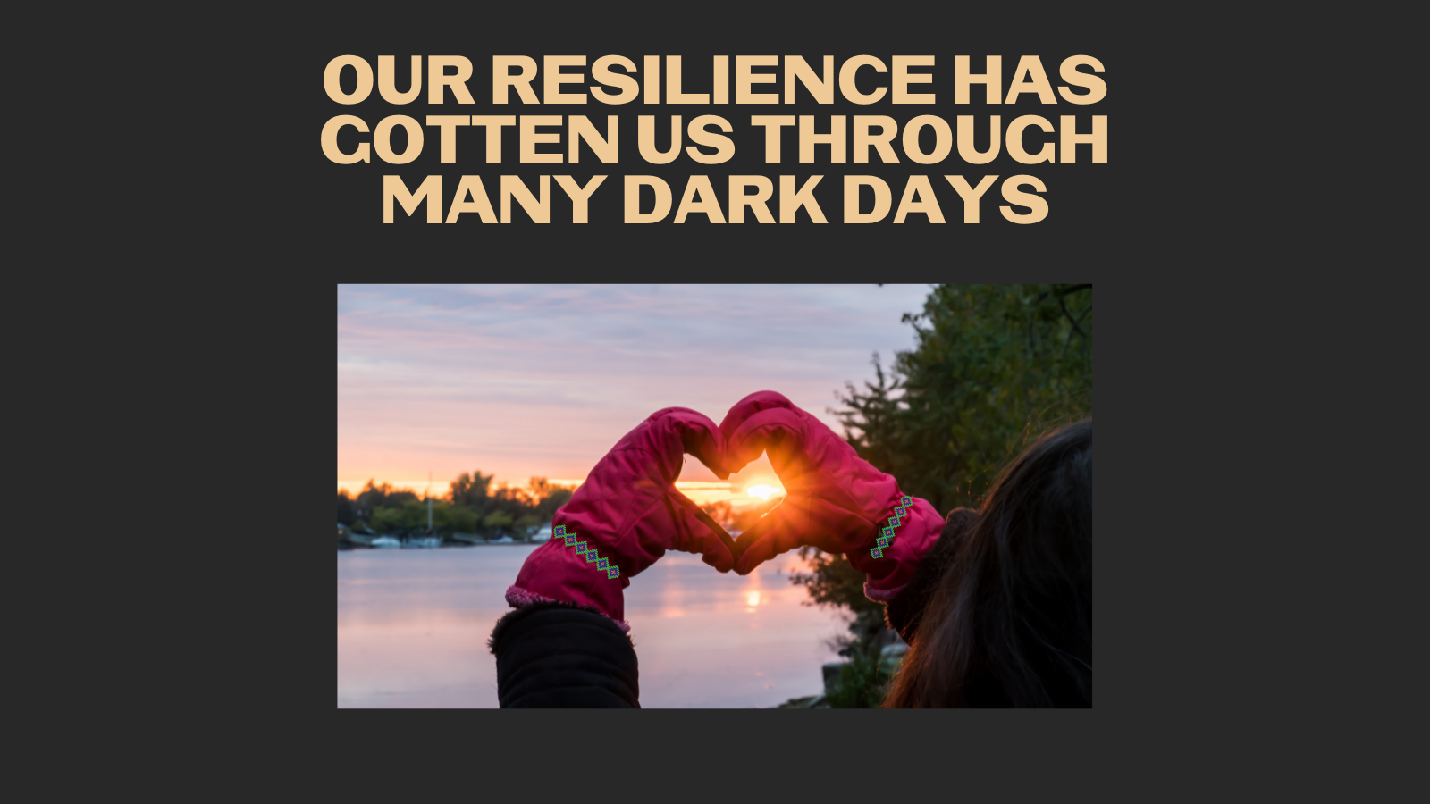
Description: The days are getting shorter, but our community values of caring for one another have gotten us through many dark seasons. Those ways will see us to brighter days once more.
#NativeValues #NativeHealth #NativesStopTheSpread

