“Diné Traditional Healer talks about #COVID19 #Vaccination” Video Stills: Social Media Toolkit
Social Media Message (Facebook/Twitter): Getting your #vaccine protects you and your community from #COVID19. Vaccines are safe for Native people and 100% effective at preventing death and hospitalization due to COVID-19. Watch our newest video to learn more at Beverly Gorman, Diné Traditional Healer talks about the COVID-19 Vaccine - YouTube.
Social Media Message: Getting your #vaccine protects you and your community from #COVID19. Vaccines are safe for Native people and 100% effective at preventing death and hospitalization due to COVID-19. Watch our newest video to learn more at the link in bio. (Include link in bio: Beverly Gorman, Diné Traditional Healer talks about the COVID-19 Vaccine - YouTube).

1. 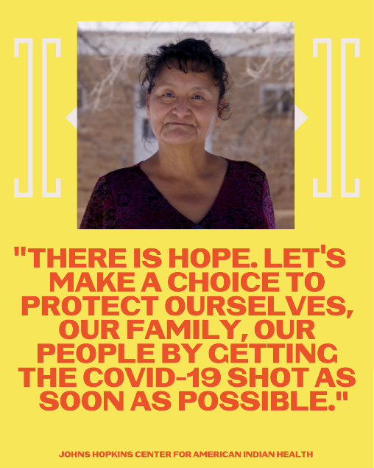 2. 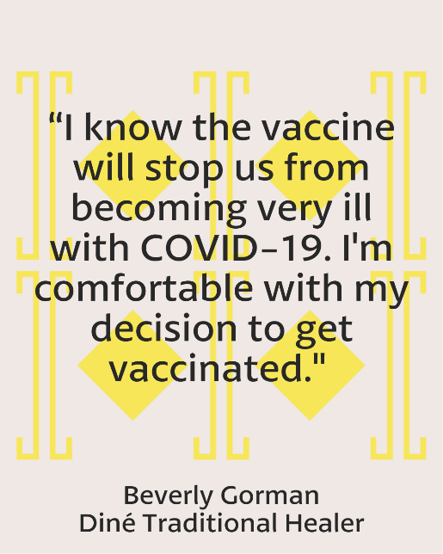

3. 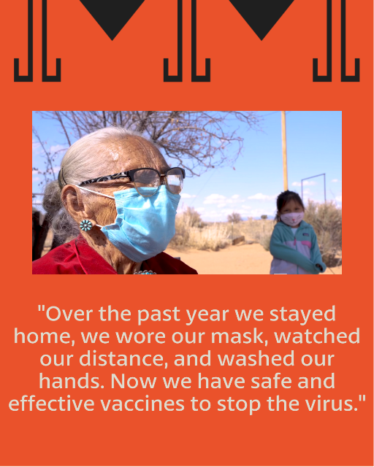 4. 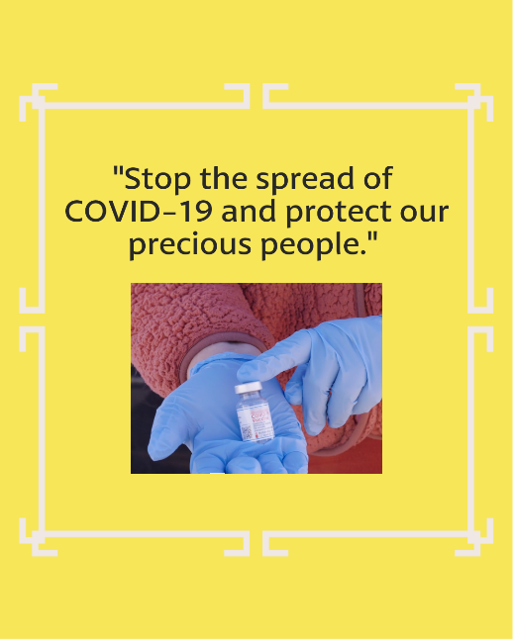
5. 