Elders and Children Meme Toolkit
Instagram: Panels are prepared in ten Indigenous languages, all in one post.
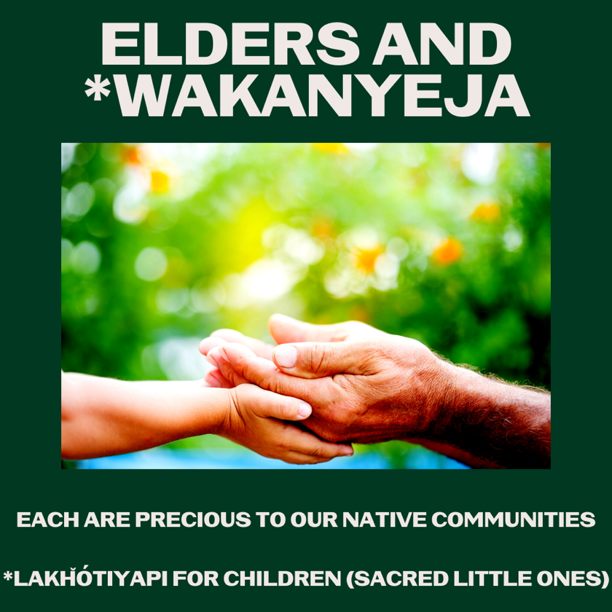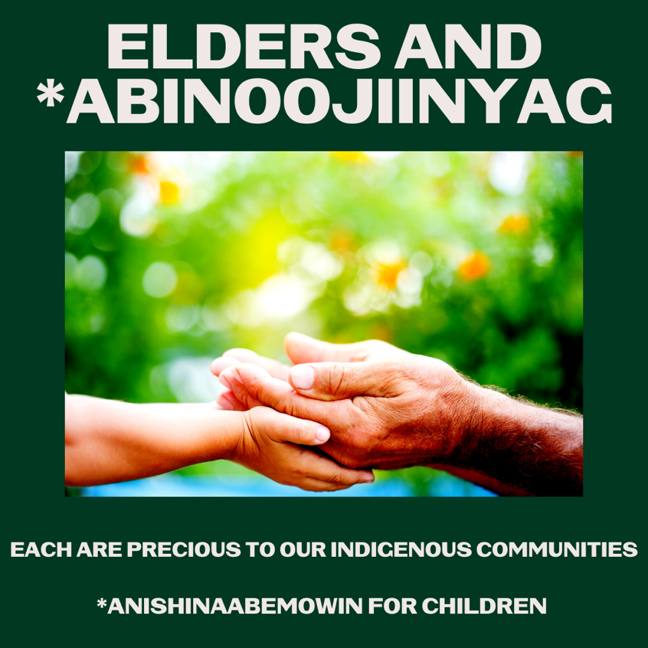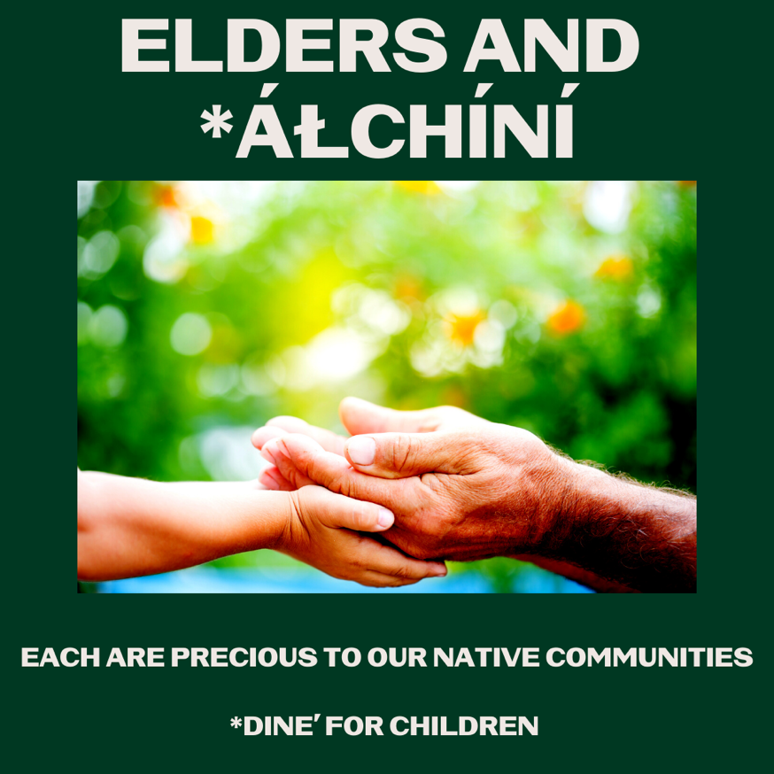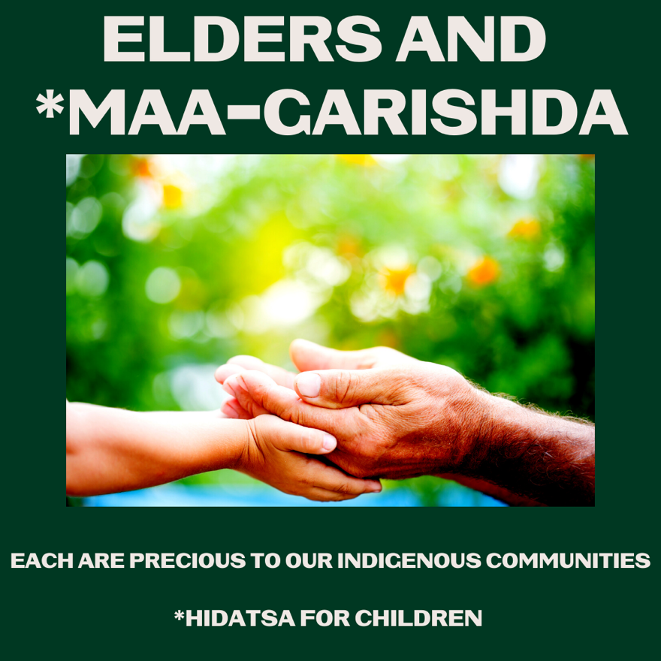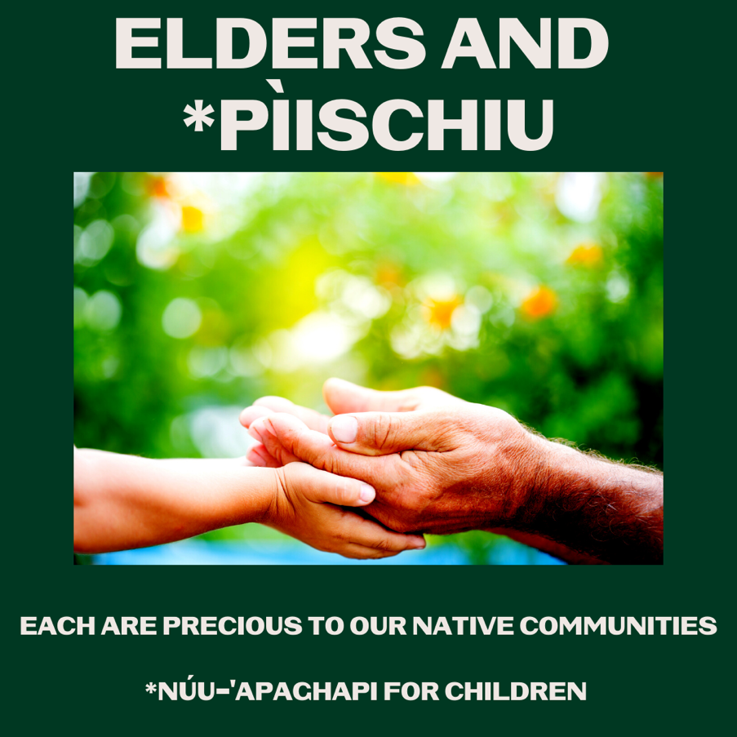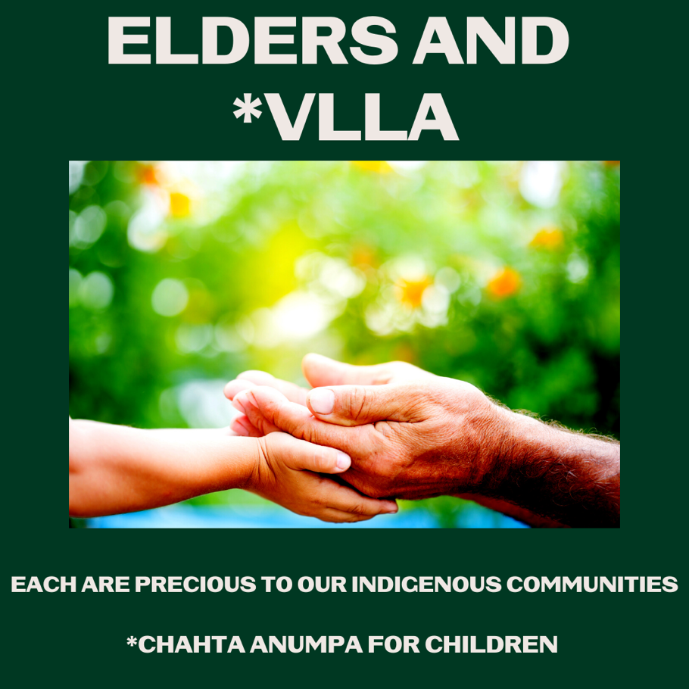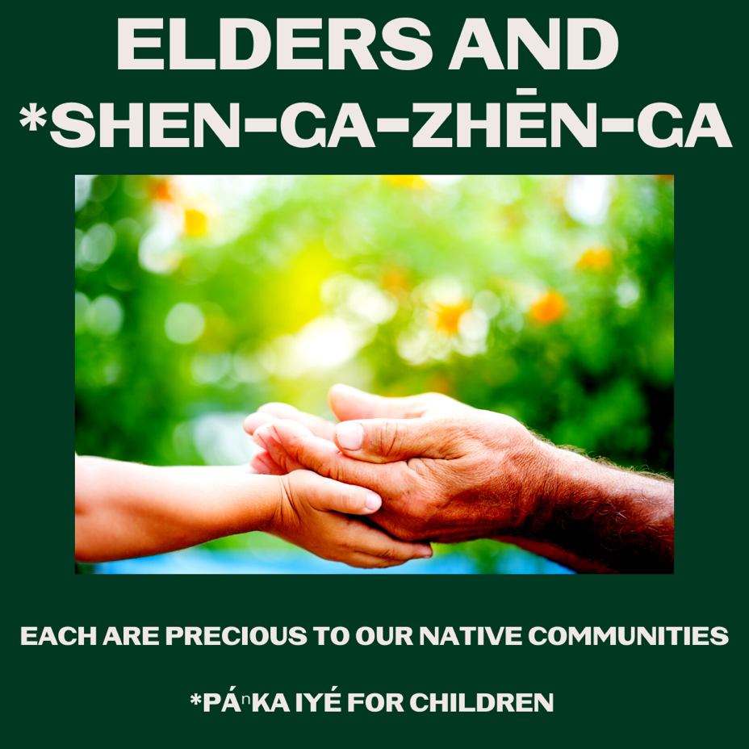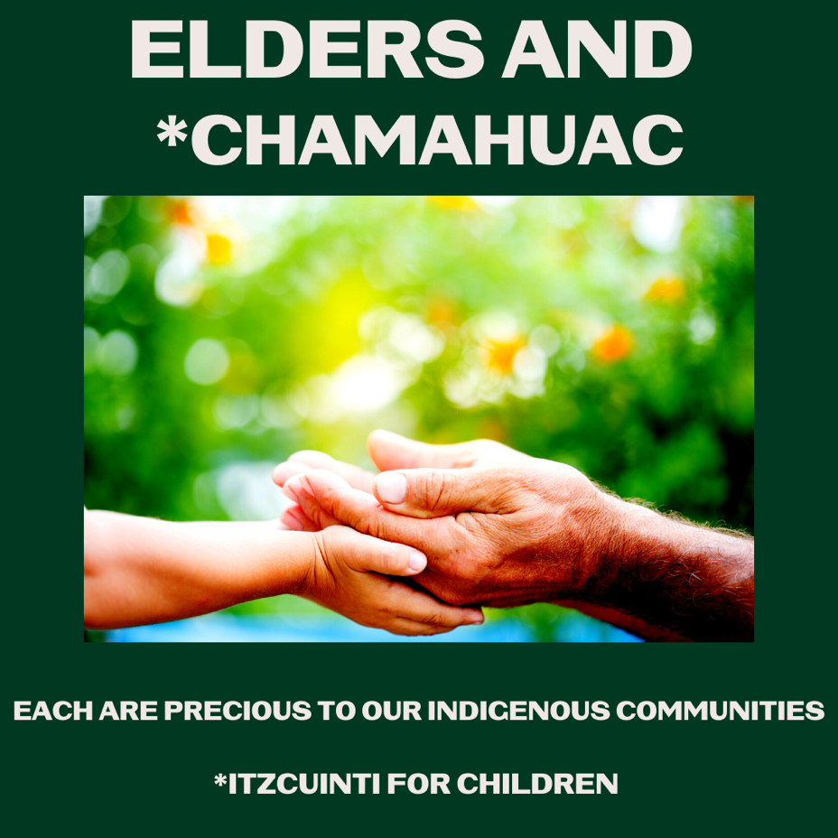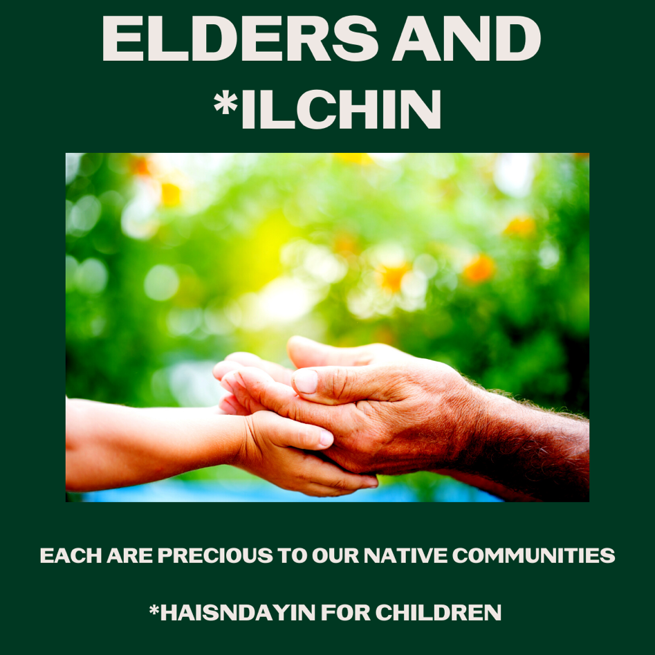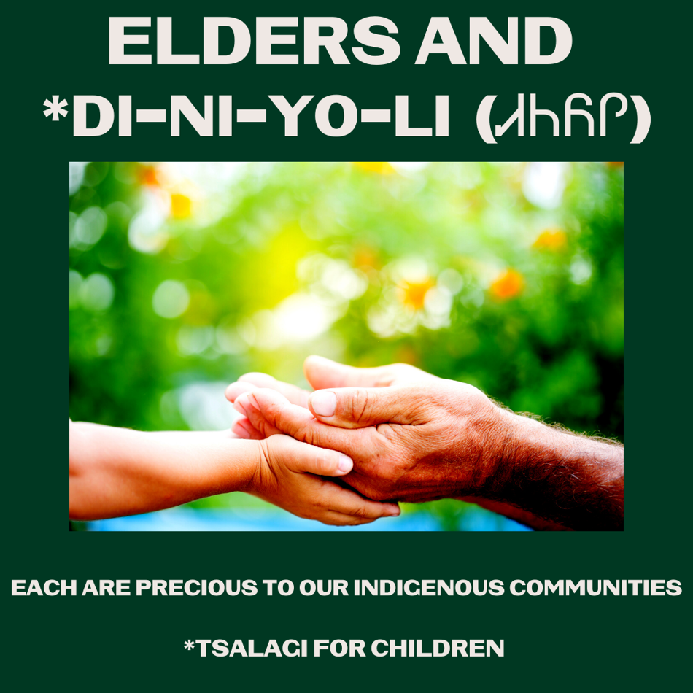
Description:
Indian Country has gotten our elders vaccinated at astonishing rates because they are our connection to our history, culture, and language. Our children are our hope and future. Now that vaccines are available for kids, make an appointment to get your young ones vaccinated. For more information visit https://bit.ly/3o1Cwvg #NativesStopTheSpread #HealthyNatives #HealthyTribes #IndigenousLanguage #NativeYouth
Twitter and Facebook: 10 panels in one post, to be shared upon final approval (slated for Nov 3rd)
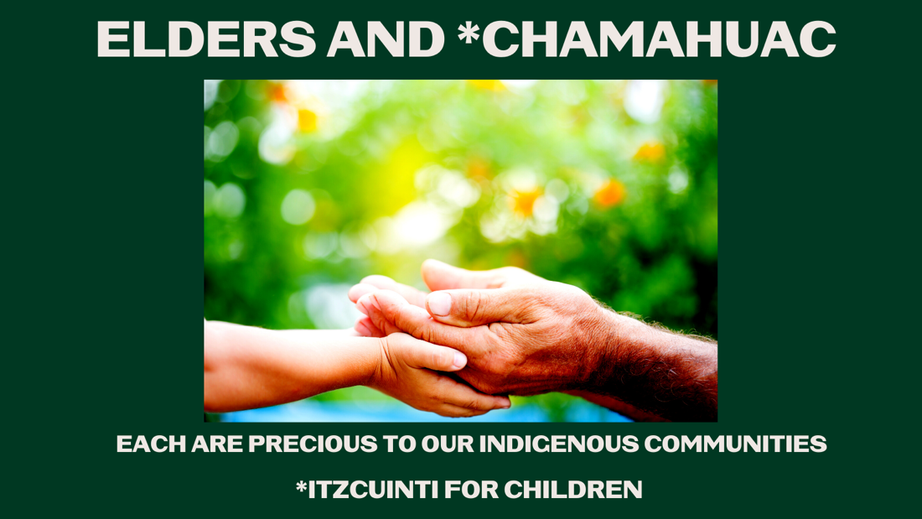
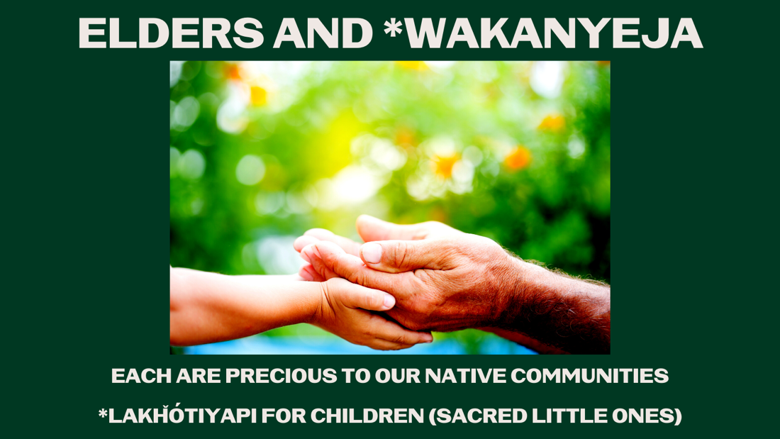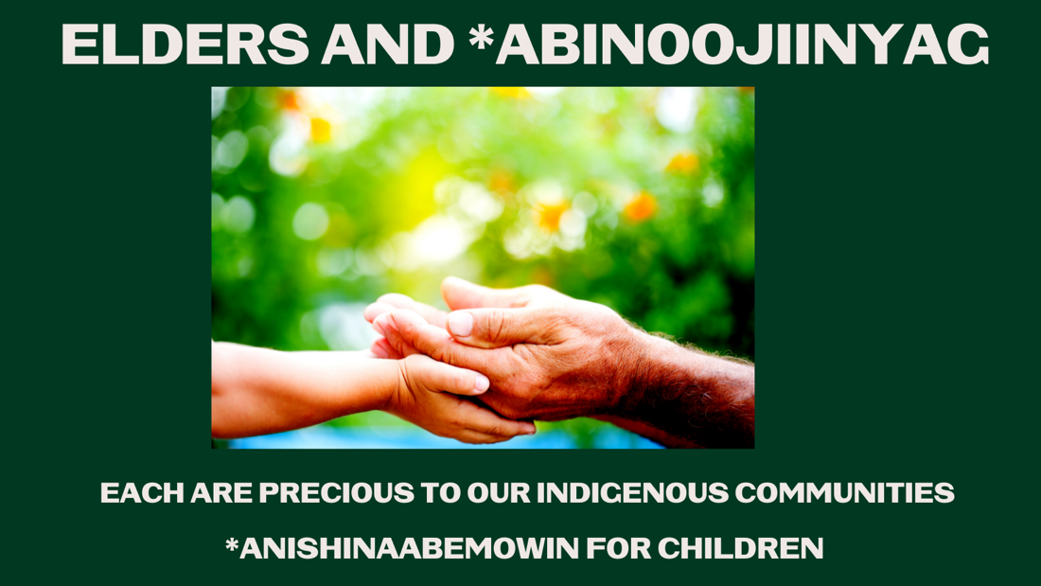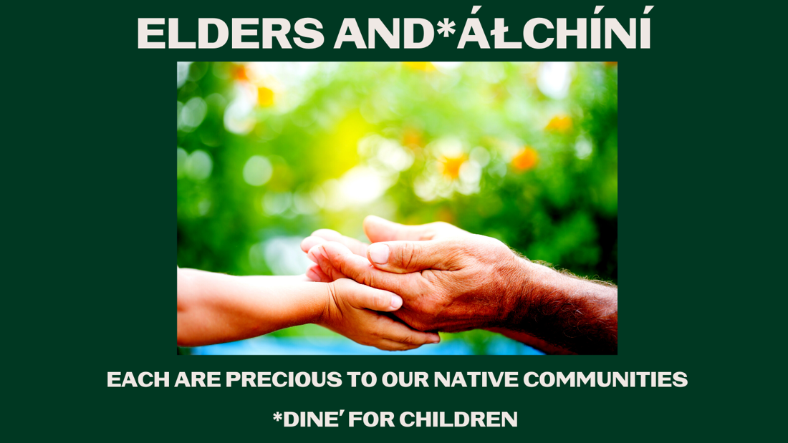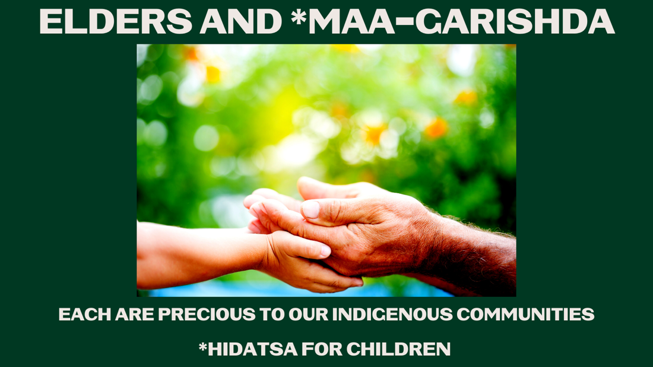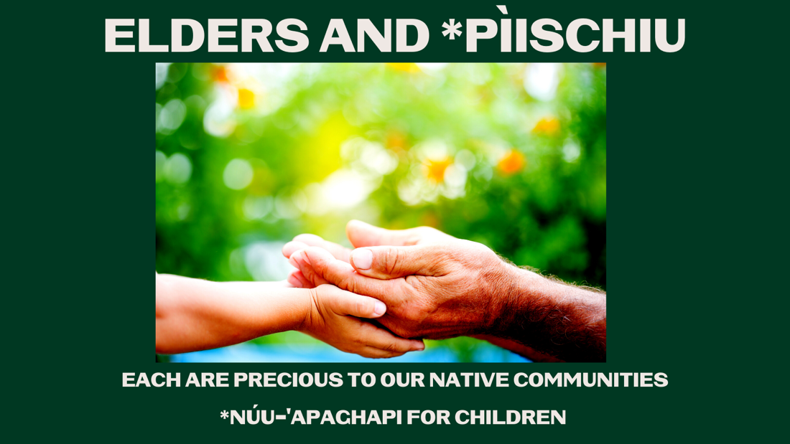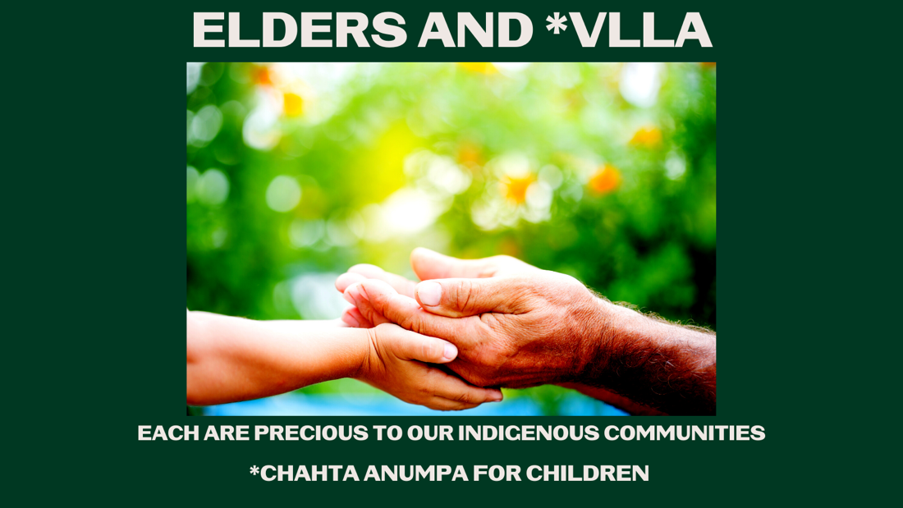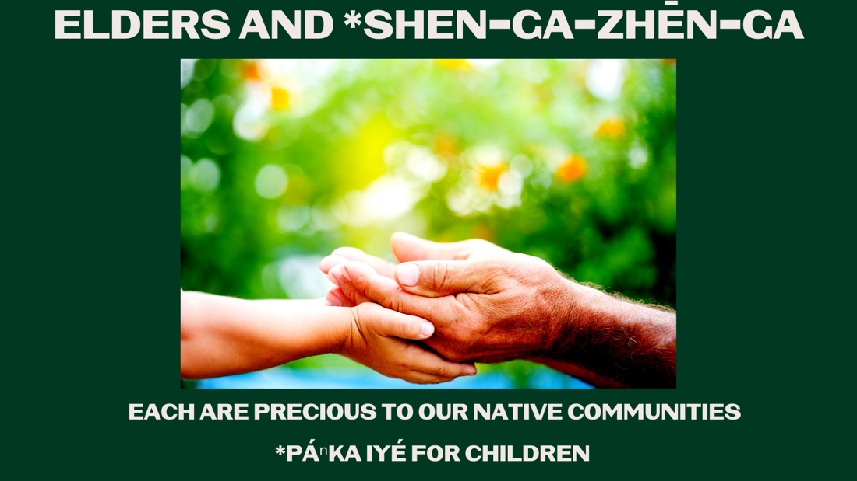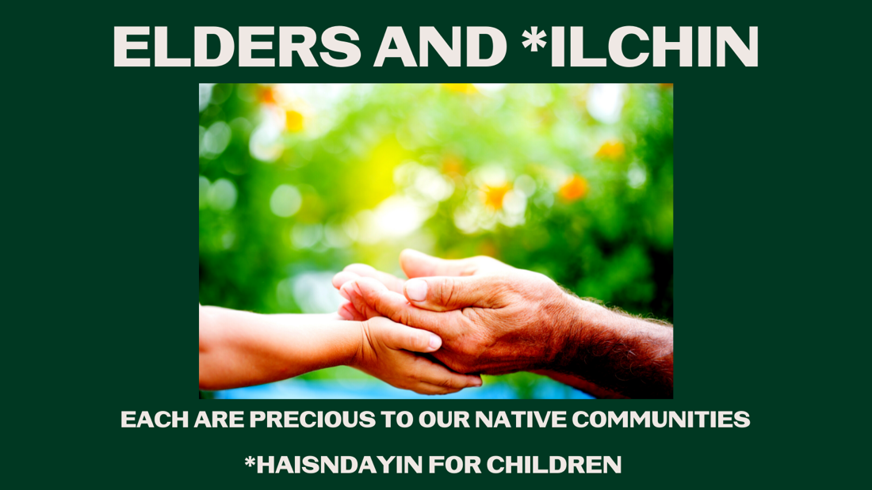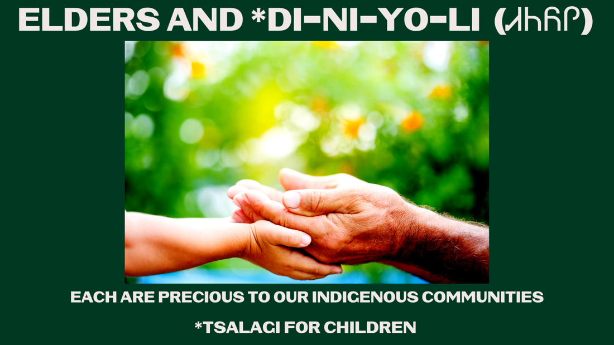
Description:
Indian Country has gotten our elders vaccinated at astonishing rates. They are our connection to our history, culture, and language. Our children are our hope & future. Make an appointment to get your young ones vaccinated. For more information visit https://bit.ly/3o1Cwvg

