Handwashing Social Media Toolkit

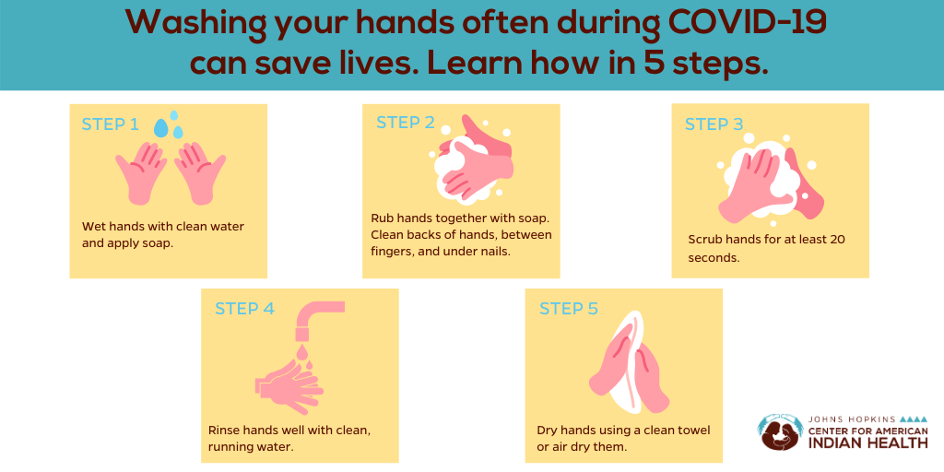
Handwashing👐🏽 with soap prevents the spread of germs.🦠Wash hands often, especially when returning 🏠from outside, after using the bathroom, before eating, and after coughing or sneezing. Follow these 5⃣ easy steps for success! #BeatCovid #WellnessWarriors #WarriorUp

Instructions: to download the following images as GIFs, right click the graphic and select “save as” to save the GIF to your computer. Upload this to desired social media site. Copying and pasting will not preserve the animated portions of the files.

Handwashing👐🏽 with soap prevents the spread of germs.🦠Wash hands when returning 🏠from outside, after using the bathroom, before eating, and after coughing. Learn more about washing hands with shared wash pans: https://bit.ly/2ZkcOHK
#BeatCovid #WellnessWarriors #WarriorUp

Handwashing👐🏽 with soap prevents the spread of germs.🦠Wash hands often, especially when returning 🏠from outside, after using the bathroom, before eating, after coughing. Wash for 20 secs:
✅Front + back of hands,
✅Between fingers,
✅Under nails.💯
#WellnessWarriors

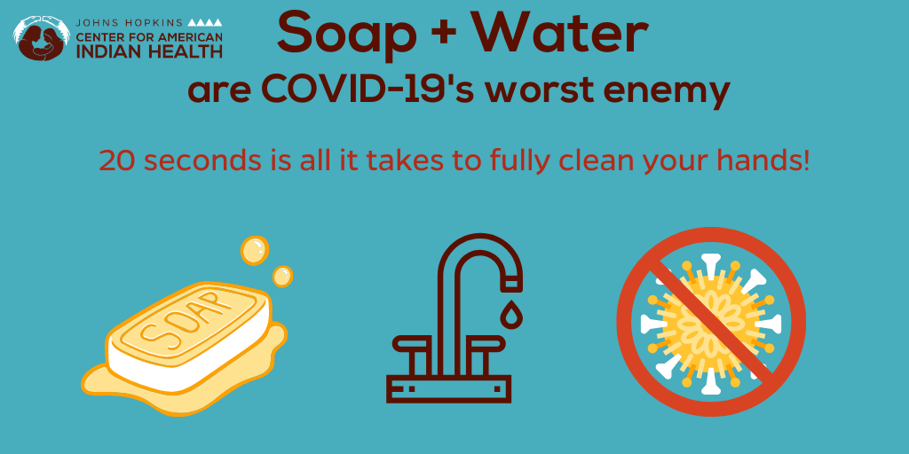

DYK? Handwashing with soap destroys the virus that causes COVID-19. 🦠Wash hands often, especially when returning 🏠from outside, after using the bathroom, before eating, and after coughing. Clean backs of hands, between fingers, under nails.💯
#BeatCovid #WellnessWarriors #WarriorUp

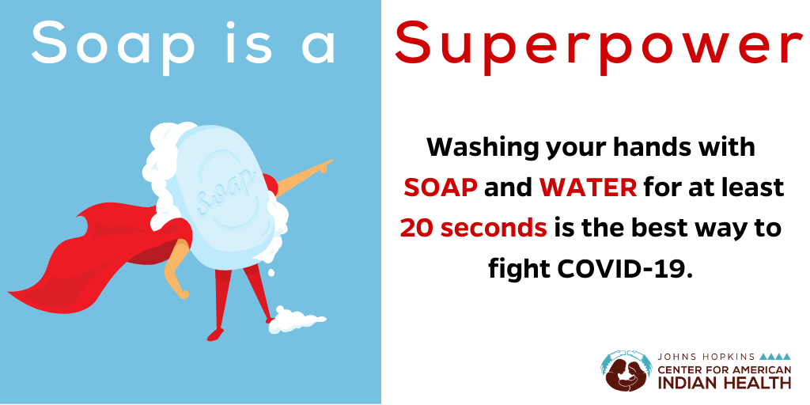
DYK? Handwashing with soap destroys the virus that causes COVID-19. 🦠Wash hands often, especially when returning 🏠from outside, after using the bathroom, before eating, and after coughing. Clean backs of hands, between fingers, under nails.💯
#BeatCovid #WellnessWarriors #WarriorUp

