Healthy Lung Month Social Media Toolkit

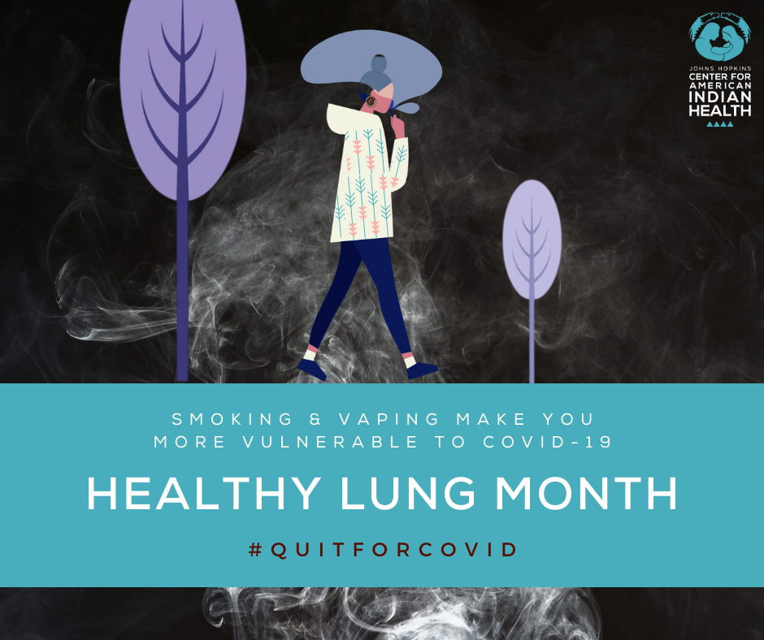

Message: #DYK that October is #HealthyLungMonth? We can't emphasize it enough: smoking is a risk factor for more severe #COVID19 infections. There's no better time to #QuitInQuarantine and be #HealthyAtHome. Visit smokefree.gov for more information or call 1-800-QUIT-NOW for advice from the CDC.

Message: #DYK that tobacco is an Indigenous plant with sacred and ceremonial relations? During #HealthyLungMonth make the change to stop using commercial tobacco and return to Indigenous teachings. Remember: smoking is a risk factor for more severe #COVID19 infections. There's no better time to #QuitInQuarantine and be #HealthyAtHome. Visit smokefree.gov for more information or call 1-800-QUIT-NOW for advice from the CDC.

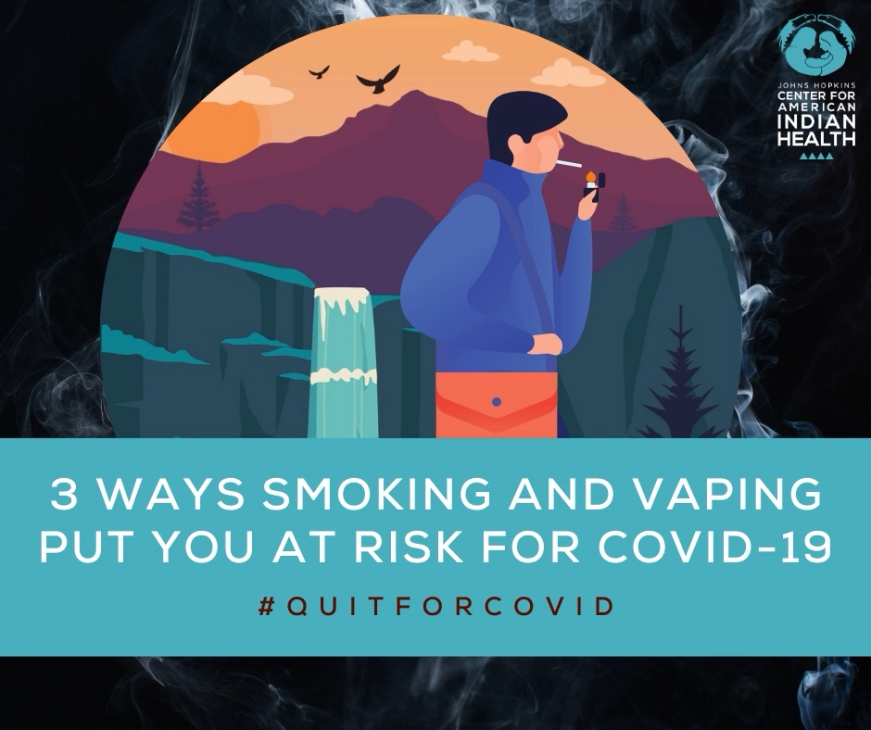
*This is a video, if you right click you should be able to download it from Dropbox. Meets requirements for Instagram, Twitter, and Facebook.

Or download it here: https://www.dropbox.com/s/0gj2fyr8q3hbi8e/Healthy%20Lung%20Month%20%281%29.mp4?dl=0

Message: Lung health has always been important, but with #COVID19 attacking our lungs, we've got to do everything in our power to keep them strong. If you do smoke, make the #coronavirus pandemic your motivation to kick the addiction for good! Visit smokefree.gov or call 1-800-QUIT-NOW.

