Influenza Vaccine Social Media Toolkit

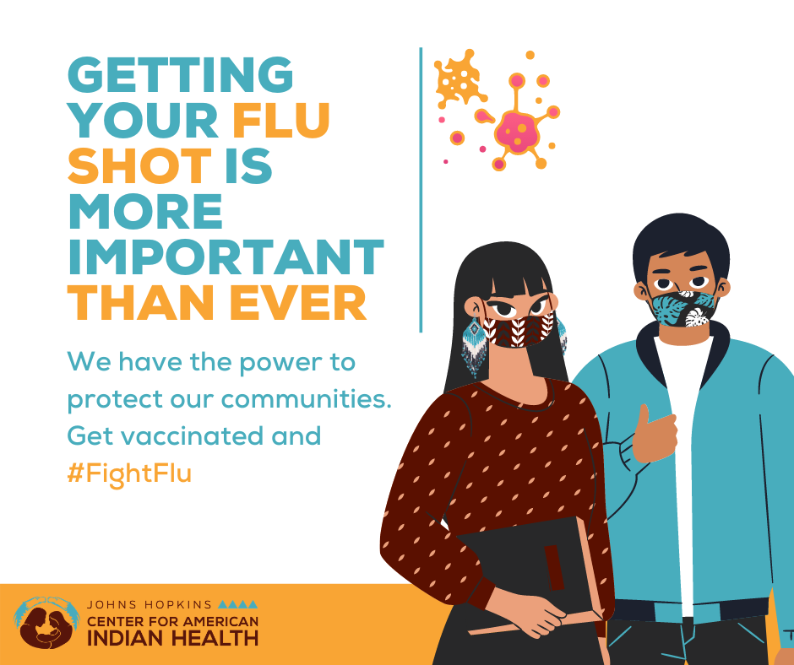

Message: Everyone 6 months and older should get a #flu vaccine every season. Flu vaccine can reduce flu illnesses, doctors’ visits, hospitalization, and is lifesaving. #FightFlu in our communities and get vaccinated today! Learn more at cdc.gov/flu/prevent/vaccinations.htm

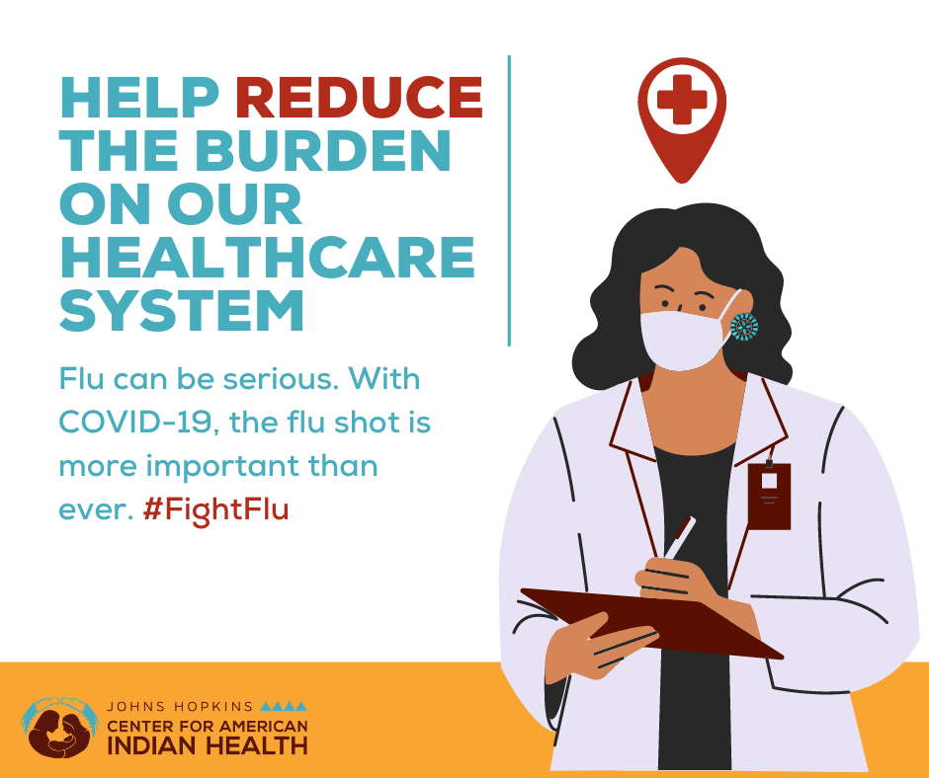
Message: Getting your #flu #vaccine is more important than ever this year. #Fluvaccine helps to protect you and your loved ones from flu and helps to reduce the burden of flu on tribal hospitals and healthcare systems. Learn more about flu vaccine benefits: cdc.gov/flu/prevent/vaccine-benefits.htm

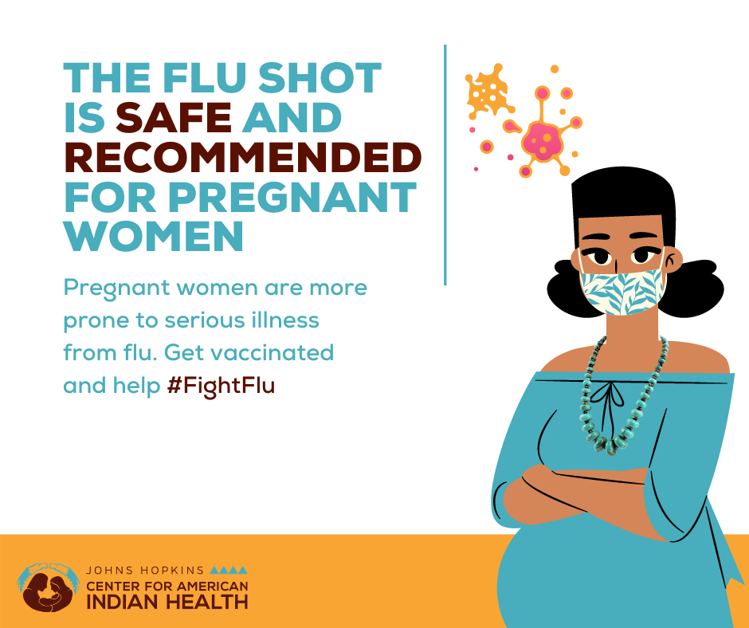

Message: Changes in the immune system, heart, and lungs during pregnancy make #pregnant women more prone to severe illness from #flu. The CDC recommends that pregnant women get #vaccinated during any trimester of pregnancy. Learn more: cdc.gov/flu/highrisk/pregnant.htm

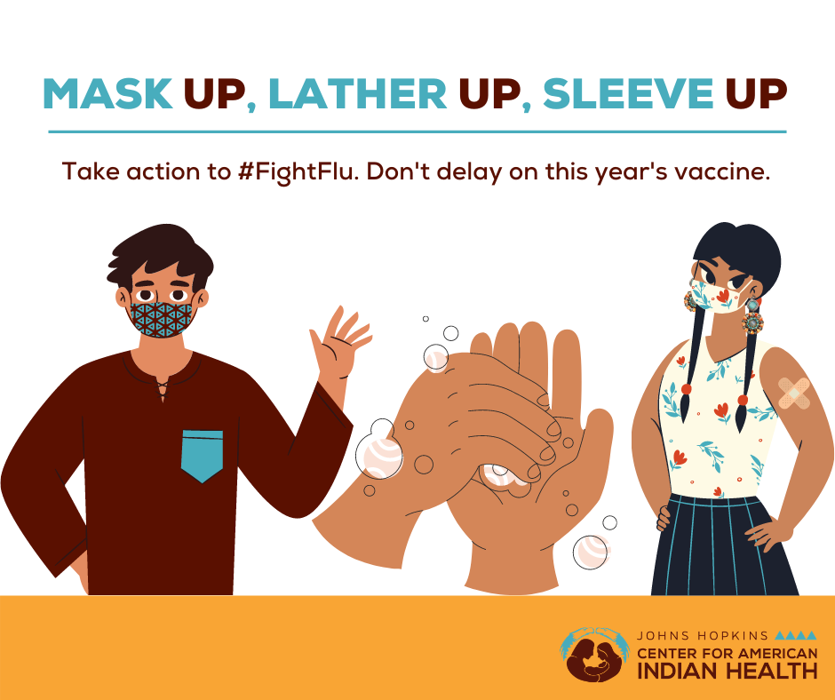

Message: The best way to prevent #flu is to get #vaccinated, but healthy habits like covering your cough and washing your hands often can help #stopthespread of germs and prevent respiratory illnesses like flu or #COVID19. Learn more at cdc.gov/flu/about/disease/spread.htm

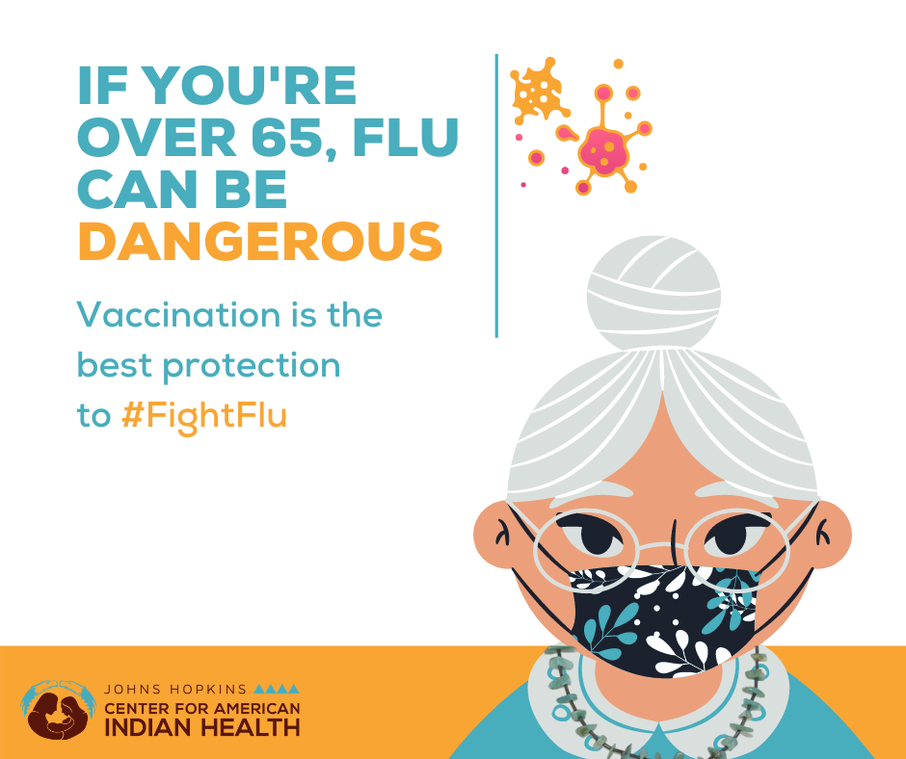

Message: This year, getting the #flu #vaccine is more important than ever. Elders are at high risk from developing serious complications from #flu and the #flushot is the best protection against #flu illness. Ask your pharmacy today if you can #getVaccinated. #FightFlu
Learn more with the CDC: cdc.gov/flu/high/risk/65over.htm

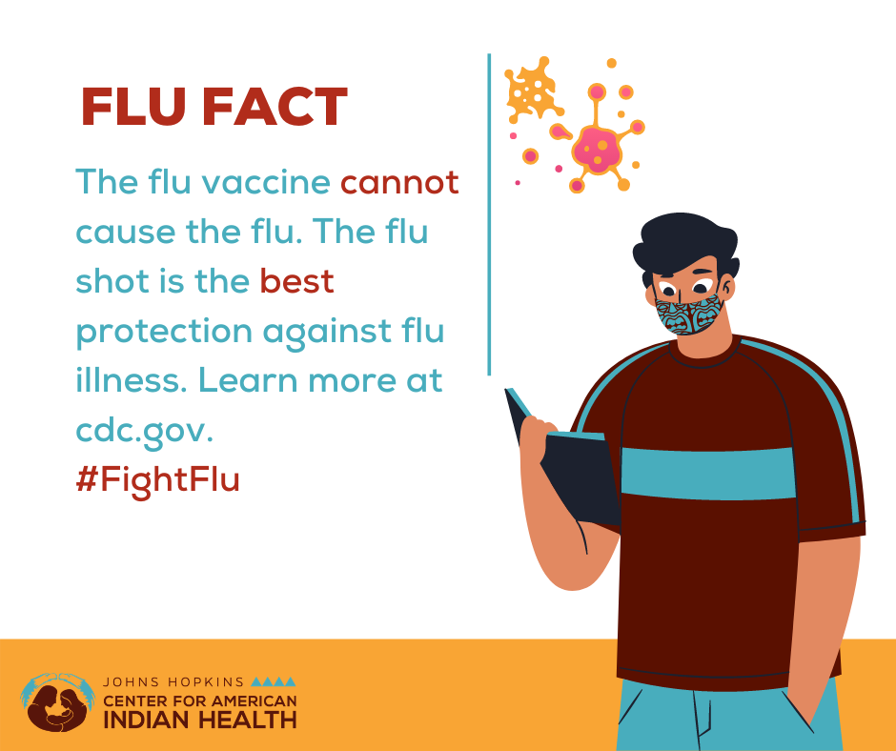

Message: #FluFact: Flu vaccination cannot cause flu illness because the #vaccines are made with inactivated (dead) and weakened viruses, but it can cause common side effects like body aches, a sore throat, or a cough. The flu vaccine is still #YourBestShot against flu illnesses. Learn more facts about common flu misconceptions: https://go.usa.gov/xnZ4xexternal icon

