COVID-19 and Long-Term Physical Health: Social Media Toolkit
Social Media Message: Get #vaccinated to lower your risk of long-term symptoms after #COVID19 disease. Even if you are only mildly sick, post-COVID conditions could leave lasting impacts on your body. Protect yourself and our communities by joining the #VACCINation and getting your #vaccine today.
#NativesStoptheSpread #NativesVaxUp #SkoVaxDen #VacciNative #TribalHealth #StopTheSpread #Indigenous #PublicHealth #NativeHealth #VaccinesWork #NativesDoingTheirPart #NativeAmericanHealth #IndigenousHealth #NativeAmerican #AmericanIndian #AlaskanNative #HealthyTribes #COVIDWarrior
Instagram:
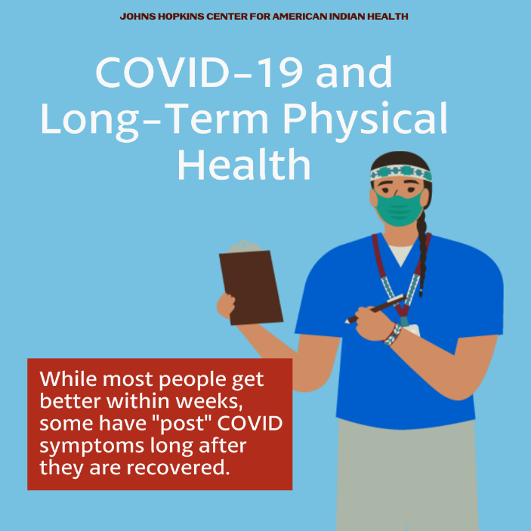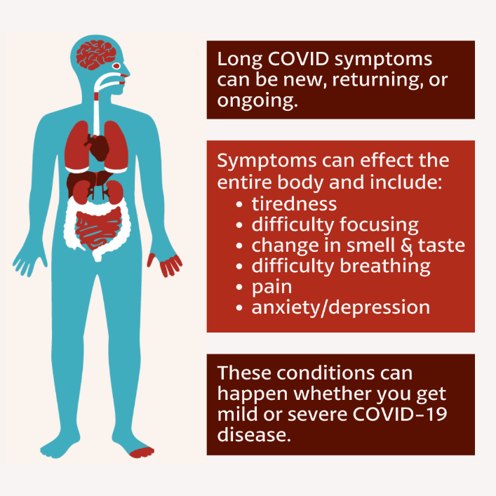
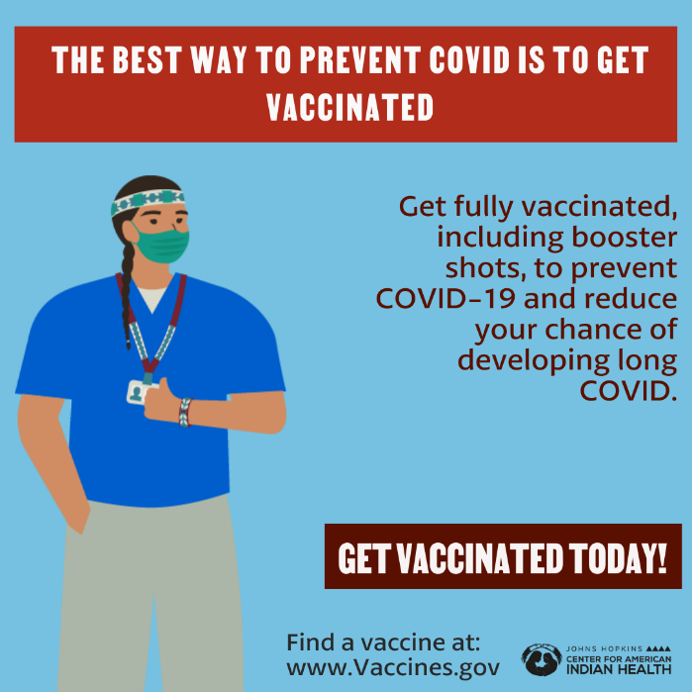
Facebook/Twitter:
