National Immunization Awareness Month Social Media Content: August

Key Hashtags Being Used on Social Media:
#NIAM or #NIAM2020 (General)
#IVax2Protect (CDC & partners)
#VaccinesWork (All)
#DontWaitVaccinate (A handful of state health departments)
#CatchUpGetAhead (Vaccines.gov)
#FightFlu (AAP)

Potential Partners to Tag (mention in alt tag not text portion of message):
- Centers for Disease Control and Prevention @CDCgov
- American Academy of Pediatrics @AmerAcadPeds
- Indian Health Service @IHSgov
- National Institute on Minority Health and Health Disparities @NIMHD
- Healthy Native Youth @HealthyN8Vyouth
- Northwest Portland Area Indian Health Board @NPAIHB
- National Indian Health Board@NIHB1
- National Council for Urban Indian Health @NCUIH_official
- Indian Country Today @IndianCountry
- Native America Calling @180099native
Messages:
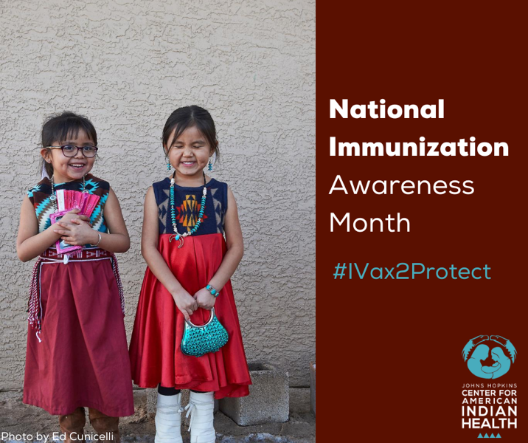
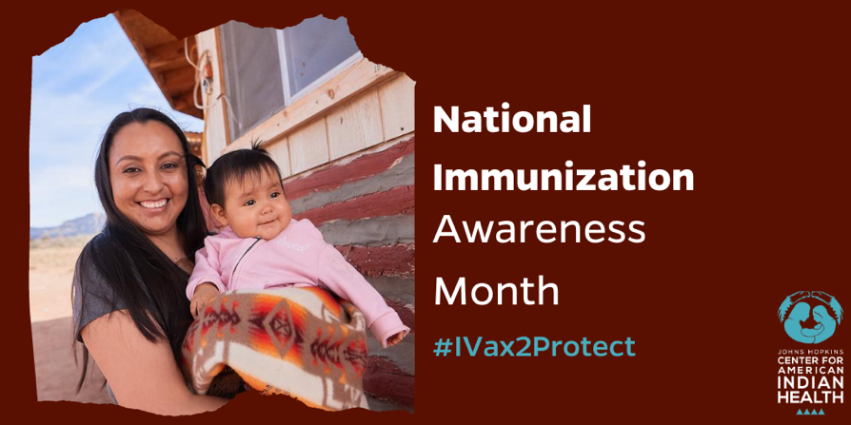

Right: For Facebook + Instagram
Left: Twitter

Tweet 1: #DYK August is National Immunization Awareness Month? This month catch-up on #vaccines 💉missed because of #COVID19 🦠 to protect against avoidable diseases. #CatchUpGetAhead #NIAM2020

Tweet 2: This National Immunization Awareness Month, make sure #vaccinations 💉 are up to date to protect against deadly diseases. #DontwaitVaccinate #NIAM2020

Instagram Post/Facebook Post: Did you know that August is National Immunization Awareness Month? Use this month to catch up on any vaccines that may have been missed because of COVID-19. Help make sure our families and communities are safe from vaccine-preventable diseases! Learn more about vaccination at vaccines.gov.
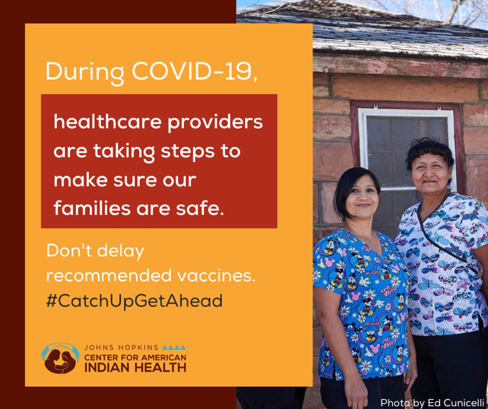

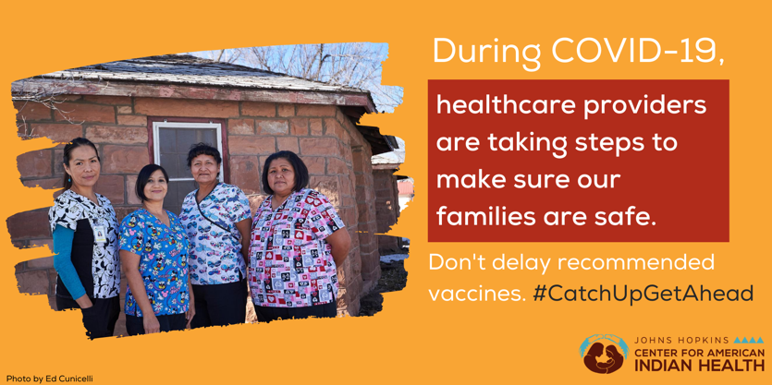

Tweet 1: Even during #COVID19 🦠, #vaccination 💉 for our families is essential to avoid outbreaks of vaccine-preventable diseases. We all have the power to #protect our community. #CatchUpGetAhead #NIAM2020

Tweet 2: #VaccinesWork for all. For National Immunization Awareness Month, call their health care provider to 👩‍⚕️ ask whether children have missed any routine #vaccinations 💉 to protect against serious diseases. #NIAM2020

Instagram Post/Facebook Post 1: During the COVID-19 pandemic, healthcare providers are taking extra steps to make sure that families are safe during well child visits. This August, families can catch-up on vaccines to avoid vaccine-preventable diseases. We have the power to protect loved ones! Learn more at vaccines.gov.

Instagram Post/Facebook Post 2: Vaccines work to protect us all against serious diseases! During National Immunization Month, speak with children’s health care providers about whether anyone in the family has missed routine vaccinations. Especially during COVID-19, vaccination is essential to keep our communities safe.

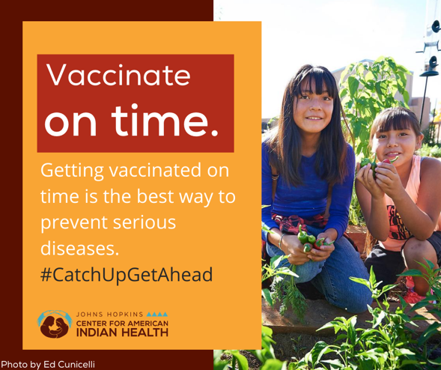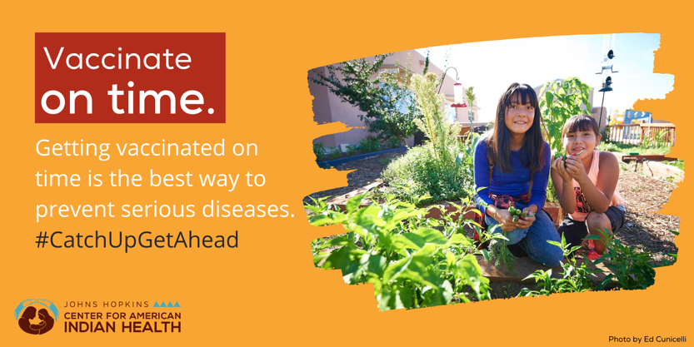

Tweet: #DYK on-time vaccination ⏰ 💉 is essential to provide #immunity before children are exposed to avoidable diseases? This August, #CatchUpGetAhead on #vaccines. Learn more with the @CDCgov below
https://bit.ly/33VQgzq #NIAM2020

Instagram Post/Facebook Post: Did you know that on-time vaccination is essential to provide immunity before children are exposed to serious, avoidable diseases? If children have missed essential vaccines because of COVID-19, families can schedule a well-visit with their healthcare provider this National Immunization Awareness Month! Learn more with the CDC here: https://bit.ly/33VQgzq

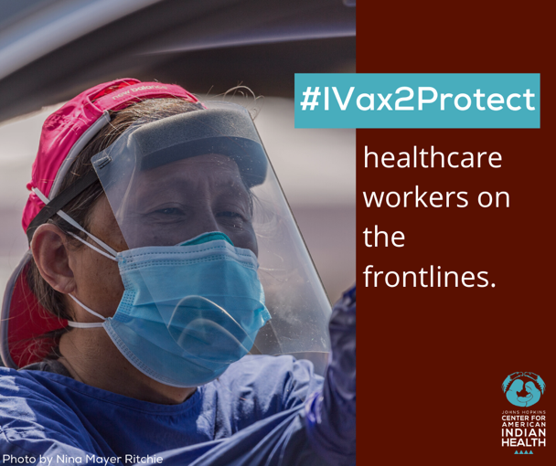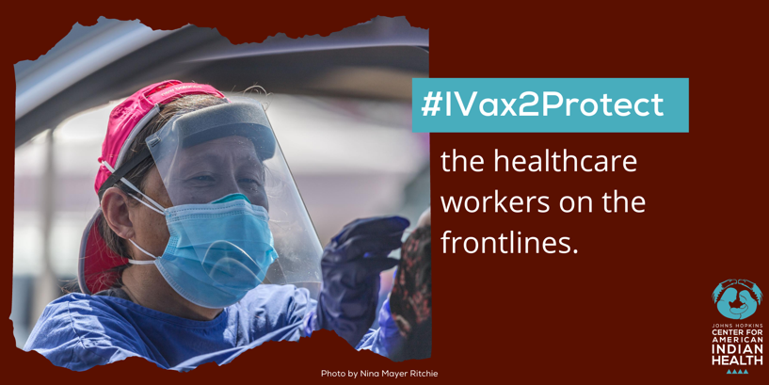

Tweet: #Vaccines protect individuals 👨‍👩‍👦‍👦, communities 🏡, and the healthcare 🏥 systems that are burdened with meeting the demands of #COVID19. This August, #CatchUpGetAhead to prevent against deadly diseases. #NIAM2020

Instagram Post/Facebook Post: Healthcare systems are already burdened with COVID-19. For National Immunization Awareness Month, we can prevent further outbreaks of serious diseases by making sure that our families are up to date on all our vaccinations. We can protect communities by scheduling a well-visit today! Visit vaccines.gov in order to learn more.

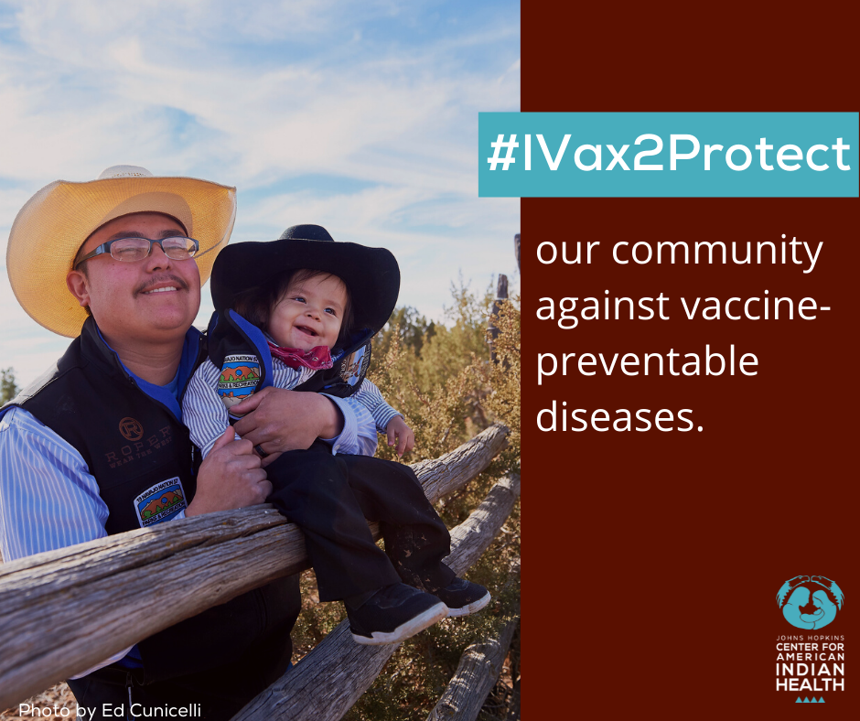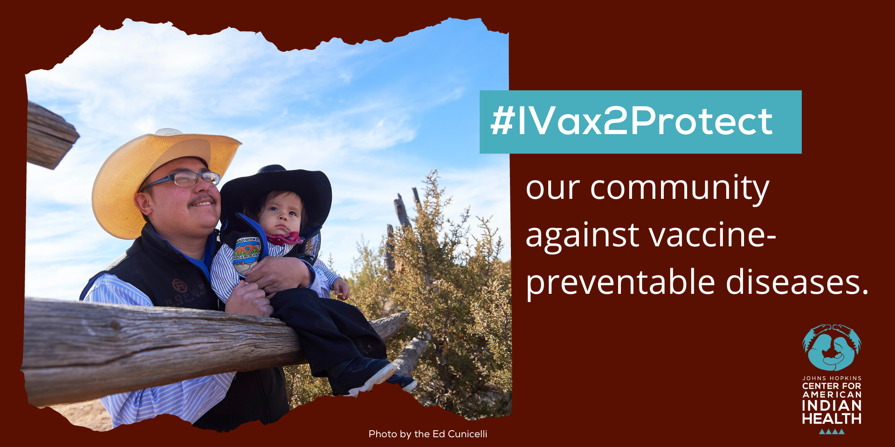

Tweet: We have the power to protect ourselves and community against diseases 🦠 that are still a threat. Stay protected and #dontwaitvaccinate 💉. Get more information from @HHSGov below https://bit.ly/2E3WdQ8 #Ivax2Protect #NIAM2020

Instagram Post/Facebook Post: We have the power to protect ourselves and our community against avoidable deadly diseases that are still a threat. In order to stay protected, catch up on vaccines missed during COVID-19. Get more information below from the U.S. Department of Health and Human Services here: https://bit.ly/2E3WdQ8

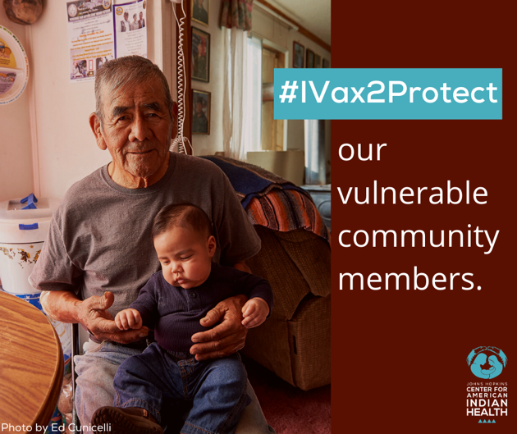

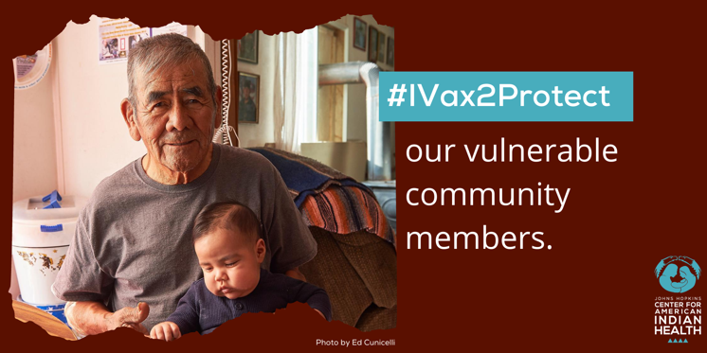

Tweet: #DYK #vaccines 💉 can protect those in our community who can’t get certain vaccines (like people with cancer or type 1 diabetes) through herd #immunity? For National Immunization Awareness Month, #CatchUpGetAhead on vaccines and #Vax2Protect. #NIAM2020
Learn more about herd immunity with @NIHB1 below
https://bit.ly/2XXDwEG

Instagram Post/Facebook Post: Did you know that vaccines can protect members of our community who can’t get certain vaccines, like people with cancer or type 1 diabetes, through herd immunity? For National Immunization Awareness Month, catch up on vaccines missed due to COVID-19. Share with us below why you #Vax2Protect!
https://bit.ly/2XXDwEG

