INSTAGRAM

What is your favorite way to practice self-care? Caring for yourself is an important part of continuing to care for your community during the pandemic. Find tips for self-care, resources for coping with stress, and much more in our free, online resource, Psychological First Aid for COVID-19 Frontline Workers in AI/AN communities. Learn more from the link in our bio!

#selfcare #healing #communityhealth #skoden
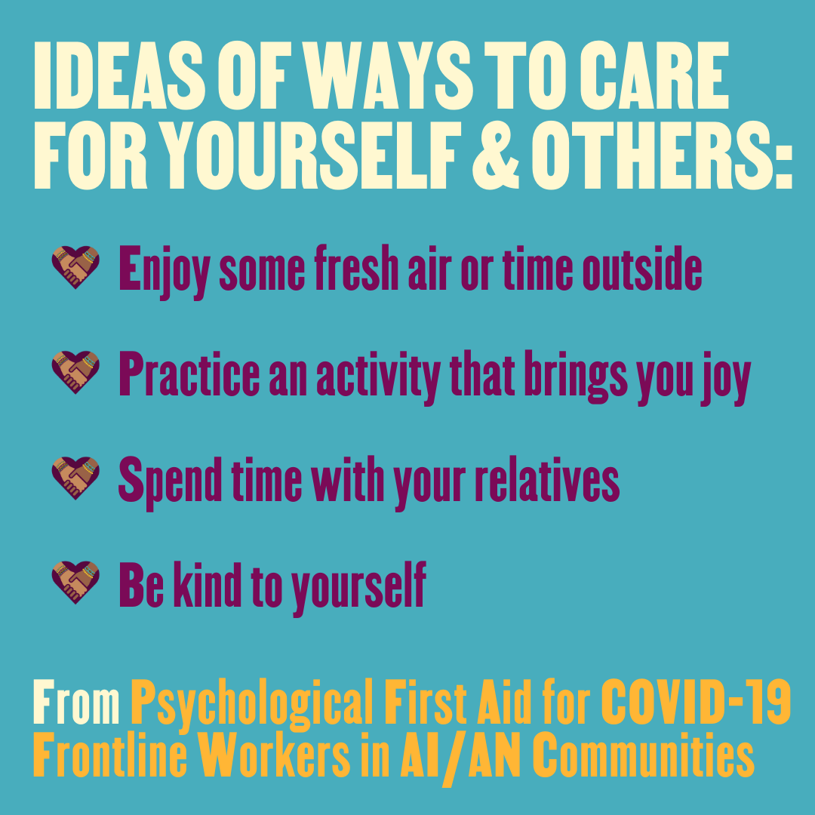
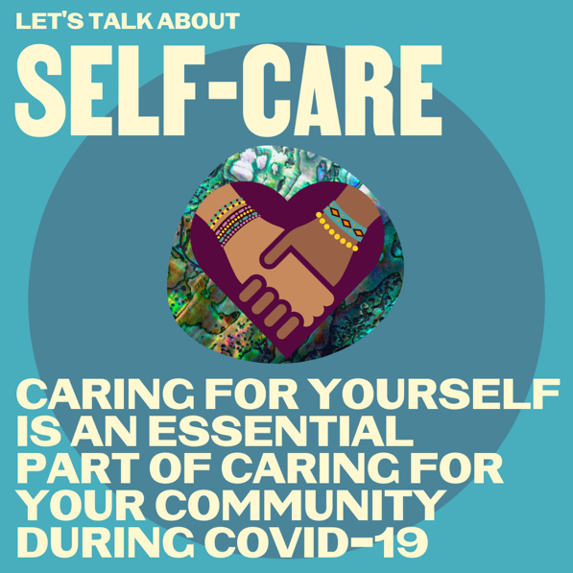

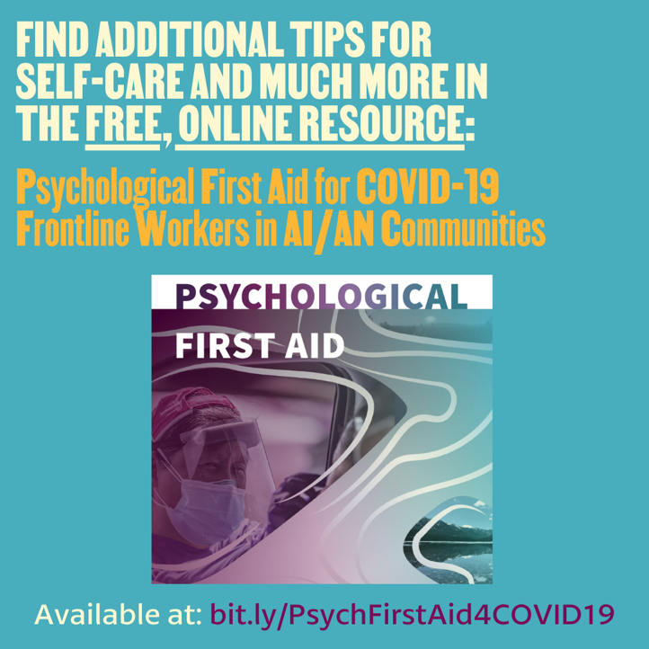

FACEBOOK

What is your favorite way to practice self-care? Caring for yourself is an important part of continuing to care for your community during the pandemic. Find tips for self-care, resources for coping with stress, and much more in our free, online resource, Psychological First Aid for COVID-19 Frontline Workers in AI/AN communities. Available at bit.ly/PsychFirstAid4COVID19

#selfcare #healing #communityhealth #skoden

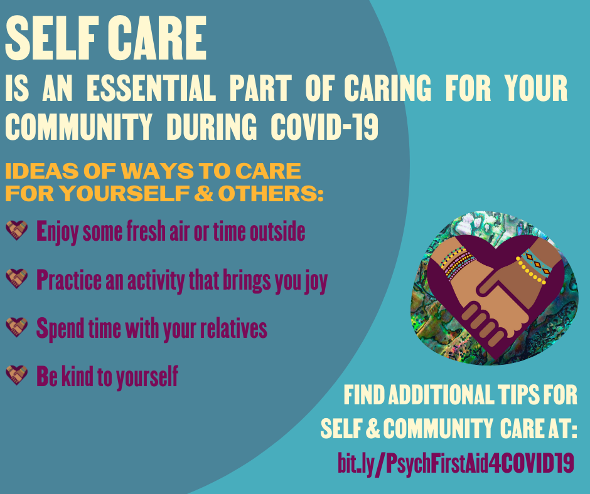

TWITTER

Caring for yourself is an important part of continuing to care for your community during the pandemic. Find tips for self-care, resources for coping with stress, and much more in our free, online resource: bit.ly/PsychFirstAid4COVID19 #selfcare #healing #communityhealth #skoden

