Precision Family Spirit Social Media Toolkit

Facebook
Message: We are pleased to share the results of the Precision Family Spirit® Pilot Study, conducted in partnership with the Inter-Tribal Council of Michigan. Home visitors in this study were given support to tailor the curriculum and meet the varied needs of each mother. Overall, we found that precision #homevisiting is a well- received approach to delivering the #FamilySpirit program. #ITCMI #homevisitingworks #newmoms #MIECHV

@kbichealth @KBICMCH @InterTribalCouncilMichigan @HannahvilleHealthCenter @HannahvilleHealthyStart

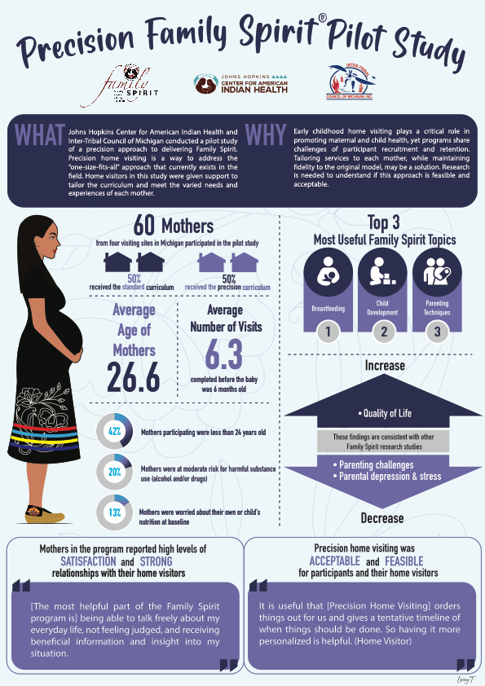

Twitter
Message: Results of the Precision Family Spirit Pilot Study indicate that precision #homevisiting, which tailors the curriculum to meet the needs of each mom, is a well-received approach to deliver the #FamilySpirit program. @ITCofMichigan #ITCMI #homevisitingworks #newmoms #MIECHV
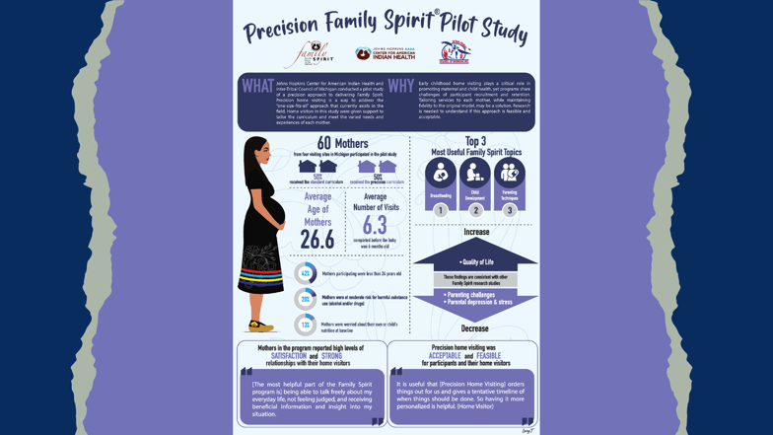

Instagram
Message: We are pleased to share the results of the Precision Family Spirit® Pilot Study, conducted in partnership with the Inter-Tribal Council of Michigan. Home visitors in this study were given support to tailor the curriculum and meet the varied needs of each mother. Overall, we found that precision #homevisiting is a well-received approach to delivering the #FamilySpirit program. @Intertribalcoundilmichigan
#ITCMI
#homevisitingworks
#pregnant
#homevisiting
#newmoms​
#MIECHV
