Second Booster for 50+ Social Media Toolkit
Social Media Message: A second booster shot for Pfizer and Moderna COVID-19 #vaccines to extend protection against #COVID19 has been authorized for people 50 and older. Booster shots strengthen the response our bodies have already built through vaccination. Current vaccines are still very effective against severe disease and hospitalization, so get vaccinated today!
#VacciNation #NativesStopTheSpread #NativesDoingTheirPart #IndigenousHealth #NativeAmerican #AmericanIndian #AlaskanNative #HealthyTribes #IndigenousPeople #NativeHealth #TribalHealth #COVIDWarrior
Instagram:
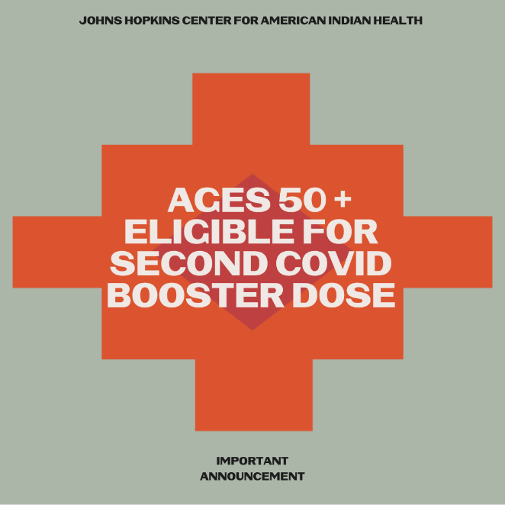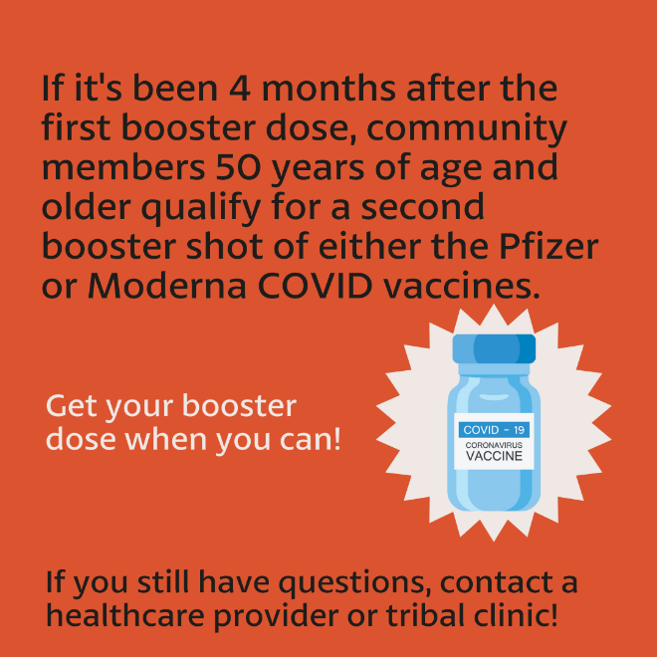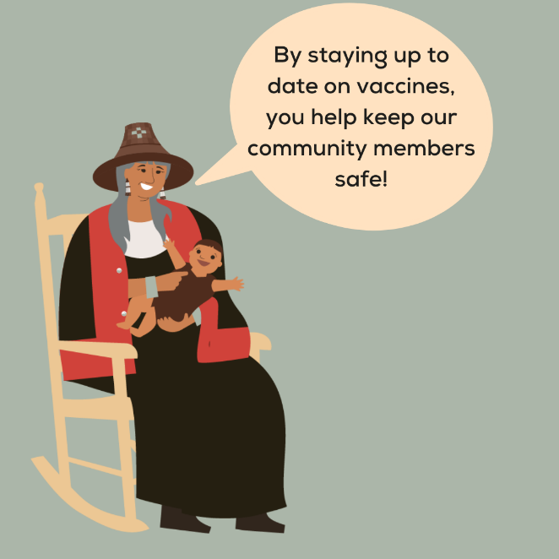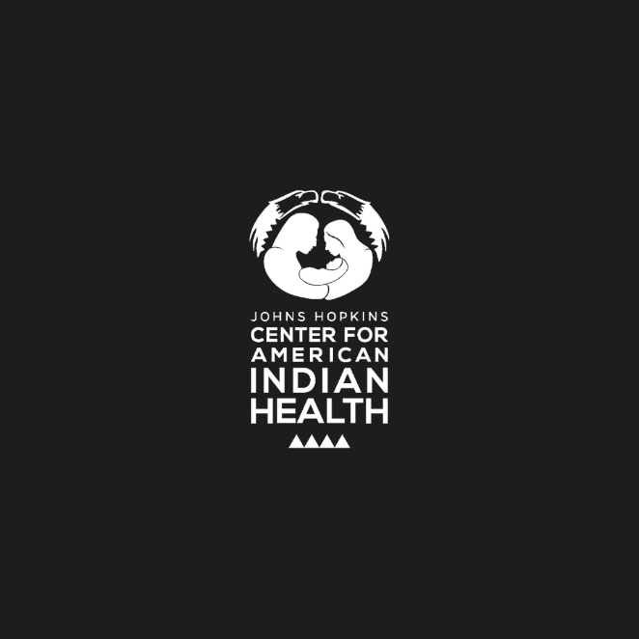

Partners to Tag: @Anthctoday @Aaipdocs @CDCgov @HealthyNativeYouth @HonoringNations @IndianCountryToday @_IllumiNatives @IndianHealthBoard_Minneapolis @IndianHealthService
@Indianz @JohnsHopkinsSPH @NationalIndianHealthBoard @Npaihb @Nihb1 @NationalNativeNews @NativeAmericans @NativeAmericanLifelines @Nimhgov @NNNnativenews @ProjectMosaicllc @SeattleIndianHealthBoard @UrbanIndigenousCollective@UrbanIndianHealth
@UrbanIndianHealthInstitute @WeAreHealers @WeRNative

Social Media Message: A second booster shot for Pfizer and Moderna COVID-19 #vaccines to extend protection against #COVID19 has been authorized for people 50 and older. Booster shots strengthen the response our bodies have already built through vaccination. Current vaccines are still very effective against severe disease and hospitalization, so get vaccinated today!#VacciNation
#NativesStopTheSpread #NativesDoingTheirPart #IndigenousHealth #NativeAmerican #AmericanIndian #AlaskanNative #HealthyTribes #IndigenousPeople #NativeHealth #TribalHealth #COVIDWarrior
Facebook/Twitter:
