Social Media Toolkit

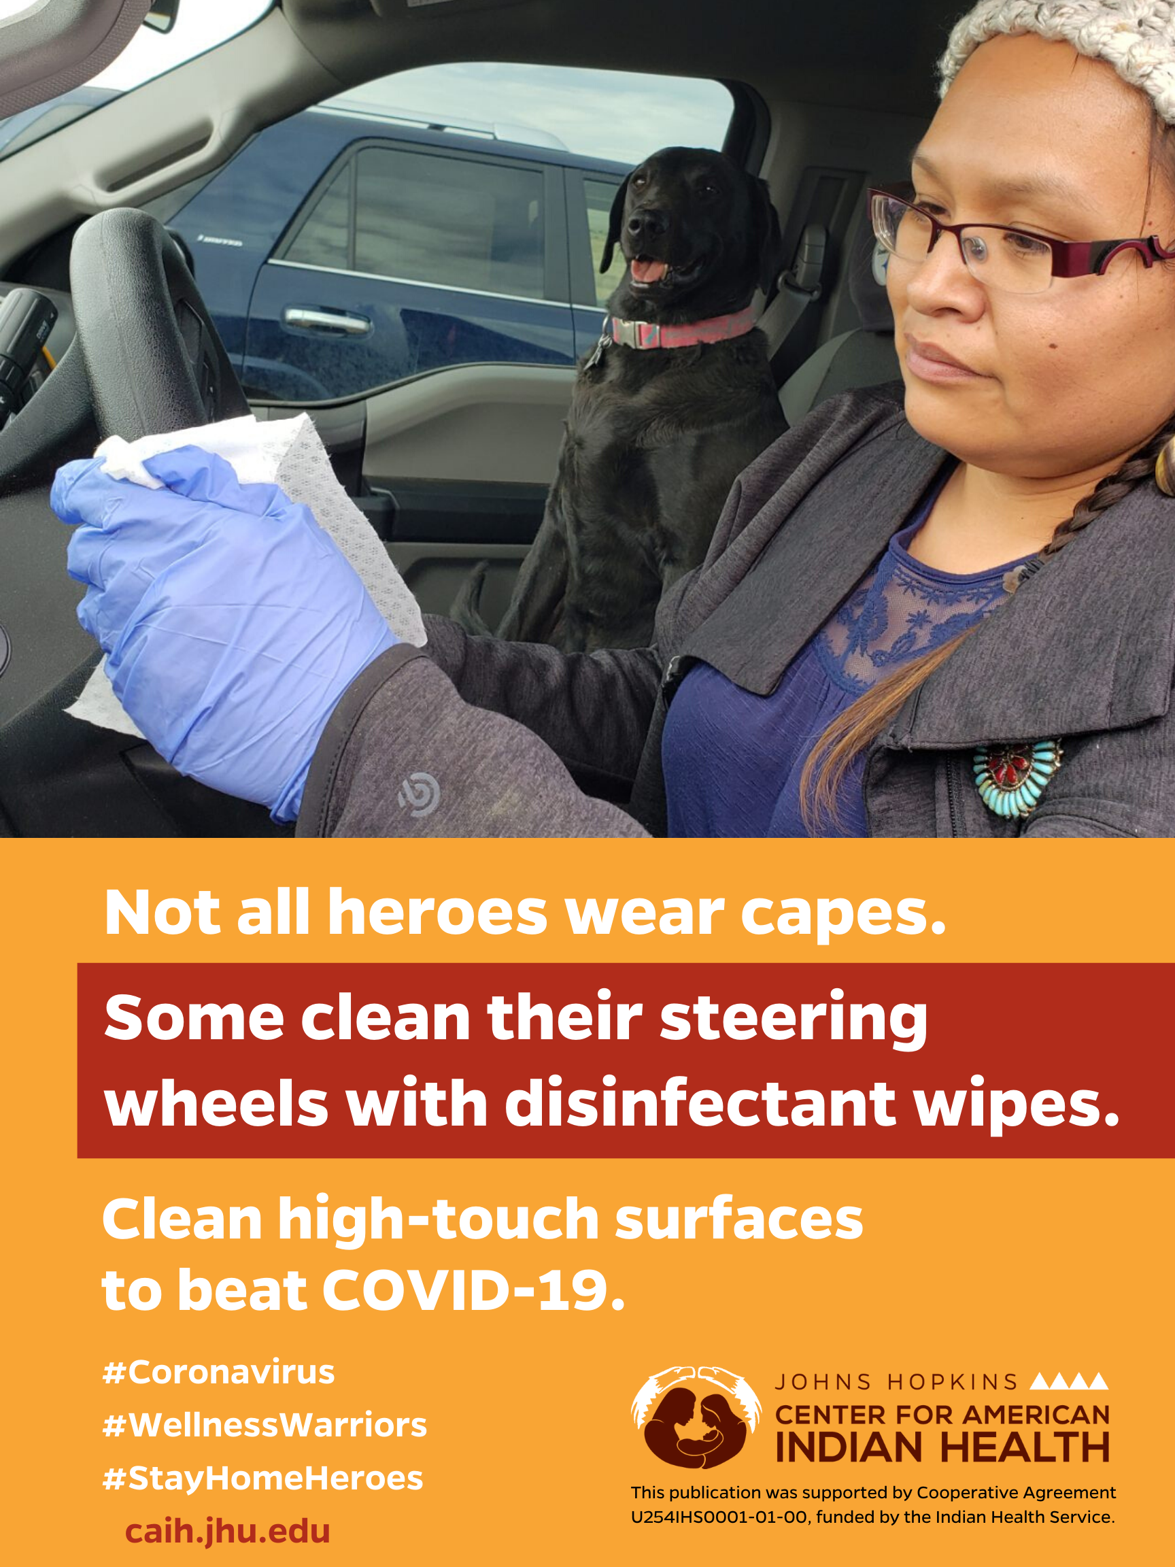
Prevent the spread of germs by cleaning “high-touch” objects—steering wheel, door handles, and your phone! Wear a mask 😷 if out in public.
Learn more: CDC.gov/COVID19
#WellnessWarriors 🤜
#coronavirus #FlattenTheCurve #KeepYourDistance

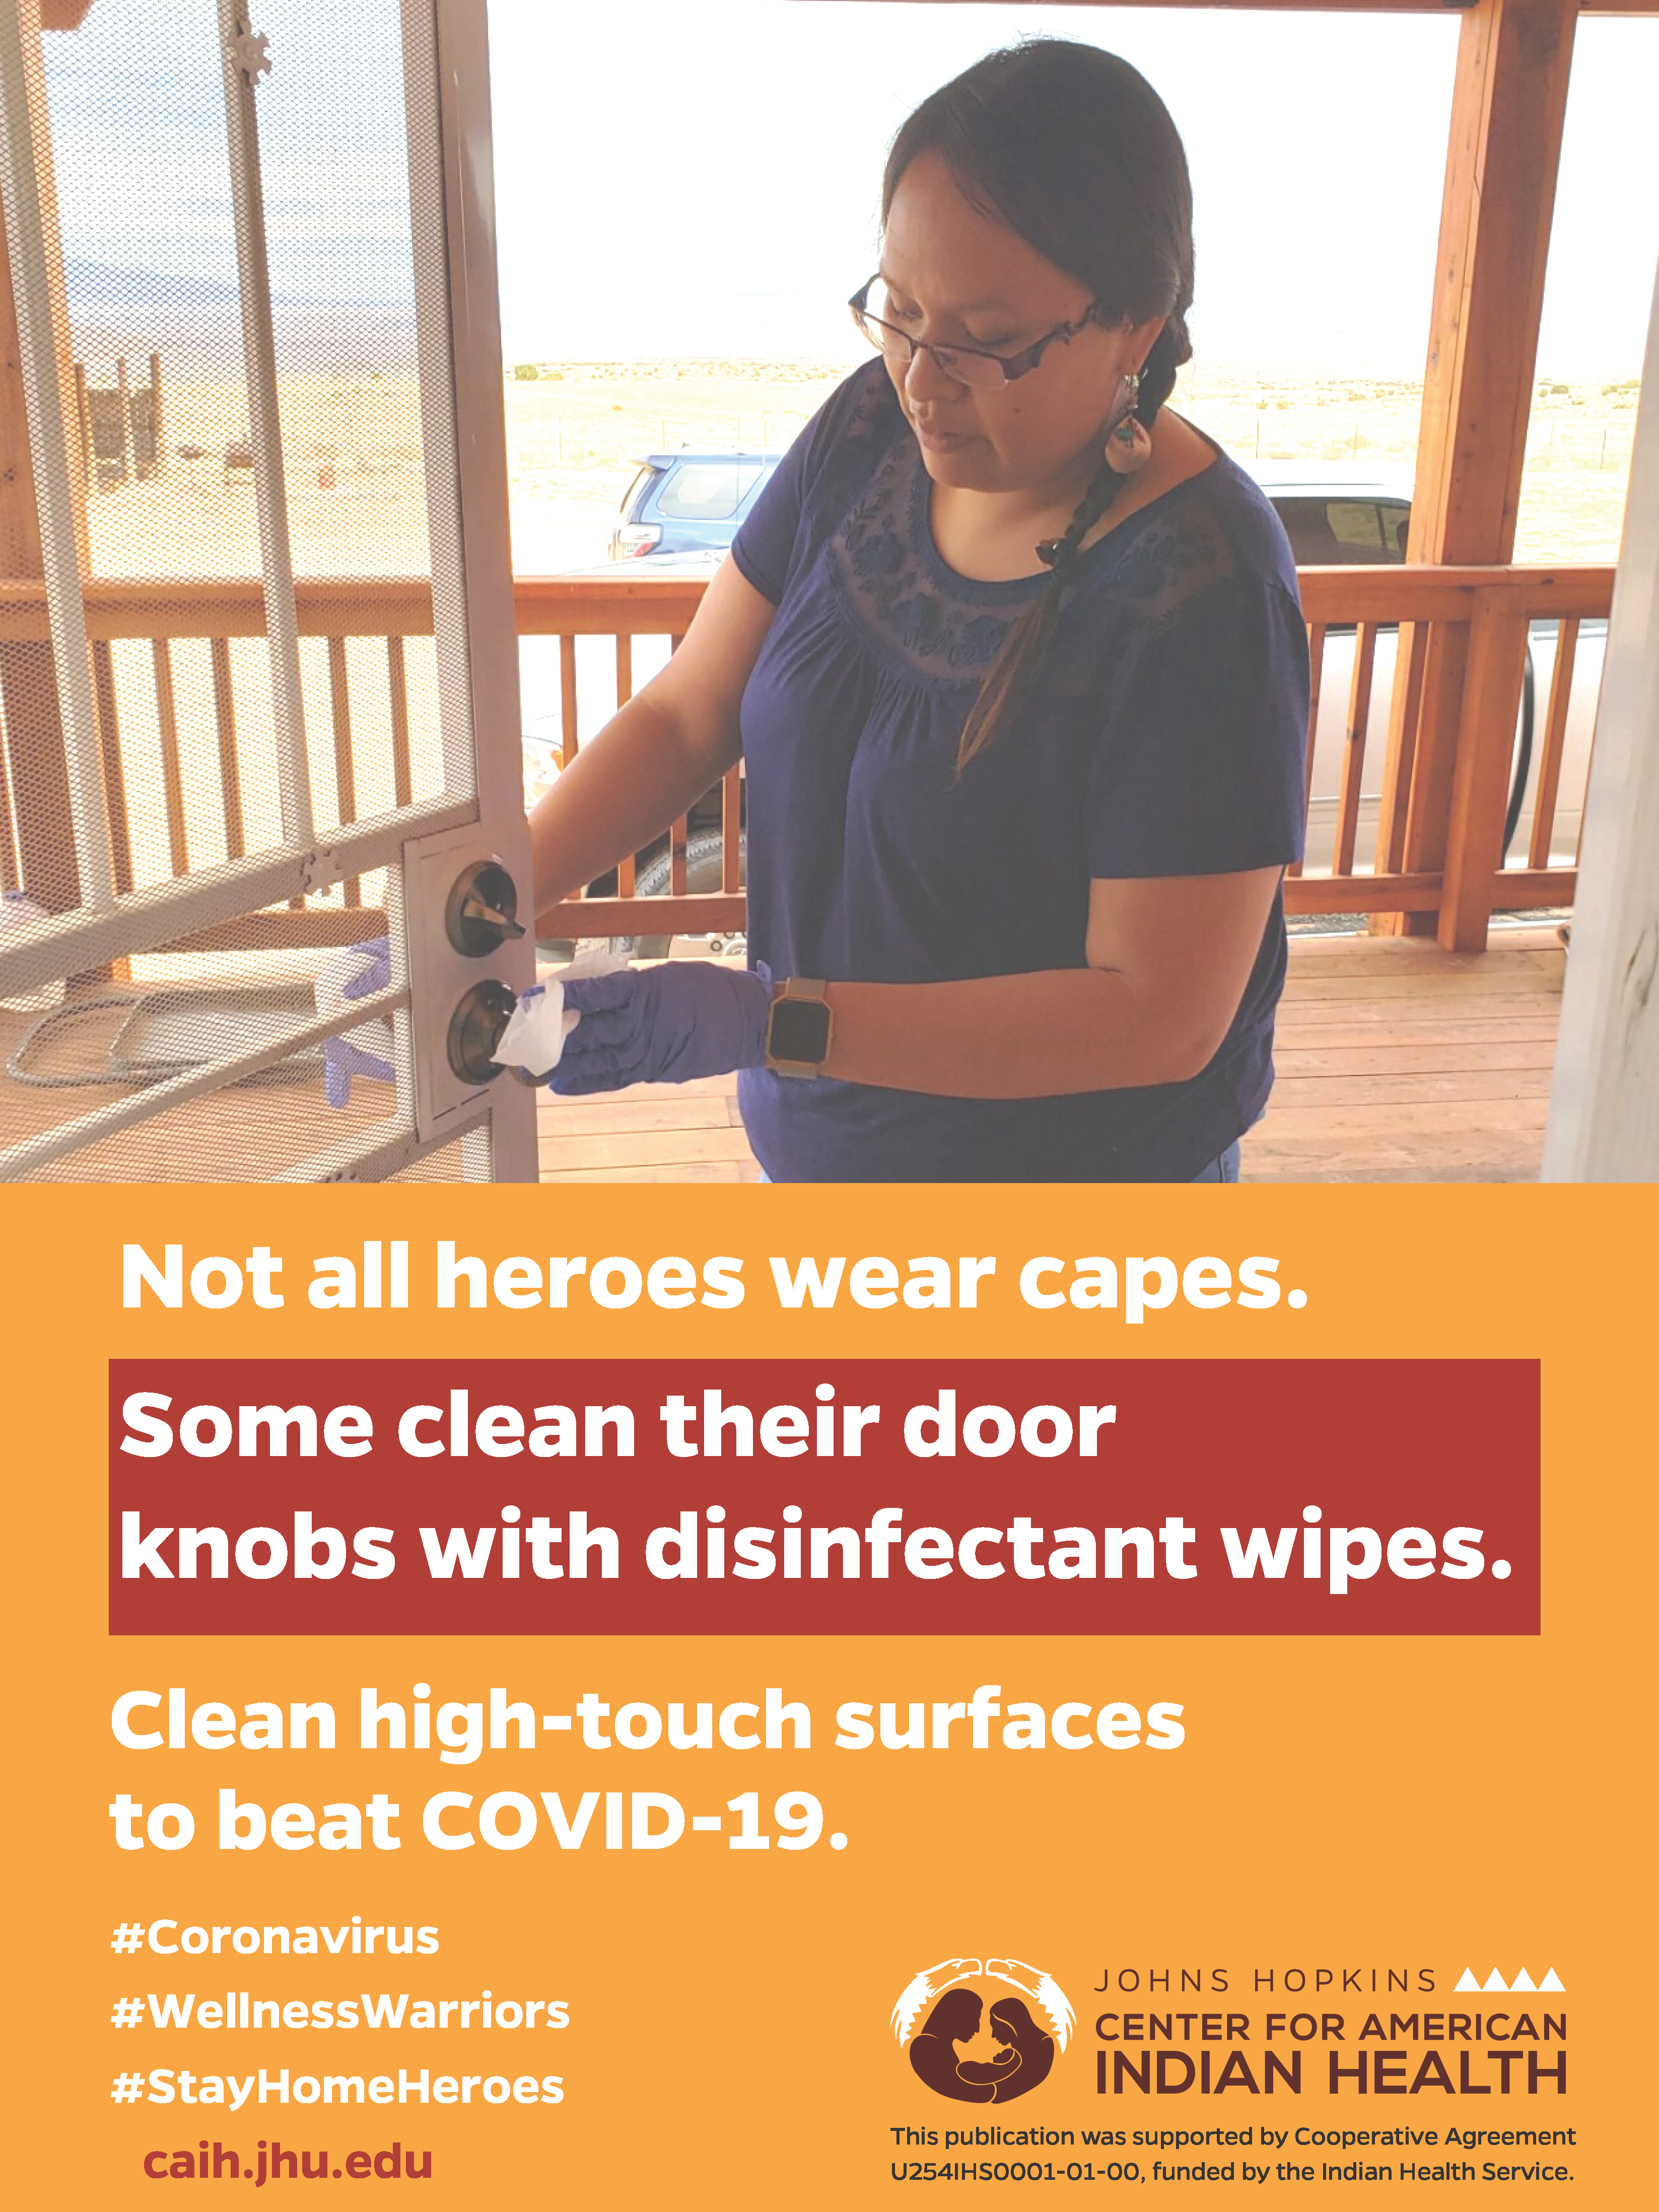
Prevent the spread of germs by cleaning “high-touch” objects and surfaces—doorknobs, counters, tables, remote control! Wear a mask 😷 if out in public. Learn more https://bit.ly/2w1Ldz0
#StayHomeHeroes 👏🏽👏🏽
#coronavirus #COVID2019 #COVID #KeepYourDistance

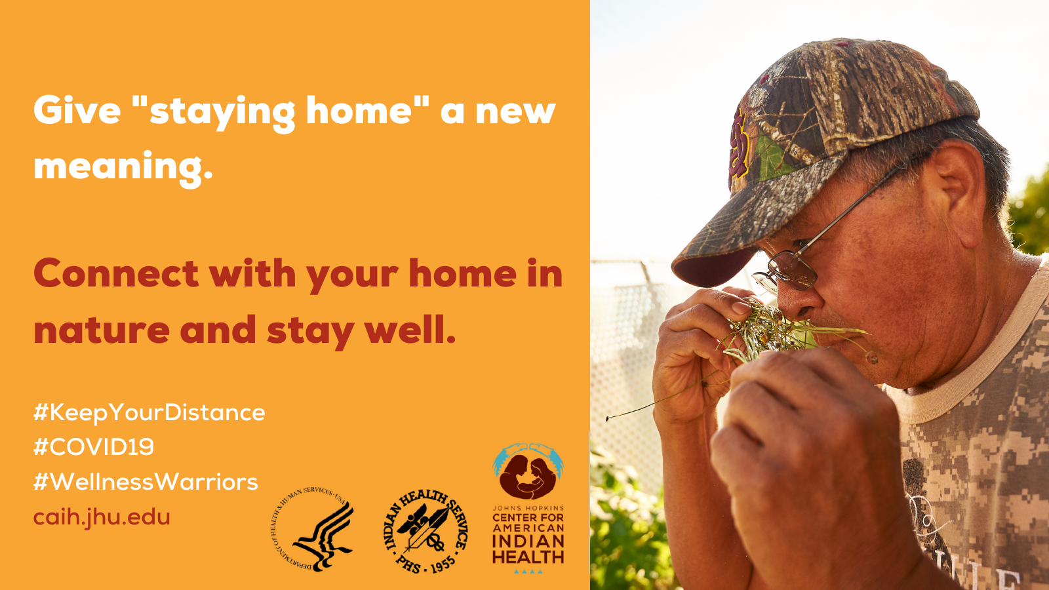
Be well in your body & mind by staying home! Worship while keeping your distance. Gather herbs, pray, and be with loved ones on the phone. Wear a mask😷 if ever in public.
Learn more: CDC.gov/COVID19
#SpiritualWarriors 🤜
#coronavirus #KeepYourDistance

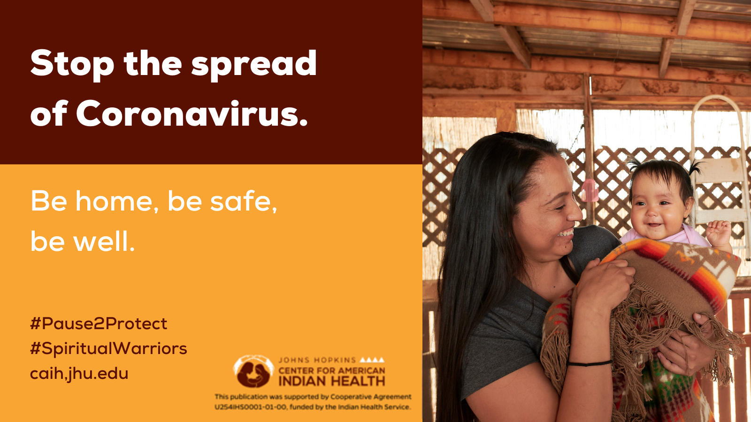
Be well in your body & mind by staying home! Worship while keeping your distance. Gather herbs, pray, and be with loved ones in your household. Wear a mask😷 if ever in public.
Learn more: CDC.gov/COVID19
#SpiritualWarriors 🤜
#coronavirus #KeepYourDistance

INSTAGRAM

[share message with all visuals listed above]

Social Distancing Saves Lives! Now that there are confirmed cases in all 50 U.S. states, everyone has a role to play in preventing the spread of germs🦠. Stay home as much as possible. 🏠 Wear masks😷 when out in public. Consider doing your grocery 🍎shopping in off-peak hours. Avoid crowded places such as shopping centers, bars, and movie theatres. When out in public, keep a distance of at least 6 feet from others even if wearing a mask! If you are sick🤒, stay home!

For more information, visit CDC.gov/coronavirus
Materials for tribal communities 👉 Bit.ly/TribesFightCOVID19
#StayHomeHeroes
#WellnessWarriors
#KeepYourDistance
#FlattentheCurve
#COVID19

*Thanks to @Bmore_Healthy for letting us adapt their #StayHomeHeroes campaign 🙏

