Stay Home When You’re Sick: Social Media Toolkit
Social Media Message: If you have symptoms such as a fever, cough, or sore throat, you should stay home if you can - even if you test negative for #COVID19. If you can’t stay home, wear a well-fitted mask and limit time around others. Together, we can help protect our communities and loved ones. #NativesStopTheSpread #StopTheSpread #IndigenousHealth #MaskUp #Vaccinate #StayHome #Quarantine #Isolation

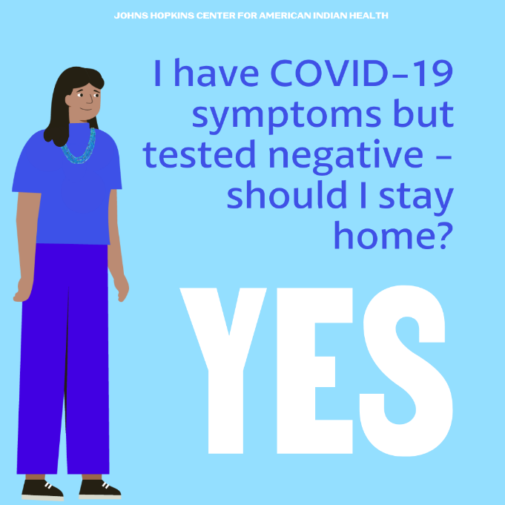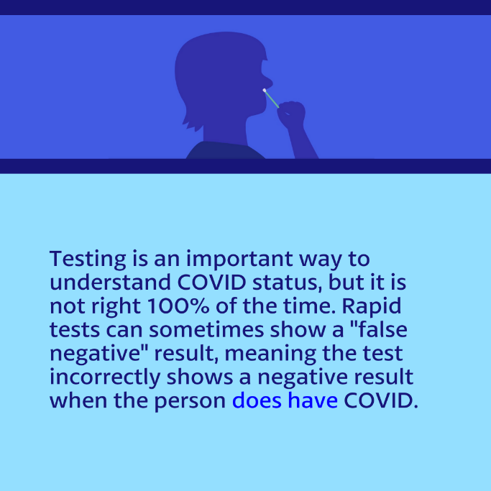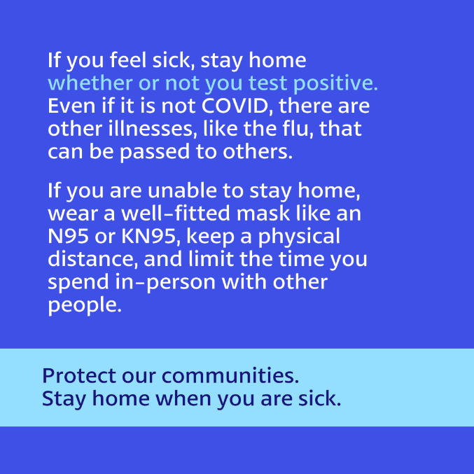
Tag:@Anthctoday @Aaipdocs @CDCgov @HealthyNativeYouth @HonoringNations @IndianCountryToday @_IllumiNatives @IndianHealthBoard_Minneapolis @IndianHealthService
@Indianz @JohnsHopkinsSPH @NationalIndianHealthBoard @Npaihb @Nihb1 @NationalNativeNews @NativeAmericans @NativeAmericanLifelines @Nimhgov @NNNnativenews @ProjectMosaicllc @SeattleIndianHealthBoard @UrbanIndigenousCollective @UrbanIndianHealth
@UrbanIndianHealthInstitute @WeAreHealers @wernative

