Stop the Spread Stills 2: Social Media Toolkit
Social Media Message: This year, it is still important to take precautions to have a safe holiday season. Protect all our relatives by getting vaccinated for #COVID19 and getting tested if you have symptoms. Stopping the spread starts with you!
#NativesStopTheSpread #StopTheSpread #COVIDWarrior #VacciNation #ProtectOurElders #SevenGenerations #SkoVaxDen
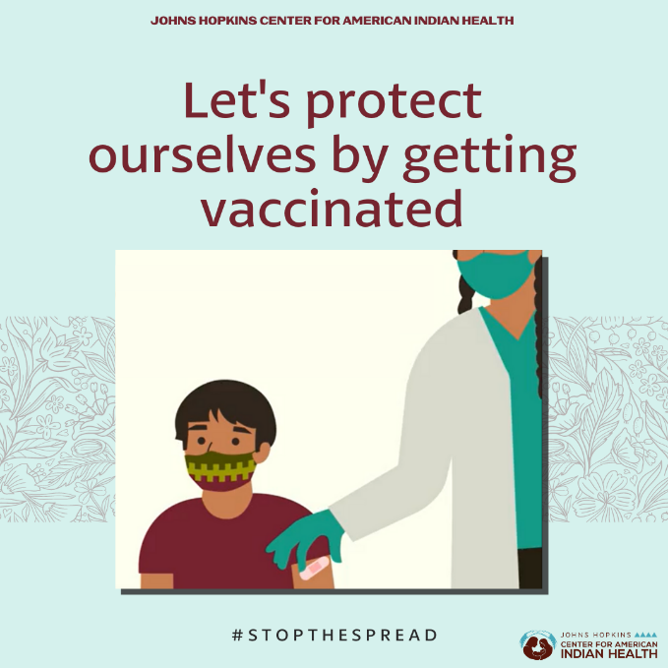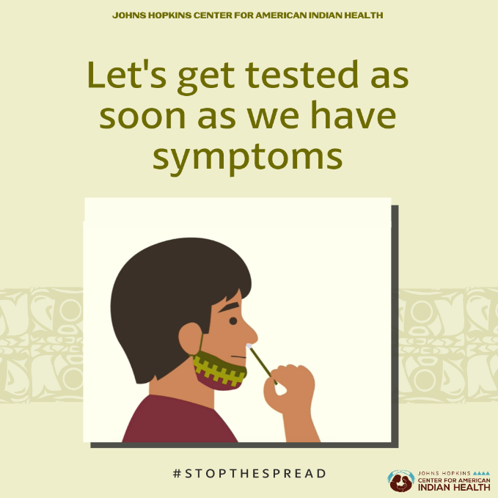
Tag: @Anthctoday @Aaipdocs @CDCgov @HealthyNativeYouth @HonoringNations @IndianCountryToday @_IllumiNatives @IndianHealthBoard_Minneapolis @IndianHealthService
@Indianz @JohnsHopkinsSPH @NationalIndianHealthBoard @Npaihb @Nihb1 @NationalNativeNews @NativeAmericans @NativeAmericanLifelines @Nimhgov @NNNnativenews @ProjectMosaicllc @SeattleIndianHealthBoard @UrbanIndigenousCollective @UrbanIndianHealth
@UrbanIndianHealthInstitute @WeAreHealers @wernative

