Substance Use Social Media Toolkit

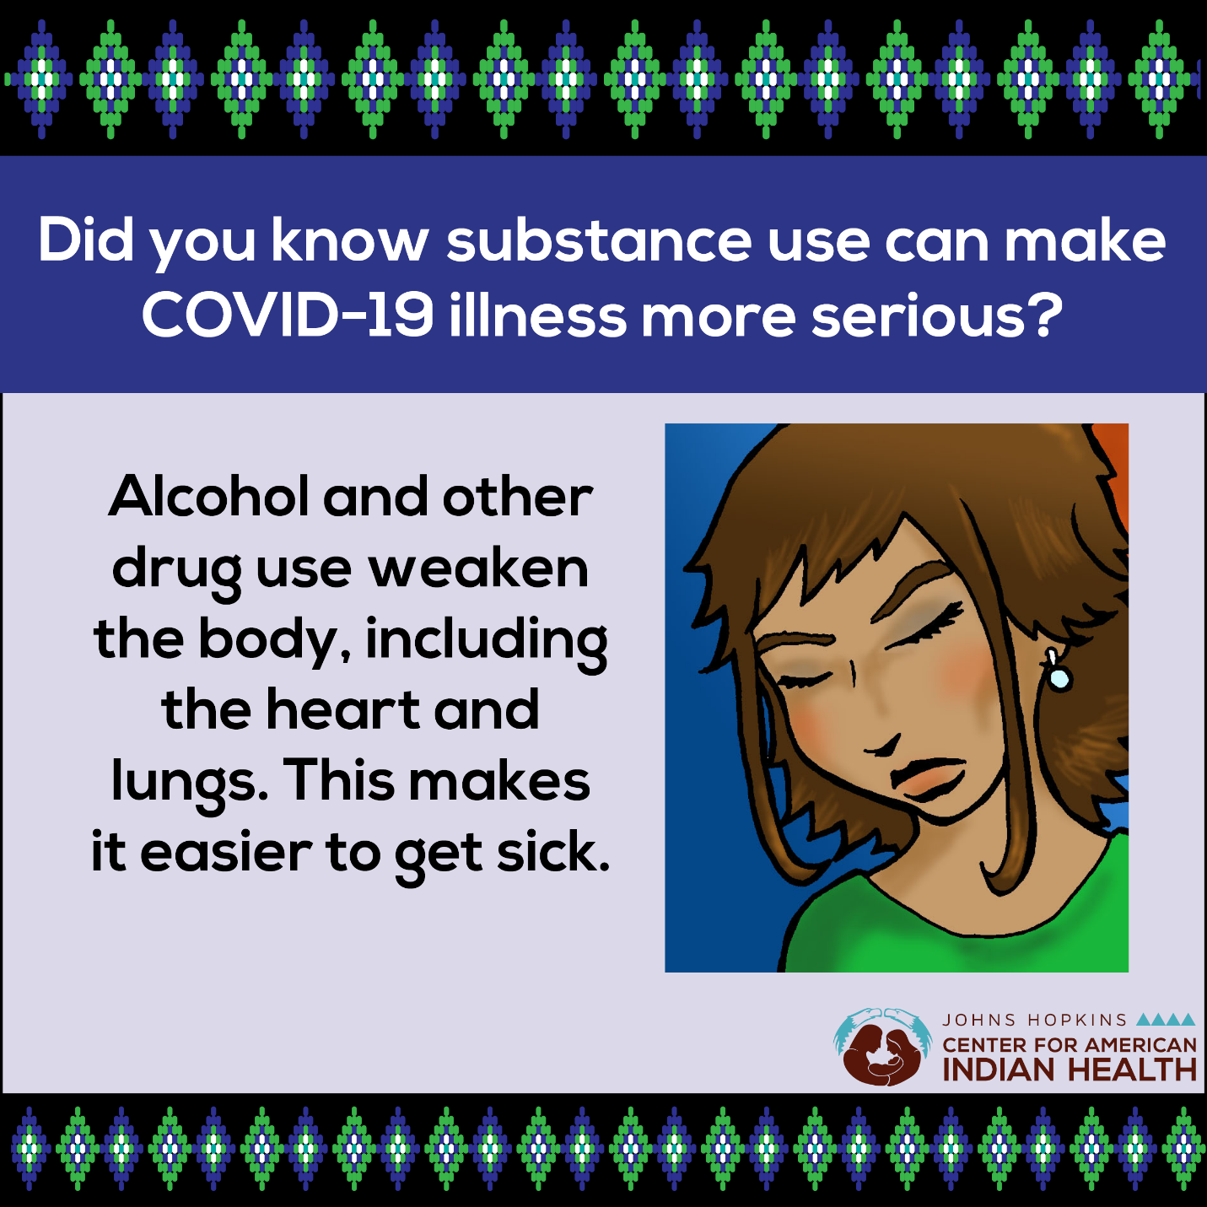
Social Media Message: Alcohol and other drug use can make #COVID19 illness more severe by weakening important organs, including the heart and lungs, but you are #notAlone. If you’re struggling with substance abuse or recovery, reach out to family, friends, support groups, or healthcare provider. Click here to get more information on substance use and #COVID19 — https://bit.ly/3m6CMIf. #Recovery #NativeHealth
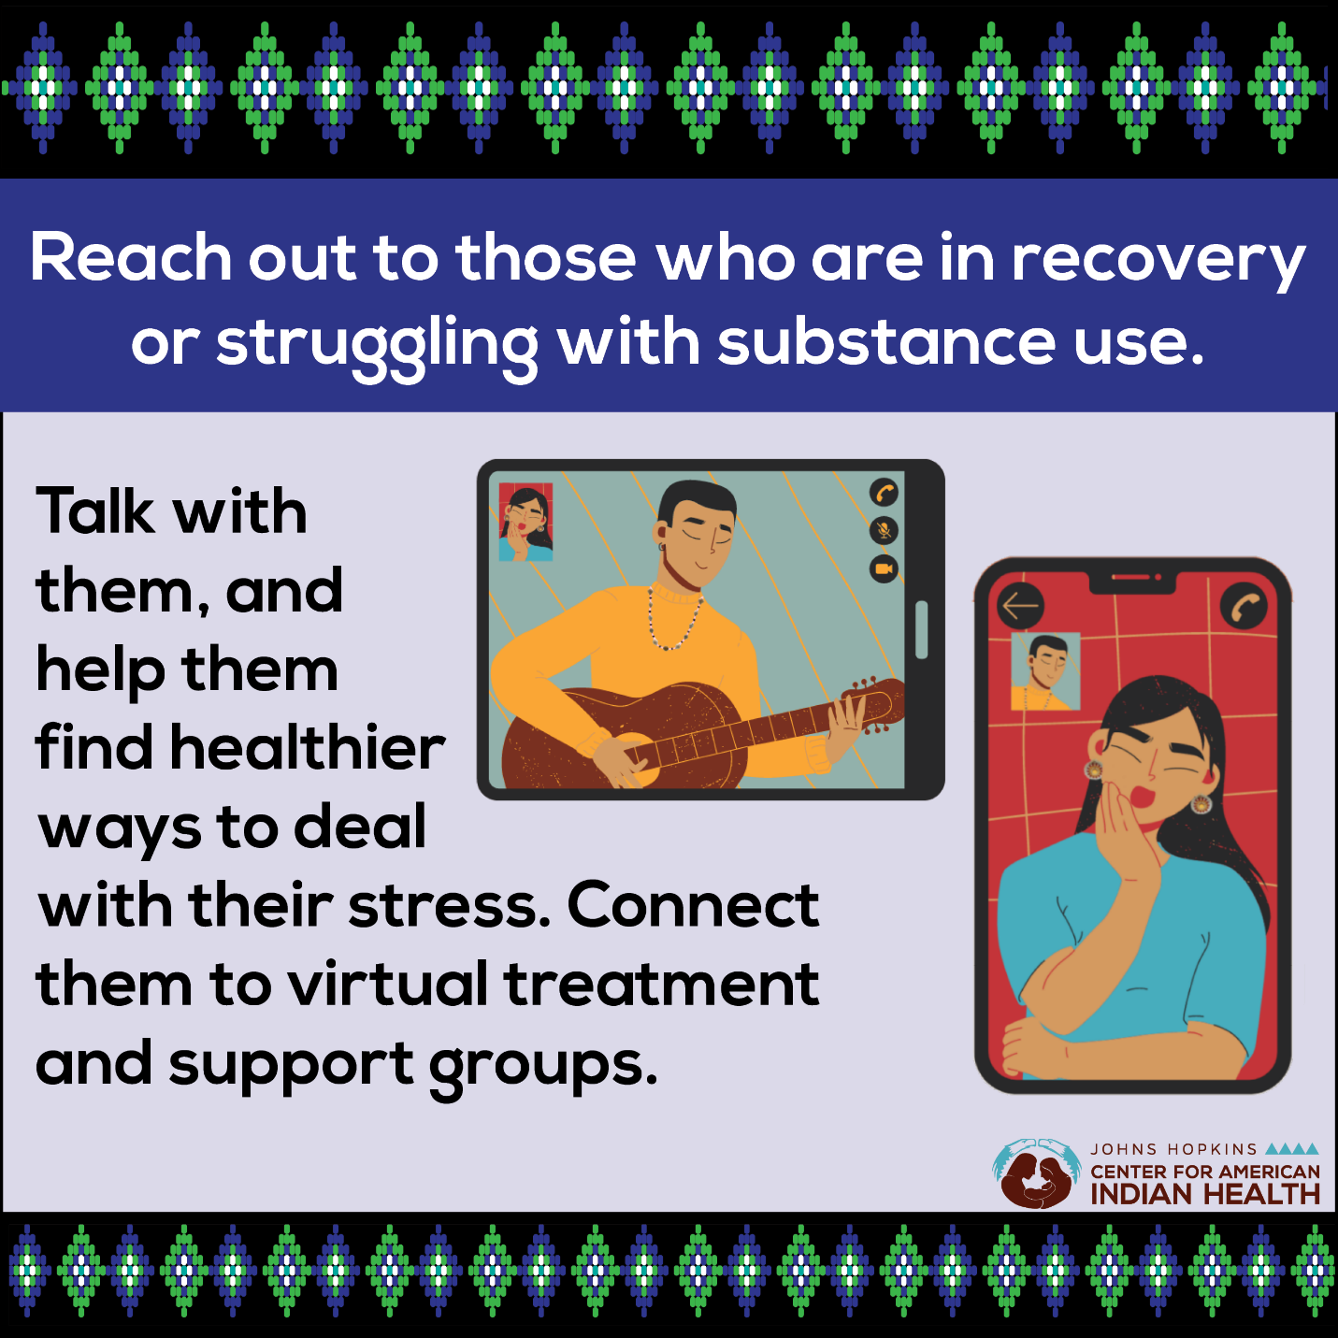

Social Media Message: The #COVID19 pandemic can make recovering from drug, alcohol, or other substance use more challenging. Reach out your family and friends who are struggling to remind them they are #NotAlone. Virtual treatment and support groups are available to help deal with stress and to provide additional help. Get more information and helpful resources here: https://bit.ly/3m6CMIf. #NativeHealth
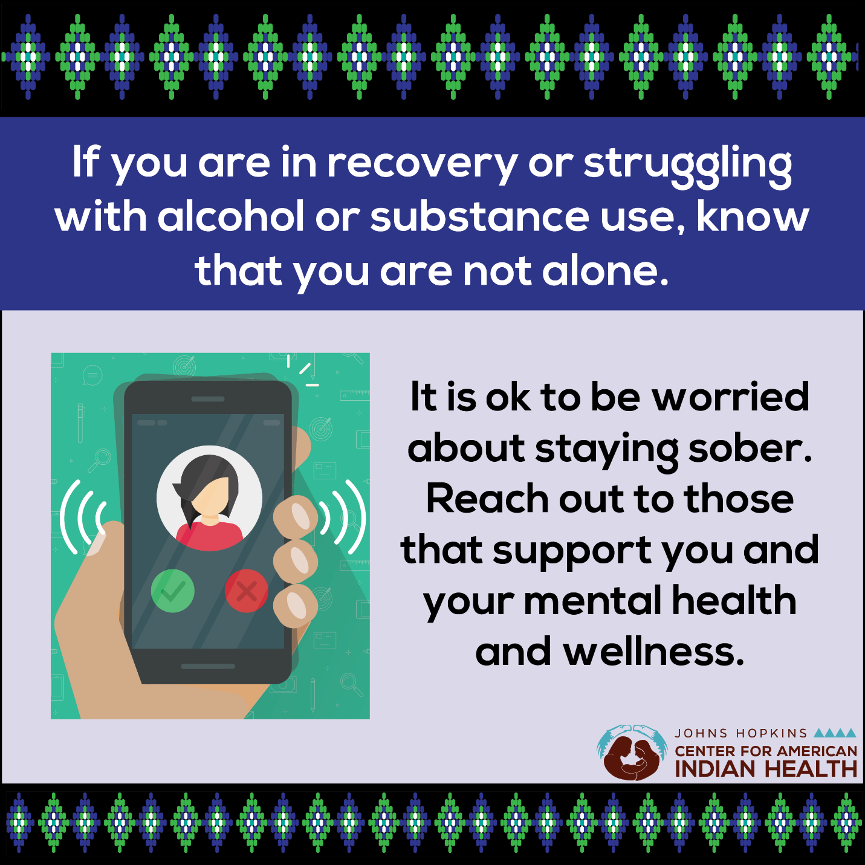
Social Media Message: If you’re struggling with alcohol or substance use, you’re #NotAlone. It’s normal to feel scared, anxious, or stressed, but help is available. Stay in touch with those who support you, including your healthcare provider, sponsors, and loved ones, and have a plan to get help if you’re in crisis. It’s okay to not be okay. Find resources to support your recovery at https://bit.ly/3m6CMIf. #NativeHealth #MentalHealth

