Truthsgiving Toolkit
Instagram:

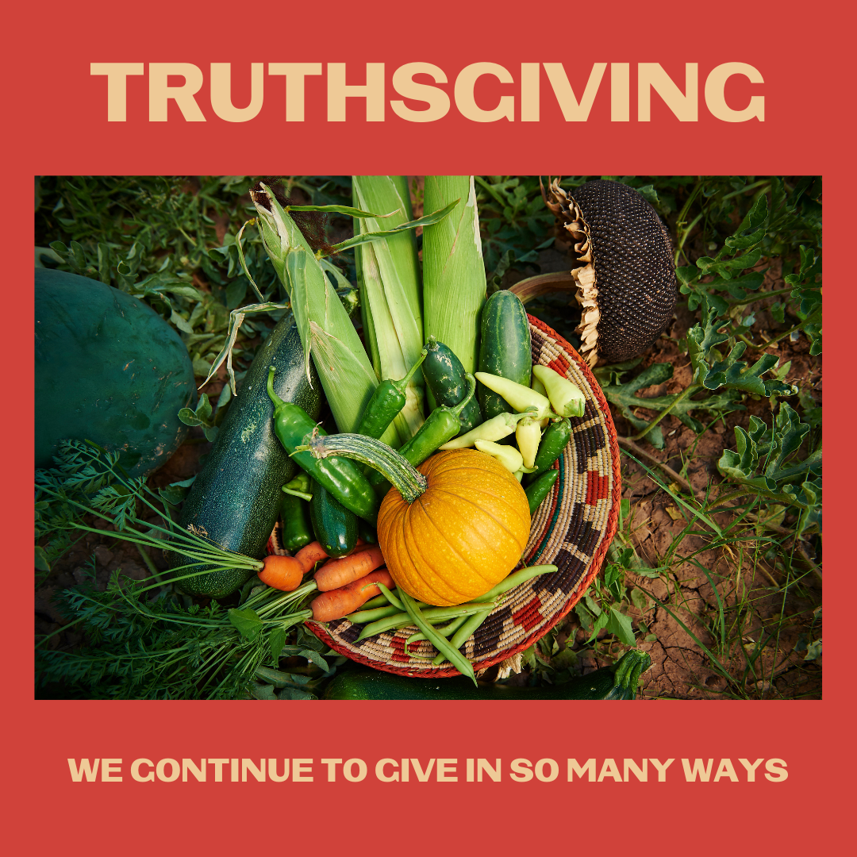
Description:
Indigenous values include generosity and selflessness, which have led to high rates of vaccination across Indian Country. Native people are continuing to give by getting vaccinated to protect our communities. That is something to be thankful for. #Truthsgiving #NativeValues #NativesStopTheSpread

Twitter and Facebook:

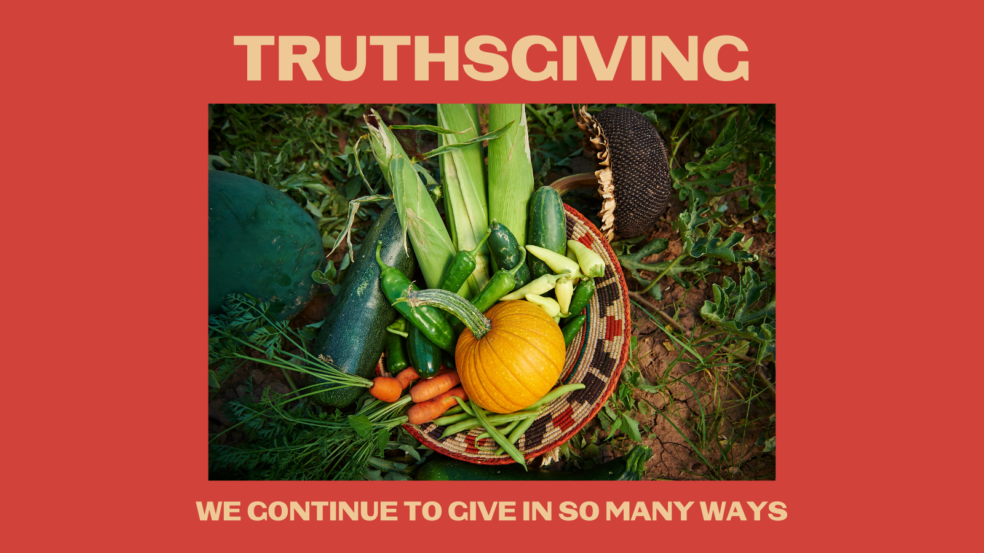
Description: Indigenous values include generosity and selflessness, which have led to high rates of vaccination across Indian Country. Native people are continuing to give by getting vaccinated to protect our communities. That is something to be thankful for. #Truthsgiving #NativeStopTheSpread

