COVID-19 Vaccine Ingredients: Mythbusters Social Media Toolkit
Social Media Message: #DYK you can find all the ingredients in the #COVID19 #vaccines on the FDA website? All available vaccines are safe and contain zero harmful ingredients. Millions have already safely been vaccinated and protected from the negative effects of COVID-19 disease.
#VacciNation #NativesStopTheSpread #StopTheSpread #Vaccinated #COVIDWarrior #SkoVaxDen
Instagram:
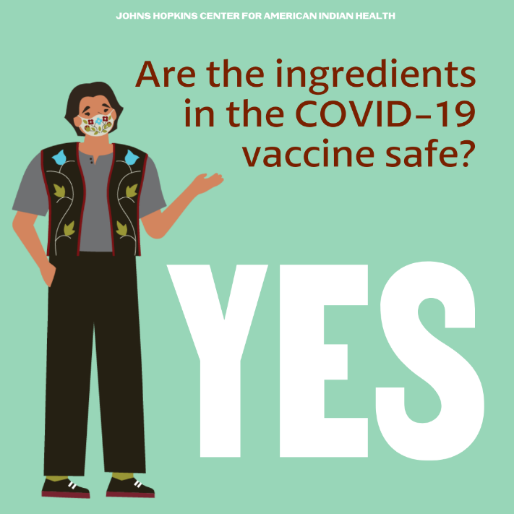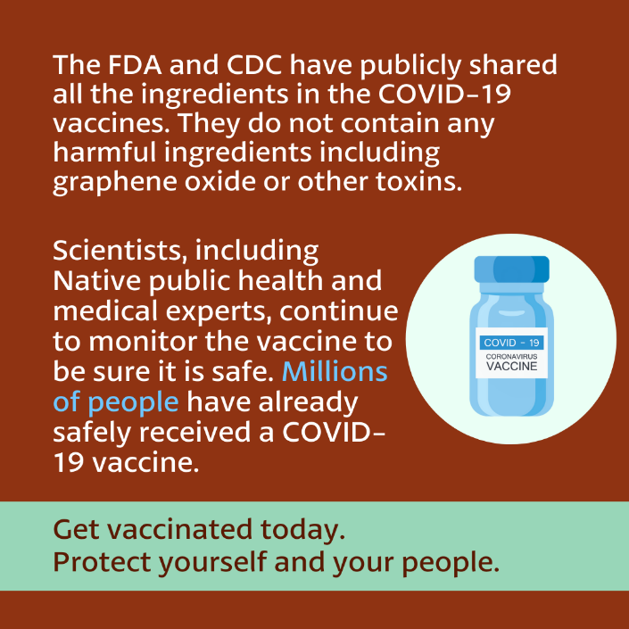

FB/Twitter:
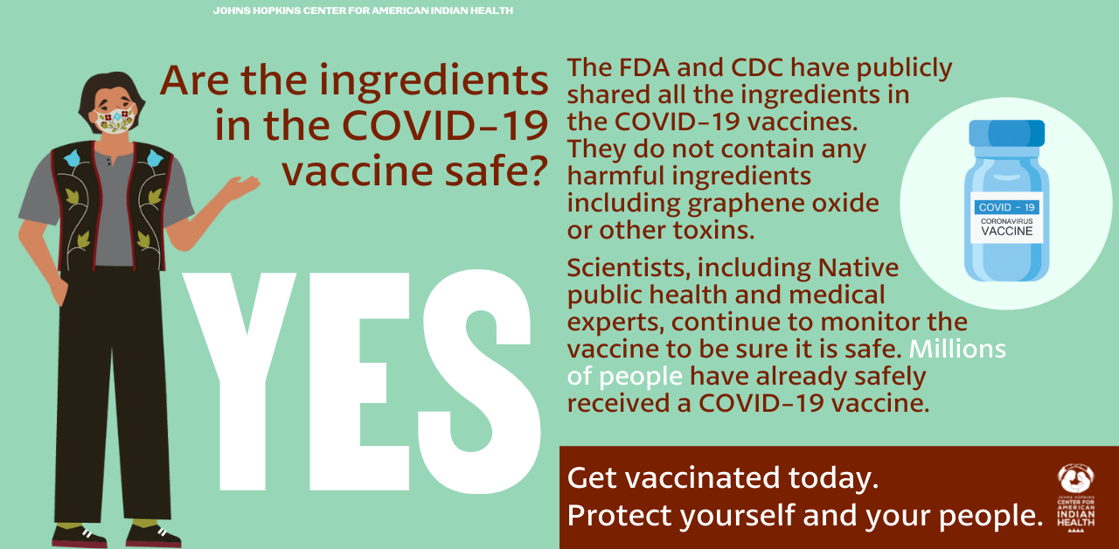
Tag:
@Anthctoday @Aaipdocs @CDCgov @HealthyNativeYouth @HonoringNations @IndianCountryToday @_IllumiNatives @IndianHealthBoard_Minneapolis @IndianHealthService
@Indianz @JohnsHopkinsSPH @NationalIndianHealthBoard @Npaihb @Nihb1 @NationalNativeNews @NativeAmericans @NativeAmericanLifelines @Nimhgov @NNNnativenews @ProjectMosaicllc @SeattleIndianHealthBoard @UrbanIndigenousCollective @UrbanIndianHealth
@UrbanIndianHealthInstitute @WeAreHealers @WeRNative @HealthyN8Vyouth @HonoringNations @_Illuminatives @JohnsHopkinssph @Npaihb @ProjectMosaicLLC @UrbanIndigenousCollective @Nimhgov @Nimhd @Nihb1 @UrbanIndianHealth @WeAreHealers

