Social Media Toolkit
Taking Care of Us During COVID-19
National Women’s Health Week May 10-16, 2020

National Women’s Health Week serves as a reminder for all women to make health a priority and to build healthy habits for life. Mother’s Day, May 10, 2020, marks the 21st annual National Women’s Health Week and continues through May 16, 2020.

Twitter Messages

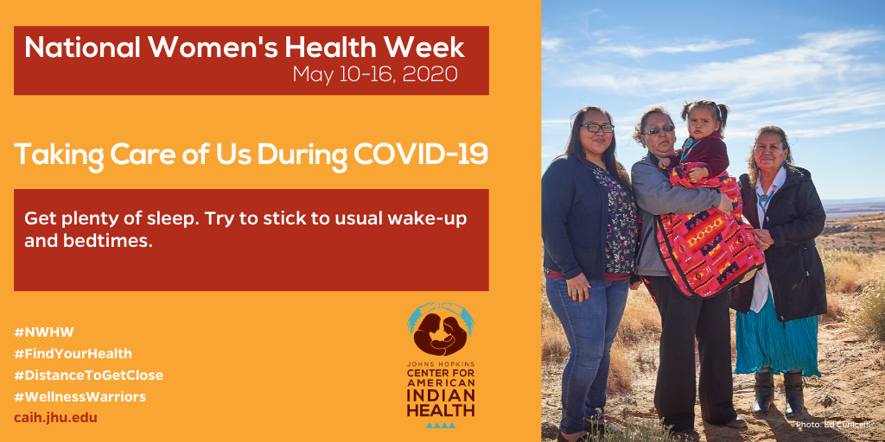

During the coronavirus outbreak, it’s more important than ever to focus on well-being and health. Get plenty of sleep 💤and try to stick to regular routines.🌄
👇Learn more @IHSgov:

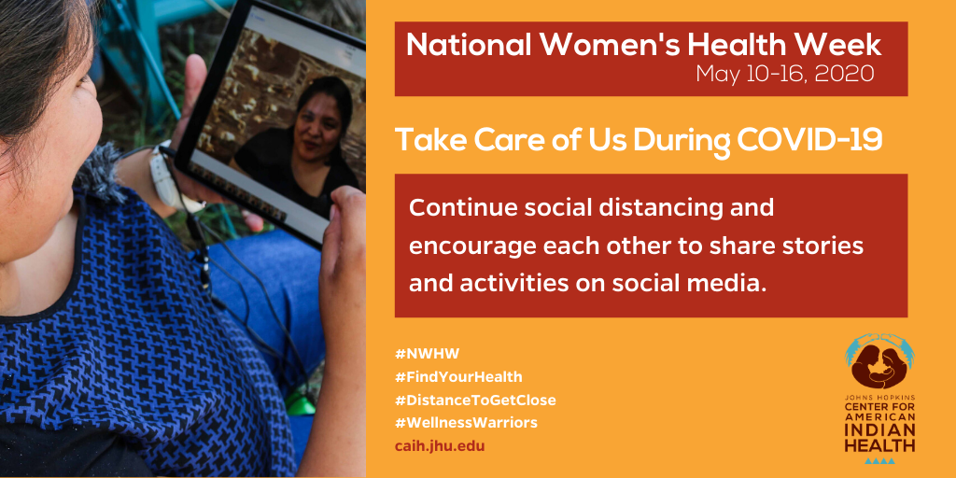
Most of us are home🏠 now, but we can stay social to maintain good health and well-being 👩🏽‍🦱. Virtual chats 💻 help us stay connected!
👇Learn more @IHSgov:

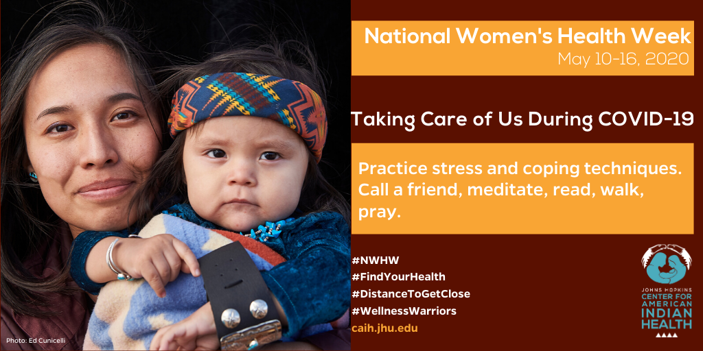
Most of us are home🏠 now, but we can connect with support networks through phone📱 or web to maintain good health and well-being 👩🏽‍🦱.
👇Learn more @IHSgov:

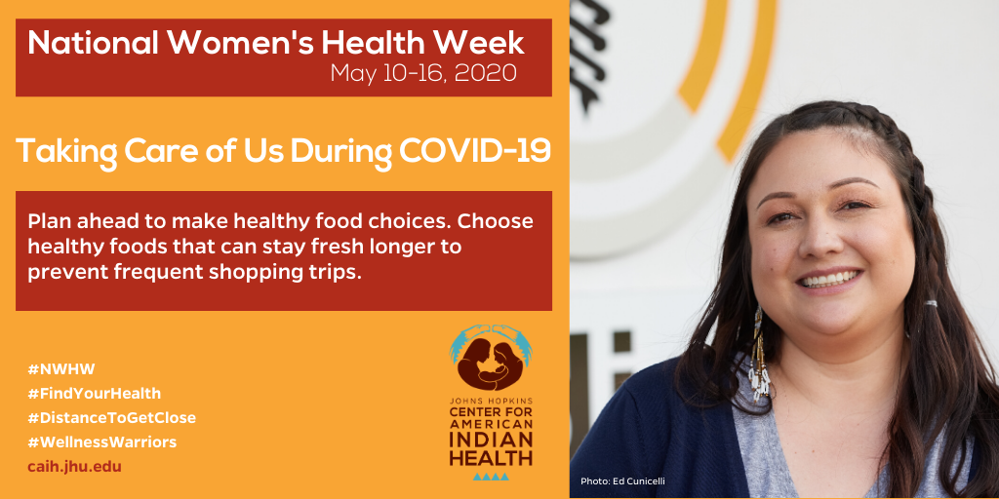
Plan ahead for grocery runs 🛒🍏 to stay healthy during long periods of being home-bound 🏠. Phone 📱a friend for a new recipe!
👇Learn more @IHSgov:

INSTAGRAM

[share message with all visuals listed above]

National Women’s Health Week (May 10-16) serves as a reminder for all women to make health a priority and to build healthy habits 🍎 for life! Although we are experiencing disruptions during the coronavirus outbreak, we can take steps🚶🏽‍♀️to improve our health and well-being.

Connect with others via virtual chats 💻 while staying home. 🏠 Wear masks😷 if you need to be out in public. Plan ahead to grocery shop🛒 off-peak.

For more information, visit CDC.gov/coronavirus
Materials for tribal communities 👉 Bit.ly/TribesFightCOVID19
#StayHomeHeroes
#WellnessWarriors
#KeepYourDistance
#FlattentheCurve
#COVID19

