World Immunization Week Social Media Kit

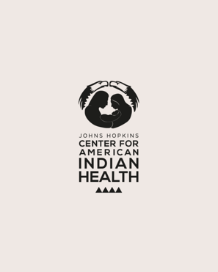
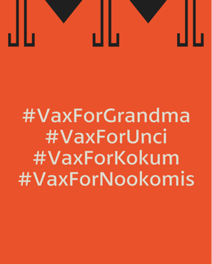
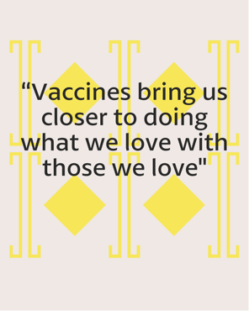
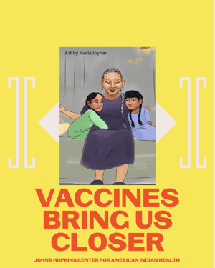
IG Post 1

Description: Every grandma hug is precious. Vaccines bring us closer to all of our family members and loved ones. Artist Joelle Joyner.
#VaxForGrandma #VaxForUnci #VaxForKokum #VaxForNookomis #WorldImmunizationWeek #WIW2021

FB and Twitter Post 1
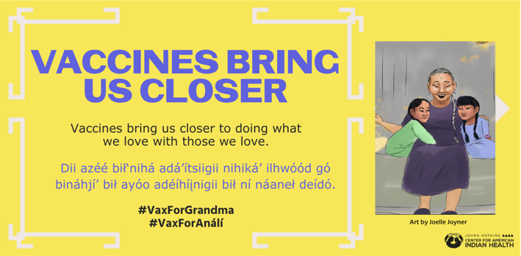

Description: Every grandma hug is precious. Vaccines bring us closer to all of our family members and loved ones. Artist Joelle Joyner.
#VaxForGrandma #VaxForUnci #VaxForKokum #VaxForNookomis #WorldImmunizationWeek #WIW2021 #IndigenousLanguage

IG Post 2
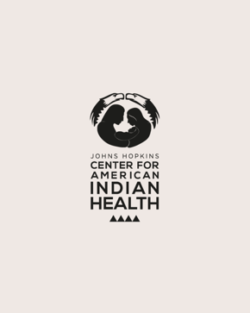
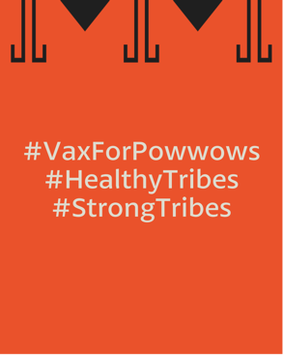
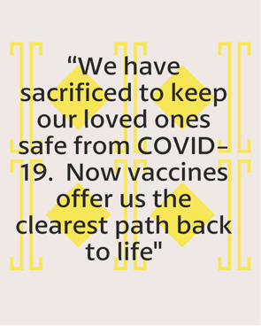
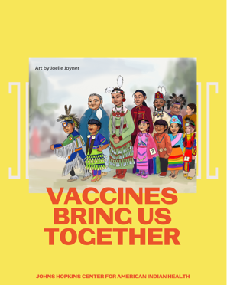

Description: These special times will come around again. Vaccines offer a path back to life.
Artist Joelle Joyner.
#VaxForPowwows #HealthyTribes #StrongTribes #WorldImmunizationWeek #WIW2021
FB and Twitter Post 2
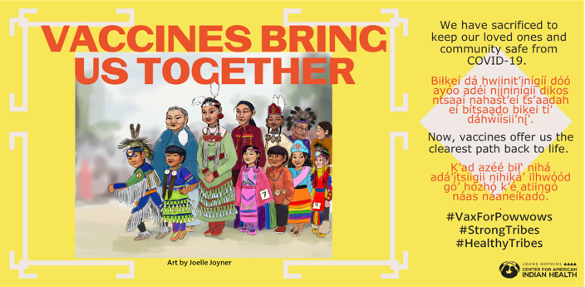

Description: These special times will come around again. Vaccines offer a path back to life. Artist Joelle Joyner.

#VaxForPowwows #HealthyTribes #StrongTribes #WorldImmunizationWeek #WIW2021 #IndigenousLanguage"

IG Post 3
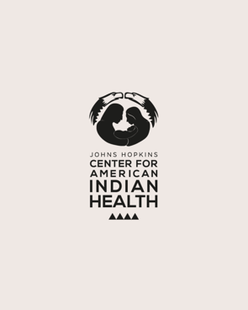
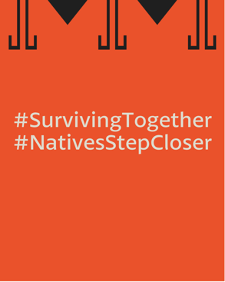
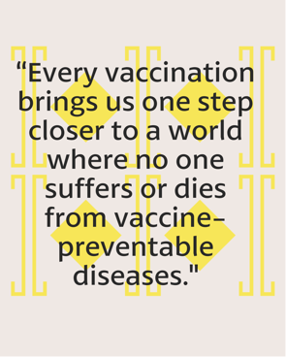
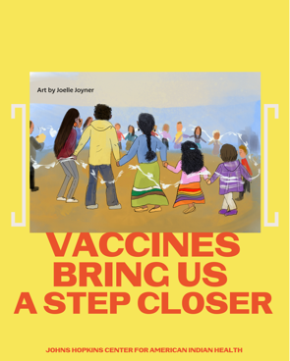

Description: In the round dance of life, every vaccination brings us one step closer to a world where no one suffers or dies from vaccine-preventable diseases. Artist Joelle Joyner.
#SurvivingTogether #NativesStepCloser #HealthyTribes #StrongTribes #WorldImmunizationWeek #WIW2021

FB and Twitter Post 3
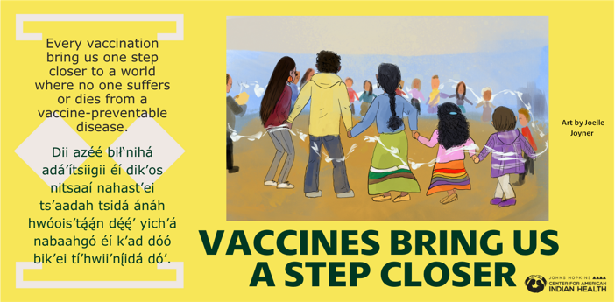

In the round dance of life, every vaccination brings us one step closer to a world where no one suffers or dies from vaccine-preventable diseases. Artist Joelle Joyner

#SurvivingTogether #NativesStepCloser #HealthyTribes #StrongTribes #WorldImmunizationWeek #WIW2021 #IndigenousLanguage

