INSTAGRAM
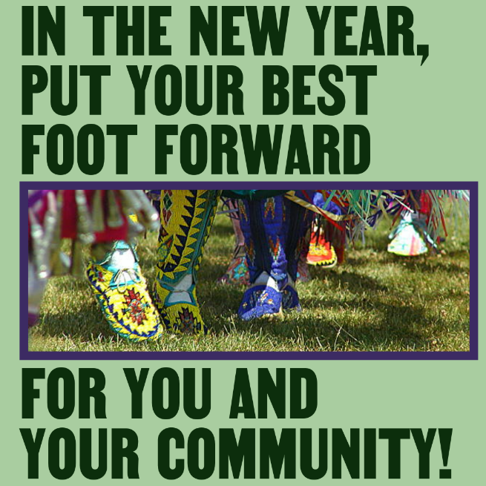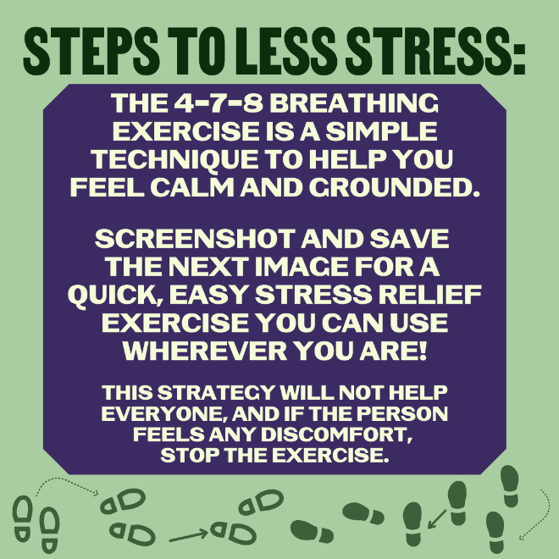
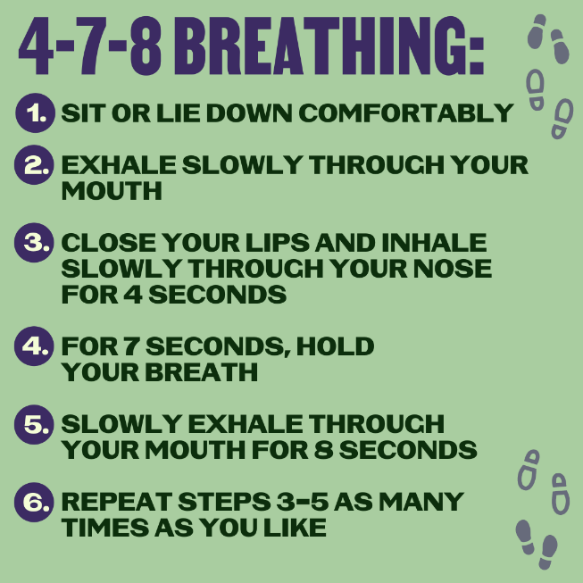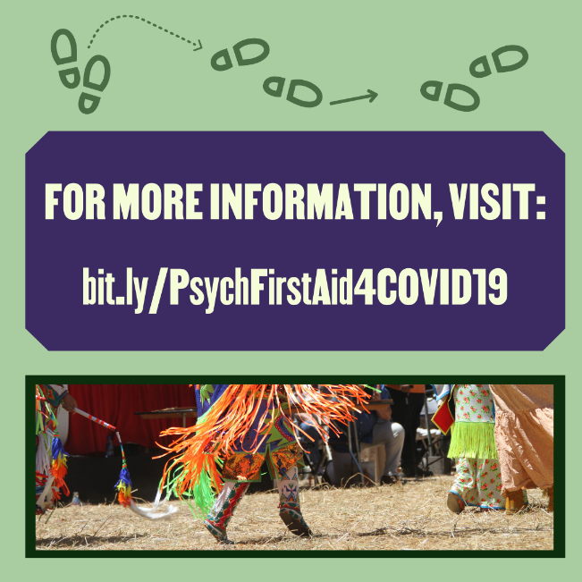
Learning how to react to stress can be like dancing – it gets easier the more you practice!
In 2022, use techniques like 4-7-8 breathing to help prioritize the mental health and well-being of yourself and others. For more ideas for self-care activities in the new year, visit: bit.ly/PsychFirstAid4COVID19 (link in bio).

FACEBOOK
Learning how to react to stress can be like dancing – it gets easier the more you practice!
In 2022, use techniques like 4-7-8 breathing to help prioritize the mental health and well-being of yourself and others. For more ideas for self-care activities in the new year, visit: bit.ly/PsychFirstAid4COVID19.

