Pride Month
Social Media Toolkit
#1 Monday
Instagram:
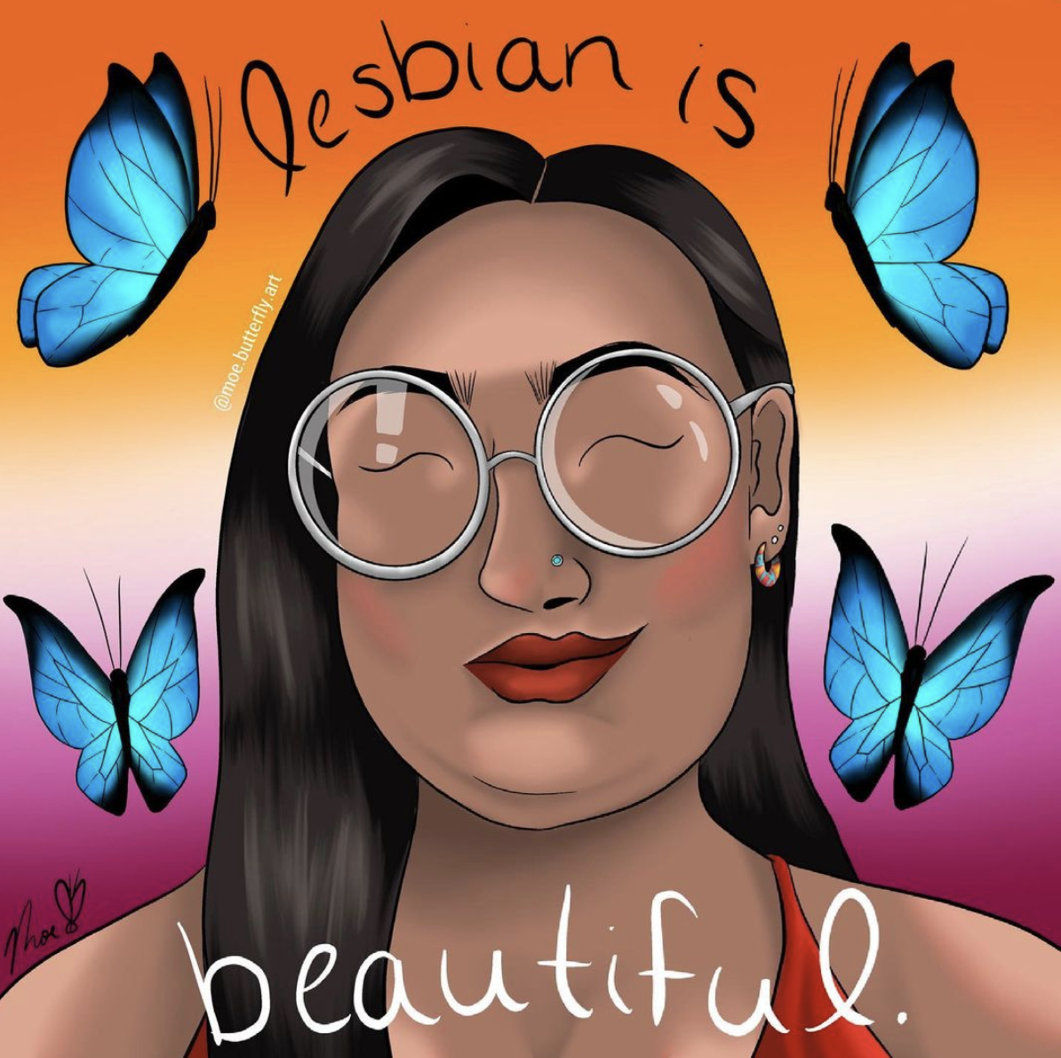
Tag: moe.butterfly.art
Note: Please insert brown raised fist emoji after SACRED, word deletes it between document formatting.
Description:
#pride #pridemonth #lgbtq #indigenous #native #indigenousartist #TwoSpirit #NativeArt

Twitter and Facebook
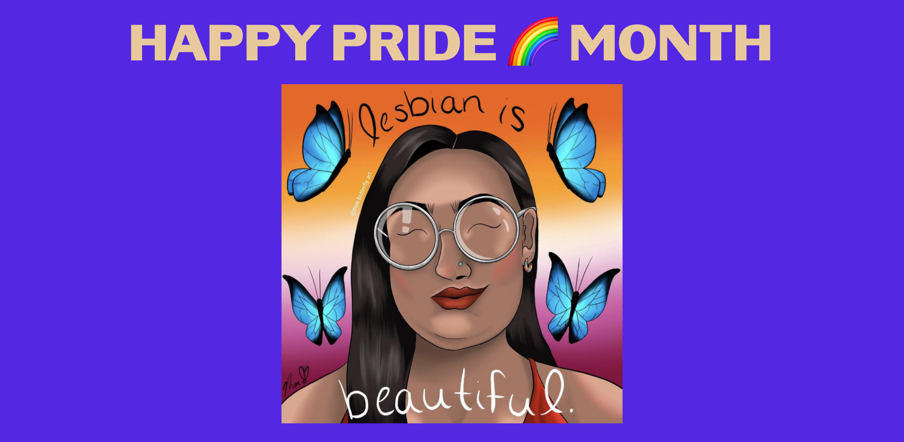
Twitter tag: @butterfly_moe
Note: Please insert brown raised fist emoji after SACRED, word deletes it between document formatting.

Description: C Celebrating Pride Month by sharing this message from Onödowa’ga:’ artist, Moe Butterfly, who expresses love for the LGTBQ, Two-Spirit, and all Native community through art “Never forget, your transness is SACRED” #pride #pridemonth #lgbtq #native #TwoSpirit #NativeArt

#2 Tuesday
Instagram:
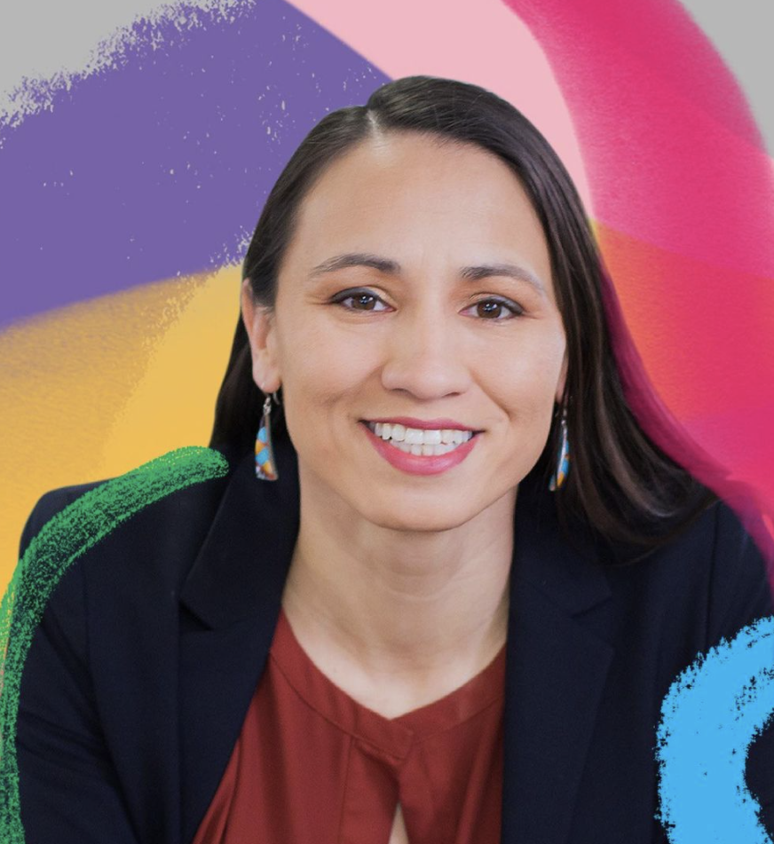
Tag: @repdavids @fastcompany
Description: Congrats to Representative Sharice Davids (Ho Chunk) on your selection as one of @fastcompany’s #FCQueer50
Thanks for all you do for the Native community and the LGBTQ community, you make us all proud! #NativePride #PrideMonth

Twitter and Facebook:
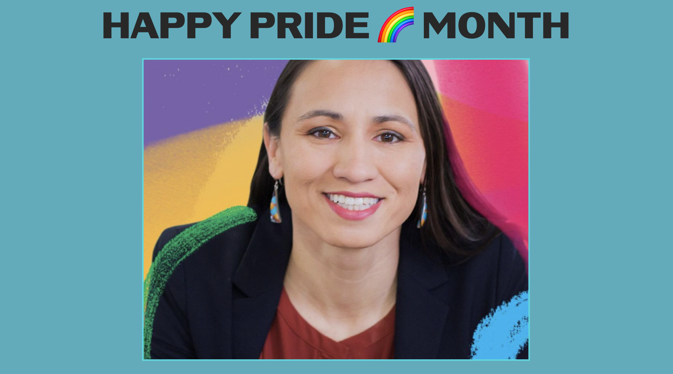
Twitter tag: @repdavids
Description: Congrats to Representative Sharice Davids (Ho Chunk) on your selection as one of @fastcompany’s #FCQueer50 Thanks for all you do for the Native community and the LGBTQ community, you make us all proud! #NativePride #PrideMonth

#3 Wednesday
Instagram:
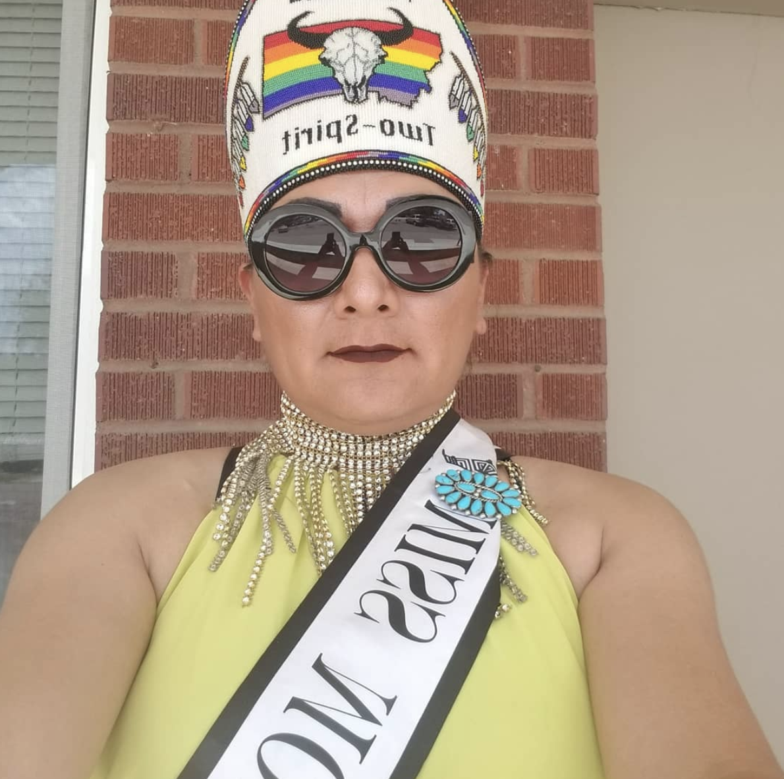
Tag @barbiebuffalo
Description: Miss Montana Two-Spirit, Buffalo Barbie, is always ready to uplift community members who need support. Uplifting our communities makes us stronger. Thank you, Buffalo Barbie!
#NativePride #PrideMonth

Twitter and Facebook:

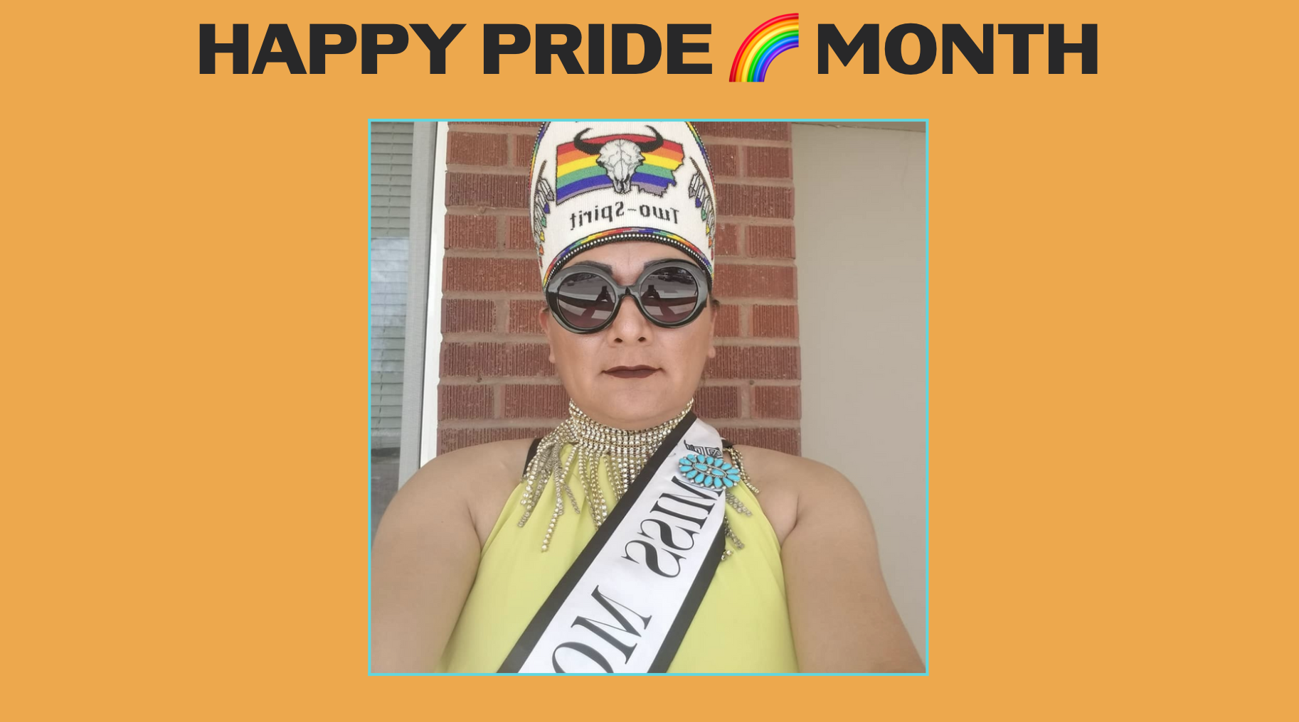

Facebook Tag: @buffalo.barbie
Description: Miss Montana Two-Spirit, Buffalo Barbie, is always ready to uplift community members who need support.Uplifting our communities makes us stronger. Thank you, Buffalo Barbie!
#NativePride #PrideMonth

#4 Thursday
Instagram:
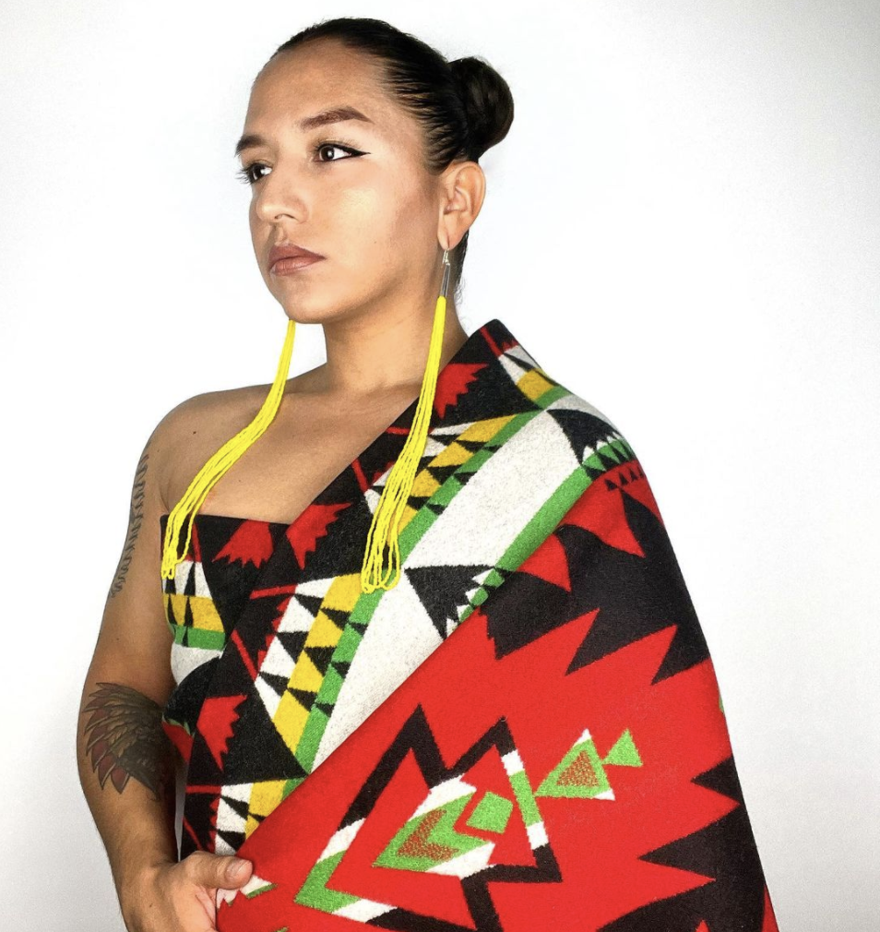
Tag @landbackbaddie @iiyc5280

Description: Environmental advocate, Lopez Jr., is a co-founder of @iiyc5280, which creates visibility for QT BIPOC youth through spiritual practice, civic engagement & non-violent direction action. Indigenous people know public health and environmental health are one and the same. Thank you, Thomás, for all that you do! #NativePride #PrideMonth

Twitter and Facebook:

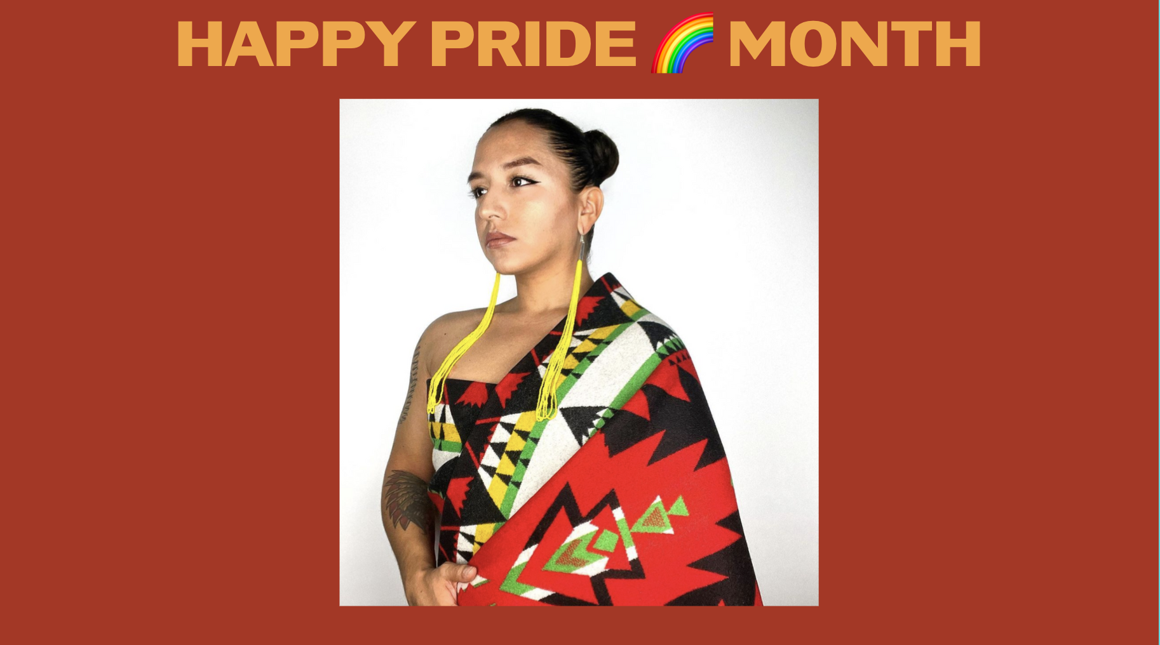

Twitter Tag: @iiyc5280
Description: Thomás Lopez Jr., is a co-founder of @iiyc5280, creating visibility for QT BIPOC youth through spiritual practice, civic engagement & non-violent direction action. Indigenous people know public health and environmental health are the same. Thank you, Thomas, for all that you do.

#5 Friday
Instagram:
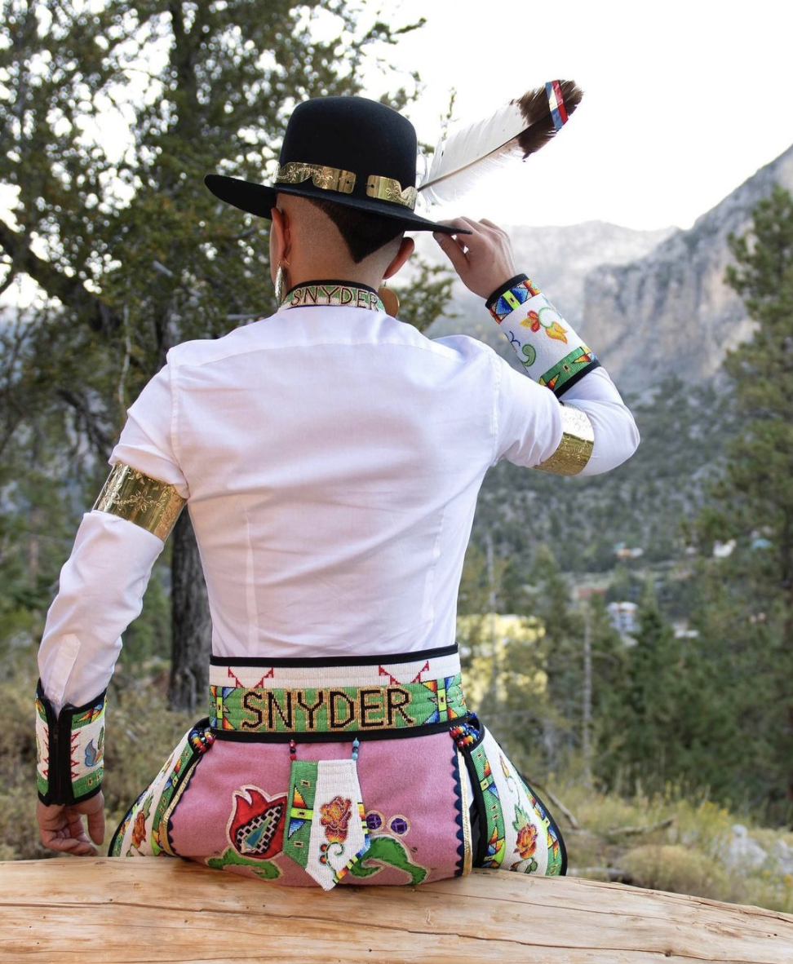
Tag: @seanqsnyder

Description: “Native people have relied on creating art and healing dances to get each through the pandemic & now we are leading the way on vaccines. We’ve shown the world the power of Indigenous values.” Sean Snyder (Navajo/Ute) Thank you, Sean, for keeping our communities in balance. #ForOurPeople #NativePride #PrideMonth

Twitter and Facebook:

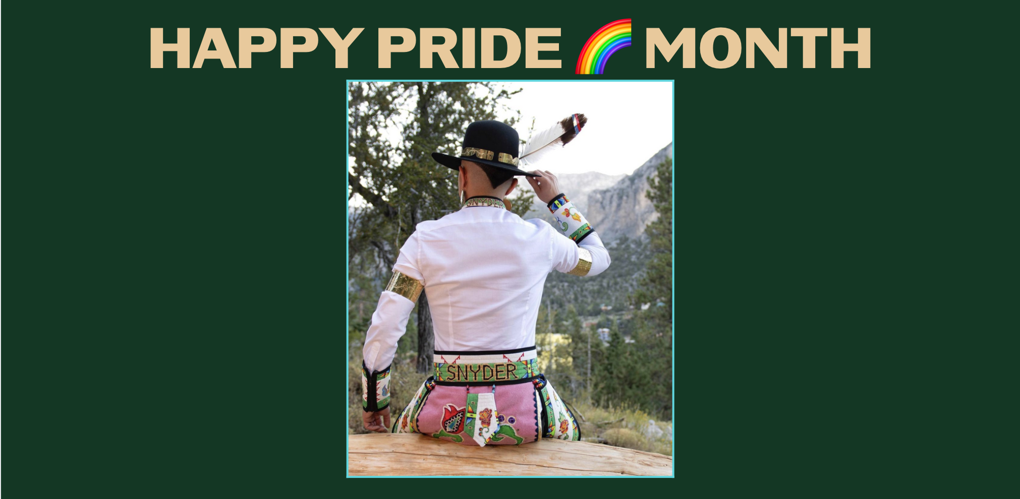

Description: “Native people have relied on creating art and healing dances to get each through the pandemic & now we are leading the way on vaccines. We’ve shown the world the power of Indigenous values.” Sean Snyder (Navajo/Ute) Thank you, Sean, for keeping our communities in balance. #Pride

