Family Spirit Nurture Messages: Postcard & Social Media Toolkit
Postcard:
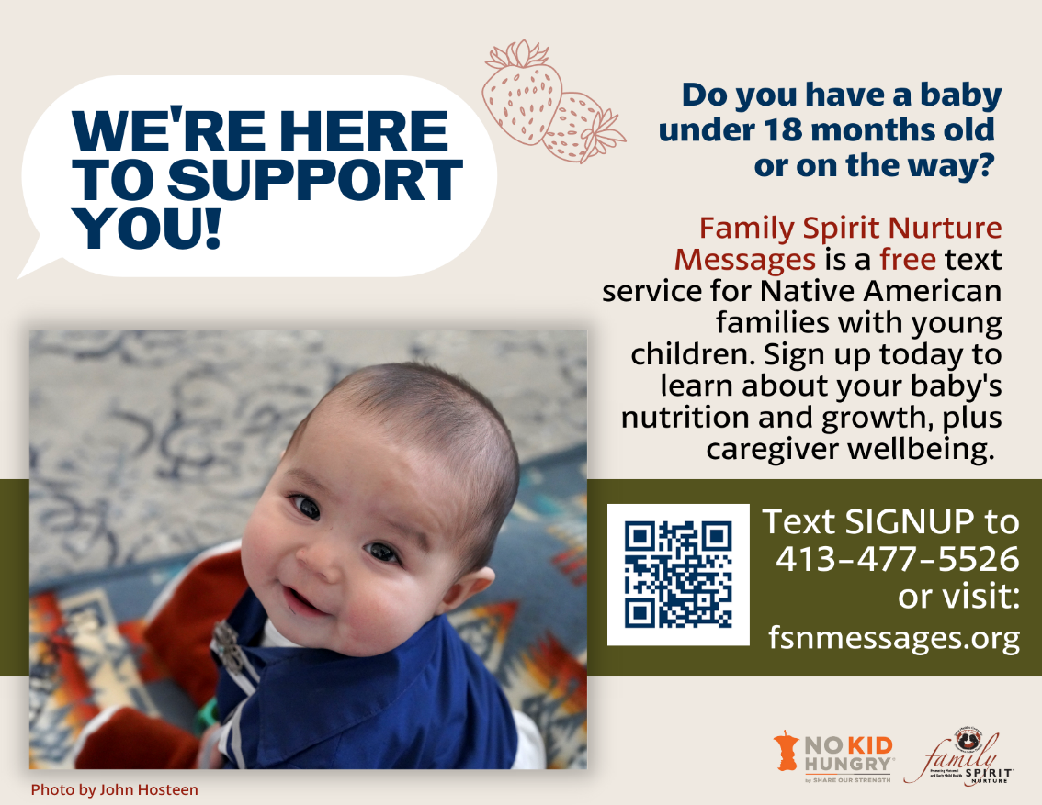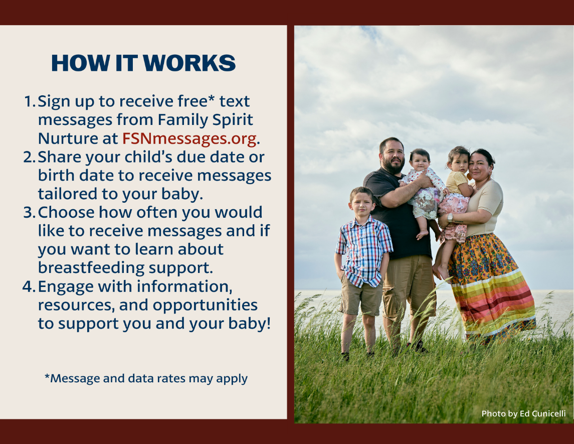

Social Media Message: Family Spirit Nurture is a culturally based home visiting program proven to support Native American children’s nutrition, health, and growth! Family Spirit Nurture key teaching points, resources and support are now available to all interested families through our free text messaging service, Family Spirit Nurture Messages (Message and data rates may apply).
#HealthyBabiesHealthyFutures #HomeVisiting #FamilySpirit
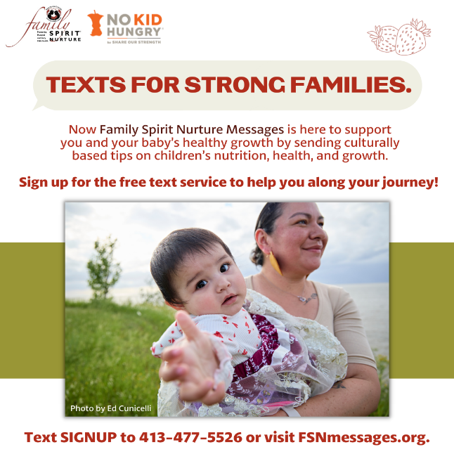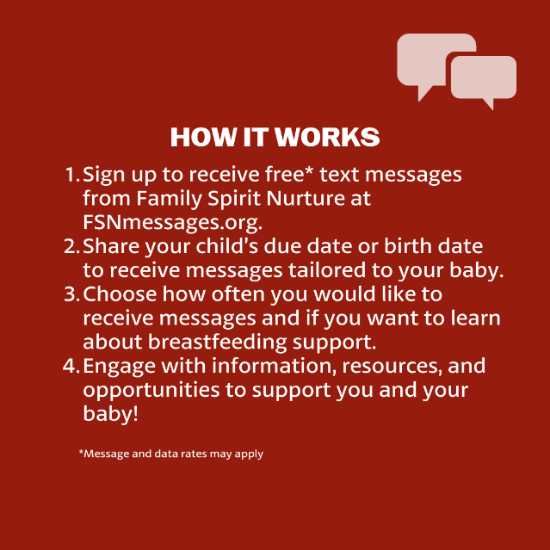
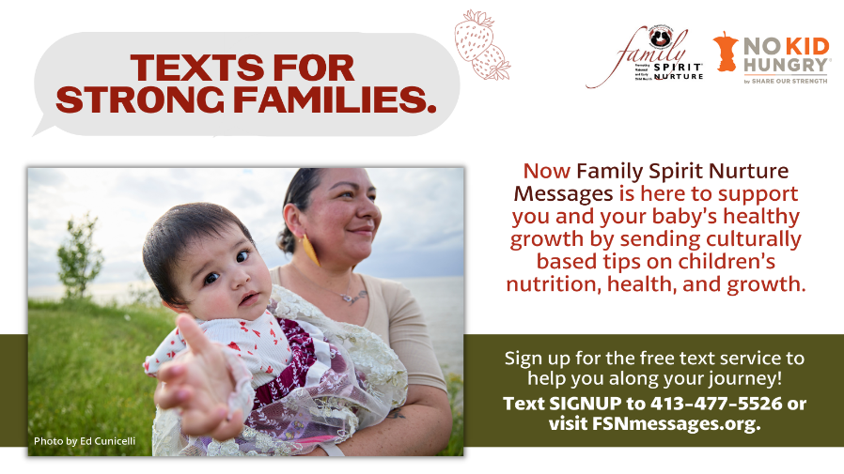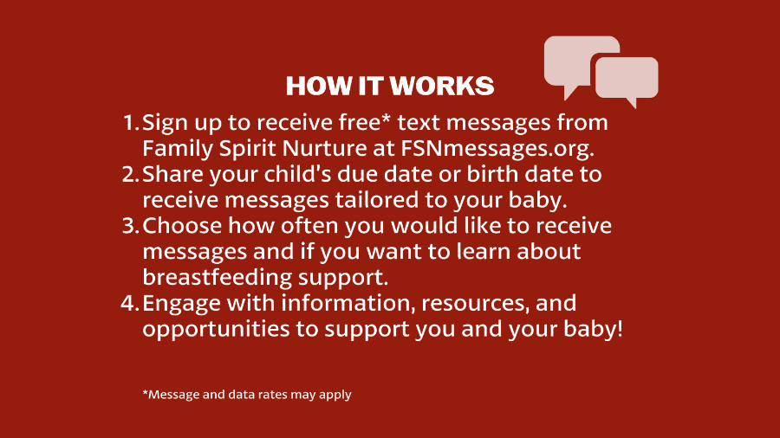
Social Media Message: Sign up today to receive texts from Family Spirit Nurture Messages featuring culturally based information on your baby’s nutrition, health, and growth!
#HealthyBabiesHealthyFutures #HomeVisiting #FamilySpirit #InfantFeeding
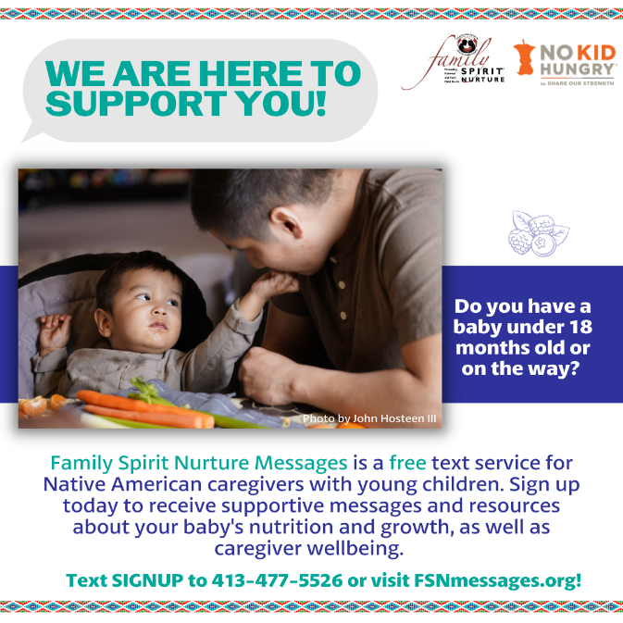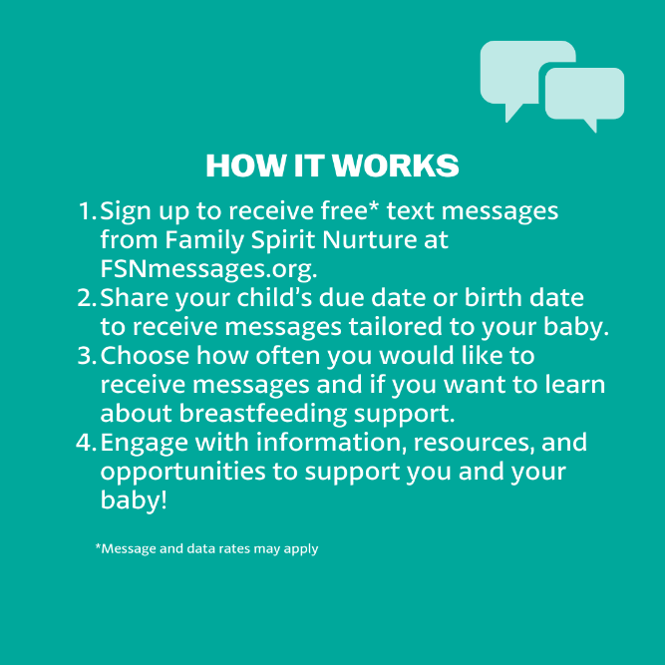
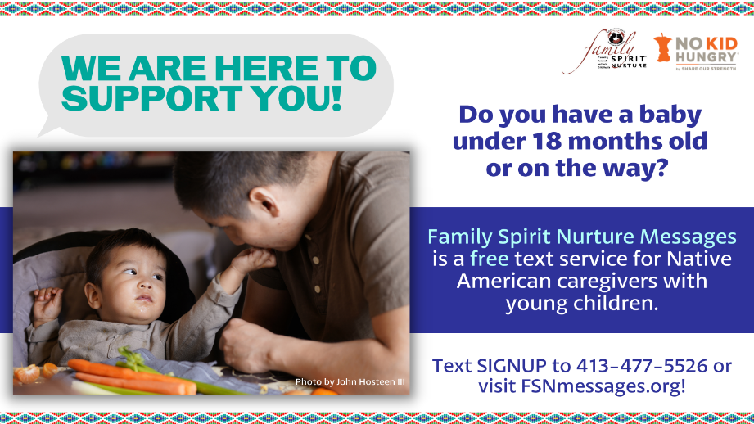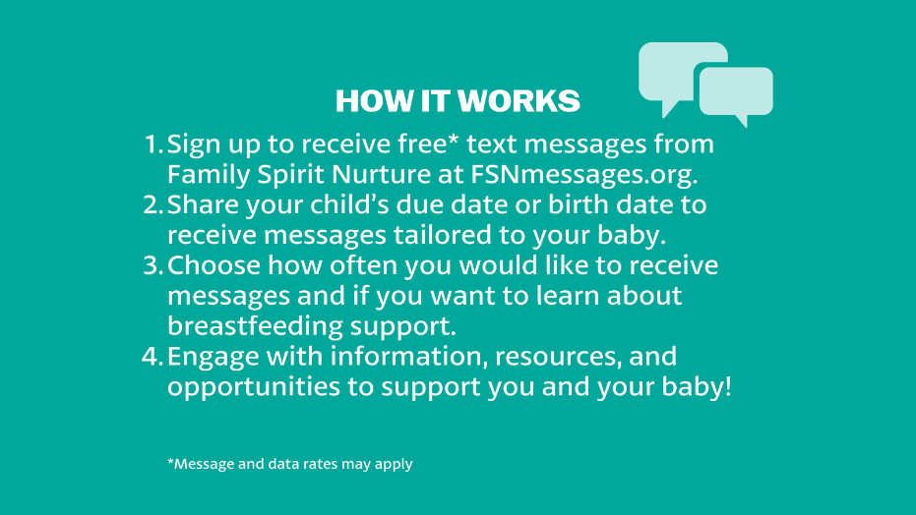
Social Media Message: Find local and national resources, including delicious Native recipes to feed your family, on our new FSNmessages.org website!
#HealthyBabiesHealthyFutures #HomeVisiting #FamilySpirit #IndigenousFoodways #IndigenousRecipes
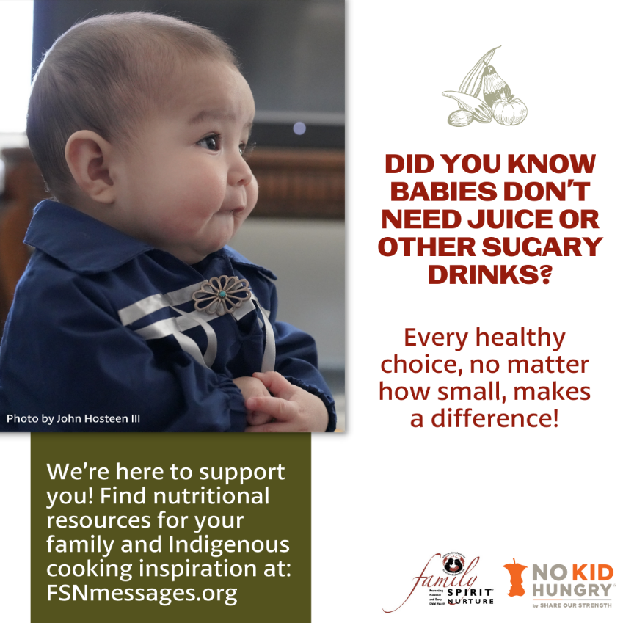
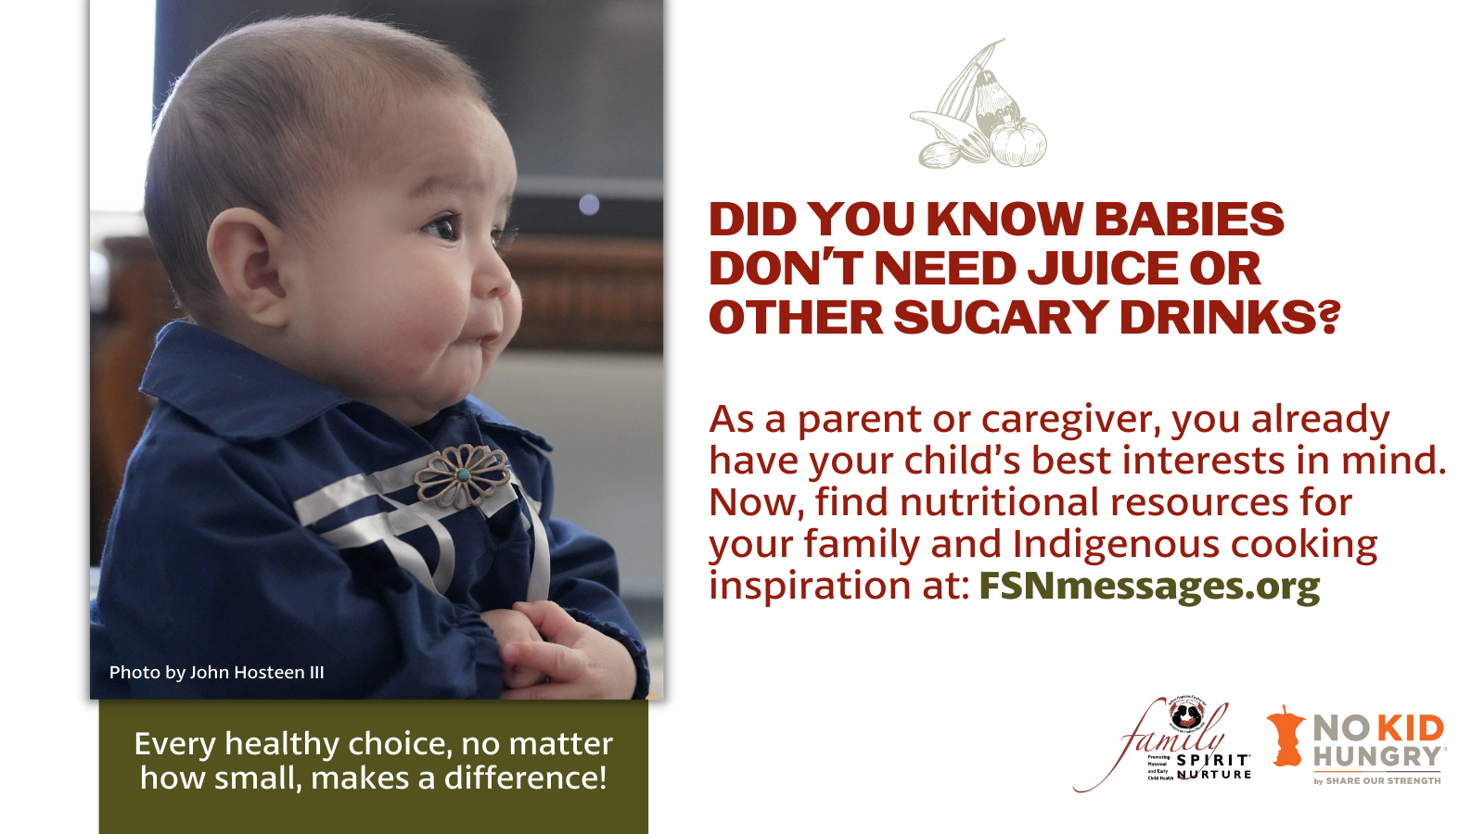

Social Media Message: Breastfeeding can be a powerful way to nourish and connect with your baby. To learn more, sign up for our free text service at FSNmessages.org.
#HealthyBabiesHealthyFutures #InfantFeeding #FamilySpirit #HomeVisiting
