RSV: Social Media Toolkit
Social Media Message: Fall and winter bring respiratory viruses like RSV, COVID, and flu that affect our lungs. Washing hands, getting vaccinated, wearing a mask, and staying home when feeling sick are ways we can #stopthespread and protect our communities.
@Anthctoday @Aaipdocs @CDCgov @HealthyNativeYouth @HonoringNations @IndianCountryToday @_IllumiNatives @IndianHealthBoard_Minneapolis @IndianHealthService @Indianz @JohnsHopkinsSPH @NationalIndianHealthBoard @Npaihb @Nihb1 @NationalNativeNews @NativeAmericans @NativeAmericanLifelines @Nimhgov @NNNnativenews @ProjectMosaicllc @SeattleIndianHealthBoard @UrbanIndigenousCollective @UrbanIndianHealth @UrbanIndianHealthInstitute @WeAreHealers @whetstoneradio

#RSV #FightFlu #FluShot #COVIDBooster #NativesStopTheSpread #NativesDoingTheirPart #NativeAmericanHealth #IndigenousHealth #NativeAmerican #AmericanIndian #AlaskaNative #HealthyTribes #IndigenousPeople #NativeHealth #TribalHealth #COVIDWarrior #NativesVaxUp #NativesMaskUp #SkoVaxDen #VacciNative #VACCINation #NDNCommunityImmunity #HealthyNativeYouth #ProtectFutureGenerations
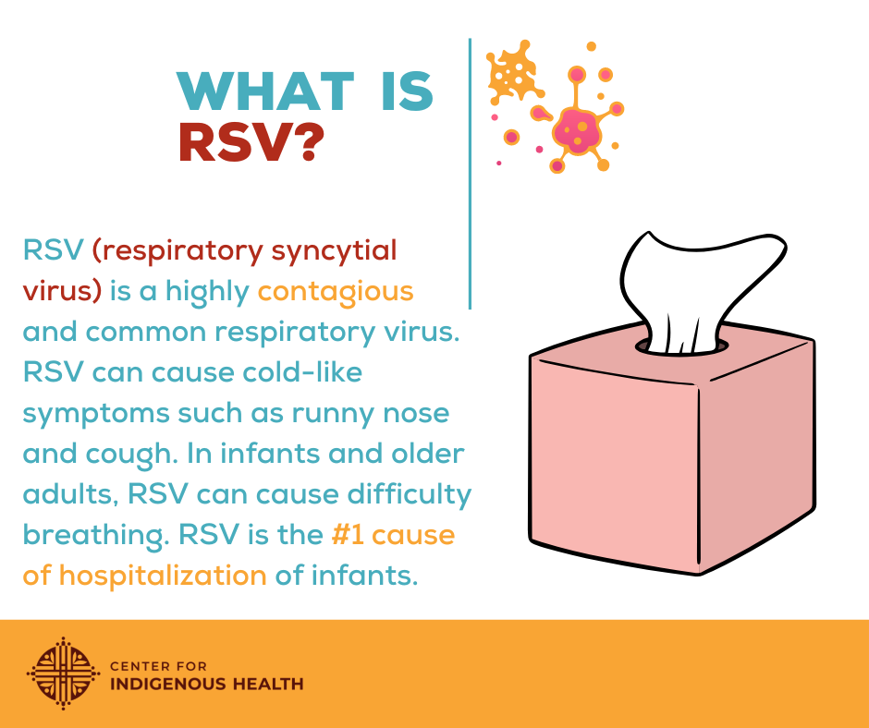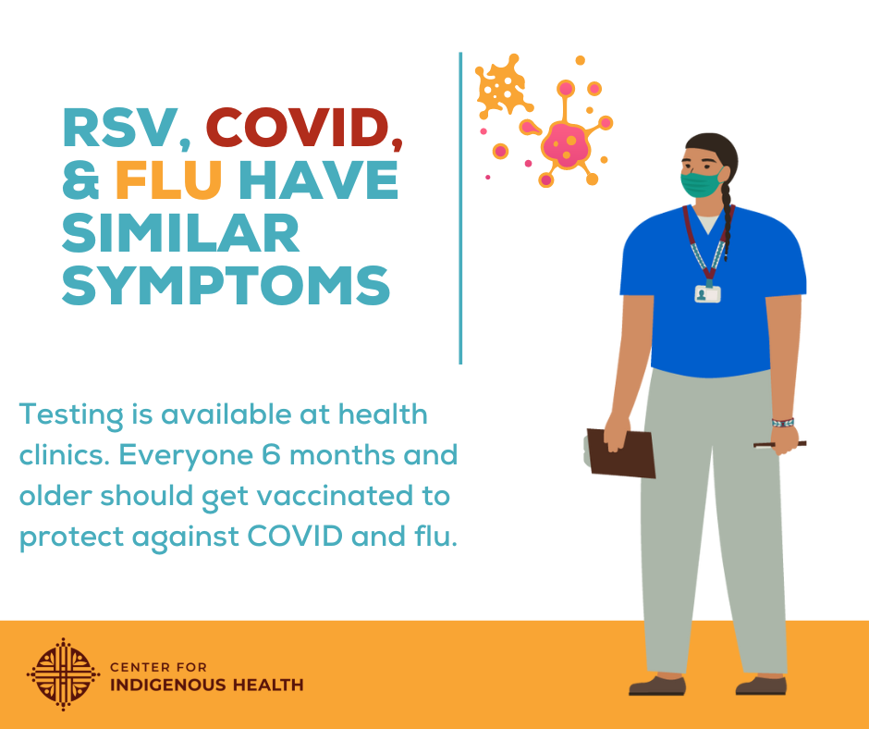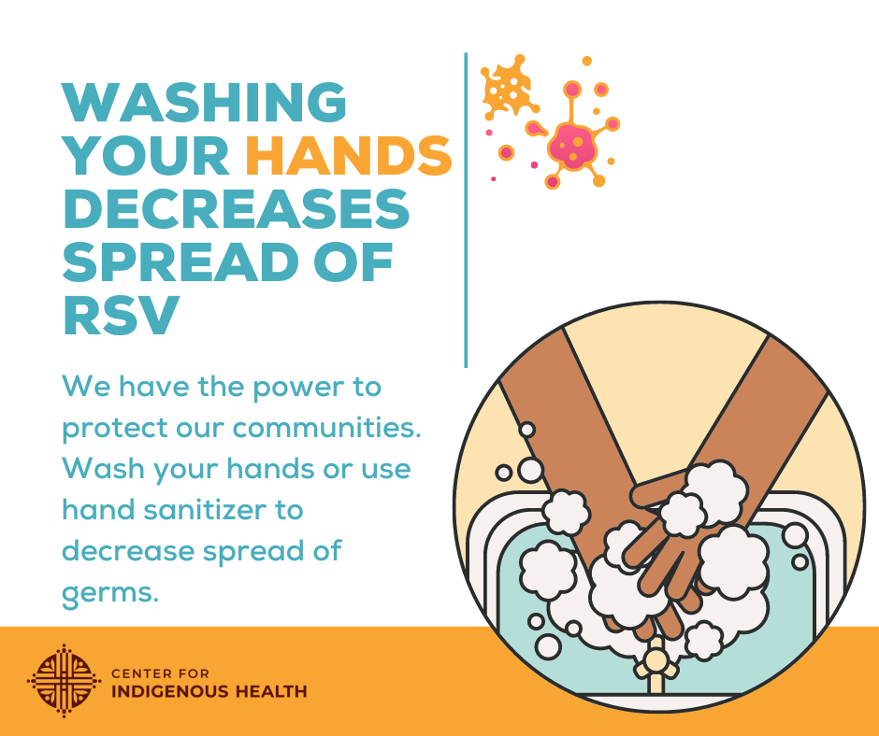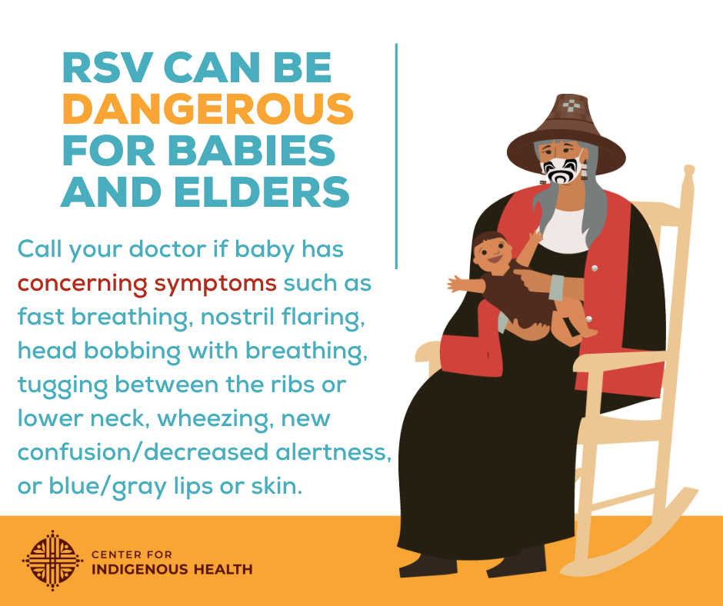
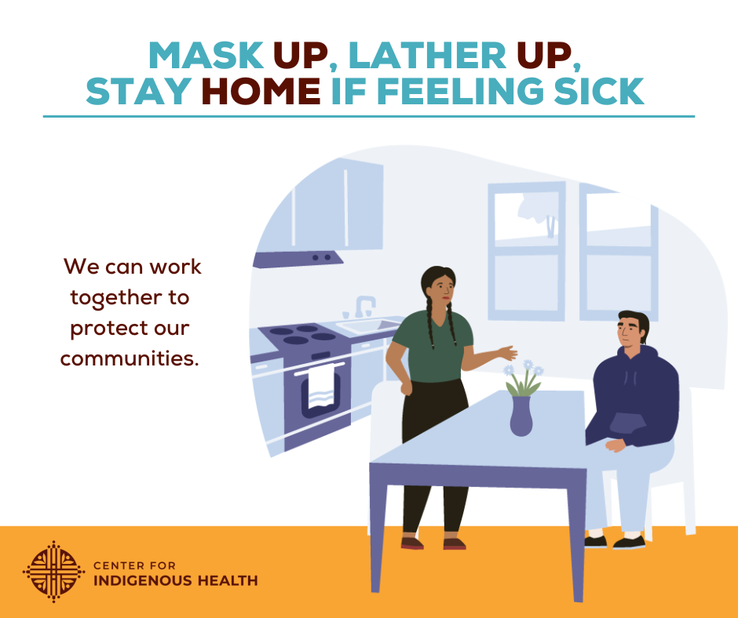

Social Media Message: Let’s protect our communities by washing our hands, getting vaccinated, wearing a mask, avoiding large gatherings, and staying home when feeling sick. Decreasing spread of germs keeps our communities healthy.

@Anthctoday @Aaipdocs @CDCgov @HealthyNativeYouth @HonoringNations @IndianCountryToday @_IllumiNatives @IndianHealthBoard_Minneapolis @IndianHealthService @Indianz @JohnsHopkinsSPH @NationalIndianHealthBoard @Npaihb @Nihb1 @NationalNativeNews @NativeAmericans @NativeAmericanLifelines @Nimhgov @NNNnativenews @ProjectMosaicllc @SeattleIndianHealthBoard @UrbanIndigenousCollective @UrbanIndianHealth @UrbanIndianHealthInstitute @WeAreHealers @whetstoneradio

#RSV #FightFlu #FluShot #COVIDBooster #NativesStopTheSpread #NativesDoingTheirPart #NativeAmericanHealth #IndigenousHealth #NativeAmerican #AmericanIndian #AlaskaNative #HealthyTribes #IndigenousPeople #NativeHealth #TribalHealth #COVIDWarrior #NativesVaxUp #NativesMaskUp #SkoVaxDen #VacciNative #VACCINation #NDNCommunityImmunity #HealthyNativeYouth #ProtectFutureGenerations
