Family Spirit Nurture Messages Toolkit
Johns Hopkins Center for Indigenous Health
Help us encourage caregivers to sign up for Family Spirit Nurture Text Messaging! Included in this toolkit are graphics formatted for Facebook, Twitter, and Instagram. Feel free to post and share this content anywhere you see fit, and please tag us on social media:
Facebook: @JHCIH @FamilySpirit
Twitter: @JHCIH
Instagram: @johnshopkinscih @jhcih_familyspirit

Download the high-quality image for posting from the included zip folder.

Postcard (For print distribution):
Front Page:
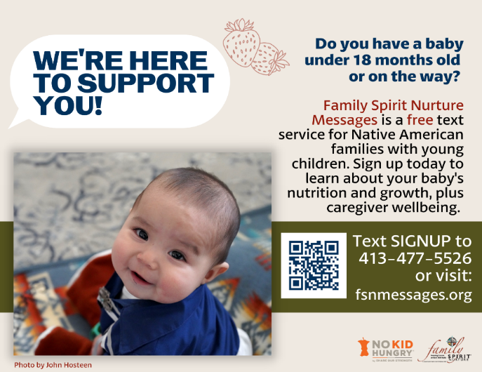

Back Page:
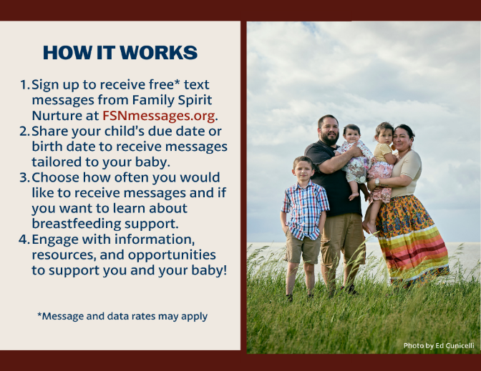
Poster:
For print distribution (dimensions: 18x24 inches or equivalent)
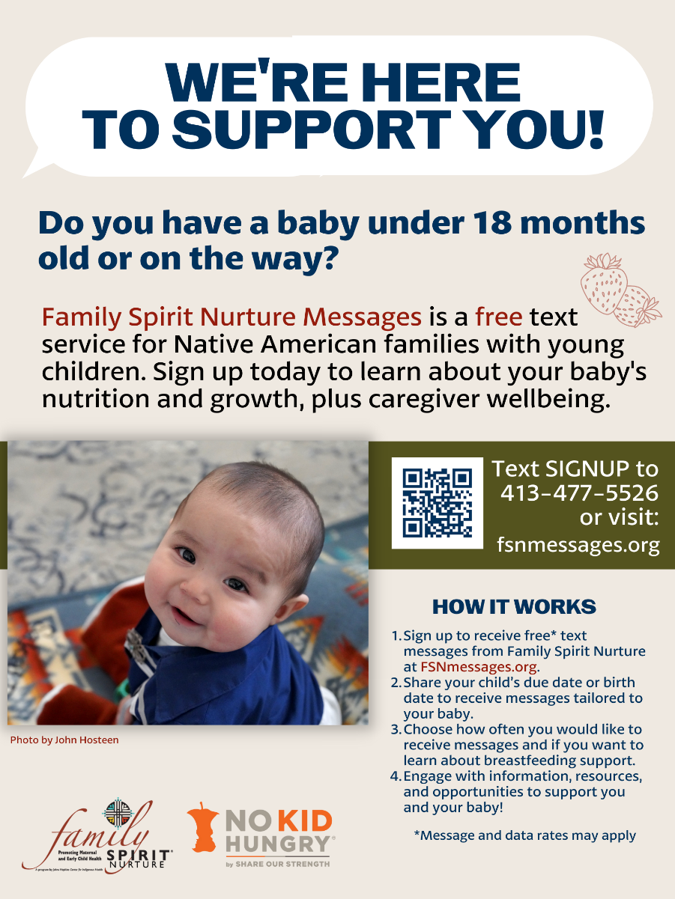

Social Media Graphics:
Suggested Social Media Message: Family Spirit Nurture is a culturally based home visiting program proven to support Native American children’s nutrition, health, and growth! Family Spirit Nurture key teaching points, resources and support are now available to all interested families through our free text messaging service, Family Spirit Nurture Messages (Message and data rates may apply).
#HealthyBabiesHealthyFutures #HomeVisiting #FamilySpirit
Graphics for Instagram (2 graphics):
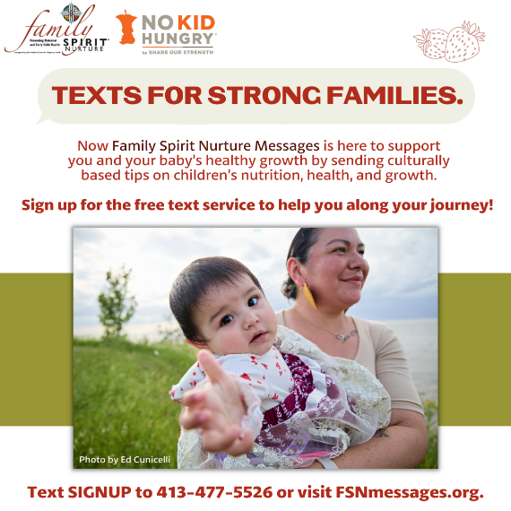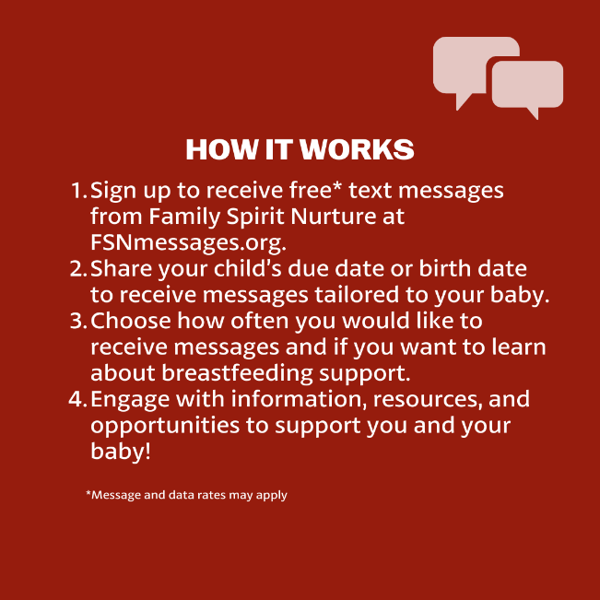
Graphics for Facebook/Twitter (2 graphics):
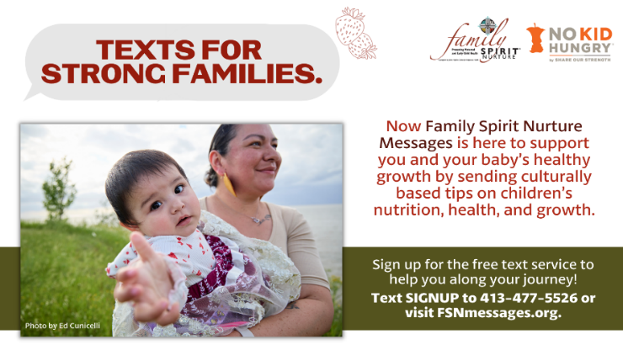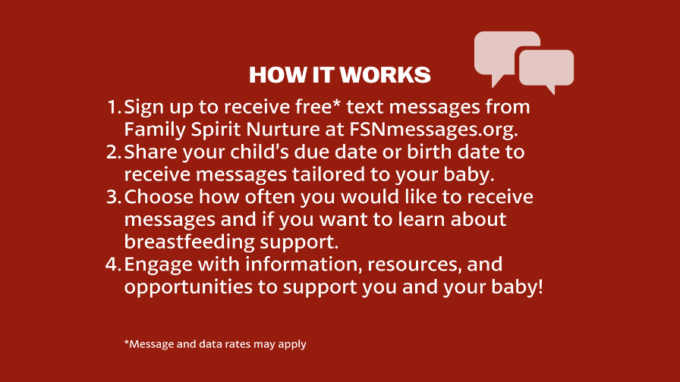
Suggested Social Media Message: Sign up today to receive texts from Family Spirit Nurture Messages featuring culturally based information on your baby’s nutrition, health, and growth!
#HealthyBabiesHealthyFutures #HomeVisiting #FamilySpirit #InfantFeeding
Graphics for Instagram (2 graphics):
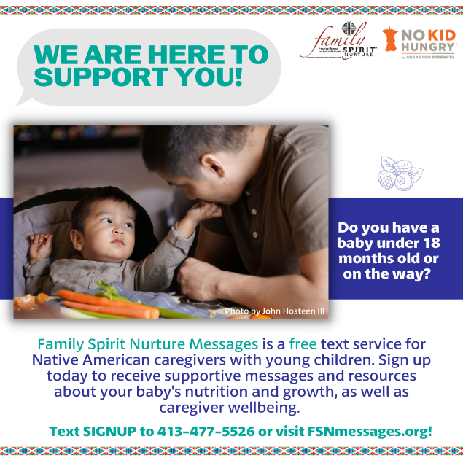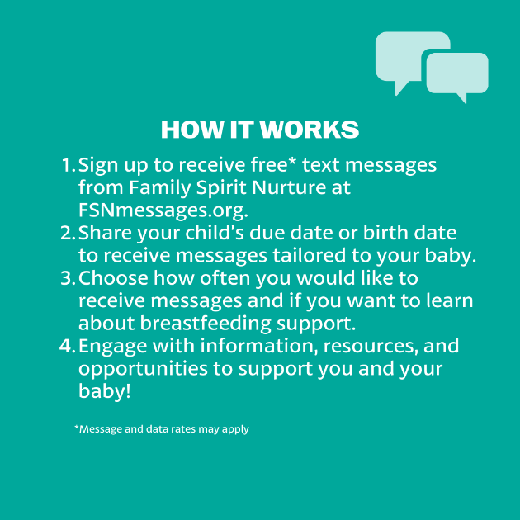
Graphics for Facebook/Twitter (2 graphics):
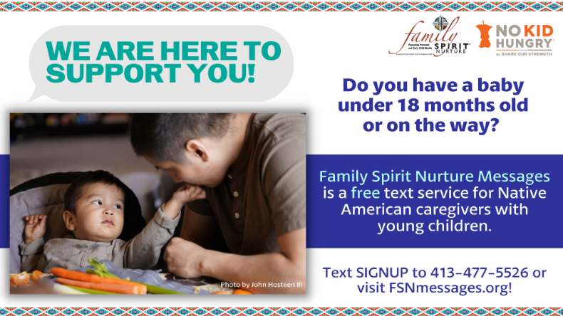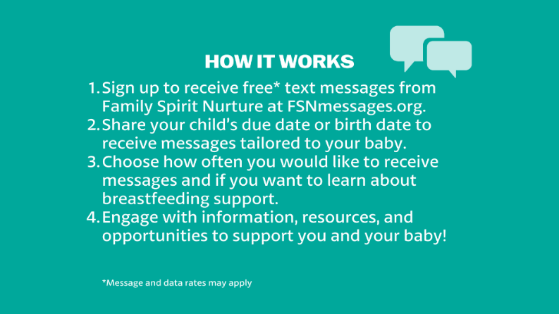
Suggested Social Media Message: Find local and national resources, including delicious Native recipes to feed your family, on our new FSNmessages.org website!
#HealthyBabiesHealthyFutures #HomeVisiting #FamilySpirit #IndigenousFoodways #IndigenousRecipes
Graphic for Instagram (1 graphic):
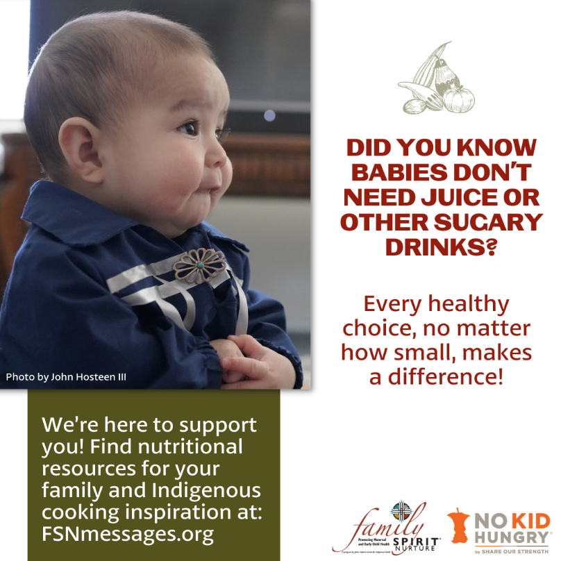

Graphic for Facebook/Twitter (1 graphic):
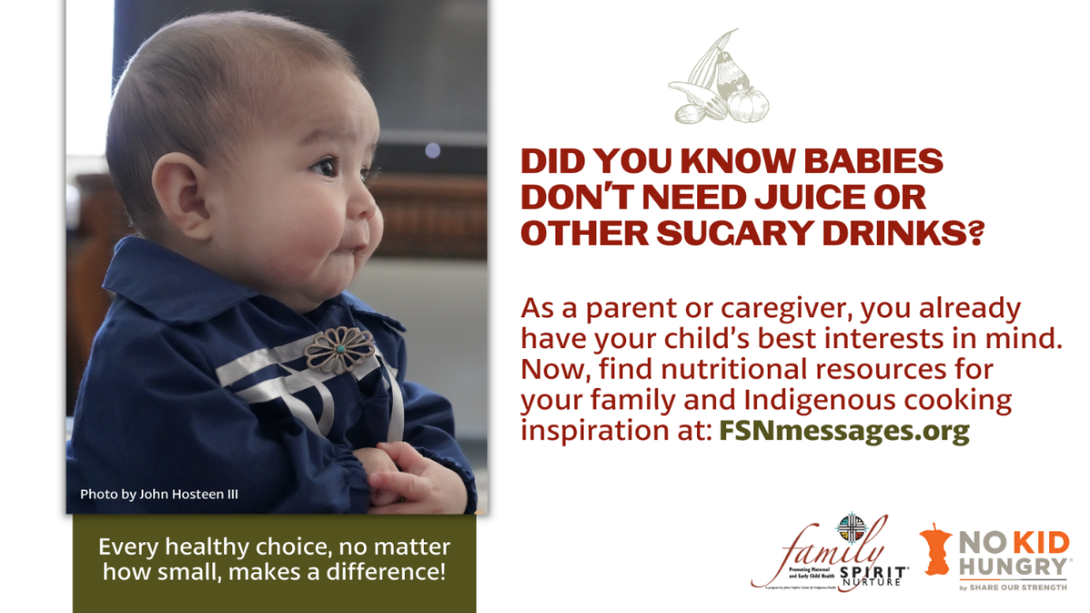
Suggested Social Media Message: Breastfeeding can be a powerful way to nourish and connect with your baby. To learn more, sign up for our free text service at FSNmessages.org.
#HealthyBabiesHealthyFutures #InfantFeeding #FamilySpirit #HomeVisiting
Graphic for Instagram (1 graphic):
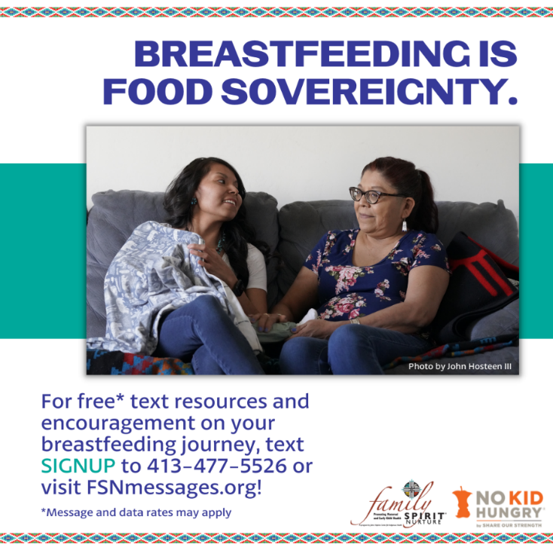

Graphics for Facebook/Twitter (1 graphic):
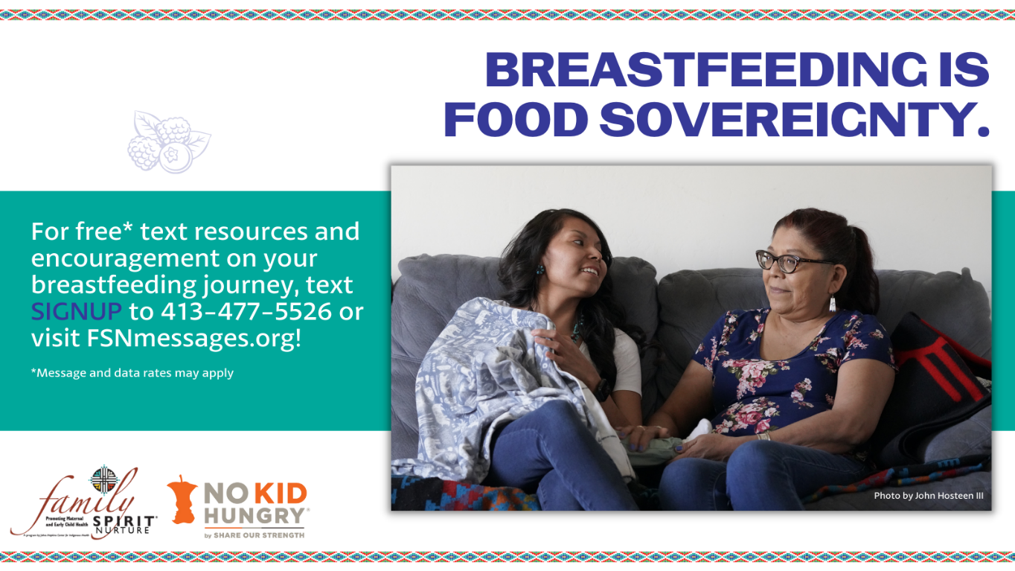

Suggested Social Media Message: Join the Family Spirit Nurture Text Messaging Program to give your family a healthy start to 2023! You will receive supportive messages and resources about your baby’s nutrition and growth, as well as caregiver wellbeing, straight to your phone. Parents, grandparents, caregivers, or anyone interested can learn more and sign up at FSNmessages.org.
#NewYearsResolution #HealthyBabiesHealthyFutures #InfantFeeding #FamilySpirit #HomeVisiting #NativeAmericanHealth #IndigenousHealth #NativeAmerican #AmericanIndian #AlaskaNative #HealthyTribes #IndigenousPeople #NativeHealth #TribalHealth #FamilySpiritNurture #FSN
Graphic for Instagram/Facebook/Twitter (1 graphic):
