Guide to Developing Your Community Orchard
COMMUNITY ORCHARDS VISIONING WORKSHEET
This worksheet is designed as a guide to help the CAB plan and develop your Community Orchard. If your community does not yet have a CAB, see the Create your Community Advisory Board section. Filling out the spaces below will help your CAB and community partners think through what the Community’s Orchard could look like.

Let’s get started by filling in your information below:

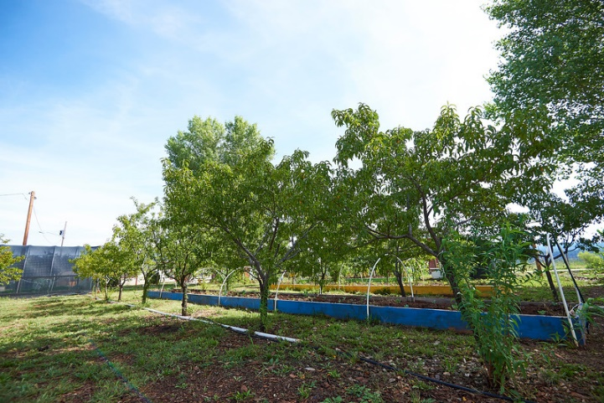
Your Organization

Your Community Name

Today’s Date

Names of Individuals/Organizations Preparing This Plan

Goals for the Community Orchard
Some questions to consider as the CAB thinks through planning the Community Orchard include: What will the Community Orchard provide for the community? Why would your team like to have a Community Orchard? Consider whether your team would like to use the Community Orchard for other Feast for the Future programs, such as Traditional Foodways Education Program (TFEP), or the Edible School Garden program (ESG). Some of your goals in developing a Community Orchard may conflict with each other, and you may want to list them in order of importance to determine which goals are most valuable.

Here are some examples:
Goal 1: Provide a space for the TFEP and ESG programs
Goal 2: Encourage community members to plant and harvest food from orchards
Goal 3: Connect youth to traditional food systems
Goal 4: Connect youth with elders, farmers, and other knowledge keepers

Write your goals for the Community Orchard below:

Goal 1:

Goal 2:
Goal 3:

Goal 4:

Goal 5:
Goal 6:

Goal 7:

Goal 8:

Goal 9:

Goal 10:

Community Orchard Description
Next, write a description of the Community Orchard that your team would like to see, and how that vision relates to the goals (above). An example is included below:

At our Community Orchard, the TFEP and ESG programs will meet and grow traditional foods and pass on knowledge to younger generations. Sections of the orchard will also be available for elders and farmers and their families to use, to promote growing and harvesting food in the community. We see the Community Orchard as a place where community members can learn to grow orchards that will provide fresh, local, food for the community.

Your Community Orchard
Write a description of the Community Orchard below:

IDENTIFY LEADERSHIP
Identify a lead organization and a Community Orchard Coordinator to take responsibility to maintain and nurture the Community Orchard. Make sure that this organization has the skills needed to develop a Community Orchard, such as:
- Familiarity with the agricultural systems relevant to orchards, including local customs and language
- Experience cultivating orchards or a willingness to learn
- Connections to external agencies willing to provide support for the orchard
- Passion and commitment to develop a Community Orchard
- Patience
- Willingness to partner and involve volunteers in all stages of the Community Orchard development
- Familiarity with tribal laws/approval processes
- A good relationship with tribal officials
- A working knowledge of available resources
- A large enough team to manage all necessary tasks.
Examples of lead organizations include tribal agricultural departments, natural resource departments, and health and wellness programs. The lead organization may already be committed to the development of a Community Orchard because it is in line with their organizational mission. Decide on what the lead organization will do in their role as a leader. This organization may already be a part of the CAB that guides the Feast for the Future programs.

Lead Organization Contact Information:

Organization Name:

Community Orchard Coordinator:

Address:
Telephone #:

Fax:

Website:

Describe the Role of the Lead Organization
In collaboration with the organization, the CAB, and key stakeholders, decide on the role of the lead organization. An example is included below:

The lead organization for the Community Orchard will oversee the development, implementation, and evaluation of the orchard, including setting a timeline and managing the overall progress. The lead organization will be responsible for scheduling events with collaborating organizations, maintaining a financial log to make sure all purchases are within budget, and maintaining the Community Orchard to make sure it stays in good condition (maintenance, weeding, etc.). They will also be expected to create and maintain working relationships with tribal officials and community members, and coordinate regular meetings with the Community Orchard leadership team, the CAB, community partners, and other key stakeholders.

Write a description of the responsibilities for the Community Orchard lead organization below:

If there isn’t anyone at the lead organization with expert knowledge, consider investing in training to help the organization develop needed skills.

Identify the Community Orchard Leadership Team
A team of individuals, each with unique contributions, will help make the Community Orchard a success. Make sure to work with tribal agencies to receive needed commitments and approvals for the Community Orchard, which may involve a signed and approved letter from tribal leadership. Consider involving tribal government, tribal members, youth and youth groups, schools and colleges, farmers, the state’s cooperative extension services/programs, FoodCorps, community volunteers, and staff of health programs. Determine who will coordinate different aspects of the Community Orchard to ensure that the program will continue to benefit the community. An example of potential roles and responsibilities is included below:

Name | Role | Responsibilities
Frank | Community Orchard Coordinator | Serves as the point person for the Community Orchard. Oversees maintenance of the orchard. Works with all the other individuals listed below. Reports back to the CAB.
Gabby | Evaluation Manager | Leads the development of the evaluation; keeps track of what is working well and what could be improved about the Community Orchard and shares that information with the team.
Lisa | Community Outreach Coordinator | Coordinates with local farmers, elders, and other community members that would like to use the Community Orchard. Coordinates when the space will be used by TFEP, ESG, Farmer’s Workshops, or other programs.
Your Community Orchard leadership team may have different roles and responsibilities than in the example. Fill in the following table with your leadership team, their roles, and their responsibilities:
Name | Role | Responsibilities
If some individuals can no longer fulfill their role on the Community Orchard team, transition another individual into that role to ensure sustainability.

IDENTIFY A LOCATION

Where will the Community Orchard be located?
In recognition of the rich agricultural history of many American Indian communities, your team may already know of fertile land to create the Community Orchard. In addition to how well the land can support the orchards, here are some other things to think about when choosing a location:
- Is the location easily accessible for many people in your community to get to? Remember that some folks who use the Community Orchard may be elders who need handicap access.

- Where are water sources that can be used for the orchard? Who controls the water supply and what permissions will need to be maintained to use water for the orchard? Some communities require that domestic water not be used for orchards without permission. Your team may need to contact the local water authority, obtain approval from tribal leadership, or gain permission from neighboring communities to use water.

- Where are there available facilities like bathrooms and running water that people may need to use while they’re working in the Community Orchard?
- Is approval for the space needed? If so, who is responsible for giving permission to use the space?

Thinking about potential locations, write down where your team would like the Community Orchard to be, as well as why you’d like to use the space and what your team would need to do to gain permission to use the space. An example is below:

We would like to use the abandoned orchard located just outside town. While it isn’t the most convenient location, there is access to bathrooms and water, and there are several old plants that we could prune and maintain. There is also plenty of room for new seedlings to be planted. We will need to talk to the owners of the land to see if they will donate it for our use, or write a Memorandum of Agreement that allows us to use the land for the Community Orchard.

Write down your team’s plan for the Community Orchard location below:

PREPARING FOR THE COMMUNITY ORCHARD

Preparing the Community Orchard
Orchards may take several seasons before they produce food. Your team may decide to prepare the Community Orchard by planting seedlings, putting a fence around the orchard, or doing other work before the trees are ready to produce. Your team may also want to map out the orchard, label what trees they want to see grown, identify where the water sources are, etc. This preparation work may be something that the TFEP and/or ESG programs could do, or that your team may choose to leave to individuals/organizations that use the Community Orchard. Write down what your team would like to contribute to the orchard, and what other individuals/organizations are expected to contribute.

At our Community Orchard, our team will plant 50 seedlings during the first season. We expect individuals/organizations to help with the planting, prune the trees, and to assist us in future seasons to plant more seedlings.

Your team’s ideas may be different than the example. Write a description of what your team would like to contribute to the Community Orchard versus what contributions other people are expected to make:

If there are areas where your team needs additional help or guidance, you may also choose to hire a consultant to help with specific aspects of the Community Orchard, such as providing instruction on how to prepare the soil, graft trees, pruning, etc.

Needed resource | Plan | Lead
50 seedlings | Contact neighboring orchards and individuals with trees about taking cuttings and/or receiving donated seedlings. Contact the Fruit Tree Foundation to ask about getting free fruit trees. | Community Outreach Coordinator
Fertilized soil to plant around the seedlings | Contact local farms about donating manure | Community Orchard Coordinator
Coordinating help to plant the seedlings | Contact community partners, TFEP, and ESG programs, as well as others interested in the Community Orchard to find dates and times where each group can help plant | Community Outreach Coordinator
Based on your team’s plan, what resources will your team need to contribute to the Community Orchard, and who will be responsible for leading each of those efforts? An example is included below:

Based on your team’s plan, what resources will you need, and what will your plans be to prepare the land for the Community Orchard? Fill in the table below:
Resources Needed | Plan | Lead

Who Might Use the Community Orchard?

Your Community Orchard may need maintenance throughout the year. Identify individuals and organizations who are interested in learning how to maintain an orchard. Consider individuals who have previous experience with orchards, organizations that specialize in nutrition/health/traditional knowledge sharing, and individuals that live or work close to the Community Orchard.

Identify Interested Individuals

Potential Interested Community Members/Organizations | Contact Information | Notes from Follow-Up

Evaluation plan
Decide how your team will figure out what is going well, and what needs to be improved with the Community Orchard. What are your goals for the Community Orchard and how will they be measured? This plan should be completed before the Community Orchard is started.

Below are some examples of Community Orchard goals and an evaluation plan to help determine how each goal will be measured:

Community Orchard Goal | How The Goal Will Be Measured and Evaluated
Provide a space for the TFEP and ESG programs | The Evaluation Coordinator will record how often the TFEP and ESG programs use the Community Orchard, tracking this information on an Excel spreadsheet. The Evaluation Coordinator will also talk with the coordinators of the TFEP and ESG programs at least three times per year about what’s working well about the space and what could be improved. The Evaluation Coordinator will share this information at the spring, summer, and fall CAB meetings.
Encourage community members to plant and harvest food from orchards | The Evaluation Coordinator will track who has used the orchard space and will share information with the CAB four times a year on the number of community members who’ve worked in the Community Orchard. The Evaluation Coordinator will talk with these community members at least once per year about what’s working well and what could be improved about the Community Orchard, and will share this information with the CAB during the fall meeting.

Your community may have different goals for your Community Orchard, and different ways to evaluate those goals. Fill out the table below with your goals for the Community Orchard and how your team will evaluate each of those goals.
Community Orchard Goal | How The Goal Will Be Measured and Evaluated

Approval for evaluation activities
Many communities and tribes require that evaluation plans are reviewed and approved by an Institutional Review Board or other entity. Find out what, if any, approvals are needed for your team’s evaluation plan, potentially by contacting a local researcher who works in your community.

STARTING THE COMMUNITY ORCHARD
Let’s double-check that everything has been planned for the Community Orchard. Check the box next to each item to make sure it’s completed:

Have a lead organization and individual to guide the Community Orchard
Have space for the Community Orchard
Team has done their contribution to get the Community Orchard ready
Have identified community members interested in working in the Community Orchard
Developed the Community Orchard evaluation plan
Coordinated with TFEP and ESG programs about using the Community Orchard

Finalizing Plans
Does your team have everything ready for the Community Orchard, or are there still be some things that are yet to be done? Brainstorm if there are any remaining things that need to be taken care of before launching the Community Orchard. Consider:
- Equipment needs
- Transportation needs for individuals that will use the Community Orchard
- Ways to keep pests out of the Community Orchard

Use the following table to write down any remaining things your team needs to do before launching the Community Orchard, who will take the lead on each task, and when each task will be completed:
Task | Deadline | Lead

PLANNING FOR CONTINUED SUCCESS AND SUSTAINABILITY
To sustain the Community Orchard, the Community Advisory Board (CAB) and a strong Community Orchard team must help ensure that the orchard continues to benefit the community. Consult with the CAB at ongoing meetings to plan for success by setting short-term and long-term goals. Items to consider for long-term sustainability:

Communication
To ensure that the Community Orchard continues to thrive, maintain communication with the community about the program, including reporting to tribal leaders, parents/guardians and the CAB about program updates and successes. Consider also documenting and sharing program updates through photos, newsletters, social media, etc.

Funding
As the Community Orchard continues, it may grow or change to better serve the community. Additional funding may be needed for things such as hiring additional staff, providing honoraria to farmers who provide workshops, purchasing supplies, or renting equipment. To ensure that these needs are met, designate an individual on the leadership team to identify and pursue funding opportunities. In looking for funding, consider organizations that offer grants, such as the First Nations Development Institute.

Moving Forward
As the Community Orchard continues, consider working to:
- Set up regular Community Advisory Board/community partner meetings to provide a forum for discussion and planning
- Plan for expansion if the need arises

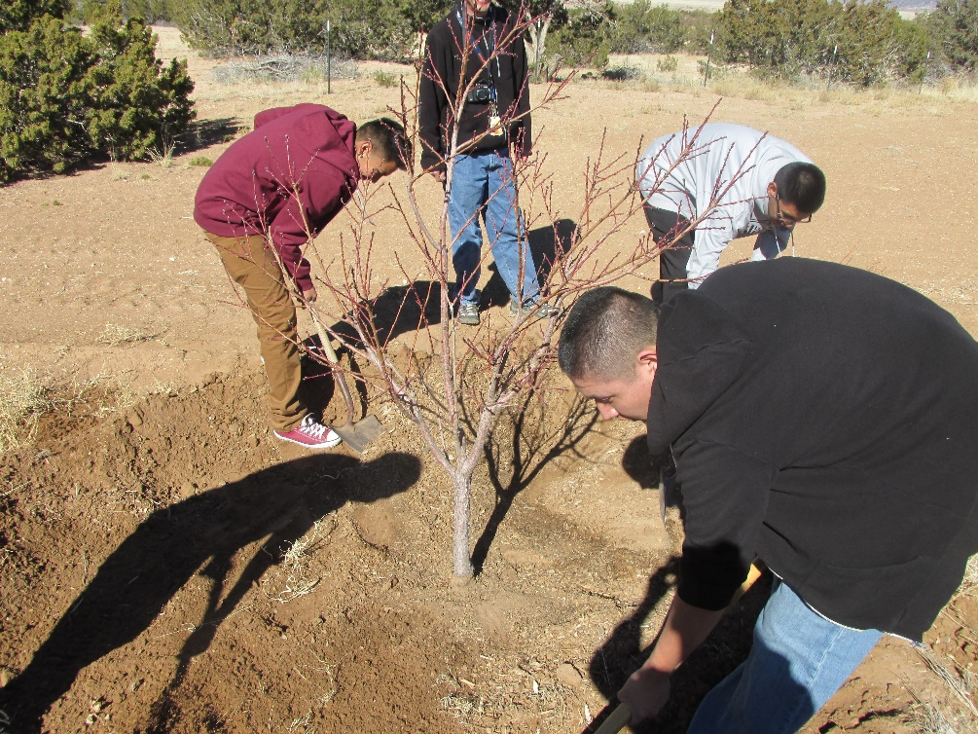

Congratulations on getting the Community Orchard up and running!

