Farmers Workshops
Farmers Workshops are a great resource for new and experienced farmers to learn how to establish and successfully maintain a farm. Community members can discover traditional ways to plant and harvest crops, control pests, and make a living as a farmer. Farmers Workshops allow experienced farmers to share their knowledge with younger generations, and creates opportunity to revitalize interest in traditional agricultural practices.

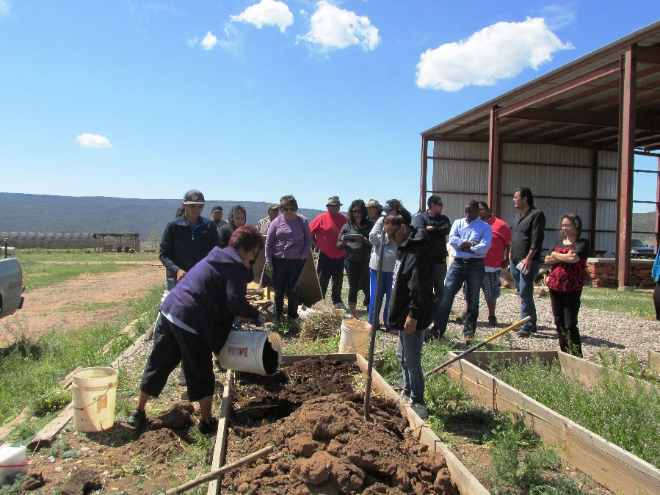

Click on the link below for a how-to guide to help your Community Advisory Board and partners develop Farmers Workshops. If your community does not yet have a CAB, see the Create your Community Advisory Board section.
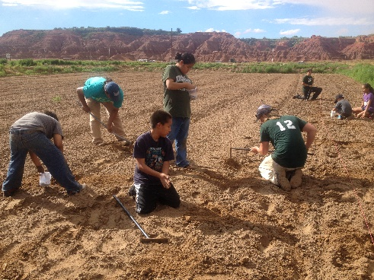

Farmers Workshops

