Introduction to Family Gardens
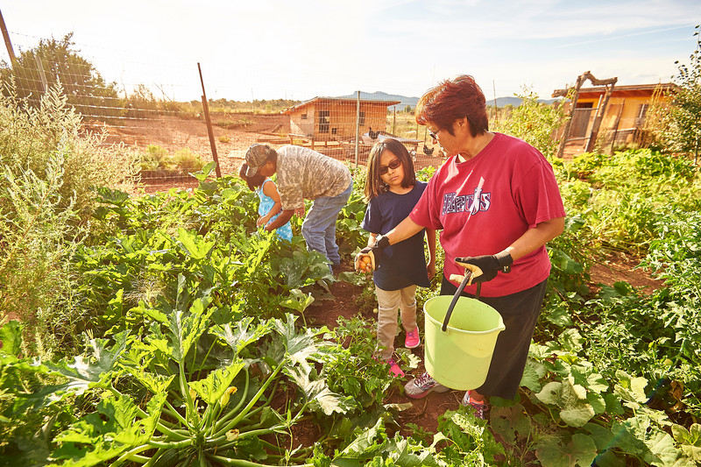
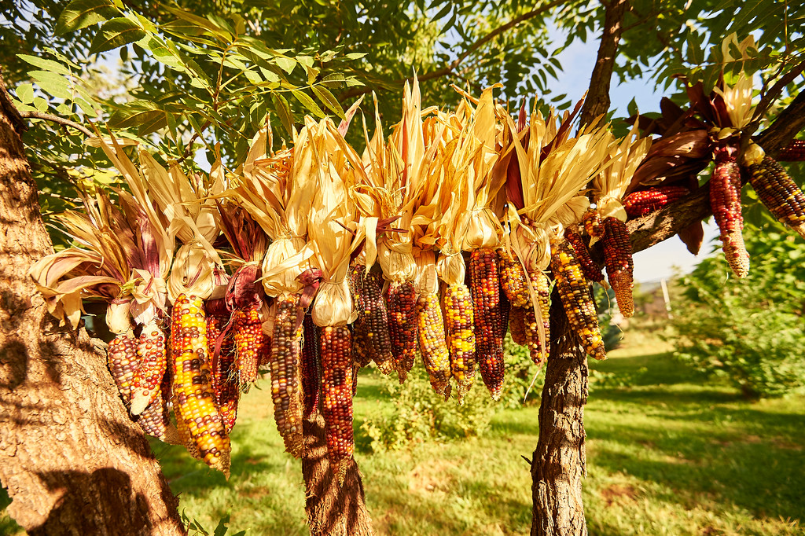
American Indian tribes and communities are disproportionately affected by high rates of diet related diseases including diabetes and obesity. These rates are a result of several factors including determinants such as poverty, food policies, and access to healthy foods including fresh fruits and vegetables. There has also been a nutritional shift from traditional to more processed foods in the diets of many American Indian communities.

Historically, many Native communities grew their own foods including corn and squash. More recently, numerous public health agencies and tribal health departments are realizing the need for more culturally based programs that strengthen the connection between communities and their local food systems through activities such as community gardens and farming.

Click on the links below to:
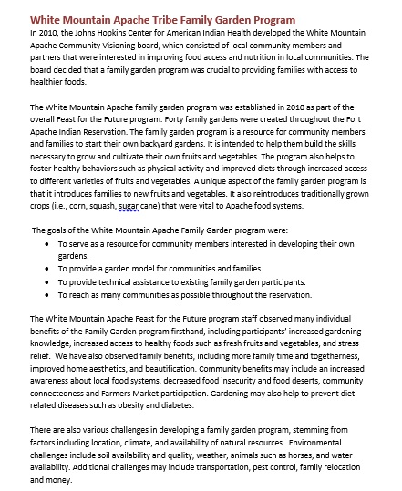
Read how the White Mountain Apache Tribe developed Family Gardens in their communities.

Complete interactive worksheets to vision and create a Family Garden program in your community.

