**Traditional Foodways Education Program Guide**

**OVERVIEW**

Agriculture is central to many American Indian communities. The Traditional Foodways Education Program (TFEP) connects elders and farmers with youth to pass on traditional knowledge about growing and gathering healthy foods. TFEP was created to connect young people to their cultures and traditional food practices, and to promote food security and healthy eating/drinking behaviors among American Indian youth.

The TFEP program usually takes place in a community or school garden/farm and a community center or other building that has access to a kitchen, fire, or other way to prepare food. More information about logistics is included in the **PLANNING FOR TFEP** section of this TFEP Program Guide.

This TFEP Program Guide will help the Community Advisory Board (CAB) and partners implement your community’s TFEP.

The CAB provides vision and leadership for the development of the Feast for the Future Program and is a key element to ensure ownership and sustainability of the Feast for the Future Program. To develop your community’s CAB, see the Create your Community Advisory Board (CAB).

**Your Organization**

**Your Community Name**

**Today’s Date**

**Names of Individuals/Organizations Preparing This Plan**

**VISIONING WORKSHEET**

This worksheet is designed as a guide to visioning TFEP for your community. Fill in the spaces below each question to help formalize ideas of what your community’s TFEP could look like.

**TFEP Goals**

Some questions to consider as the CAB thinks through the community’s TFEP include: What do you hope TFEP will provide for the community? Why would you like to have a TFEP in your community?

Some of your goals may conflict with each other, and you may want to list them in order of importance to determine which goals are most valuable. Some examples of goals for a TFEP are included below:

*Our community would like to start a TFEP in our community in order to:*

*Goal 1: Educate youth on the importance of a healthy diet*

*Goal 2: Connect youth to traditional food systems*

*Goal 3: Promote local farming/gardening*

*Goal 3: Connect youth with elders, farmers, and other knowledge keepers*

Goal 1:

Goal 2:

Goal 3:

Goal 4:

Goal 5:

Goal 6:

Goal 7:

Goal 8:

Goal 9:

Goal 10:

**TFEP Description**

After the CAB has written down some goals for the TFEP, write a description of the TFEP that your team would like to see in your community, and how it relates to the program goals. An example of a TFEP description is included below:

*At our TFEP, elders and farmers will teach weekly lessons to youth on planting, growing, harvesting, preserving, and preparing traditional foods. We see TFEP as a weekly gathering where youth and elders are the main participants, but family and other community members are also invited to participate and learn about traditional food systems.*

**IDENTIFY LEADERSHIP**

Designate a lead organization and a designated TFEP Coordinator to take responsibility to coordinate and implement TFEP. A lead organization may already be committed to TFEP because it is in line with their organizational mission. Decide on what the lead organization will do in their role as a leader. This organization may already be a part of the Community Advisory Board (CAB) that guides the Feast for the Future programs. To develop your community’s CAB, see the Create your Community Advisory Board (CAB). Suggestions of organizations to approach to be the lead agency include tribal agricultural departments, schools, natural resource departments, and health and wellness programs.

**Lead Organization Contact Information:**

Organization Name:

TFEP Program Coordinator:

Address:

Telephone #:

Fax:

Website:

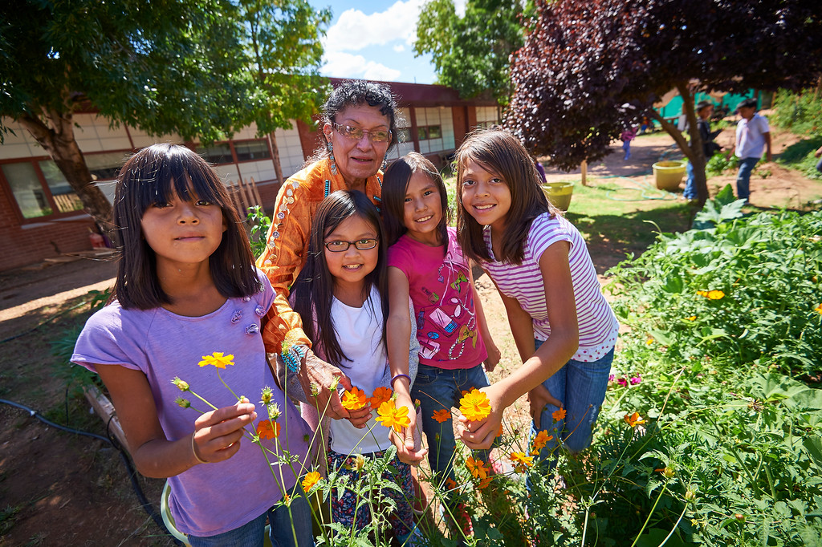

**Identify the TFEP Leadership Team**

A team of individuals, each with unique contributions, will help make the TFEP a success. Determine who will coordinate which aspects of TFEP to ensure that the program will continue to benefit the community. An example of potential roles and responsibilities is included below:

|  |  |  |
| --- | --- | --- |
| ***Name*** | ***Role*** | ***Responsibilities*** |
| *Erin* | *Program Coordinator* | *Serves as the point person in the community for the TFEP program. Liaises with all other individuals listed below. Coordinates instructors to ensure appropriate staffing for each session. Coordinates youth recruitment and parent engagement. Coordinates the space, equipment, snacks and other material needs for each session. Reports back to Community Advisory Board.* |
| *Matt* | *Instructor/ Elder Coordinator* | *Leads the development of the TFEP curriculum. Works with the elders/instructors to see who will be instructing at which time, and which lessons each feels comfortable with. More than one instructor/elder may teach, but at least one is needed.* |
| *Gilbert* | *Evaluation Manager* | *Leads the development of the evaluation; keeps track of what is working well and what could be improved about TFEP (see* Planning for TFEP) *and shares that information with the team.* |
| *Scott* | *Community Outreach Coordinator* | *Coordinates with local youth groups and afterschool programs to recruit youth to participate in TFEP.* |

Your TFEP leadership team may have different roles and responsibilities. Fill in the following table with your leadership team, their roles, and their responsibilities:

|  |  |  |
| --- | --- | --- |
| **Name** | **Role** | **Responsibilities** |
|  |  |  |
|  |  |  |
|  |  |  |
|  |  |  |
|  |  |  |
|  |  |  |
|  |  |  |
|  |  |  |
|  |  |  |
|  |  |  |

If some individuals can no longer fulfill their role on the TFEP team, transition another individual into that role to ensure sustainability.

**IDENTIFY FARMERS AND ELDERS IN YOUR COMMUNITY**

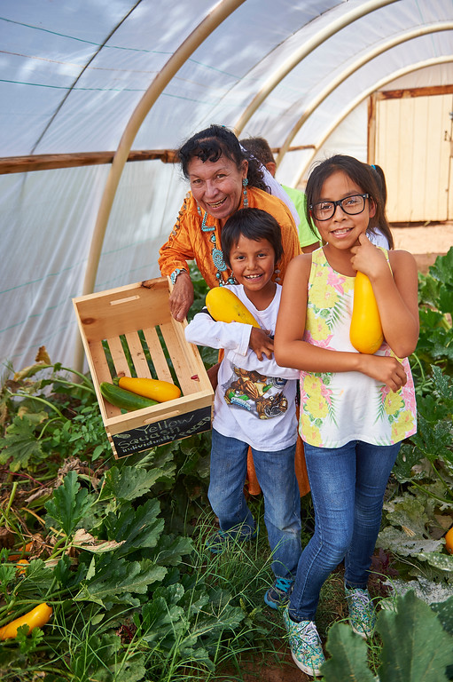**Who instructs TFEP?**

In recognition of the rich cultural knowledge that Elders possess, the TFEP promotes intergenerational teaching by inviting Elders, farmers, and other traditional knowledge keepers to teach the lessons. Many lessons may be instructed in your community’s language.

**Identifying potential TFEP instructors and partners**

Work with the other members of the Community Advisory Board (CAB) to identify elders, farmers, or other traditional knowledge keepers who may develop and instruct TFEP lessons. Also identify community partners who may be able to help with program implementation. As your team is thinking about potential instructors and other program partners, consider: tribal council members, health and nutrition departments, schools, Indian Health Service organizations, local diabetes/obesity prevention organizations, economic development boards, churches/religious organizations, farming/gardening clubs and organizations, senior citizen organizations, state/local governments, cooperative extension services, or other community organizations.

An example of a way to keep track of the potential TFEP instructors/partners your team identifies is below:

|  |  |  |  |  |
| --- | --- | --- | --- | --- |
| ***Potential TFEP Instructor / Partner*** | ***Role / Organization*** | ***Telephone*** | ***Email*** | ***Notes*** |
| *Person 1* | *Director / Tribal Clinic* | *XXX-XXXX* | [*XX@XXX.com*](mailto:XX@XXX.com) | *Could offer lessons on nutrition and the role of traditional foods in a healthy diet* |
| *Person 2* | *Traditional Healer/ Tribal Clinic* | *XXX-XXXX* | [*XX@XXX.com*](mailto:XX@XXX.com) | *Could offer lessons on harvesting and preparing traditional medicines* |
| *Person 3* | *Farmer / Community Farm* | *XXX-XXXX* | [*XX@XXX.com*](mailto:XX@XXX.com) | *May have a field where class could be held, and could guide youth through planting, watering, maintaining a field, and harvesting foods* |
| *Person 4* | *Teacher’s Aide / School* | *XXX-XXXX* | [*XX@XXX.com*](mailto:XX@XXX.com) | *Facilitates a youth group after school that focuses on language and culture that could be interested in TFEP.* |

Here’s a blank form for your team to use to keep track of potential TFEP instructors/partners:

|  |  |  |  |  |
| --- | --- | --- | --- | --- |
| **Potential TFEP Instructor / Partner** | **Role / Organization** | **Telephone** | **Email** | **Notes** |
|  |  |  |  |  |
|  |  |  |  |  |
|  |  |  |  |  |
|  |  |  |  |  |
|  |  |  |  |  |

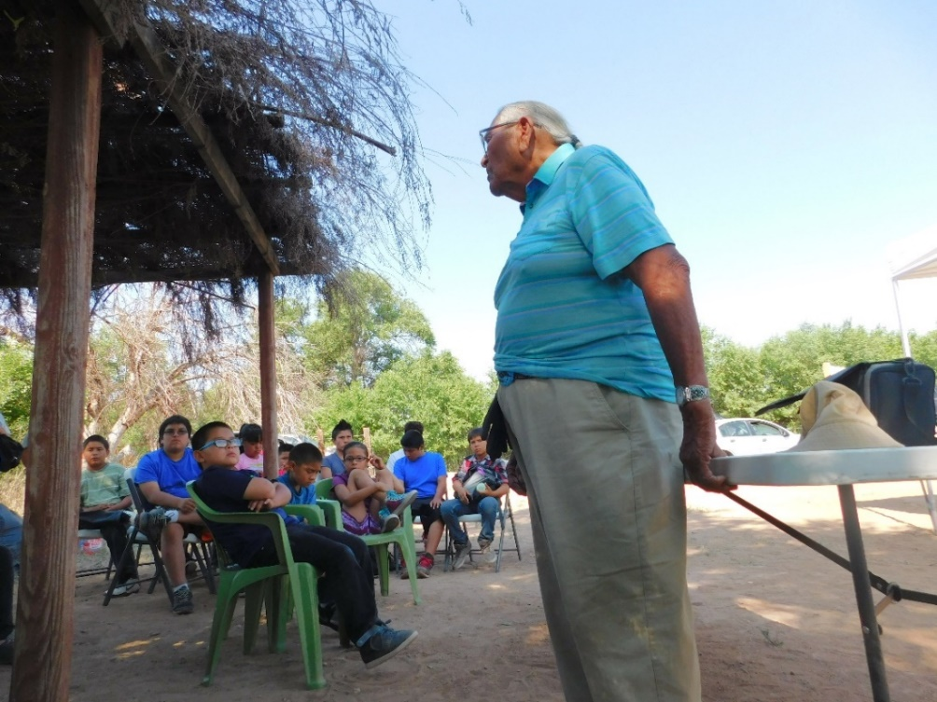**CREATE THE TFEP CURRICULUM**

TFEP lessons focus on growing, harvesting, and preserving healthy foods. Lessons may also discuss livestock, hunting, traditional stories and games, ceremonial uses of foods and drinks, the role of foods in the culture, local kinship, connection to land, traditional values, Native languages, or other pillars of your community’s identity.

**Putting together a team**

The TFEP lessons are developed in partnership with the Community Advisory Board (CAB), elders, farmers, and other traditional knowledge keepers in the community. Each TFEP curricula usually has at least 8 lessons in each season (spring, summer, and fall) for a total of at least 24 community-based classes. Lessons are designed to share traditional knowledge with younger generations. After contacting the list of people your team identified above (the “Potential TFEP Instructors / Partners) – write down below which of those people will help develop the TFEP lessons for your community:

|  |  |  |  |  |
| --- | --- | --- | --- | --- |
| **Potential TFEP Instructor / Partner** | **Willing to Help Develop TFEP Lessons?** | **Willing to Instruct TFEP Lessons?** | **Phone / Email** | **Notes** |
|  |  |  |  |  |
|  |  |  |  |  |
|  |  |  |  |  |
|  |  |  |  |  |
|  |  |  |  |  |

Download the TFEP Sample Curricula to see what other communities’ lesson plans look like, then visit the TFEP Curriculum Template to develop your community’s TFEP lessons.



Santo Domingo Pueblo, NM White Mountain Apache Tuba City, AZ

**Keep the curriculum flexible**

The TFEP curriculum is developed with enough flexibility so that each Elder or other Instructor is welcome to teach the lesson his or her own way, while still emphasizing the primary learning objectives. The curriculum is organized seasonally according to when ceremonies and food-related activities happen throughout the year. For example, the Fall lessons could focus on harvesting, hunting, storing, and preparing foods. The Spring lessons could focus on preparing the field/garden for planting, watering, gathering greens, and maintaining the field/garden. The Summer lessons could focus on garden/field management, wool dying, corn pollen harvesting, fishing, and preparing for harvest.

**Revise the lesson plans as needed**

Once the TFEP is being taught, your team may discover that new lessons could be added, or written lessons might need to be changed so that they’re a better fit for the timing, instructors, and students.

**PLANNING FOR TFEP**

**Recruiting youth**

Who will TFEP instruct and how will your team reach out to young people to include them in TFEP? Offering TFEP to an already existing group of youth can be a good way to get started. Think about offering the program to a tribal youth group, or an existing afterschool group of youth. For example:

*TFEP will work with youth in grades 3-5 who participate in the garden club at the elementary school.*

Describe what youth your community’s TFEP will work with, including their ages/grades and what group (if any) they already belong to:

How will your team recruit youth to participate in TFEP? Think about how you will reach out to youth and parents/guardians to let them know about TFEP. For example:

*We will coordinate with the garden club instructor to give a presentation to youth in the club who are in grades 3-5 to get them interested in TFEP. At the presentation we will send parent/guardian flyers home with youth in grades 3-5 who are in the garden club. The flyers will describe TFEP and invite parents/guardians to a meeting to sign their youth up for the program. We will follow up with parents/guardians by phone to answer questions and make sure they got the message about the meeting. After the meeting, we will make home visits to meet with parents/guardians who didn’t attend the meeting but may be interested in TFEP.*

Describe how your team will recruit youth for TFEP:

**Deciding when and where TFEP will be taught**

Your team will also need to decide when and where TFEP will be instructed. TFEP is usually taught at a community garden/farm. Communities have also used a community building that has a kitchen, electrical outlets for crockpots, or access to a fire pit. Where is a garden/farm space and a food preparation space that your community’s TFEP can use?

Your plan might depend on where and when space is available to instruct, and when existing youth groups already meet. As an example, TFEP could be taught once a week on Saturdays from 9am-12pm at a community farm. However, a different schedule might work better for your community:

TFEP will be taught at:

TFEP will be taught on the following days:

TFEP will be taught at the following times:

**Evaluation plan**

Decide how your team will figure out what is going well, and what needs to be improved with your community’s TFEP. What are your goals for TFEP and how will they be measured? Look back at the Visioning Worksheet to see if they can be included. This plan should be completed at least a couple weeks before the first TFEP meeting.

Below are some examples of TFEP goals and an evaluation plan to help determine how those goals will be measured:

|  |  |
| --- | --- |
| ***TFEP Goal*** | ***How The Goal Will Be Measured and Evaluated*** |
| *Involve young people* | *The Program Coordinator will take attendance at each TFEP and record the number in an Excel spreadsheet next to the date of each meeting. At each CAB meeting, the Coordinator will let the team know how many young people have come to each meeting. We’d like to have an average of 10 young people at each session and see a general increase in the number of youth involved during the year.* |
| *Elders satisifed with TFEP and guiding program change* | *The Program Coordinator will have a conversation with each of the Elders/instructors at least once each during the fall, spring, and summer to ask about how they feel the program is going and hear their guidance on how we can make TFEP better. The Coordinator will share the findings at the January (fall interviews), June (spring), and September (summer) CAB meetings.* |
| *Promote local farming/gardening* | *When the Program Coordinator takes attendance, they’ll ask each young person/adult/instructor if they work on a local farm/garden. The answers will be recorded in an Excel spreadsheet next to the date they answered. At the end of the year, the Coordinator will ask each of the participants if they work on a local farm/garden and record that information. At the end of the year, the Coordinator will share how many people started working on a farm/garden during TFEP.* |

Your community may have different goals for your TFEP, and different ways to evaluate those goals. Fill out the table below with your goals for TFEP, and how your team will evaluate those goals.

|  |  |
| --- | --- |
| **TFEP Goal** | **How The Goal Will Be Measured and Evaluated** |
|  |  |
|  |  |
|  |  |
|  |  |
|  |  |
|  |  |
|  |  |
|  |  |
|  |  |
|  |  |

**Approval for evaluation activities**

Many communities and tribes require that evaluation plans are reviewed and approved by an Institutional Review Board or other entity. Find out what, if any, approvals are needed for your team’s evaluation plan, potentially by contacting a local researcher who works in your community.

**IMPLEMENTING TFEP**

Let’s double-check that everything has been planned for TFEP. Check the box next to each item to make sure it’s completed:

🞏 Develop the TFEP curriculum

🞏 Develop the TFEP evaluation

🞏 Have identified and recruited students to participate in TFEP

🞏 Have a location where TFEP will be taught

🞏 Have instructors/Elders to teach TFEP

🞏 Have a lead organization to coordinate TFEP

🞏 Know what time/days TFEP will be taught

**Finalizing Plans**

Although your team may have everything ready for the first TFEP, there may still be some things that are yet to be done. Brainstorm if there are any remaining things that need to be taken care of before the first TFEP meeting. Consider:

* Equipment needs
* Transportation needs for elders/instructors or youth
* Snacks for the meeting

Use the following table to write down any remaining things your team needs to do before the first TFEP, who will take the lead on each task, and when each task will be completed:

| **Task** | **Deadline** | **Lead** |
| --- | --- | --- |
|  |  |  |
|  |  |  |
|  |  |  |
|  |  |  |
|  |  |  |
|  |  |  |
|  |  |  |
|  |  |  |
|  |  |  |
|  |  |  |

**PLANNING FOR CONTINUED SUCCESS AND SUSTAINABILITY**

To continue TFEP, the Community Advisory Board (CAB) and a strong team of committed instructors/elders and partners will help the TFEP improve, meet goals, and benefit the community. Consult with your community partners at the ongoing meetings to plan for success by setting short-term and long-term goals.

**Communication**

To ensure that TFEP continues to thrive in your community, maintain communication with the community about the program, including reporting to tribal leaders, parents/guardians and the CAB about program updates and successes. Consider also documenting and sharing program updates through photos, newsletters, social media, etc.

**Funding**

As TFEP expands, additional funding needs may arise, such as hiring the TFEP coordinator part-time, providing honoraria to elders, purchasing supplies or renting space. To ensure that these needs are met, designate an individual on the leadership team to identify and pursue funding opportunities.

**Moving Forward**

As TFEP grows, consider working to:

* Setting up regular Community Advisory Board/community partner meetings to provide a forum for discussion and planning
* Plan for expansion if the need arises

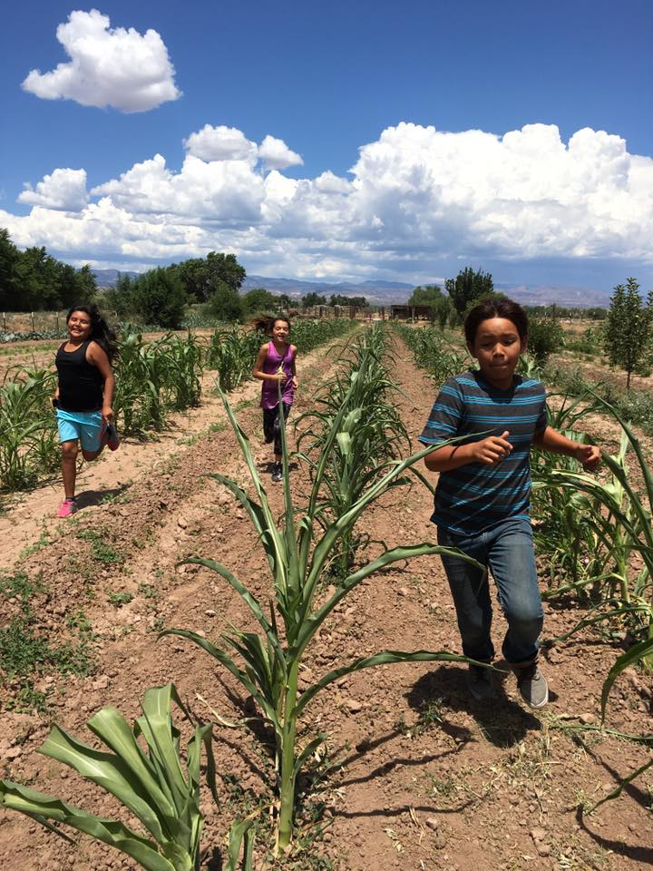

**Congratulations on getting your community’s TFEP up and running!**