Traditional Foodways Education Program
The Traditional Foodways Education Program (TFEP) is an innovative and holistic initiative that connects elders, farmers and youth through hands-on learning. Elders and farmers are the primary instructors of traditional agriculture and food systems lessons, often sharing knowledge with younger generations in their Native languages. TFEP reinforces and extends lessons from the Edible School Garden Program into the community space.

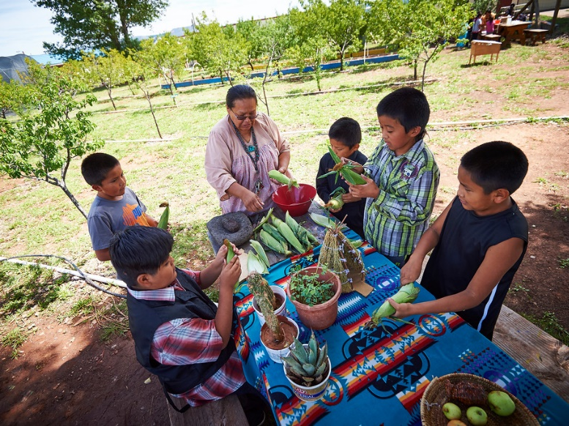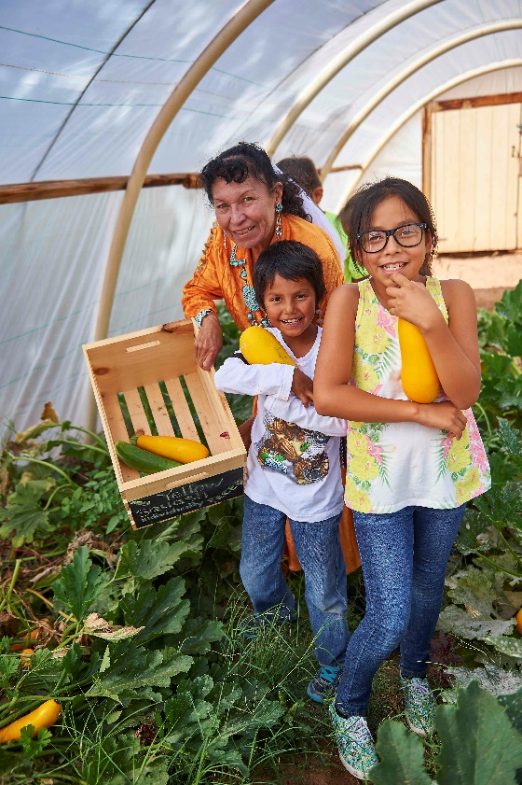
The Traditional Foodways Education Program Guide can be used to help you and your community plan, create, and implement your own Traditional Foodways Education Program.

This How-to video shows how to navigate through the website and use the tools to develop a Traditional Foodways Education Program that fits your community.
How-to video

Develop your own Traditional Foodways Education Program curriculum! Use the resources below to access samples of TFEP curriculum and a template to help your community create their own TFEP curriculum.
Sample Traditional Foodways Education Program Curricula
The TFEP curricula are specific to each community and are based upon local cultural teachings about nutrition, agriculture and living in balance. The following sample curricula were developed by Native elders, farmers, and traditional healers, with support from JHCAIH staff at each site. Click on each picture below to see the TFEP curricula developed and implemented by the three communities:

Santo Domingo Pueblo, NM White Mountain Apache Tuba City, AZ

Traditional Foodways Education Program Curriculum Template
Using the template below, your community can develop their own unique curriculum.

TFEP curriculum template

