Back to School Checklist 2022
Social Media Toolkit
Instagram, four-page carousel:
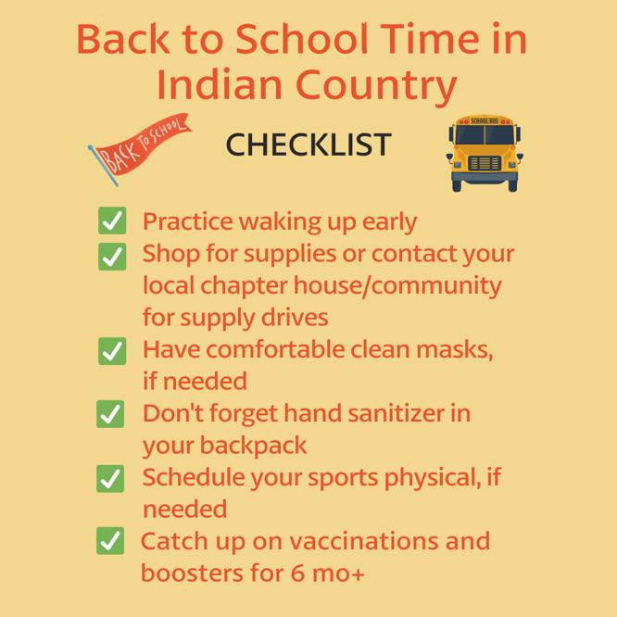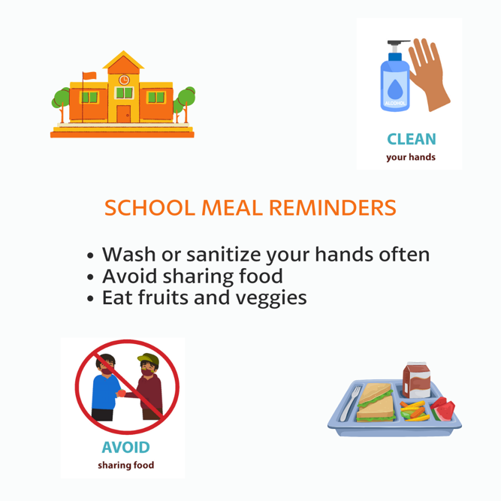

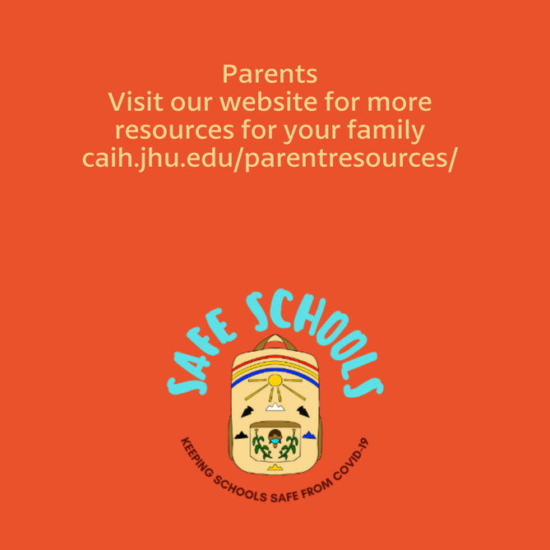

Description:
School is back in session, which gives children a new space to return to and practice our Indigenous values of protecting our families, our communities, and ourselves. Here are a few things to remember as we prepare to see teachers and friends. #NativesStopTheSpread #HealthyNatives #BacktoSchool #SkodenSchool #HealthyN8Vs
Twitter and Facebook
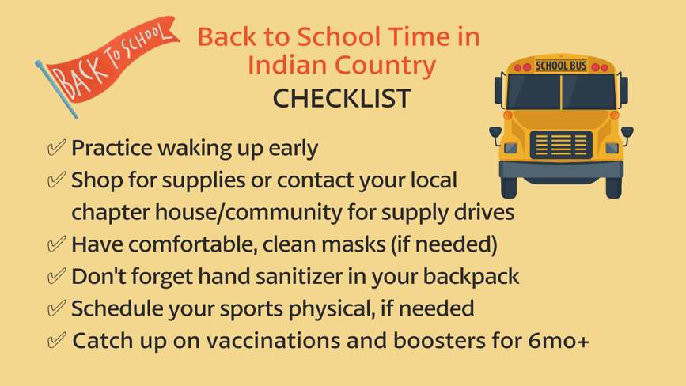
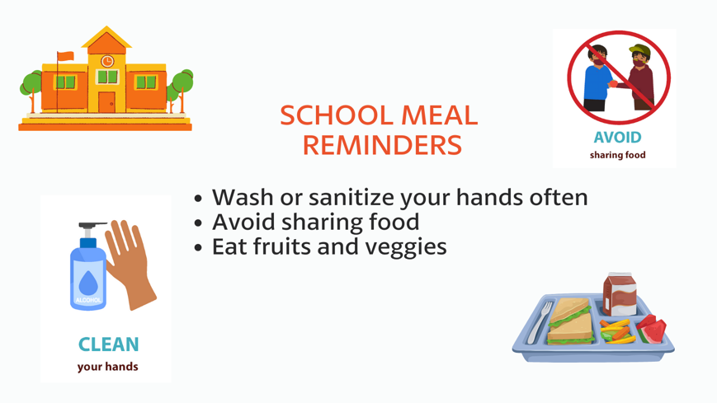
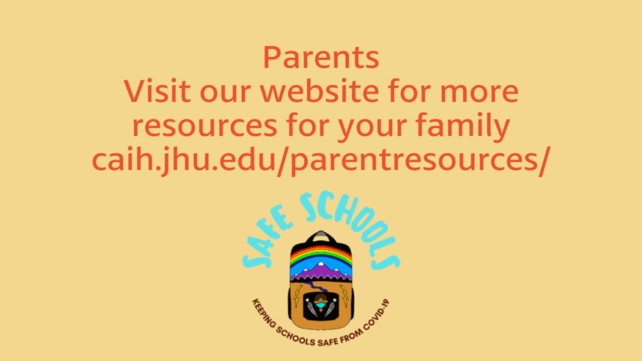
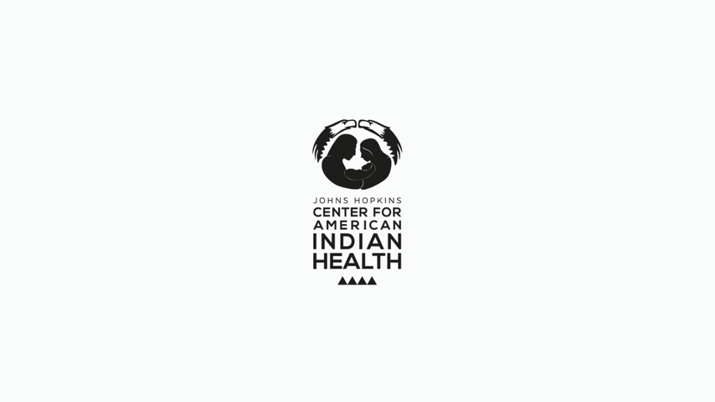
Description:
School is back in session, which gives children a new space to return to and practice our Indigenous values of protecting our families, our communities, and ourselves. Here are a few things to remember as we prepare to see teachers and friends. #NativesStopTheSpread #HealthyN8Vs

