Booster Vaccines Available for 5 and Up
Social Media Message: DYK? Booster shots are now available for kids ages 5 and up! Get youth #vaccinated to lower the risk of #COVID19 disease and to keep summer plans! Find a vaccine at: www.Vaccines.gov #HealthyNativeYouth #NativesStoptheSpread #NativesVaxUp #SkoVaxDen #VacciNative #TribalHealth #StopTheSpread #Indigenous #PublicHealth #NativeHealth #VaccinesWork #NativesDoingTheirPart #NativeAmericanHealth #IndigenousHealth #NativeAmerican #AmericanIndian #AlaskanNative #HealthyTribes #COVIDWarrior Photo tag: @cunicelliphoto
Instagram:

Facebook/Twitter:
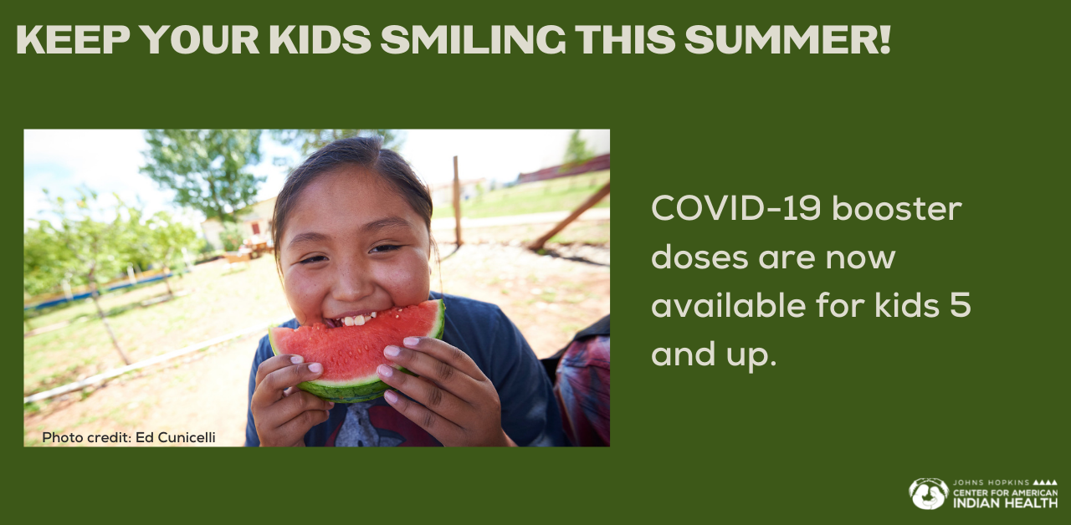

Social Media Message: Summertime is coming soon! Booster shots keep youth at their favorite indoor and outdoor activities! Get kids 5 and up #vaccinated to lower the risk of #COVID19 disease and to keep summer plans! Find a vaccine at: www.Vaccines.gov
#HealthyNativeYouth #NativesStoptheSpread #NativesVaxUp #SkoVaxDen #VacciNative #TribalHealth #StopTheSpread #Indigenous #PublicHealth #NativeHealth #VaccinesWork #NativesDoingTheirPart #NativeAmericanHealth #IndigenousHealth #NativeAmerican #AmericanIndian #AlaskanNative #HealthyTribes #COVIDWarrior Photo tag: @jhastiin
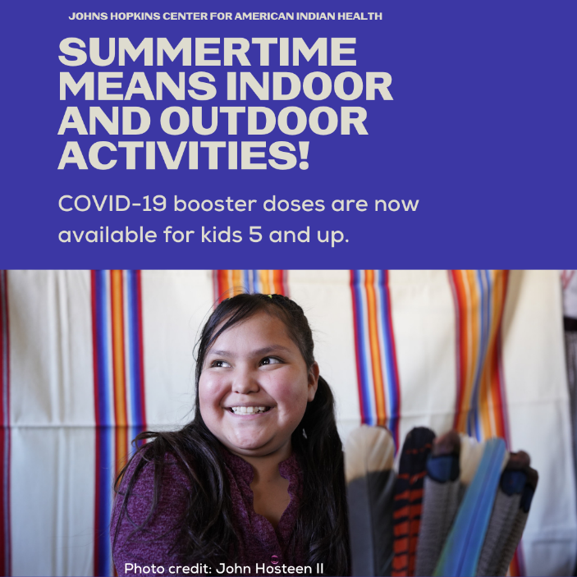
Facebook/Twitter:
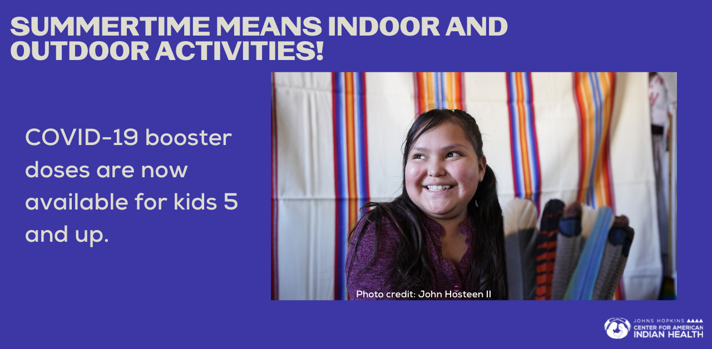
Social Media Message: Summertime means fresh fruits and veggies, sunshine, and booster vaccines! Youth 5 and up can get their booster vaccine to lower the risk of #COVID19 disease and play all summer long! Find a vaccine at: www.Vaccines.gov .
#HealthyNativeYouth #NativesStoptheSpread #NativesVaxUp #SkoVaxDen #VacciNative #TribalHealth #StopTheSpread #Indigenous #PublicHealth #NativeHealth #VaccinesWork #NativesDoingTheirPart #NativeAmericanHealth #IndigenousHealth #NativeAmerican #AmericanIndian #AlaskanNative #HealthyTribes #COVIDWarrior Photo tag: @ cunicelliphoto

Facebook/Twitter:
