COVID-19 Variants Social Media Toolkit

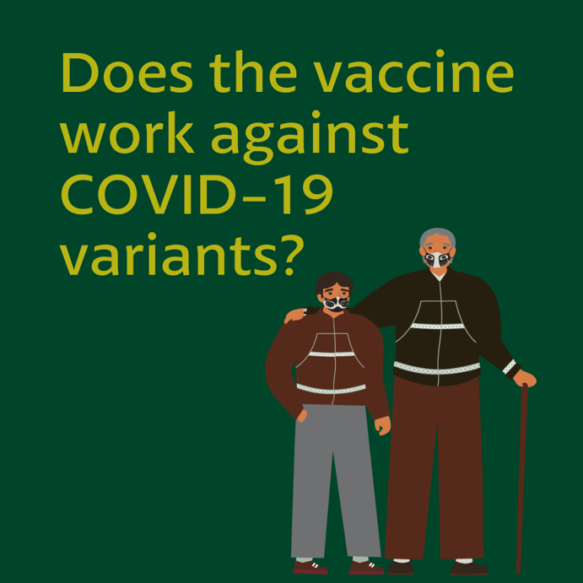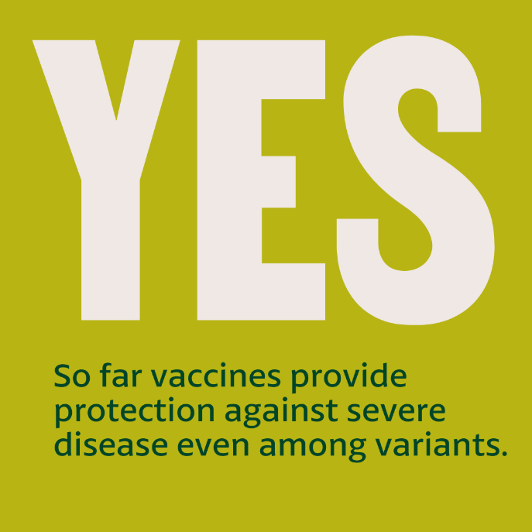

Message: All of the currently authorized #COVID19 #vaccines — Pfizer, Moderna, and J&J — provide protection against severe disease of #COVID19, even among variants. While this can change, new vaccines that fully protect against the variants are in development. The COVID-19 vaccines are still #YourBestShot against getting sick.

#NativeHealth #VaccinesWork

