Continue Testing Toolkit

Social Media Message: It might just be allergies, or it might be COVID, so it’s important to continue #COVID19 testing if you have symptoms or are exposed. Testing early helps you prevent spread and allows you to access effective treatments to prevent severe disease. Free tests are available online at covid.gov/tests or in your community.
#NativesStopTheSpread #NativesDoingTheirPart #NativeAmericanHealth #IndigenousHealth #TribalHealth #StopTheSpread #ProtectOurElders #COVIDtest #VacciNation #Vaccinated
Instagram:
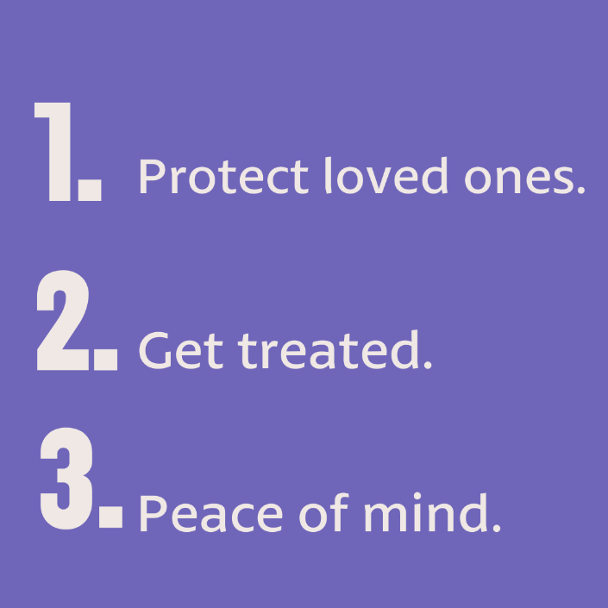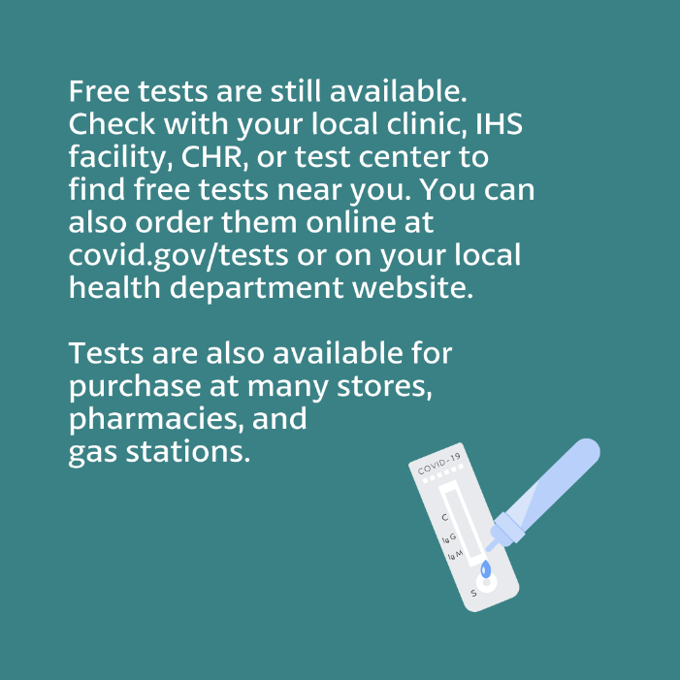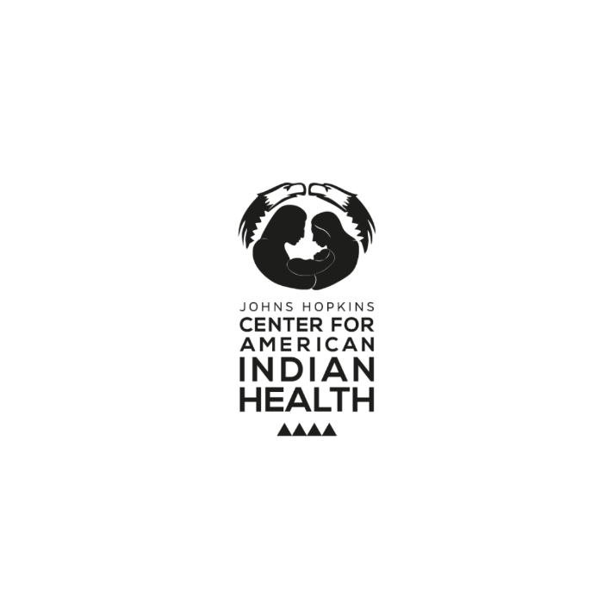

Facebook/Twitter: 