Early Testing Social Media Toolkit
Social Media Message: This holiday season, keep our elders and aunties safe by getting #tested early for #COVID19 anytime you have symptoms. Knowing your status keeps our communities safe and allows us to get any needed treatments early for a better recovery. Visit cdc.gov/coronavirus for more info.
#NativesStopTheSpread #NativesDoingTheirPart #NativeAmericanHealth #IndigenousHealth #TribalHealth #StopTheSpread #ProtectOurElders #COVIDtest #VacciNation #Vaccinated
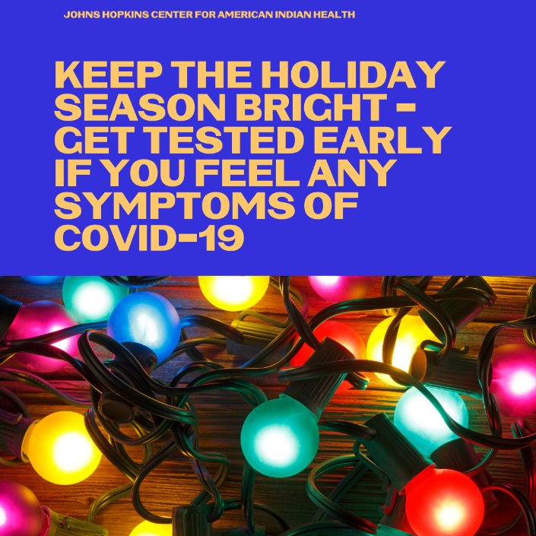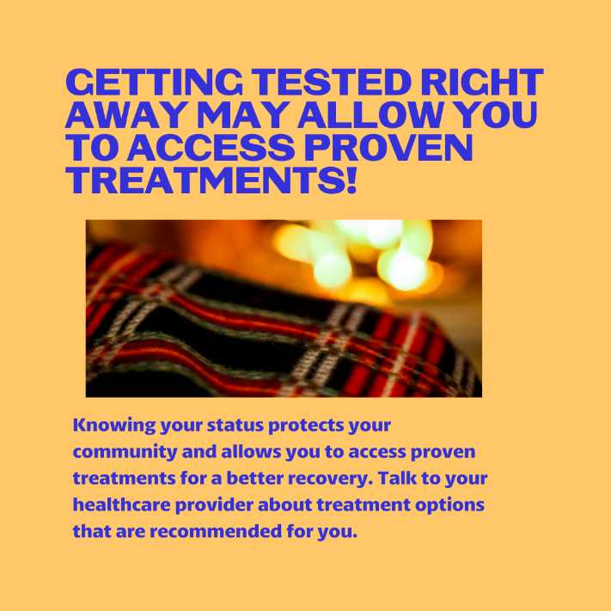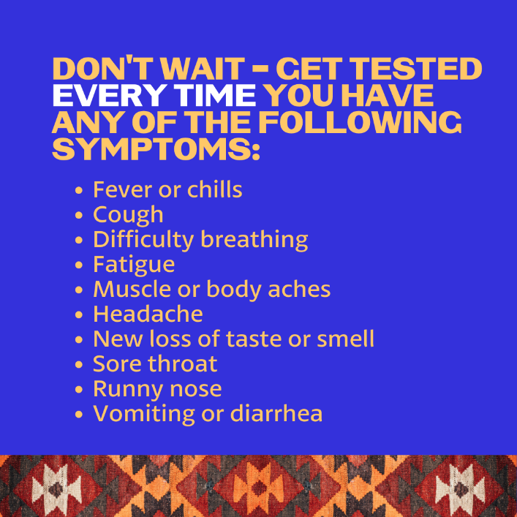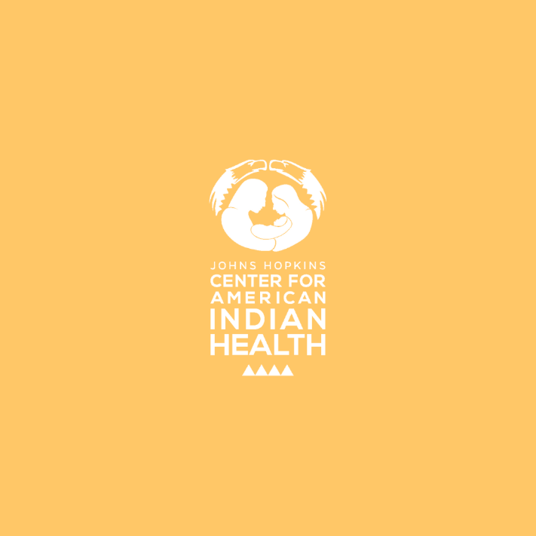

Twitter/FB:
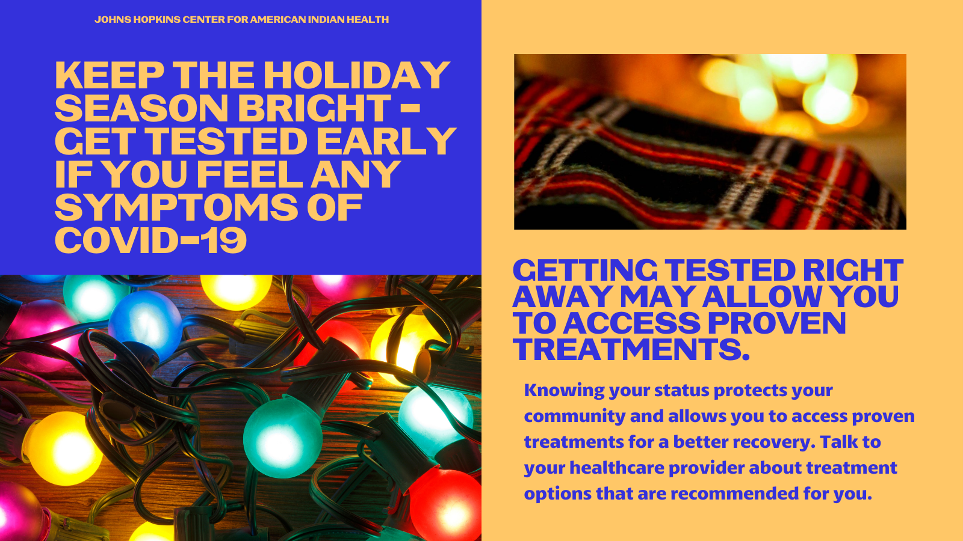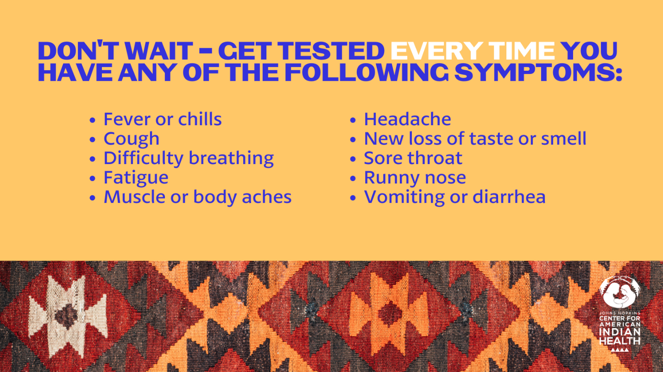

Tag: @Anthctoday @Aaipdocs @CDCgov @HealthyNativeYouth @HonoringNations @IndianCountryToday @_IllumiNatives @IndianHealthBoard_Minneapolis @IndianHealthService
@Indianz @JohnsHopkinsSPH @NationalIndianHealthBoard @Npaihb @Nihb1 @NationalNativeNews @NativeAmericans @NativeAmericanLifelines @Nimhgov @NNNnativenews @ProjectMosaicllc @SeattleIndianHealthBoard @UrbanIndigenousCollective @UrbanIndianHealth
@UrbanIndianHealthInstitute @WeAreHealers @wernative

