Importance of Getting Tested SM Toolkit

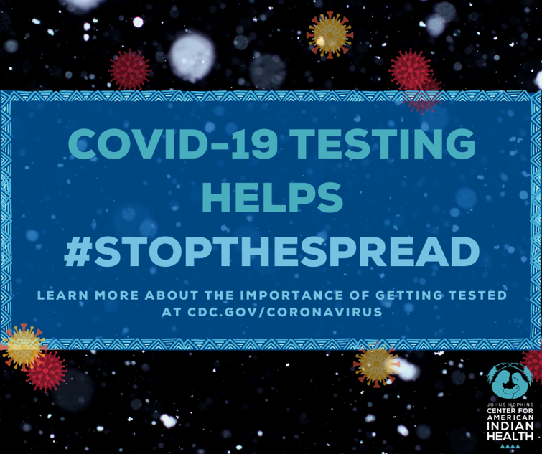
Social media message (CDC): It’s important to get tested for #COVID19 to prevent the spread of the virus. Knowing your status helps keep our communities and families safe. If someone has symptoms including fever or chills, shortness of breath, new loss of taste or smell, fatigue, muscle or body aches, or if they have had close contact with someone with confirmed COVID-19, they should get tested. To learn more about how to get tested, call your tribal health department or visit cdc.gov/coronavirus. #COVIDWarriors #Indigilove

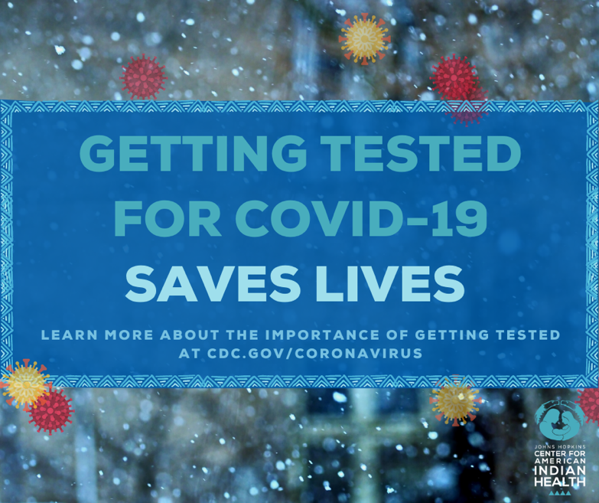
Social media message (CDC): Knowing your #COVID19 status saves lives by helping #StopTheSpread of the virus in our communities. With rising cases, this is more important than ever. If someone has symptoms of COVID-19, including fever or chills, shortness of breath, new loss of taste or smell, or if they have had close contact with confirmed COVID-19, they should get tested. To get tested, call your tribal health department or visit cdc.gov/coronavirus for more information. #COVIDWarriors #Indigilove

