Hang in There: Social Media Toolkit

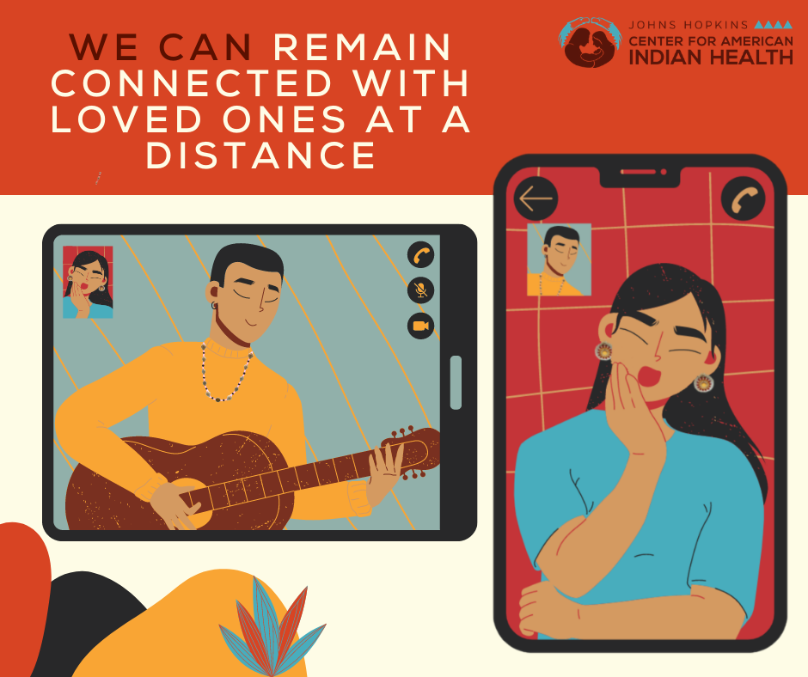
Social Media Message: We can remain connected with loved ones virtually to make the distance feel shorter. Follow guidance at cdc.gov/coronavirus to #StoptheSpread of #COVID19 and keep our families and communities safe.

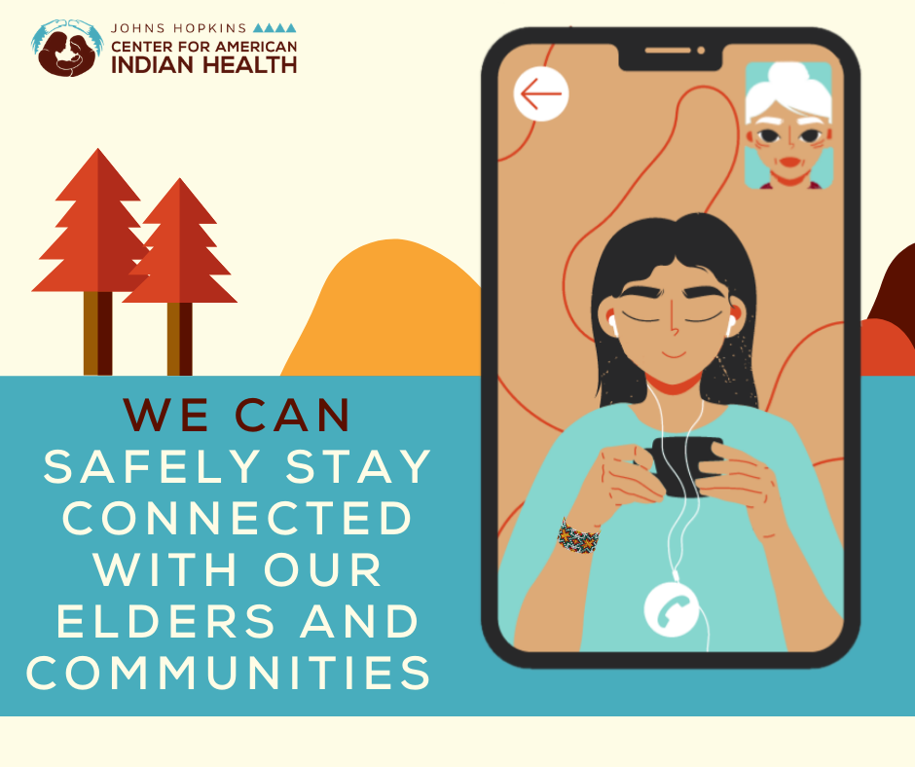
Social Media Message: #ProtectOurElders and stay culturally connected by sharing prayers, stories, or traditional recipes virtually. Learn more about maintaining traditions while staying safe at http://bit.ly/36nyntT.

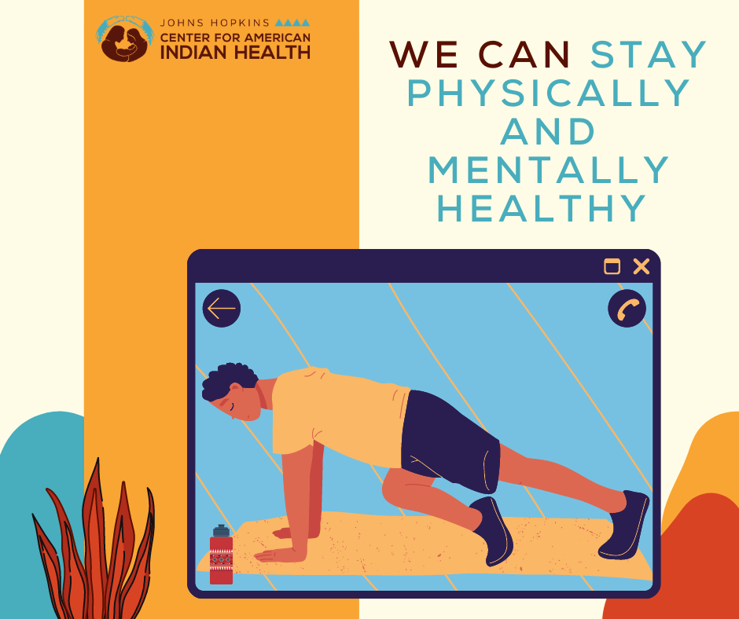
Social Media Message: Adjusting to life during the #COVID19 pandemic has been difficult, but there are ways to stay mentally and physically healthy. Stretch, walk, and take deep breaths throughout the day and social distance to #StoptheSpread. Find more tips to safely care for your mind and body at http://bit.ly/3ado0de.
@wellforculture

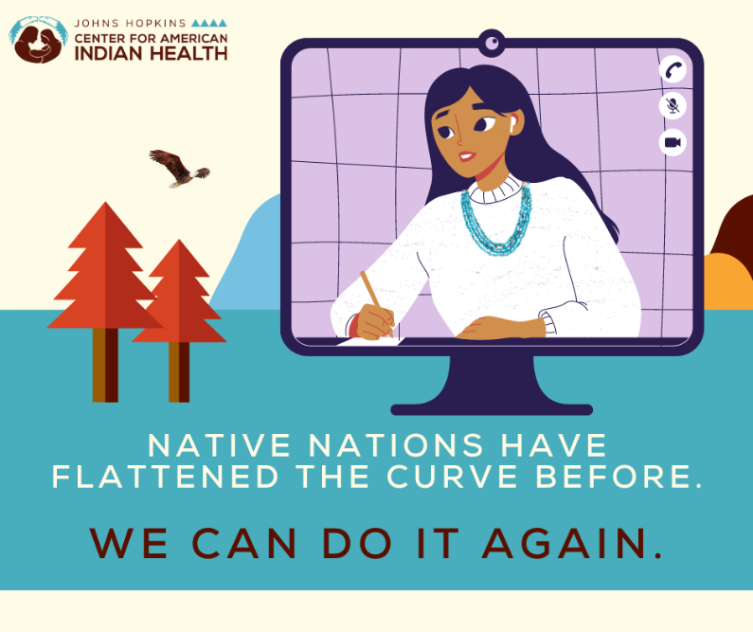
Social Media Message: This winter, #COVID19 remains a top concern. Native nations use sovereign authority to protect the public by setting up community-wide prevention methods like mandated mask-wearing and curfews to #FlattentheCurve. We will #HanginThere as we #StoptheSpread. Learn more: https://bit.ly/3ayd63x.

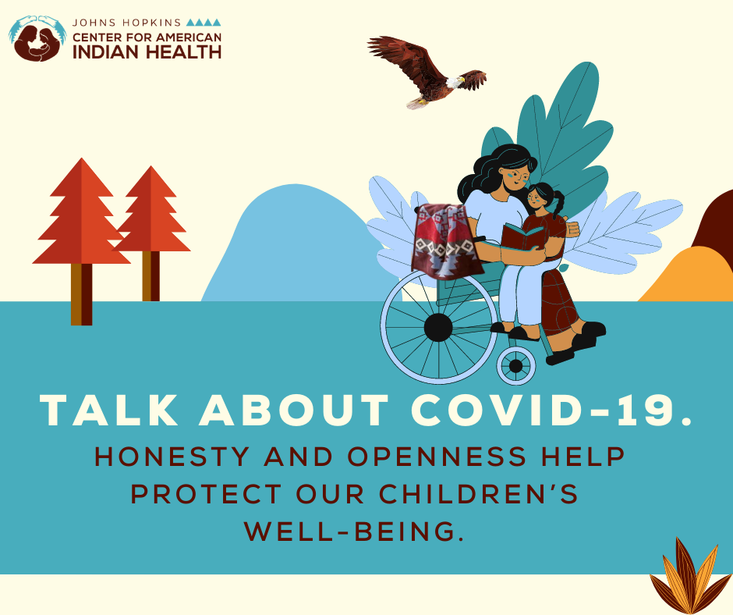
Social Media Message: It can be challenging to care for ourselves and our children during #COVID19. Talking about COVID-19 in an open, honest way can help protect our children’s well-being. Not sure how to get started? Read “Our Smallest Warriors, Our Strongest Medicine: Coping With COVID-19” with them for free: https://bit.ly/SmallestWarriorBook.

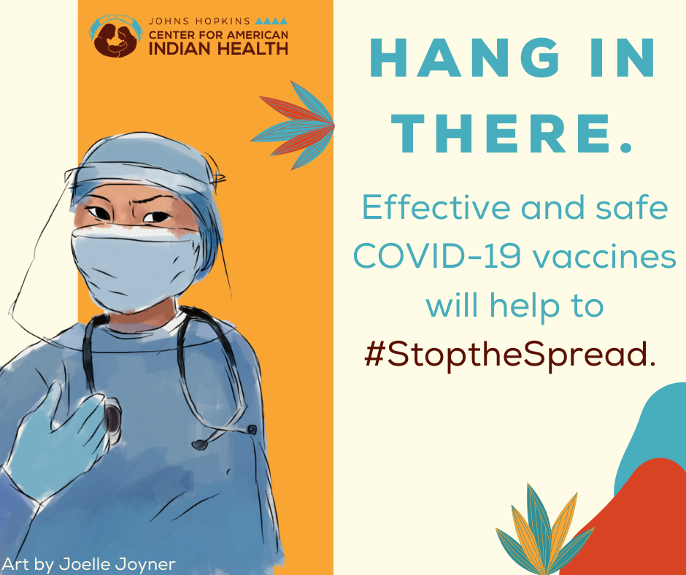
Social Media Message: Although #COVID19 rates have remained high this winter, help from vaccines are on the way. Safe and effective vaccines will be offered to those who need it most in our communities, but we can continue to protect our families by social distancing and wearing masks. We can #StoptheSpread. #HanginThere! Read more on vaccines here: http://bit.ly/UnderstandVaccines.

Potential Partners to Tag (mention in alt tag not text portion of message):
1. Centers for Disease Control and Prevention @CDCgov
2. American Academy of Pediatrics @AmerAcadPeds
3. Indian Health Service @IHSgov
4. National Institute on Minority Health and Health Disparities @NIMHD
5. Healthy Native Youth @HealthyN8Vyouth
6. Northwest Portland Area Indian Health Board @NPAIHB
7. National Indian Health Board@NIHB1
8. National Council for Urban Indian Health @NCUIH_official
9. Indian Country Today @IndianCountry
10. Native America Calling @180099native
11. Alaska Native Tribal Health Consortium @ANTHCtoday

