Holiday Guidance Social Media Toolkit
Social Media Message: With holidays right around the corner, it is important to know how to reduce the risk of #COVID19 at gatherings you might be hosting or attending! Consider any specific risks for you, your family, or friends, and encourage everyone to get #vaccinated or wear a #mask! Celebrate safely to protect your loved ones this year.
#NativesStopTheSpread #StopTheSpread #ProtectOurElders #VacciNation #Vaccinated #Vaccine
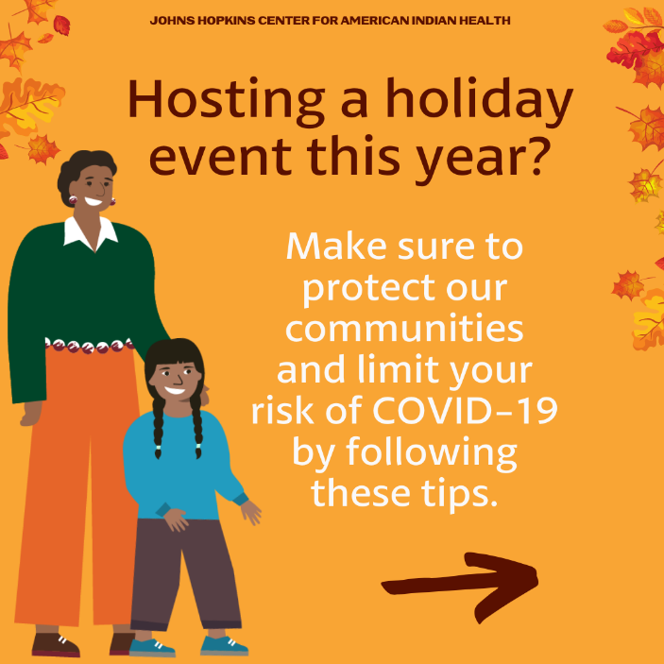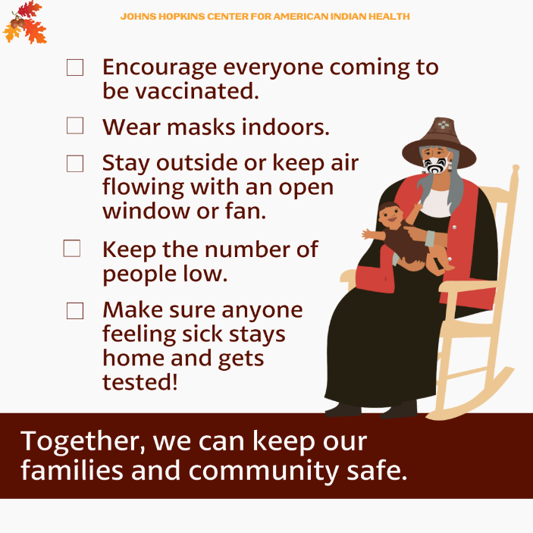
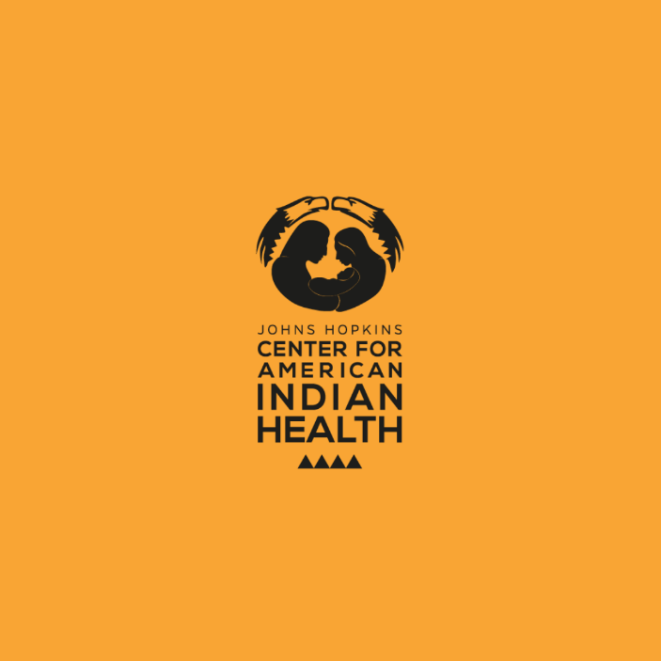

Twitter/FB:
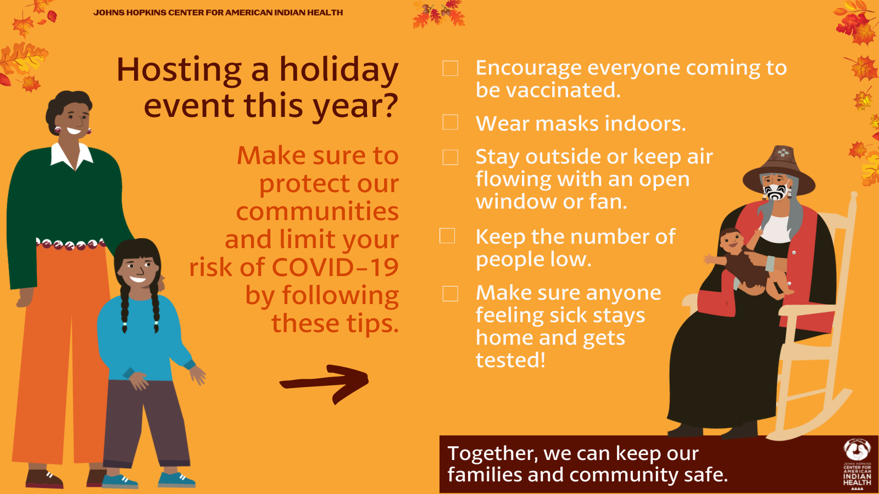

Social Media Message: This year, find some holiday cheer but remember to stay #COVIDSafe to keep the season jolly. We can reduce the risk of #COVID19 among our loved ones by encouraging #vaccination and taking precautions like wearing #masks and opening windows.
#NativesStopTheSpread #StopTheSpread #ProtectOurElders #VacciNation #Vaccinated #Vaccine
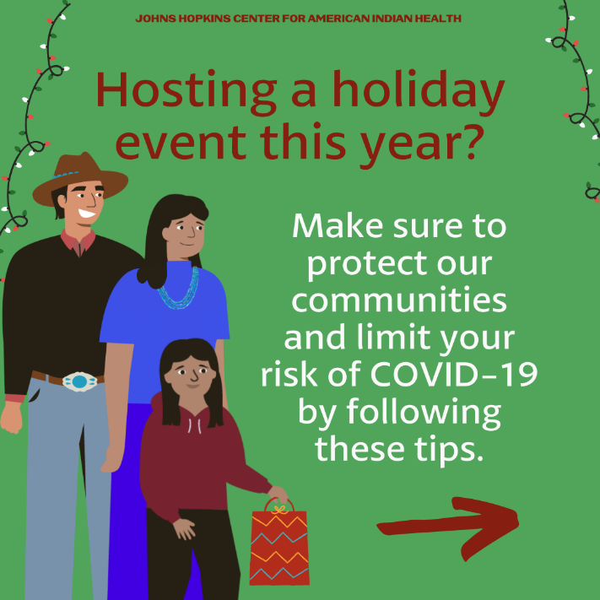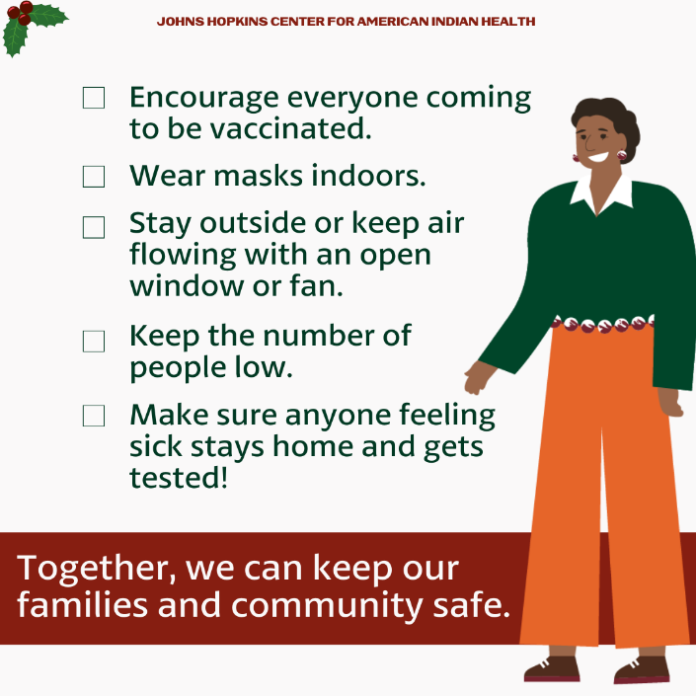
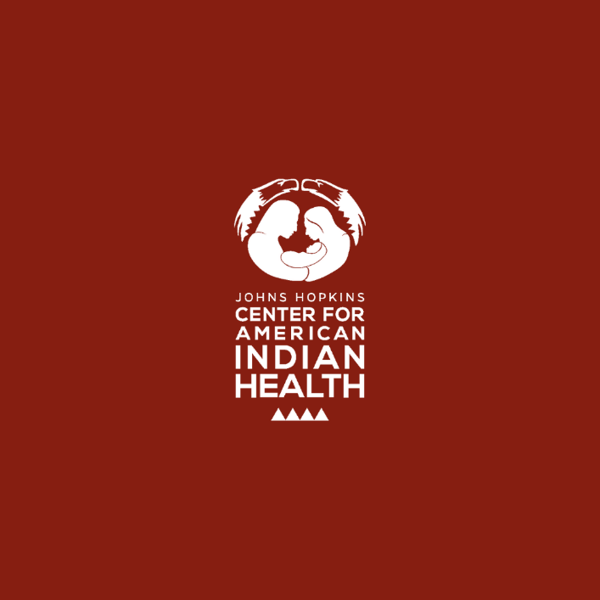
Twitter/FB:
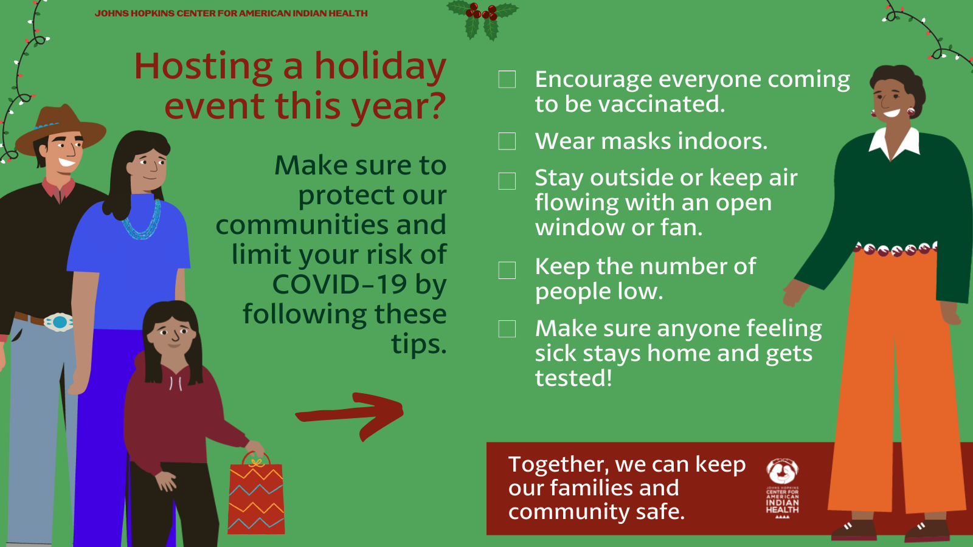
Tag: @Anthctoday @Aaipdocs @CDCgov @HealthyNativeYouth @HonoringNations @IndianCountryToday @_IllumiNatives @IndianHealthBoard_Minneapolis @IndianHealthService
@Indianz @JohnsHopkinsSPH @NationalIndianHealthBoard @Npaihb @Nihb1 @NationalNativeNews @NativeAmericans @NativeAmericanLifelines @Nimhgov @NNNnativenews @ProjectMosaicllc @SeattleIndianHealthBoard @UrbanIndigenousCollective @UrbanIndianHealth
@UrbanIndianHealthInstitute @WeAreHealers @wernative

