Importance of Getting Tested Social Media Toolkit

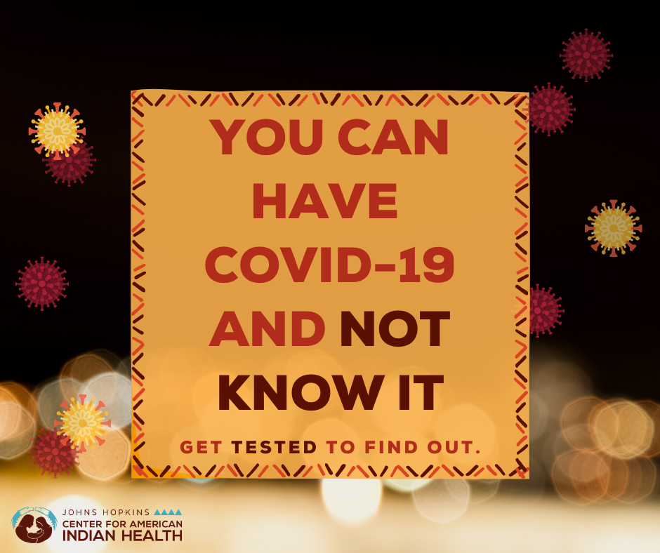
Social media message: Getting tested for #COVID19 is essential to #StoptheSpread of the virus. Knowing your COVID-19 status can help you get a head start on the virus to keep our families and our communities safe in the holiday season. Schedule a test today! Call your local health department for more information or visit cdc.gov/coronavirus for more information.

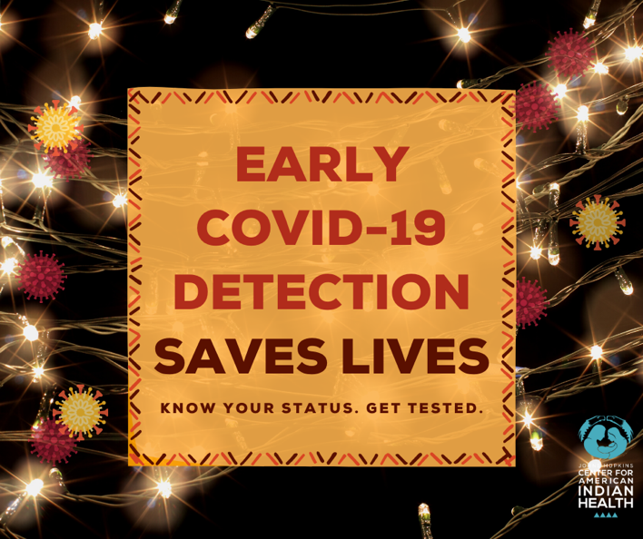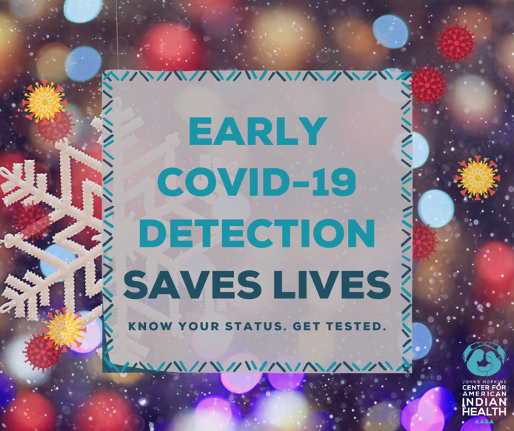
Social media message (red): Early detection saves lives by preventing the spread of the virus and allowing someone to get medical attention before severe symptoms develop. Help to #StopTheSpread in our communities. Know your status, get tested! Visit cdc.gov/coronavirus for more information.

Social media message (blue): It can be harder to social distance during the #holiday season. Early detection saves lives by preventing the spread of the virus in our communities and allowing someone to get medical attention as soon as possible. #StoptheSpread. Know your status and get tested! Visit cdc.gov/coronavirus for more information.

