Measuring Your COVID-19 Risk During Daily Activities

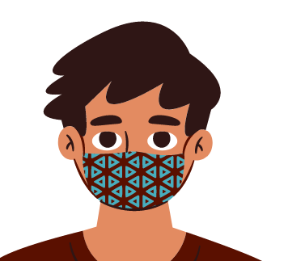Three Major Risk Factors: Location, Time, Distance
Reduce Your Risk. Wear a Mask.
Everyone should wear a mask during all activities, no matter the location, time, or distance from others. Any activity where someone is not wearing a mask is high risk for getting COVID-19.
Mask fully covers the mouth and nose
Measuring your risk for COVID-19 during an activity starts with thinking about three major factors: location, time, and distance. Do not engage in any activity without wearing a mask.
- Location. Is the activity outdoors? Outdoor activities are safer than indoor activities. COVID-19 moves through the air and stays in the air longer when indoors, increasing your risk of exposure.
- Time. How long will you be doing the activity? Try to spend less than 15 minutes total with others over a 24-hour period, especially if indoors. Spending more time around others increases your risk of exposure to COVID-19.
- Distance. Will you be able to stay 6 feet apart from others? Activities where you can remain at least 6 feet away from others are safest. Distancing is important because most germs cannot travel more than 6 feet from person to person in the air.

Measuring Your Risk During Daily Activities
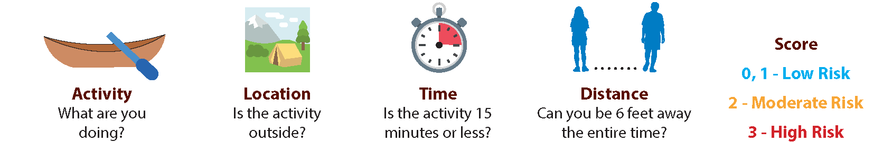

Getting Fuel 0
Feeding livestock 1
Going to outdoor sporting 1
event
Hiking with friends 2
Gathering traditional foods 2
or medicines with others
Attending indoor family 3
gathering with others
Eating at a restaurant 3
Attending indoor tribal 3
meeting
your activity here
your activity here
3


Effective December 1, 2020 Source: CDC
your logo here

