Native American Heritage Month Social Media Toolkit
Link to Stop the Spread Factsheet: https://bit.ly/2YIaybE
Insert in Instagram Link for IG messages below

Follow Johns Hopkins Center for American Indian Health
Twitter.com/JHUCAIH
Facebook.com/JHUCAIH
Instagram.com/JohnsHopkinsCAIH/

Instagram Message #1:

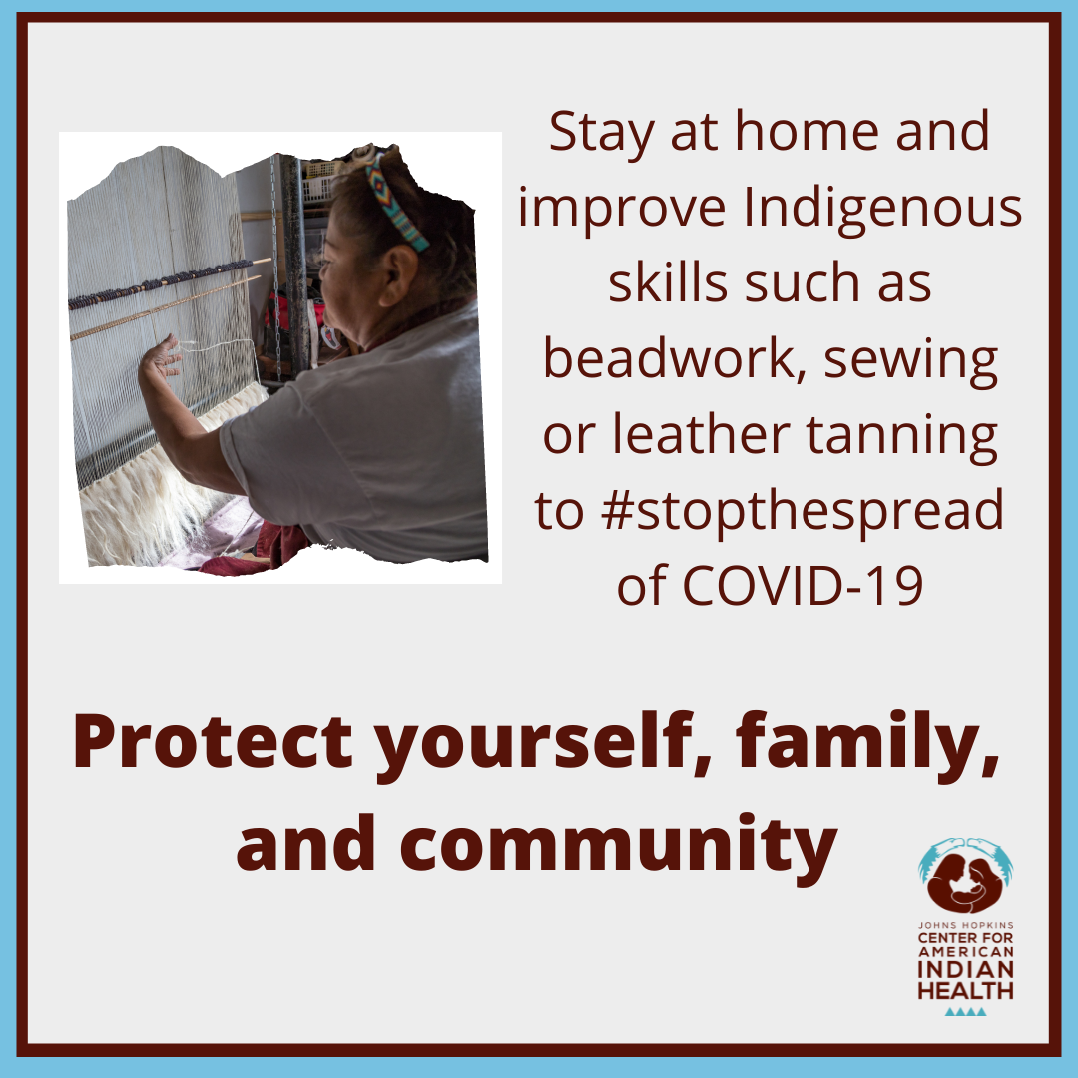

This November, for #NativeAmericanHeritageMonth, celebrate our heritage while preventing the spread of #COVID19. We can stay #HealthyAtHome by praying with loved ones through video chat or honing our Indigenous skills like weaving. Want more ideas? Check out the link in our bio.

Instagram Message #2:

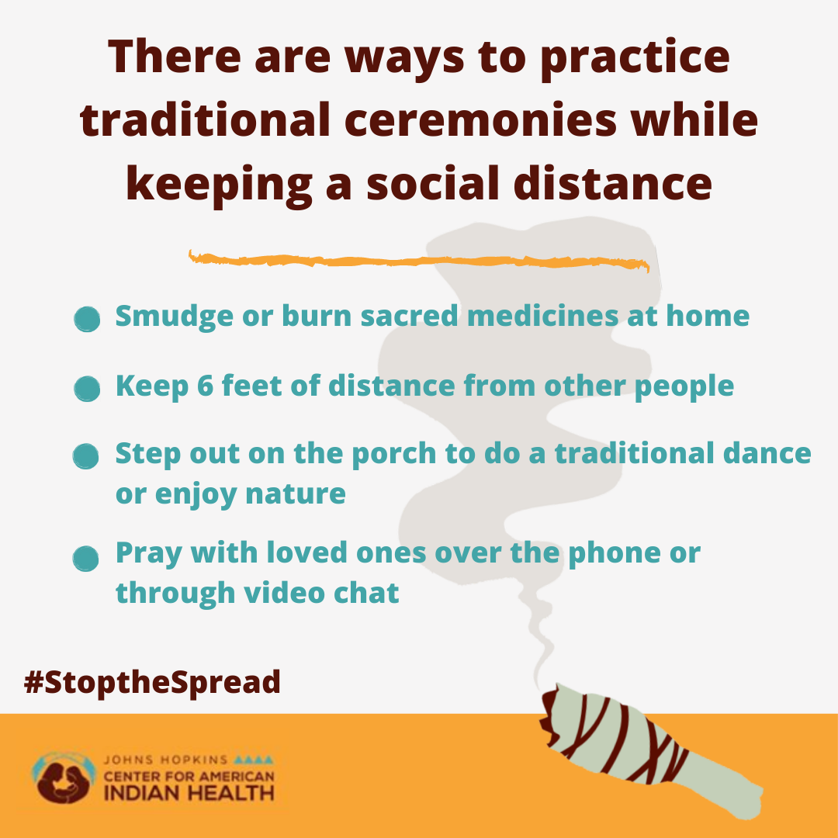

Keep away stress and #StoptheSpread this November during #NativeAmericanHeritageMonth by participating in ceremony #SocialDistanceStyle. Protect yourself, family, and community from #COVID19 by being creative and staying safe. Want more ideas? Check out the link in our bio.



With #COVID19 cases rising around us, avoiding unnecessary travel is the best way to prevent the spread. During #NativeAmericanHeritageMonth we can share traditional stories at home with loved ones. Learn more about how to celebrate our heritage while keeping safe: https://bit.ly/2YIaybE

Instagram:
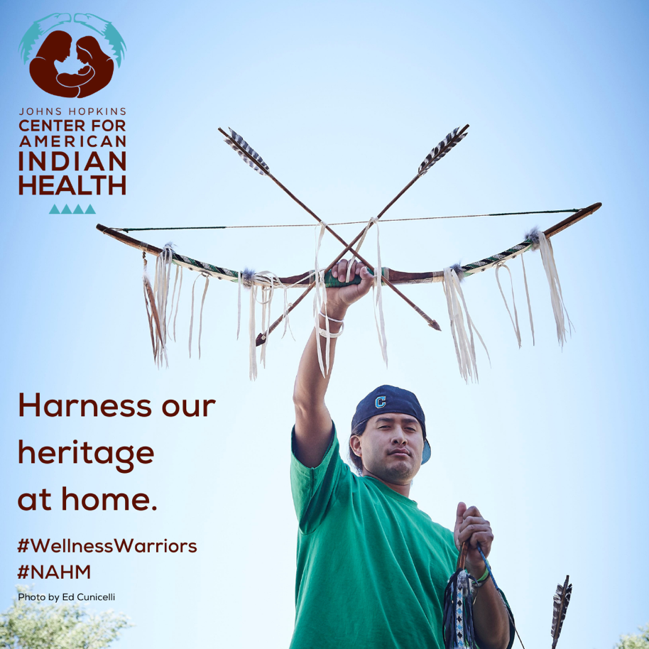
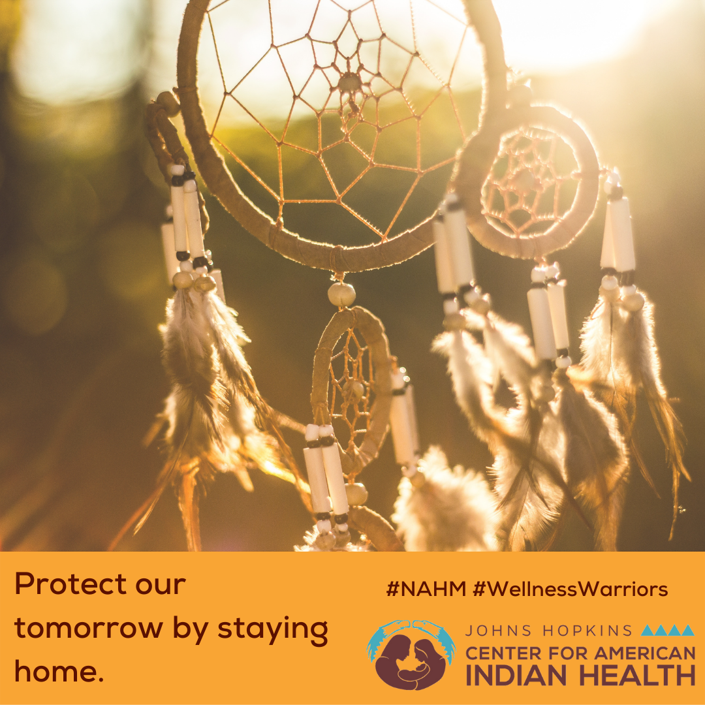

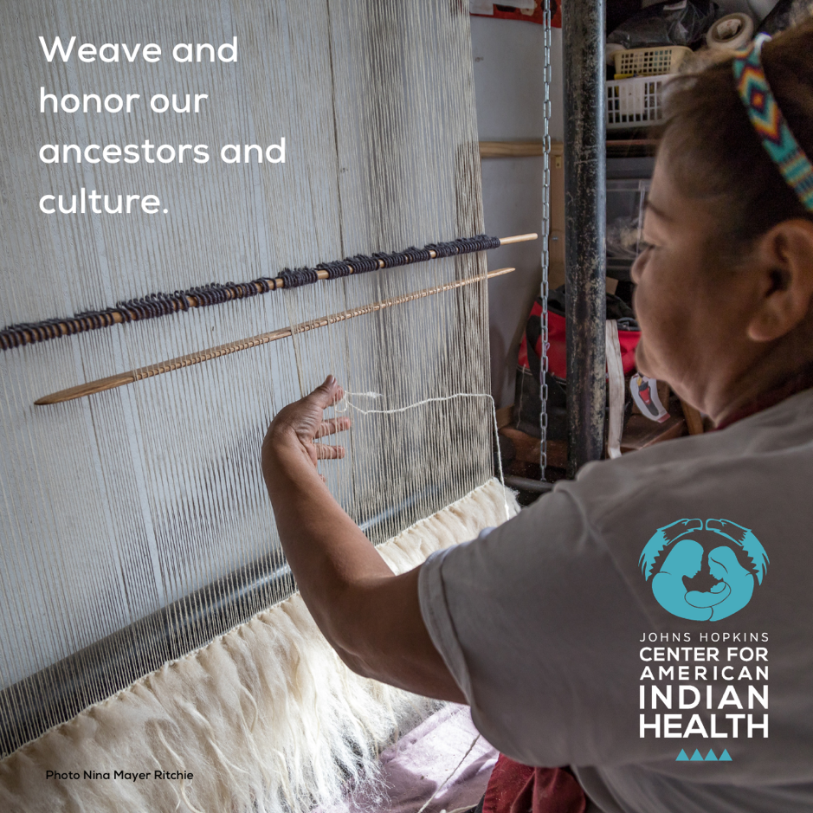

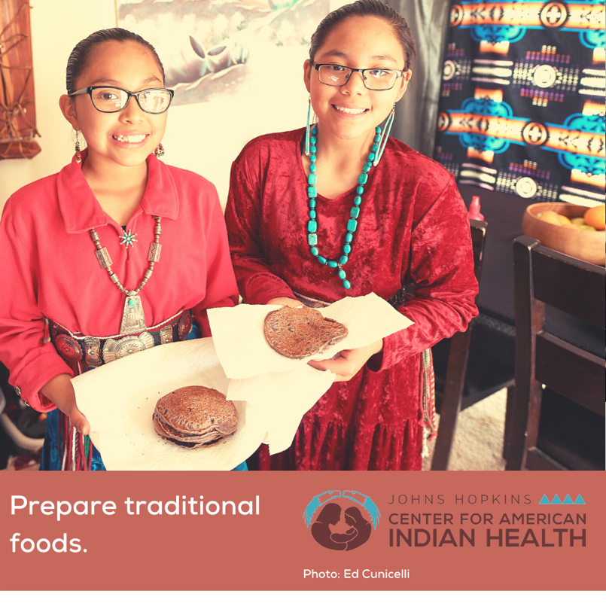
[slideshow] As cases rise around us, now is the perfect time to stay warm and safe at home. Hone our Indigenous skills such as weaving, carving, and making traditional foods. What traditional skills do you practice? Explore more ideas on celebrating Native American Heritage Month—see link in bio.

@HonoringNations @nihb1 @NCAI @TheUIHI

#NAHM
#StayHomeHeroes
#StoptheSpread

