Continue to Protect Against New Variants: SM Toolkit
Social Media Message: Continuing to monitor new #COVID19 variants is an important part of moving forward. Although variants are expected, we can still do our part by slowing the spread – get vaccinated & boosted and make sure to stay home when you are sick!
#NativesStopTheSpread #StopTheSpread #SkoVaxDen #VacciNation #NativesDoingTheirPart #IndigenousHealth #NativeAmerican #AmericanIndian #AlaskanNative #HealthyTribes #IndigenousPeople #NativeHealth #TribalHealth #COVIDWarrior
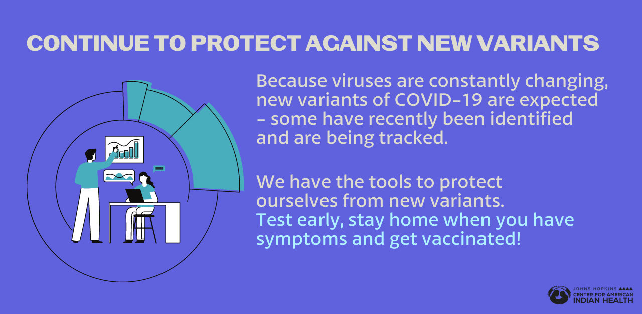
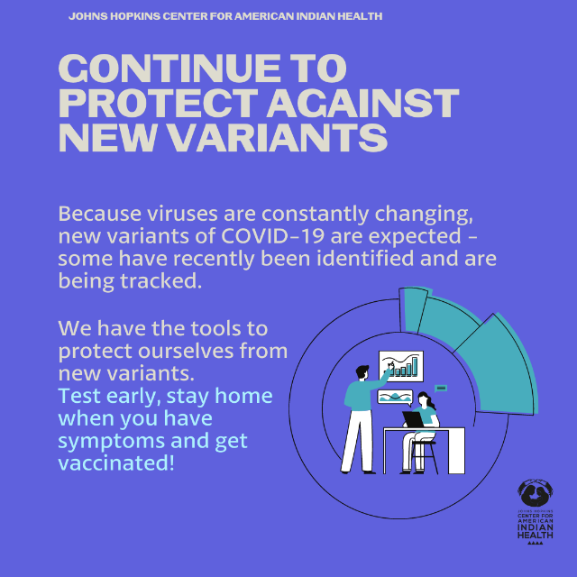
Partners to Tag: @Anthctoday @Aaipdocs @CDCgov @HealthyNativeYouth @HonoringNations @IndianCountryToday @_IllumiNatives @IndianHealthBoard_Minneapolis @IndianHealthService
@Indianz @JohnsHopkinsSPH @NationalIndianHealthBoard @Npaihb @Nihb1 @NationalNativeNews @NativeAmericans @NativeAmericanLifelines @Nimhgov @NNNnativenews @ProjectMosaicllc @SeattleIndianHealthBoard @UrbanIndigenousCollective@UrbanIndianHealth
@UrbanIndianHealthInstitute @WeAreHealers @WeRNative

