Omicron Social Media Toolkit
Social Media Message: The new Omicron variant gives us more reasons to be #COVIDsafe and use our trusted tools, like #vaccinating, #masking, #testing, and #SocialDistancing this winter. While we wait to learn more about this new version of COVID-19, it’s important that we keep calm and keep doing what we know works!
#Omicron #COVID19 #NativesStopTheSpread #StopTheSpread #SkoVaxDen #Vaccinate #Vaccine #IndigenousHealth
FB/Twitter:
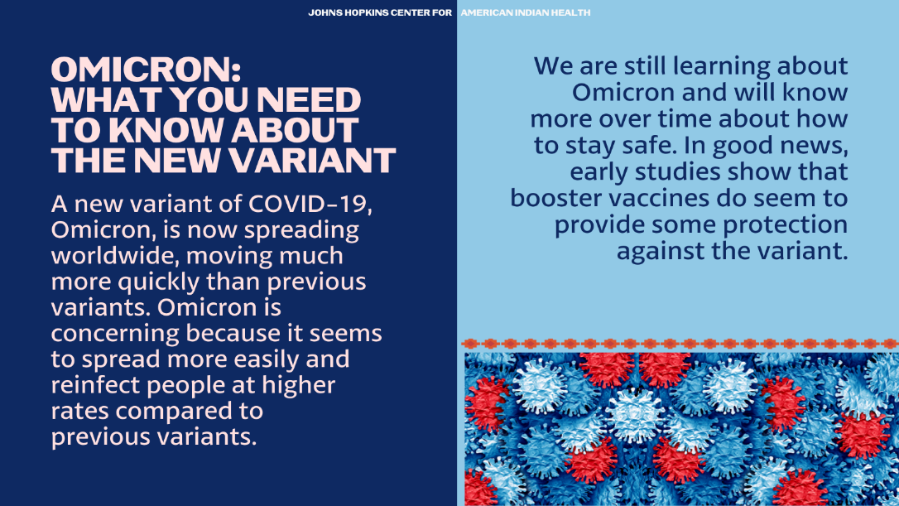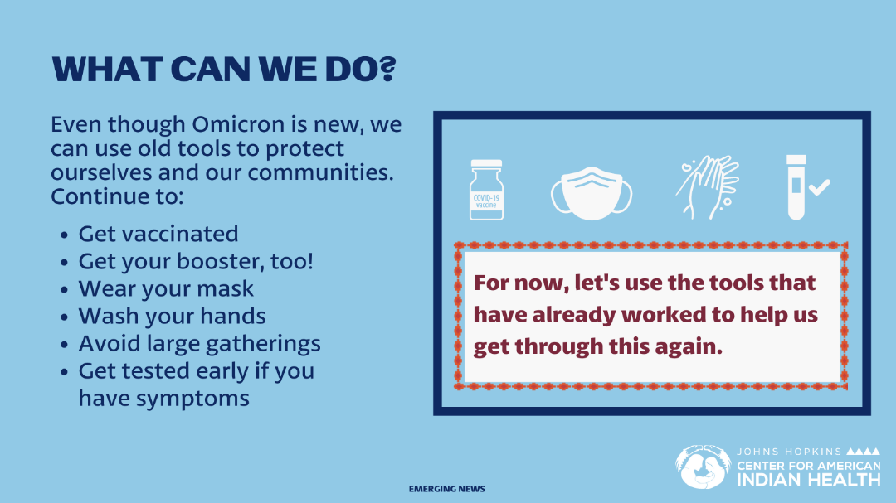

Instagram:
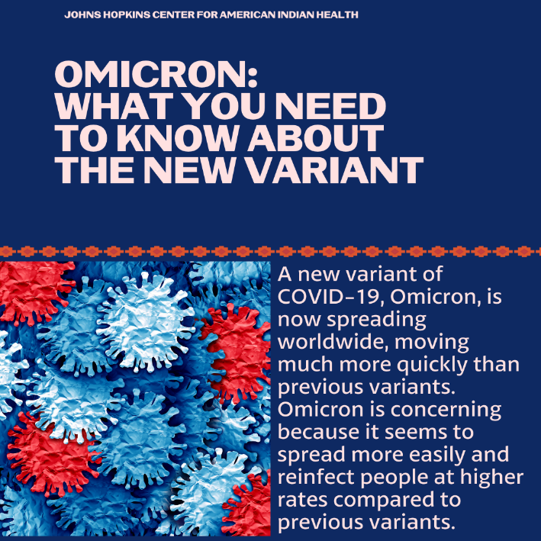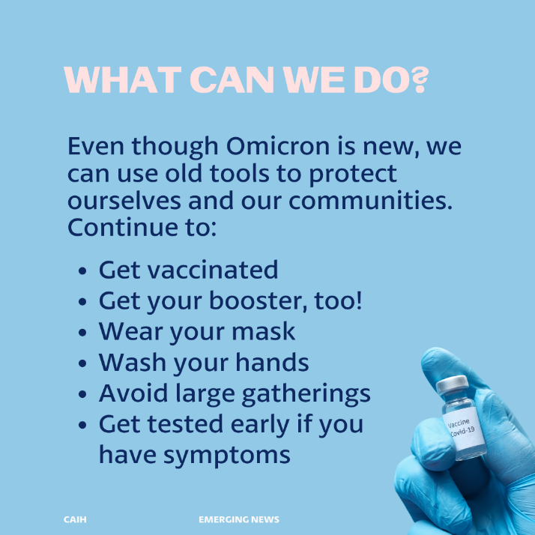
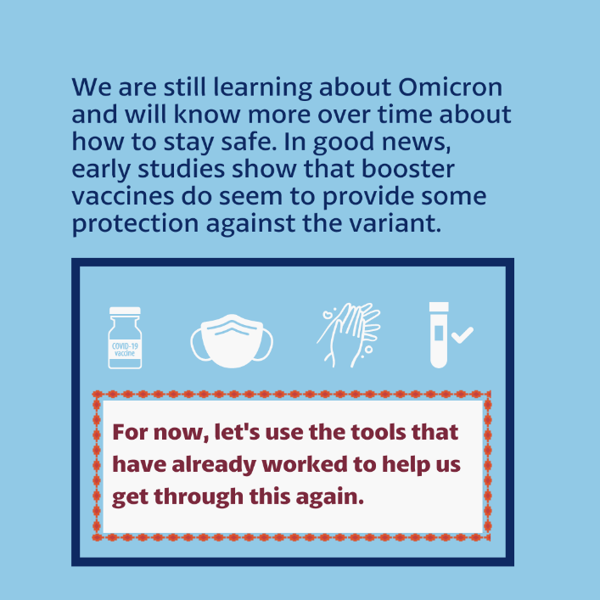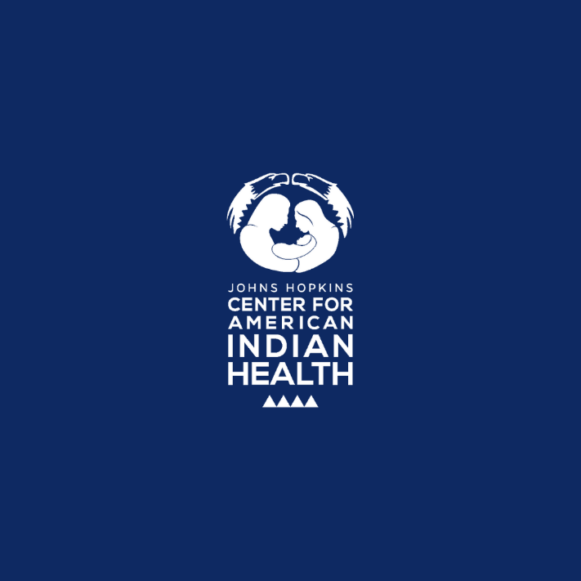

Tag: @Anthctoday @Aaipdocs @CDCgov @HealthyNativeYouth @HonoringNations @IndianCountryToday @_IllumiNatives @IndianHealthBoard_Minneapolis @IndianHealthService
@Indianz @JohnsHopkinsSPH @NationalIndianHealthBoard @Npaihb @Nihb1 @NationalNativeNews @NativeAmericans @NativeAmericanLifelines @Nimhgov @NNNnativenews @ProjectMosaicllc @SeattleIndianHealthBoard @UrbanIndigenousCollective@UrbanIndianHealth
@UrbanIndianHealthInstitute @WeAreHealers @WeRNative

