Quarantine and Isolation in a Shared Living Space: Social Media Toolkit
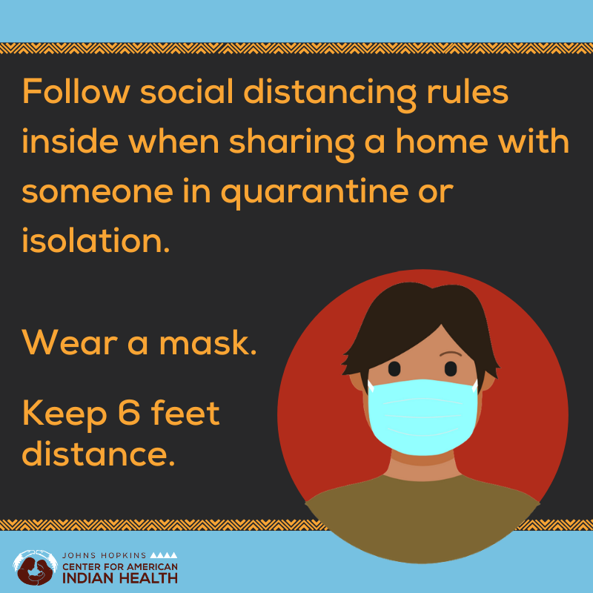
Social Media Message: Keep your family safe by following #SocialDistancingRules in the home when someone has been exposed to #COVID19, shows symptoms, or tests positive. Maintaining distance from others and wearing a mask indoors are effective ways to prevent the virus from spreading. Learn more ways to keep your family safe at http://bit.ly/SharedLivingSpace.
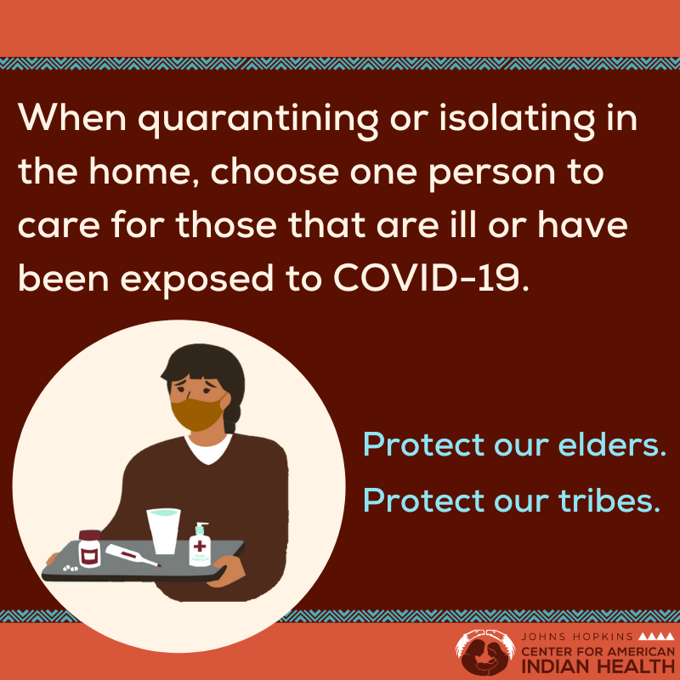
Social Media Message: It is important to quarantine if you are exposed to #COVID19, have symptoms, or test positive. Choose one healthy member of the household to do the grocery shopping and care for those that are ill. It can be hard when sharing a home with multiple people but knowing the proper steps can help #StoptheSpread and #ProtectOurElders. Find more tips at http://bit.ly/SharedLivingSpace.

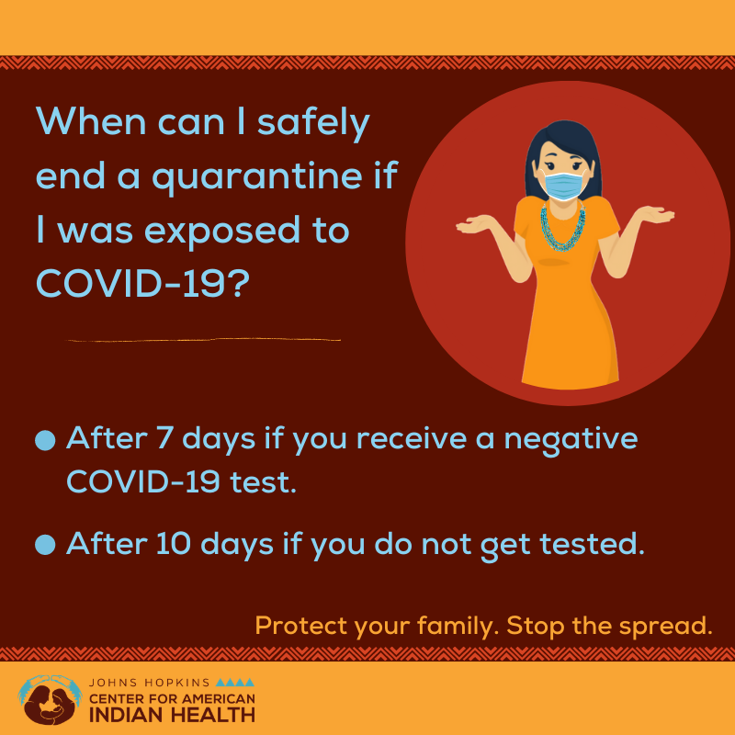
Social Media Message: You can spread #COVID19 without having symptoms or before symptoms start. If you have been exposed, stay home except for urgent health care, and apart from others. Find more tips on how to safely quarantine at home at http://bit.ly/SharedLivingSpace.

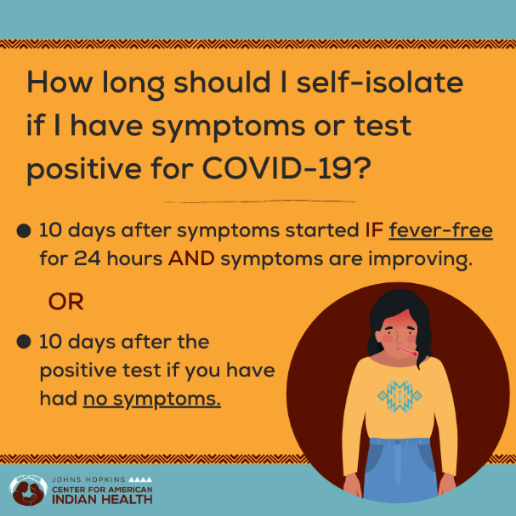
Social Media Message: Self-isolating in your home when you show symptoms or test positive for #COVID19 keeps your family and community safe. Avoid sharing household objects like dishes and towels, use a separate bathroom, and sleep apart from others if possible. For more advice on how to #StoptheSpread in your household, visit http://bit.ly/SharedLivingSpace.

Potential Partners to Tag:
Centers for Disease Control and Prevention @CDC.gov
Indian Health Service @IHSgov
National Institute on Minority Health and Health Disparities @NIMHD
Healthy Native Youth @HealthyN8Vyouth
Northwest Portland Area Indian Health Board @NPAIHB
National Indian Health Board@NIHB1
National Council for Urban Indian Health @NCUIH_official
Indian Country Today @IndianCountry
Native America Calling @180099native

