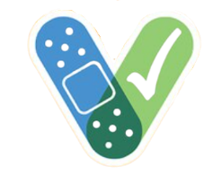
Thank you for protecting our community

By choosing to get the COVID-19 vaccine, we are caring for the health of our neighbors, our families and ourselves.

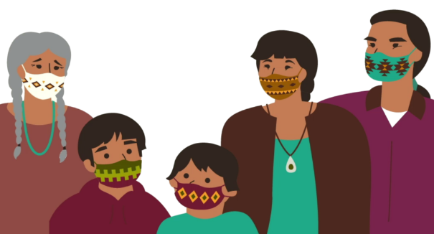
3 Reminders:
COVID-19 prevention is still important. We all need to do our part to protect our community until everyone can get the vaccine and COVID-19 rates are low. Continue the 3 Ws: Wear a mask, Watch your distance, and Wash hands frequently.
The vaccine is very effective at preventing COVID-19 only after all required doses. Make a note for your calendar:
Brand: Pfizer Moderna
J&J (only 1 dose needed)
Date of dose 1:_____________
Date of dose 2:_____________

It is common to experience side effects such as soreness, tiredness and headache for 1-2 days. The vaccine cannot make you sick with COVID-19. If you have concerns, call your health care provider.

For more information:
cdc.gov/vaccines/COVID-19

caih.jhu.edu/resource-library

Local Resources:

